word

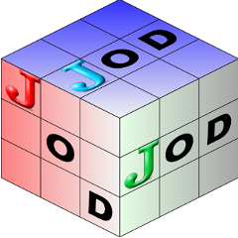

Release 0.9.4 Nov 25 2011  J addon for J 6.02 and J 7.01  Windows and Linux use JAL to install | Table of Contents  Online Documentation  PDF version: jod.pdf  The JOD Page

Introduction  Installing and Configuring JOD  Quick Tutorial  Best Practices  Scripts  Dictionary Dump Files  Generated Script Structure  Dependent Section  User Interface  Word Definitions | Directories and Files  JOD Directories  Master File: jmaster.ijf  Words File: jwords.ijf  Tests File: jtests.ijf  Groups File: jgroups.ijf  Suites File: jsuites.ijf  Macros File: jmacros.ijf  Uses File: juses.ijf  Class Source Code  jod.ijs  joddob.ijs  jodmake.ijs  jodstore.ijs  jodtools.ijs  jodutil.ijs  jodon.ijs | Appendicies  JOD Class Structure  JOD Argument Codes  Reference Path  startup.ijs entries  jodprofile.ijs  jodparms.ijs  Notes  JOD Release Notes  Linux Notes

These pages are formatted to print on Legal paper: 8.5 x 14.0 inches.

