How to make a cardboard K-9 replica from the 1970’s Doctor Who television show.


Introduction:
I enjoy learning about all things IOT ,robots and raspberry pi. K-9 is a cardboard replica from the late 70's Doctor Who television show, It is also a mobile platform for Learning about micro computing, code development and the Internet of things through robotics.

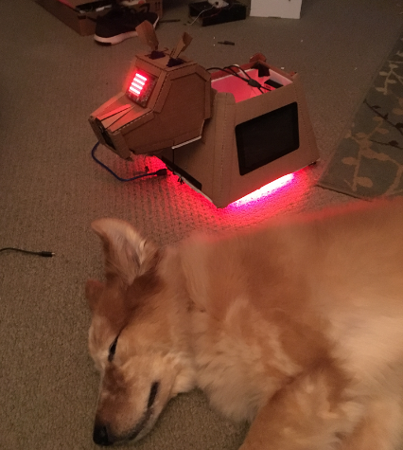

Projects
- AWS VPC - internal and external subnets
- https://docs.aws.amazon.com/AmazonVPC/latest/UserGuide/VPC_Scenario1.html
- Raspberry Pi - 2 node cluster:
- Reference: https://makezine.com/projects/build-a-compact-4-node-raspberry-pi-cluster/
- SSh key based authorization between the cluster nodes
- ref: https://www.raspberrypi.org/documentation/remote-access/ssh/passwordless.md
- Raspberry Pi to Arduino serial and I2c communications
- Sonar obstacle avoidance:
- ref: http://www.instructables.com/id/Obstacle-Avoiding-Robot-With-Servo-Motor-Arduino/
- Object Recognition
- ref: http://www.instructables.com/id/Pan-Tilt-face-tracking-with-the-raspberry-pi/
- Text to speech
- ref: http://espeak.sourceforge.net/
- Voice Recognition
- ref: http://stevenhickson.blogspot.com/2013/04/voice-control-on-raspberry-pi.html
- Environment sensor detection and data storage
- custom python scripts plus references below
- ref: https://projects.raspberrypi.org/en/projects/sense-hat-data-logger
- ref: https://github.com/adhorn/rasp-sensehat-iot
- High charts ref: https://www.highcharts.com/
- Raspberry Pi honey pot
- https://www.anomali.com/blog/create-an-army-of-raspberry-pi-honeypots-on-a-budget

Hardware
- QTY 2 Raspberry pi b3/b2
- Arduino uno 1.5
- L298N motor controller
- HC-SR04 ultrasonic Distance Sensor
- Sense hat
- RGB Leds (lots of LEDS. Because they are awesome)
- DC motors
- 12 volt Lipo battery
- 3 port cell phone charging battery
- 12 volt to 5 step down
- 7 inch touch screen
- serial cables
- Bluetooth speaker - with volume control
- usb power cables
- breadboards
- lots of cardboard

Software
- Raspbian Jesse
- Python 2.7
- Webiopi http://webiopi.trouch.com/Tutorial_Basis.html
- MJPG-Streamer https://xsatria.wordpress.com/2014/08/26/fast-video-streaming-usi$
- Arduino shell https://www.arduino.cc/en/Main/Software
- espeak http://espeak.sourceforge.net/
- openCV https://opencv.org/
- nmap https://braindrivendevelopment.com/2014/12/02/using-nmap-to-find-a-raspberry-pi-within-a-network/
- Node.js https://blog.risingstack.com/node-hero-tutorial-getting-started-with-node-js/

Faceplants /learning moments:
- bigger battery bank with at least 3 usb ports: ( Im running two raspberry pi plus a 7inch touchscreen.)

- MJPG-Streamer:
- Camera issues – some usb camera’s do not work on pi

- Webiopi:
- To debug your script and config, you should first run WebIOPi foreground before$
- sudo webiopi -d -c /etc/webiopi/config

- $ cd WebIOPi-x.y.z
- $ sed -i 's/ python3//' setup.sh
- $ sudo ./setup.sh
- $ sudo webiopi-passwd
- $ sudo service webiopi restart

Best start script for mjpg-streamer - my setup
/usr/local/bin/mjpg_streamer -i "/usr/local/lib/input_uvc.so -n -f 10 -r 1024x576" -o "/usr/local/lib/output_http.so -p 8080 -w /usr/local/www"

