**How to make a cardboard K-9 replica from the 1970’s Doctor Who television show.**



**Introduction:**

I enjoy learning about all things IOT ,robots and raspberry pi. K-9 is a cardboard replica from the late 70's Doctor Who television show, It is also a mobile platform for Learning about micro computing, code development and the Internet of things through robotics.

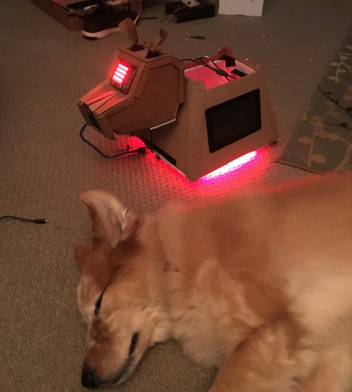

**Projects**

* AWS VPC - internal and external subnets
* https://docs.aws.amazon.com/AmazonVPC/latest/UserGuide/VPC_Scenario1.html
* Raspberry Pi - 2 node cluster:
* Reference: https://makezine.com/projects/build-a-compact-4-node-raspberry-pi-cluster/
* SSh key based authorization between the cluster nodes
* ref: https://www.raspberrypi.org/documentation/remote-access/ssh/passwordless.md
* Raspberry Pi to Arduino serial and I2c communications
* Sonar obstacle avoidance:
* ref: http://www.instructables.com/id/Obstacle-Avoiding-Robot-With-Servo-Motor-Arduino/
* Object Recognition
* ref: http://www.instructables.com/id/Pan-Tilt-face-tracking-with-the-raspberry-pi/
* Text to speech
* ref: http://espeak.sourceforge.net/
* Voice Recognition
* ref: http://stevenhickson.blogspot.com/2013/04/voice-control-on-raspberry-pi.html
* Environment sensor detection and data storage
* custom python scripts plus references below
* ref: https://projects.raspberrypi.org/en/projects/sense-hat-data-logger
* ref: https://github.com/adhorn/rasp-sensehat-iot
* High charts ref: https://www.highcharts.com/
* Raspberry Pi honey pot
* https://www.anomali.com/blog/create-an-army-of-raspberry-pi-honeypots-on-a-budget

Hardware

* QTY 2 Raspberry pi b3/b2
* Arduino uno 1.5
* L298N motor controller
* HC-SR04 ultrasonic Distance Sensor
* Sense hat
* RGB Leds (lots of LEDS. Because they are awesome)
* DC motors
* 12 volt Lipo battery
* 3 port cell phone charging battery
* 12 volt to 5 step down
* 7 inch touch screen
* serial cables
* Bluetooth speaker - with volume control
* usb power cables
* breadboards
* lots of cardboard

**Software**

* Raspbian Jesse
* Python 2.7
* Webiopi http://webiopi.trouch.com/Tutorial_Basis.html
* MJPG-Streamer https://xsatria.wordpress.com/2014/08/26/fast-video-streaming-usi$
* Arduino shell https://www.arduino.cc/en/Main/Software
* espeak http://espeak.sourceforge.net/
* openCV https://opencv.org/
* nmap <https://braindrivendevelopment.com/2014/12/02/using-nmap-to-find-a-raspberry-pi-within-a-network/>
* Node.js <https://blog.risingstack.com/node-hero-tutorial-getting-started-with-node-js/>

**Faceplants /learning moments:**

* bigger battery bank with at least 3 usb ports: ( Im running two raspberry pi plus a 7inch touchscreen.)
* MJPG-Streamer:
* Camera issues – some usb camera’s do not work on pi
* Webiopi:
* To debug your script and config, you should first run WebIOPi foreground before$
* sudo webiopi -d -c /etc/webiopi/config
* $ cd WebIOPi-x.y.z
* $ sed -i 's/ python3//' setup.sh
* $ sudo ./setup.sh
* $ sudo webiopi-passwd
* $ sudo service webiopi restart

Best start script for mjpg-streamer - my setup

/usr/local/bin/mjpg_streamer -i "/usr/local/lib/input_uvc.so -n -f 10 -r 1024x576" -o "/usr/local/lib/output_http.so -p 8080 -w /usr/local/www"