关于postgresql

create table stu2

(

name character varying(10) NOT NULL,

age double precision,

id double precision,

gender character varying(2)

)

copy stu2(name,age,stuid,gender) from 'E:\5001_DATA\csv6\stu.csv' with delimiter ',' csv header;

关于linux：

head -100 a.csv 查看文件前100行

tail -100 a.csv 查看文件后100行

过滤某一字符串

grep “xxx” a.csv

split -l 10000 a.csv split.csv

//水平分割，每10000行切一个文件出来，文件名是split a,b,c

-f 1,3 a.csv

//竖直分割 提取1，3列 可以>a2.csv输出到文件

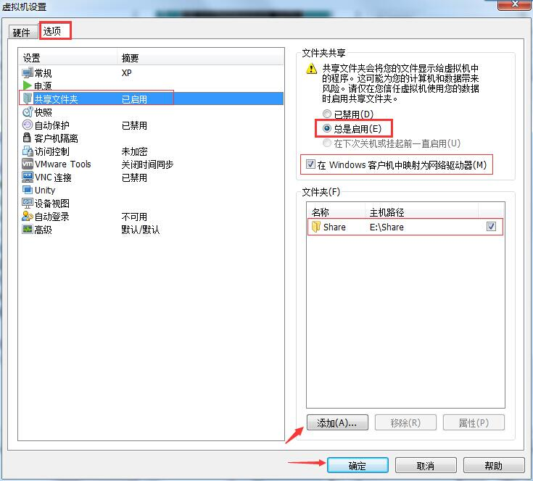

linux跳转到共享文件夹cd /mnt/hgfs/

读取唯一的车牌，保存到另一个文件：

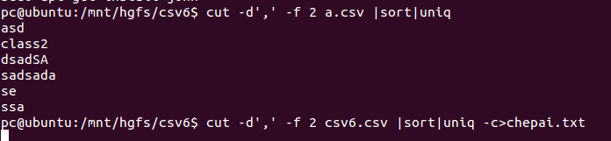

抽出来一个csv6.csv里有11660量车的信息

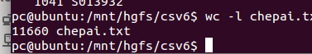

sort –n 按值排序

sort -n -r -k1 tmp.txt

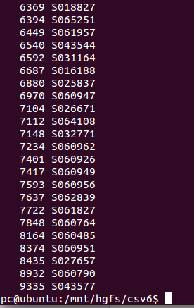

sort -n -r -k1 chepai.txt | head -20 | awk...

取数据最多的20个车牌 然后awk...

2016/11/04

运行.sh

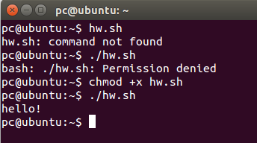

简单for循环

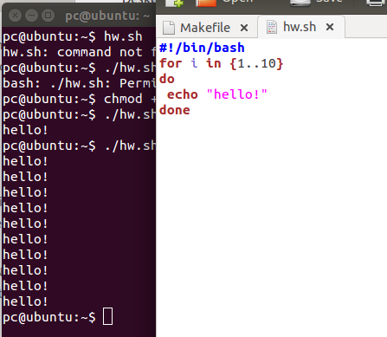

简单for读取文件内容

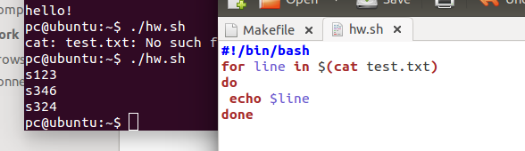

读取test1.txt中的内容，然后在a.csv中找到这个字符串相关的行，然后输出。

test1.txt

mik

sorey

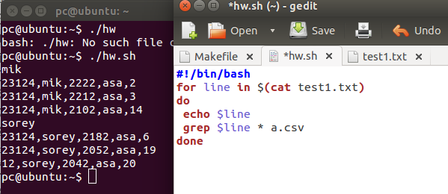

mysql导入csv：

load data infile 'E:/5001_DATA/csv6/a_1.csv'

into table a

fields terminated by ',' optionally enclosed by '"' escaped by '"'

lines terminated by '\n';

如果导入时在某一行报错，删掉那一行。比如我在导入splitab.csv时发现第1195214行报错，我就在linux里删掉这一行，语句：sed -i '1195214d' splitab.csv

大致的执行时间：

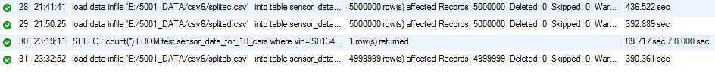

load data infile 'E:/5001_DATA/csv6/splitab.csv'

into table sensor_data_for_10_cars

fields terminated by ',' optionally enclosed by '"' escaped by '"'

lines terminated by '\n';

向外导出数据存入csv：

SELECT * FROM test.a

where class1='23124'

into outfile 'E:/5001_DATA/csv6/output_a.csv'

fields terminated by ',' optionally enclosed by '"' escaped by '"'

lines terminated by '\n';

load data infile 'F:/csv3cut.csv'

into table `5001`.sampledata

fields terminated by ',' optionally enclosed by '"' escaped by '"'

lines terminated by '\n';