The battle of the Neighborhoods – Report

1. Introduction

New York city (NYC), often called the City of New York or simply New York (NY), is the most populous city in the United States. With an estimated population of 8,400,000 distributed over about 302.6 square miles, New York is also the most densely populated major city in the United States. Situated on one of the world’s largest natural harbors, New York City is composed of five boroughs, each of which is a county of the State of New York. The five boroughs, namely Brooklyn, Queens, Manhattan, the Bronx and Staten Island were consolidated into a single city in 1898. The city and its metropolitan area constitute the premier gateway for legal immigration to the United States. New York City is a major center for banking and finance, retailing, world trade, real estate, new media, traditional media, advertising, legal services, accountancy insurance, fashion and the arts in the United States.

Which means the market in New York City is highly competitive, based on the ability to attract investments, worker and tourists among other attributes. Although New York City is one of the world’s most diverse cities and that diversity new ideas and new innovations, the costs of living and doing business in New York City are high. Therefore, any new business venture or expansion needs to be considered and analyzed carefully.

1. Description of the problem

A restaurant, or an eatery, is a business that prepares and serves food and drinks to customers. Meals are generally served and eaten on the premises, many restaurants also offer take-out and food delivery services. Restaurants vary greatly in appearance and offerings, including a wide variety of cuisines and service models ranging from inexpensive fast food restaurants and cafeterias, to mid-priced family restaurants, to high-priced luxury establishments.

If someone is looking to open a restaurant, there are so many things to consider – from choosing the right location to finding financing to selecting the right name, also buying equipment and hiring staff. The New York City is famous for its excellent cuisine, and its food culture includes various of international cuisines influenced by the city’s immigrant history.

Therefore, to survive in such competitive market, it is very important to strategically plan before going into action. Many factors need to be analyzed in order to decide the best location.

* Segmentation of the Borough
* Population density
* Average income
* Accessibility, whether locate in a remote area
* Visibility
* Traffic
* Environment
* Neighbors, who else is doing business in the neighborhood
* etc

1. Description of the data

The city be analyzed in the project: New York City. Therefore we will be using the datasets about New York City.

* The New York City Neighborhood Names point file was created as a guide to New York City’s neighborhoods that appear on the web resource.

<https://geo.nyu.edu/catalog/nyu_2451_34572>

Generate map of all 306 neighborhoods in 5 Boroughs of New York City superimposed on top.

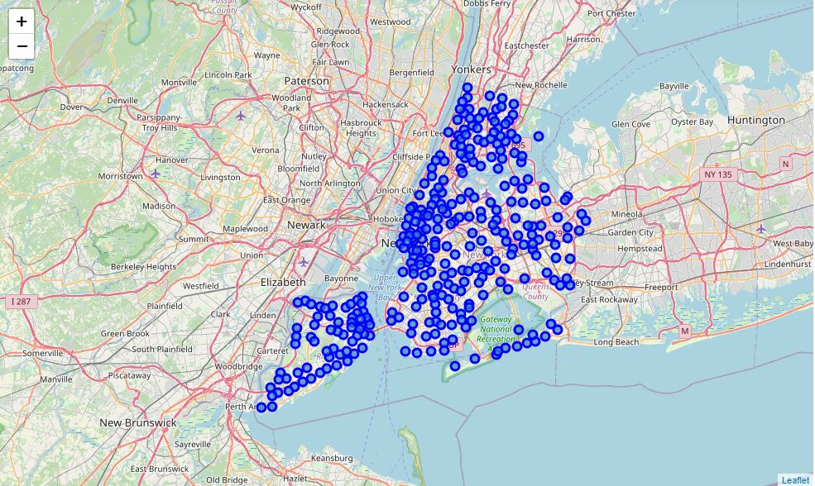

We can move further, visualize Manhattan and the neighborhoods in it.

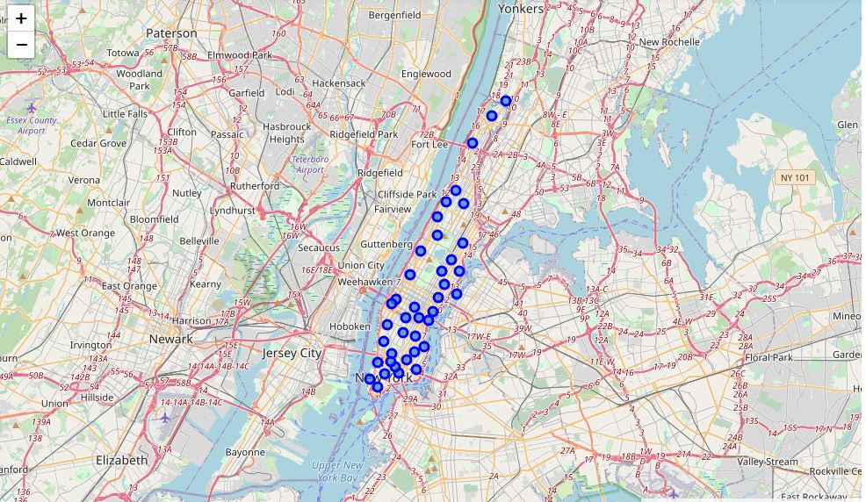

* Utilize the Foursquare API to explore the neighborhoods and segment them.

<https://developer.foursquare.com/>

Generate dataframe of Italian food that si within 500 metres from the Conrad Hotel

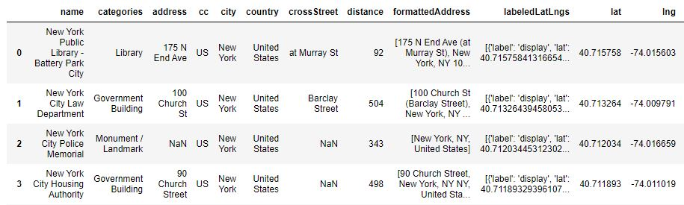

Visualize the Italian restaurants nearby