a. To verify the equation Keff=EI from the given arguments.

from Eq(10.8) we have:

$$E_{bend}=\frac{K_{eff}}{2}\int_{0}^{L}{ds\frac{1}{{R(s)}^{2}}}$$

The result of integral on the right-hand-side:

$$\int_{0}^{L}{ds\frac{1}{{R(s)}^{2}}}=\frac{L}{R^{2}}$$

For more generally case, the bending energy may be written as:

$$E_{bend}=\frac{EIL}{2R^{2}}$$

Combining the three equations above:

$$\frac{EIL}{2R^{2}}=\frac{K_{eff}}{2}\int_{0}^{L}{ds\frac{1}{{R(s)}^{2}}=\frac{K_{eff}}{2}}\frac{L}{R^{2}}$$

$$K_{eff}=EI$$

The flexural rigidity is the combination of Young modulus and areal moment of ineritia.

b. Find valid model for several molecules and calculate their areal moment of inertia.

The areal moment of inertia is defined as:

$$I=\int_{∂Ω}{z^{2}dA}$$

Now we consider the cross-sectional area for those molecules.

For DNA with double helix structure, the cross section could be taken as nanotube with certain thickness, thus the rough I is:

$$I_{1}=\int_{r}^{R}{z^{2}dA}=\int_{r}^{R}{x^{2}2πxdx}=\frac{π}{2}\left(R^{4}-r^{4}\right)=\frac{(R^{2}+r^{2})}{2}Ω$$

However, the helix structure is not equal to solid nanotube from side view, thus a factor measuring the percentage of DNA molecule comparing with the full length should be considered:

$$I=α\frac{(R^{2}+r^{2})}{2}Ω≈5×{10}^{-36}m^{4}$$

Where the radius of DNA is R=2nm,α=0.2

For actin filaments, a double strand, E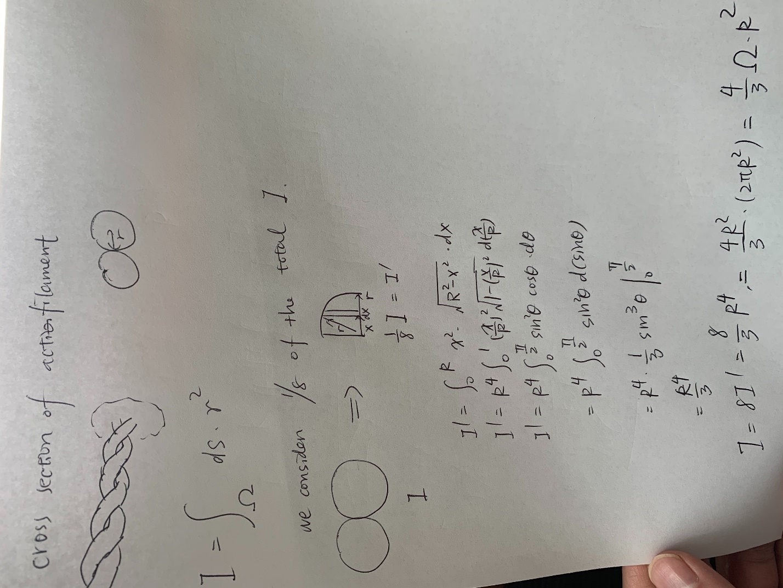

Where R=3.5nm ,

$$I=α\frac{(R^{2}+r^{2})}{2}Ω≈1.2×{10}^{-33}m^{4}$$

For microtube:

$$I_{1}=\int_{r}^{R}{z^{2}dA}=\frac{(R^{2}+r^{2})}{2}Ω≈9.6×{10}^{-33}m^{4}$$

Where r≈8.5nm, R≈12.5nm

The areal moment of inertia is highly related with the shape of the models, considering DNA, actin filaments and microtubules have unique shape, they also have different areal moment of inertia.

c. Convert the stress needed to stretch a actin and DNA with a strain of 1%.

$$E=2GPa$$

For actin:

$$W\left(ε\right)=\frac{1}{2}Eε^{2}$$

$$F=WS≈1.2×{10}^{-12}=1.2pF$$

For DNA:

$$F=WS≈0.4pF$$

d. Calculate the persistence lengths of three molecules.

$$ξ_{p}≈\frac{EI}{2k_{B}T}$$

$$ξ_{p}\left(DNA\right)≈\frac{EI}{2k_{B}T}≈1.2×{10}^{-8}m$$

e. Compute the Young modulus of DNA by using areal moment of inertia.

L=50nm

$$E=\frac{ξ_{P}k_{B}T}{I}≈4GPa$$

Close to the given assumption which $$E≈2 GPa$$

The result has the same magnitude as of the assumption.

This problem is about solving equations of Euler-Bernoulli Beam Theory by using static buckling equation. Compute the time associated with the buckling of microtubule from given variables.

1.

$$EI\frac{∂^{4}v}{∂x^{4}}+F\frac{∂^{2}x}{∂x^{2}}=-c\frac{∂v}{∂t}$$

Combing with:

$$X_{\left(x\right)}=X_{0}sin\left(\frac{πx}{L}\right)$$

and:

$$v\left(x,t\right)=X_{0}sin\left(\frac{πx}{L}\right)exp\left(\frac{t}{τ}\right)$$

We have:

$$EI{\left(\frac{π}{L}\right)}^{4}-F{\left(\frac{π}{L}\right)}^{2}=-\frac{c}{L}$$

**2.**

$$τ=\frac{c}{F{\left(\frac{π}{L}\right)}^{2}-EI{\left(\frac{π}{L}\right)}^{4}}$$

**3.**

F=4pN, L=10μm, c=12mPa,

From question 1 we know for microtube, $EI≈2×{10}^{-23}$

Thus, replacing all variables with given numbers, we have:

$$τ≈0.02$$

The equation is solved and $τ$ has a clear expression, once substituting variables with given number, the time associated with the buckling of microtubule can be computed.