**Laboratoriya ishi №4.**

**Mavzu: Jadval yaratish va uni formatlash.**

**Vazifasi:**

HTML va CSS yordamida jadval yaratish, unga ma’lumot joylash va dizayni sozlash.

**Maqsadi:**

VS Code muharririda HTML va CSS orqali jadval yaratish va uni turli usullar bilan formatlashni o‘rganish..

**Nazariy qism:**

**Jadval (table)** — bu veb-sahifalarda ma’lumotlarni qat’iy tartibda, ya’ni satrlar (rows) va ustunlar (columns) ko‘rinishida aks ettirish uchun ishlatiladigan HTML elementidir. Jadvaldan foydalanish ma’lumotlarni ko‘rinishini soddalashtiradi va foydalanuvchi uchun o‘qish qulayligini ta’minlaydi.

**HTMLda jadval yaratish:**

HTMLda jadval quyidagi asosiy teglardan iborat bo‘ladi:

<table> — jadvalni boshlab beradi.

<tr> (table row) — jadvaldagi har bir satr.

<td> (table data) — satrdagi oddiy katak (ma’lumot).

<th> (table header) — sarlavhali katak (qalin va markazlashtirilgan).

**Oddiy jadval ro’yhati:**

<table>

  <tr>

    <th>Ism</th>

    <th>Familiya</th>

    <th>Yosh</th>

  </tr>

  <tr>

    <td>Momogul</td>

    <td>Safoyozova</td>

    <td>20</td>

  </tr>

  <tr>

    <td>Muhayyo</td>

    <td>Odamboyeva</td>

    <td>21</td>

  </tr>

</table>

**CSS yordamida jadvalni formatlash:**

CSS orqali jadvalning tashqi ko‘rinishini yaxshilash mumkin. Quyidagilar jadval formatlashda eng ko‘p qo‘llaniladigan usullardir:

**Chegaralar (borders):**

table, th, td {

border: 1px solid black;

border-collapse: collapse;

}

**Katak ichidagi bo‘sh joy (padding):**

th, td {

  padding: 10px;

}

**Matn hizalanishi (text alignment):**

th {

  text-align: center;

}

td {

  text-align: left;

}

**Fon rangi (background-color) va matn rangi (color):**

th {

  background-color: #f2f2f2;

  color: #333;

}

**Amaliy qism:**

<!DOCTYPE html>

<html lang="uz">

<head>

    <meta charset="UTF-8" />

    <meta name="viewport" content="width=device-width, initial-scale=1" />

    <title>234-KIDT guruhi</title>

    <style>

        .highlight { color: #d2691e; font-weight: bold; }

        .italic-text { font-style: italic; }

        .underline-text { text-decoration: underline; }

        .strikethrough { text-decoration: line-through; color: red; }

        .small-text { font-size: 12px; color: gray; }

        table {

            border-collapse: collapse;

            width: 90%;

            margin: 20px auto;

        }

        th, td {

            border: 1px solid #1f1d1d;

            padding: 10px;

            text-align: center;

        }

        th {

            background-color: #437999;

            text-transform: uppercase;

        }

        footer p {

            text-align: center;

            font-size: 14px;

            color: #000000;

            margin-top: 30px;

        }

        div

        {

            color: #000000;

            background-color: rgb(251, 251, 252);

        }

        h1{

            background-color: #437999;

            text-align: center;

        }

    </style>

</head>

<body>

    <h1>

       Kompyuter ilmlari va dasturlash texnologiyalari yo'nalishi 234-guruh qizlar ro'yhati.

    </h1>

    <header>

    </header>

    <section>

        <table>

            <thead>

                <tr>

                    <th>N</th>

                    <th>Ism familyasi</th>

                    <th>Tug'ulgan yili</th>

                    <th>Ta'lim yo‘nalishi</th>

                    <th>Talabalikga qabul qilingan yili</th>

                </tr>

            </thead>

           <tbody>

     <tr>

        <td>1</td>

        <td><b>Safoyozova Momogul </b></td>

        <td><span class="underline-text">2005</span></td>

        <td><small><b>KIDT</b></small></td>

        <td><span class=>2023</span></td>

    </tr>

    <tr>

        <td>2</td>

        <td><b>Omonboyeva Yulduzxon</b></td>

        <td><span class="underline-text">2005</span></td>

        <td><small><b>KIDT</b></small></td>

        <td><span class=>2023</span></td>

    </tr>

   <tr>

        <td>3</td>

        <td><b>Qurbondurdiyeva Zuhrajon</b></td>

        <td><span class="underline-text">2005</span></td>

        <td><small><b>KIDT</b></small></td>

        <td><span class=>2023</span></td>

    </tr>

    <tr>

        <td>4</td>

        <td><b>Razzaqova Ro'zaxon</b></td>

        <td><span class="underline-text">2004</span></td>

        <td><small><b>KIDT</b></small></td>

        <td><span class=>2023</span></td>

    </tr>

     <tr>

        <td>5</td>

        <td><b>Ro'zimova Lobar</b></td>

        <td><span class="underline-text">2004</span></td>

        <td><small><b>KIDT</b></small></td>

        <td><span class=>2023</span></td>

    </tr>

    <tr>

        <td>6</td>

        <td><b> Rustamova Shaxrizoda</b></td>

        <td><span class="underline-text">2005</span></td>

        <td><small><b>KIDT</b></small></td>

        <td><span class=>2023</span></td>

    </tr>

    <tr>

        <td>7</td>

        <td><b>Odamboyeva Muhayyo </b></td>

        <td><span class="underline-text">2004</span></td>

        <td><small><b>KIDT</b></small></td>

        <td><span class=>2023</span></td>

    </tr>

    <tr>

        <td>8</td>

        <td><b>Tojiyeva Nasiba</b></td>

        <td><span class="underline-text">2003</span></td>

        <td><small><b>KIDT</b></small></td>

        <td><span class=>2023</span></td>

    </tr>

    <tr>

        <td>9</td>

        <td><b>Sharipova Donira</b></td>

        <td><span class="underline-text">2004</span></td>

        <td><small><b>KIDT</b></small></td>

        <td><span class=>2023</span></td>

    </tr>

    <tr>

        <td>10</td>

        <td><b>Bekchanova Sevinch</b></td>

        <td><span class="underline-text">2005</span></td>

        <td><small><b>KIDT</b></small></td>

        <td><span class=>2023</span></td>

    </tr>

    <tr>

        <td>11</td>

        <td><b>Boltayeva Shaydo</b></td>

        <td><span class="underline-text">2004</span></td>

        <td><small><b>KIDT</b></small></td>

        <td><span class=>2024</span></td>

    </tr><tr>

        <td>12</td>

        <td><b>Egamberganova Gulshan</b></td>

        <td><span class="underline-text">2004</span></td>

        <td><small><b>KIDT</b></small></td>

        <td><span class=>2024</span></td>

    </tr>

    <tr>

        <td>13</td>

        <td><b>Komilova Farangiz</b></td>

        <td><span class="underline-text">2005</span></td>

        <td><small><b>KIDT</b></small></td>

        <td><span class=>2023</span></td>

    </tr>

    <tr>

        <td>14</td>

        <td><b>Baxtiyorova Ruxshona</b></td>

        <td><span class="underline-text">2005</span></td>

        <td><small><b>KIDT</b></small></td>

        <td><span class=>2023</span></td>

    </tr>

    <tr>

        <td>15</td>

        <td><b>Ibadullayeva Dilafruz</b></td>

        <td><span class="underline-text">2005</span></td>

        <td><small><b>KIDT</b></small></td>

        <td><span class=>2023</span></td>

    </tr>

  </tbody>

        </table>

    </section>

</body>

</html>

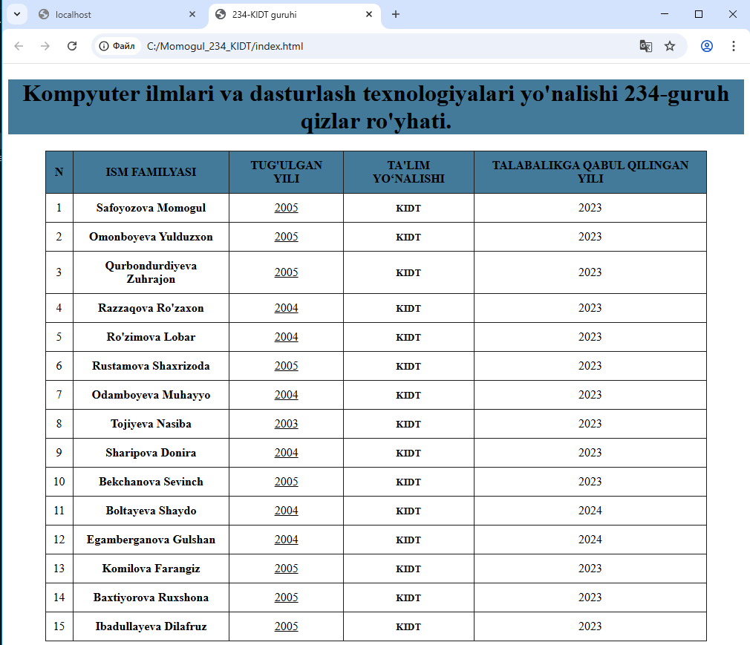

**Xulosa:**

Men bu "jadval yaratish va uni formatlash" mavzusidagi laboratoriya mashg'uloti darsida HTML da jadval yaratishni va jadval yaratish teglari haqida ma'lumotlarga ega bo'ldim.Va shu qatorda <table>,<tr>,<td>,<th> shu teglardan foydalanib jadvallar yaratdim.Jadvalimiz <table> tegi yordamida boshlanishi <th> jadval sarlavhasiligin,<tr> jadvaldagi har bir ustuni va <td> tegiga ma'lumotlarimizni kiritishimizni bilib oldim va amaliyotda qo'lladim.