Laboratoriya ishi №10.
Mavzu: CSS transition va animatsiya elementlarini yaratish.
Maqsadi:
CSS transition va animatsiya imkoniyatlaridan foydalanib, veb sahifadagi elementlarning silliq va dinamik o‘zgarishlarini yaratish, foydalanuvchi interfeysini yanada qulay va jozibador qilish ko‘nikmalarini shakllantirish.
Vazifasi:
• CSS transition tushunchasi, uning asosiy xususiyatlari va ishlash prinsipi bilan tanishish.
• CSS animation va @keyframes sintaksisini o‘rganish.
• Transition va Animation o‘rtasidagi farqlarni anglash.
• Elementlarning o‘lchami, rangi, joylashuvi va boshqa parametrlarini silliq o‘zgartirishni amalda bajarish.
• @keyframes yordamida turli animatsiya kadrlari yaratish va ularga vaqt, tezlik, takrorlanish kabi xususiyatlarni qo‘llash.
• Amaliy topshiriqlar orqali HTML elementlarga transition va animation qo‘llab ko‘nikma hosil qilish.
• Interfeysni yanada interaktiv qilish uchun animatsion effektlardan to‘g‘ri foydalanishni o‘rganish.
Nazariy qism:
CSS Transition va Animatsiya elementlarini yaratish
1. CSS Transition tushunchasi
Transition — elementning bir holatdan boshqa holatga asta-sekin o‘tish jarayonini belgilovchi CSS mexanizmidir. Ya’ni, elementning rangi, o‘lchami, joylashuvi yoki boshqa xususiyati birdan o‘zgarish o‘rniga silliq tarzda o‘zgaradi.
Transition asosiy xususiyatlari:
- transition-property — qaysi xususiyat o‘zgarishi ko‘rsatiladi (masalan: width, height, color).
- transition-duration — animatsiya davom etish vaqti (sekundlarda).
- transition-timing-function — o‘zgarish tezligi (linear, ease, ease-in, ease-out, ease-in-out).
- transition-delay — animatsiya boshlanishidan oldingi kutish vaqti.
Transition ishlash prinsipi:
Transition faqat holat o‘zgarishida ishlaydi (masalan, hover, active, focus
holatida).
Misol:
.box {
width: 100px;
height: 100px;
background: red;
transition: width 0.5s ease;
}
.box:hover {
width: 200px;
}
2. CSS Animation tushunchasi.
Animation — elementning bir holatdan boshqa holatga doimiy yoki takroriy o‘zgarishini ta’minlaydigan mexanizm. Transition faqat bir martalik o‘tishda ishlasa, Animation esa cheksiz, siklli, murakkab kadrlarga ega bo‘lishi mumkin.
Animation asosiy qismlari.
1. @keyframes
Bu animatsiya kadrlari (boshlanish → yakun)ni belgilaydi.
Misol:
@keyframes move {
from { left: 0; }
to { left: 200px; }
}
2. Animation xususiyatlari:
- animation-name — @keyframes nomi.
- animation-duration — animatsiya davom etish vaqti.
- animation-timing-function — tezlik funksiyasi.
- animation-delay — boshlanishdagi kechikish.
- animation-iteration-count — qancha marta ishlashi (1, infinite).
- animation-direction — qay tarzda animatsiya bajarilishi (normal, reverse, alternate).
- animation-fill-mode — animatsiya tugagandan keyin holatni saqlash (forwards, backwards).
Misol:
.box {
width: 100px;
height: 100px;
background: blue;
position: relative;
animation: move 3s infinite alternate ease-in-out;
}
3.Transition va Animation o‘rtasidagi farqlar
Xususiyat |  | Transition | Animation
Ishlash prinsipi |  | Holat o‘zgarishida boshlanadi | @keyframes orqali mustaqil ishlaydi
Murakkablik |  | Oddiy o‘tish uchun | Murakkab, ko‘p kadrli
Takrorlanish |  | Yo‘q | Bor (infinite)
Boshqarish |  | Trigger talab qiladi | Doimiy yoki avtomatik
4.Amalit qo’llanilishi:
- Tugma hover effektlari
- Banner animatsiyalari
- Logotip harakatlari
- Loader (yuklanish belgisi)
- Slider elementlari
- Menyu ochilish-yopilish animatsiyalari
Amaliy qism:
Index.html:

<!DOCTYPE html>
<html lang="en">
<head>
<meta charset="UTF-8" />
<meta name="viewport" content="width=device-width, initial-scale=1.0" />
<title>position</title>
<link rel="stylesheet" href="./style.css" />
</head>
<body>
<div class="container">
<div class="seedra_wrap">
<div class="seedra-left">
<h1 class="seedra-title">
SEEDRA Basil Seeds for Indoor and Outdoor Planting
</h1>
<p class="subtitle">
Be sure of our quality - the freshest batches of this season.
Non-GMO, Heirloom - our seeds were tested and have the best
germination ratings. Your easy growing experience is our guarantee
</p>
<div class="price-wrap">
<p>
<svg
width="46"
height="46"
viewBox="0 0 46 46"
fill="none"
xmlns="http://www.w3.org/2000/svg"
>
<path
d="M36.2651 21.7765C35.4967 20.047 34.3796 18.4947 32.9838 17.2167L31.832 16.1599C31.7929 16.125 31.7458 16.1002 31.6949 16.0877C31.644 16.0753 31.5908 16.0755 31.54 16.0884C31.4892 16.1013 31.4423 16.1265 31.4035 16.1617C31.3647 16.1969 31.3352 16.2411 31.3174 16.2905L30.8029 17.7669C30.4823 18.6931 29.8925 19.6391 29.0573 20.5692C29.0019 20.6286 28.9386 20.6444 28.8951 20.6484C28.8515 20.6523 28.7842 20.6444 28.7249 20.589C28.6694 20.5415 28.6417 20.4703 28.6457 20.399C28.7922 18.0162 28.0797 15.3286 26.5202 12.4036C25.2298 9.97329 23.4368 8.07734 21.1965 6.75532L19.5618 5.79349C19.348 5.66683 19.0749 5.83307 19.0868 6.08244L19.1739 7.98234C19.2333 9.28061 19.0828 10.4285 18.7266 11.3824C18.2912 12.55 17.6658 13.6346 16.8663 14.6083C16.3099 15.285 15.6792 15.897 14.9862 16.433C13.317 17.7161 11.9598 19.3601 11.0162 21.2421C10.0748 23.1405 9.58446 25.2306 9.58331 27.3495C9.58331 29.2177 9.95142 31.0266 10.6797 32.7326C11.3829 34.3751 12.3978 35.8657 13.6681 37.1222C14.9505 38.3888 16.4388 39.3862 18.0973 40.0789C19.8151 40.7993 21.6358 41.1634 23.516 41.1634C25.3961 41.1634 27.2168 40.7993 28.9346 40.0828C30.589 39.3942 32.0934 38.3899 33.3638 37.1261C34.6462 35.8595 35.6516 34.3792 36.3522 32.7365C37.0794 31.0352 37.4524 29.2037 37.4486 27.3535C37.4486 25.4219 37.0528 23.5457 36.2651 21.7765Z"
fill="#E55C5C"
/>
</svg>
</p>
<h1 class="price">$12.56</h1>
<h2 class="sub_price">$15.56</h2>
</div>
<div class="btn-wrap">
<button class="add-to-card">Add to card</button>
<button class="discover">Discover</button>
</div>
</div>
<div class="seedra-right">
<img class="img-seedra" src="rasm/image.png" alt="img" />
<img class="img-yaproq" src="rasm/yaproq.png" alt="img" />
</div>
</div>
</div>
</body>
</html>

Style.css:
* {
box-sizing: border-box;
margin: 0;
padding: 0;
font-family: sans-serif;
}
.container {
max-width: 100%;
display: flex;
justify-content: center;
align-items: center;
padding: 24px;
}

.seedra_wrap {
width: 1110px;
background-color: #eaf1eb;
height: 455px;
border-radius: 24px;
display: flex;
align-items: center;
padding: 50px;
}

.seedra-left {
width: 65%;
height: 100%;
display: flex;
flex-direction: column;
justify-content: space-between;
}

.seedra-right {
width: 35%;
height: 100%;
position: relative;
}

.seedra-title {
color: #1f2533;
font-weight: 600;
font-size: 48px;
}

.subtitle {
color: #1f2533;
font-weight: 300;
font-size: 16px;
line-height: 28px;
}

.price-wrap {
display: flex;
align-items: center;
gap: 21px;
}

.price {
color: #1f2533;
font-weight: 600;
font-size: 42px;
line-height: 54px;
}

.sub_price {
color: #70737c;
font-weight: 600;
font-size: 22px;
line-height: 54px;
text-decoration: line-through;
}

.btn-wrap {
display: flex;
align-items: center;
height: 50px;
gap: 12px;
}

.add-to-card {
background-color: #359740;
border-radius: 8px;
color: white;
font-weight: 500;
font-size: 16px;
width: 150px;
height: 100%;
border: none;
cursor: pointer;
transition: all 200ms ease-in-out;

&:hover{
background-color: white;
color: #359740;
}
}

.discover {
background-color: white;
border-radius: 8px;
color: #359740;
font-weight: 500;
font-size: 16px;
width: 150px;
height: 100%;
border: none;
cursor: pointer;
transition: all 200ms ease-in-out;

&:hover{
background-color: #359740;
color: white;
}
}

.img-seedra {
position: absolute;
z-index: 10;
top: 20px;
right: -20px;
width: 380px;
height: 380px;
}

.img-yaproq {
position: absolute;
z-index: 0;
bottom: -48px;
right: -48px;
width: 300px;
height: 300px;
}
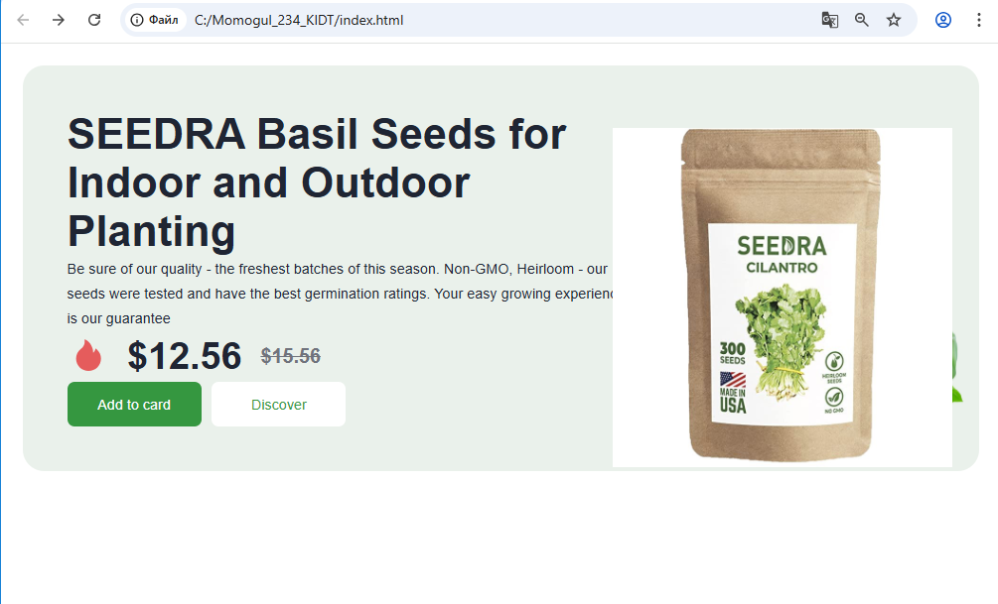
Aviatsiya mavzusida:
Html kodi:
<!DOCTYPE html>
<html lang="uz">
<head>
<meta charset="UTF-8">
<title>Aviatsiya Animatsiyasi</title>
<meta name="viewport" content="width=device-width, initial-scale=1.0">
<link rel="stylesheet" href="style.css">
</head>
<body>

<header class="header">
<h1>✈ Aviatsiya olami</h1>
</header>

<section class="cards">
<div class="card">
<h3>Boeing 737</h3>
<p>Yo‘lovchi tashish uchun mashhur samolyot.</p>
<button>Ko‘proq</button>
</div>

<div class="card">
<h3>Airbus A320</h3>
<p>Zamonaviy va tejamkor havo kemasi.</p>
<button>Ko‘proq</button>
</div>

<div class="card">
<h3>F-16 Fighter</h3>
<p>Harbiy aviatsiyada keng qo‘llaniladi.</p>
<button>Ko‘proq</button>
</div>
</section>

<!-- Animatsiyali samolyot -->
<div class="plane">✈</div>

<footer class="footer">
© 2025 Aviatsiya sahifasi
</footer>

</body>
</html>

Css kodi:
body {
margin: 0;
font-family: Arial, sans-serif;
background-color: #f2f6fa;
text-align: center;
}

.header {
background-color: #003366;
color: white;
padding: 20px;
}

.cards {
display: flex;
justify-content: center;
gap: 20px;
padding: 30px;
flex-wrap: wrap;
}
Transition:
.card {
background-color: white;
width: 250px;
padding: 20px;
border-radius: 8px;

/* Transition */
transition: transform 0.4s ease,
box-shadow 0.4s ease;
}

.card:hover {
transform: translateY(-10px);
box-shadow: 0 10px 20px rgba(0,0,0,0.2);
}

button {
margin-top: 10px;
padding: 8px 15px;
border: none;
background-color: #00509e;
color: white;
cursor: pointer;

/* Transition */
transition: background-color 0.3s ease,
transform 0.3s ease;
}
button:hover {
background-color: #003366;
transform: scale(1.1);
}

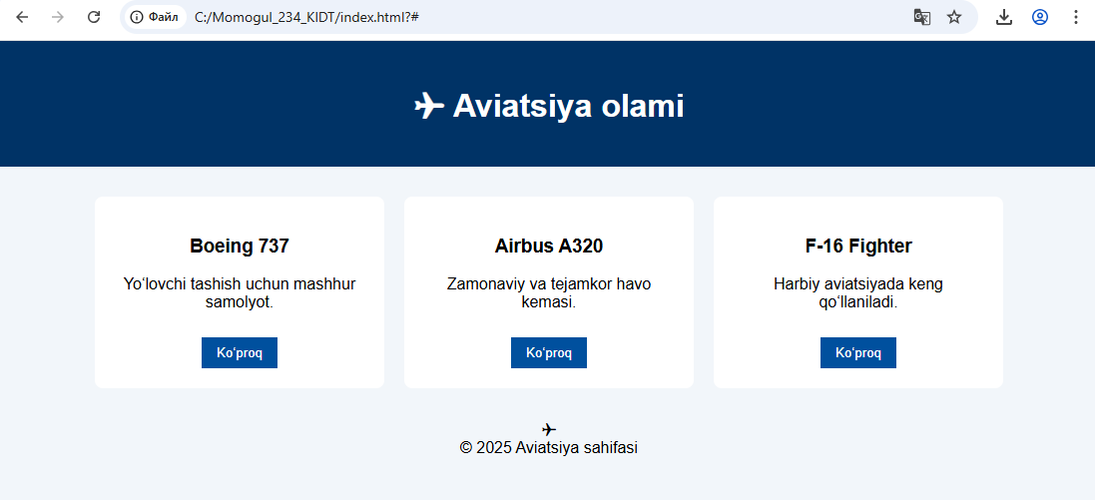
Birinchisiga mishkamizni olib borsak shunday harakatlanadi:bu transition
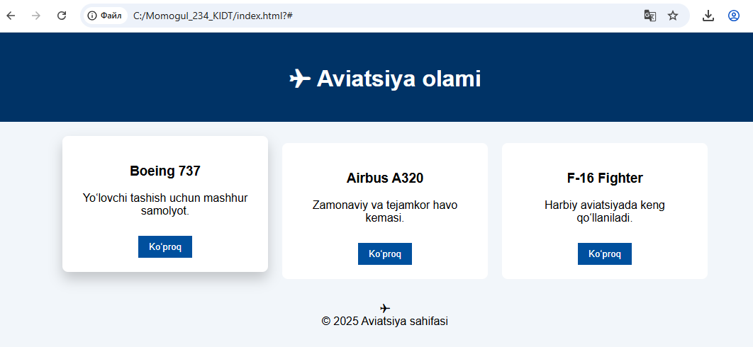
Bunda Animatsiya:
.plane {
font-size: 40px;
position: relative;
animation: fly 5s infinite linear;
}

@keyframes fly {
0% {
left: -100px;
}
50% {
left: 50%;
transform: rotate(10deg);
}
100% {
left: 110%;
transform: rotate(0deg);
}
}

