Laboratoriya ishi №9.
Mavzu:CSS media queries orqali responsiv dizayn yaratish.
Maqsadi:Maqsadi: Foydalanuvchi qurilmasi o‘lchamiga qarab veb-sahifani moslashuvchan (responsiv) qilishni o‘rganish.
Vazifasi: Oddiy veb-sahifa yaratib, unda CSS media queries yordamida turli ekran o‘lchamlariga mos dizayn qo‘llash
Nazariy qism:
1. Responsiv dizayn nima?
Responsiv veb-dizayn (Responsive Web Design) – veb-sahifaning har qanday qurilmada (telefon, planshet, noutbuk, katta monitor) to‘g‘ri ko‘rinishi va foydalanuvchiga qulay bo‘lishi uchun moslashishi.
Asosiy tamoyillari:
- Moslashuvchan tarmoq (Fluid Grid)
- Moslashuvchan rasmlar (Flexible Images)
- CSS Media Queries

2. Media Queries nima?
CSS Media Queries – CSS qoidalarini ekran o‘lchami, qurilma turi, yo‘nalishi, piksellar zichligi va boshqa xususiyatlarga qarab shartli ravishda qo‘llash imkonini beradi.

Sintaksis:
css
@media (shart) { /* CSS qoidalari */}

3. Media Query turlari.
Tur | Tavsif
@media screen | Faqat ekran uchun
@media print | Chop etish uchun
@media all | Barcha qurilmalar uchun (default)

4. Media xususiyatlari (Features)
Xususiyat | Tavsif | Misol
width | Ekran kengligi | @media (width: 600px)
min-width | Minimal kenglik | @media (min-width: 768px)
max-width | Maksimal kenglik | @media (max-width: 480px)
height | Ekran balandligi | @media (min-height: 800px)
orientation | Yo‘nalish | @media (orientation: landscape)
resolution | Piksellar zichligi | @media (resolution: 2dppx)
aspect-ratio | Nisbat | @media (aspect-ratio: 16/9)

5. Breakpoint’lar (Ekran o‘lchamlari).
Breakpoint | Qurilma turi | Tavsiya etilgan max-width
320px – 480px | Kichik telefonlar | @media (max-width: 480px)
481px – 768px | Katta telefonlar | @media (max-width: 768px)
769px – 1024px | Planshetlar | @media (min-width: 769px)
1025px – 1200px | Kichik noutbuklar | @media (min-width: 1025px)
1201px + | Katta monitorlar | @media (min-width: 1201px)
Maslahat: Breakpoint’larni kontentga qarab tanlang, “qurilmaga qarab” emas.

6. Mobile-First yondashuv
Mobile-First – avval kichik ekranlar uchun stil yoziladi, keyin katta ekranlar uchun qo‘shimcha qoidalar qo‘shiladi.
css
/* 1. Mobil uchun asosiy stil */.container { flex-direction: column;}/* 2. Planshet va undan katta uchun */@media (min-width: 768px) { .container { flex-direction: row; }}
Afzalligi:
- Tezroq yuklanadi
- Mobil foydalanuvchilar uchun optimallashtirilgan
- Google SEO uchun yaxshi

7. Viewport Meta Tag
Har bir responsiv sahifada majburiy:
html
<meta name="viewport" content="width=device-width, initial-scale=1.0">
Nima qiladi?
- Mobil qurilmalar sahifani to‘g‘ri masshtabda ko‘rsatadi
- Kattalashtirishni oldini oladi

8. Flexbox va Grid bilan responsivlik.
Texnologiya | Afzalligi
Flexbox | 1 o‘lchamli tartiblash (qator yoki ustun)
Grid | 2 o‘lchamli tartiblash (qator + ustun)
css
.container { display: flex; flex-wrap: wrap;}@media (min-width: 768px) { .item { flex: 1 1 30%; }}

9. Rasmlarni moslashtirish.
css
img { max-width: 100%; height: auto; display: block;}
Yoki srcset bilan turli o‘lchamdagi rasmlar:
html
<img src="small.jpg" srcset="medium.jpg 768w, large.jpg 1200w" sizes="(max-width: 768px) 100vw, 50vw">

10. Media Query misollari:
css
/* 1. Faqat telefonlar */@media (max-width: 480px) { body { font-size: 14px; }}/* 2. Faqat planshetlar */@media (min-width: 481px) and (max-width: 1024px) { .sidebar { display: none; }}/* 3. Faqat landshaft rejim */@media (orientation: landscape) { .video { width: 100%; }}/* 4. Retina ekranlar */@media (-webkit-min-device-pixel-ratio: 2) { .logo { background-image: url('logo@2x.png'); }}
Amaliy qism:
Index.html:
<!DOCTYPE html>
<html lang="uz">
<head>
<meta charset="UTF-8">
<meta name="viewport" content="width=device-width, initial-scale=1.0">
<title>Responsiv Dizayn Namuna</title>
<link rel="stylesheet" href="style.css">
</head>
<body>
<header class="header">
<h1>Responsiv Veb-sahifa</h1>
<nav class="nav">
<ul>
<li><a href="#">Bosh sahifa</a></li>
<li><a href="#">Biz haqimizda</a></li>
<li><a href="#">Aloqa</a></li>
</ul>
</nav>
</header>

<main class="container">
<section class="item">
<h2>1. Bo‘lim</h2>
<p>Bu yerda veb-dizayn haqida ma’lumotlar joylashadi.</p>
</section>
<section class="item">
<h2>2. Bo‘lim</h2>
<p>CSS media queries yordamida sahifa turli ekranlarga moslashadi.</p>
</section>
<section class="item">
<h2>3. Bo‘lim</h2>
<p>Bu sahifa flexbox va media queries yordamida qurilgan.</p>
</section>
</main>
<footr class="footer">
<p>&copy; 2025. Barcha huquqlar himoyalangan.</p>
</footer>
</body>
</html>

Style.css:
/* 1️⃣ Asosiy (Mobile First) – Telefonlar uchun */
body {
margin: 0;
font-family: Arial, sans-serif;
background-color: #dbd3d3;
}

.header {
background-color: #2a8cb3;
color: white;
text-align: center;
padding: 15px;
}
.nav ul {
list-style: none;
padding: 0;
margin: 0;
}
.nav ul li {
display: rgb(255, 255, 255);
margin: 8px 0;
}
.nav a {
color: white;
text-decoration: none;
font-weight: bold;
}
.container {
display: flex;
flex-direction: column; /* Telefonlar uchun ustun ko‘rinish */
gap: 10px;
padding: 10px;
}
.item {
background-color: rgb(155, 175, 81);
border: 1px solid #ddd;
padding: 15px;
border-radius: 5px;
}
.footer {
text-align: center;
background-color: #2a8cb3;
color: white;
padding: 10px;
}
/* 2️⃣ Planshetlar (min-width: 768px) */
@media (min-width: 768px) {
.nav ul {
display: flex;
justify-content: center;
gap: 15px;
}
.container {
flex-direction: row; /* Yonma-yon joylashadi */
flex-wrap: wrap;
}
.item {
flex: 1 1 45%; /* Har biri 45% kenglikda */
}
}
/* 3️⃣ Noutbuk va katta ekranlar (min-width: 1024px) */
@media (min-width: 1024px) {
body {
background-color: #349cb6;
}
.container {
max-width: 1200px;
margin: 0 auto;
}
.item {
flex: 1 1 30%; /* Har biri 3 ustunli ko‘rinishda */
}
.header {
text-align: left;
padding-left: 40px;
}
}
Telefon uchun:
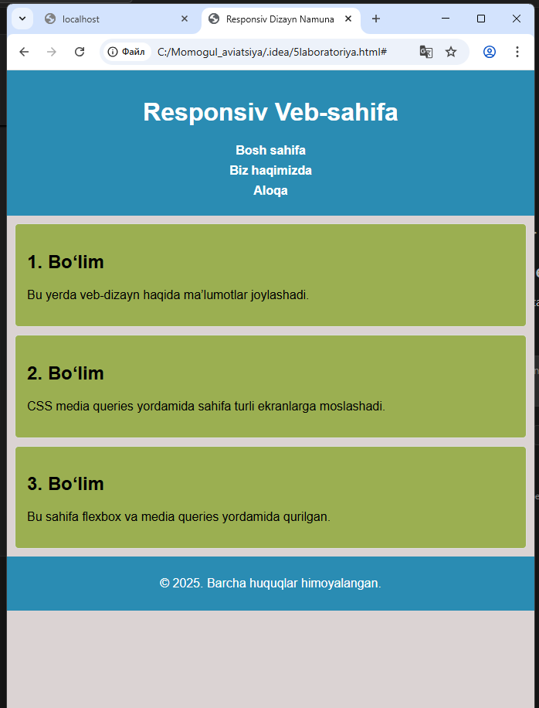
Kompyuter uchun:
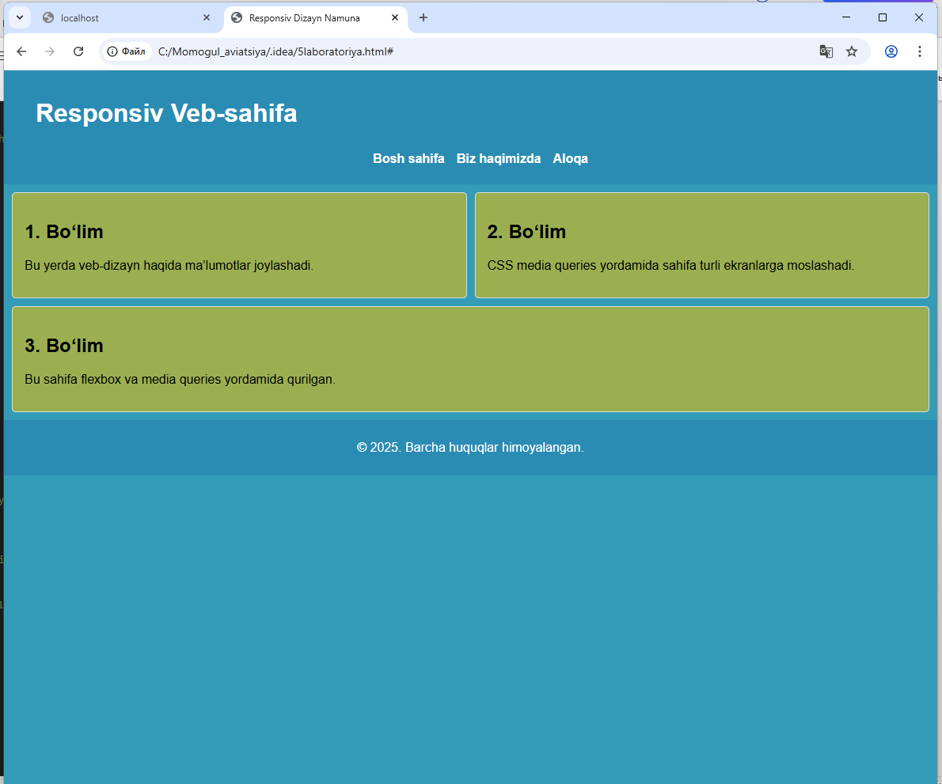
Aviatsiya mavzusida:
Html kodi:
<!DOCTYPE html>
<html lang="uz">
<head>
<meta charset="UTF-8">
<title>Aviatsiya Sahifasi</title>

<!-- Viewport -->
<meta name="viewport" content="width=device-width, initial-scale=1.0">

<link rel="stylesheet" href="style.css">
</head>
<body>

<header class="header">
<h1>✈ Aviatsiya olami</h1>
</header>

<nav class="menu">
<a href="#">Bosh sahifa</a>
<a href="#">Samolyotlar</a>
<a href="#">Parvozlar</a>
<a href="#">Aloqa</a>
</nav>

<main class="container">
<div class="card">
<img src="rasm/plane1.jpg" alt="Boeing 737">
<h3>Boeing 737</h3>
<p>Eng mashhur yo‘lovchi samolyotlaridan biri.</p>
</div>

<div class="card">
<img src="rasm/plane2.jpg" alt="Airbus A320">
<h3>Airbus A320</h3>
<p>Zamonaviy va tejamkor havo kemasi.</p>
</div>

<div class="card">
<img src="rasm/plane3.jpg" alt="F-16">
<h3>F-16 Fighter</h3>
<p>Harbiy aviatsiyada keng qo‘llaniladi.</p>
</div>
</main>

<footer class="footer">
<p>© 2025 Aviatsiya sahifasi</p>
</footer>

</body>
</html>

Css kodi
* {
box-sizing: border-box;
}
body {
margin: 0;
font-family: Arial, sans-serif;
background-color: #f2f6fa;
}
.header {
background-color: #003366;
color: white;
text-align: center;
padding: 15px;
}
.menu {
display: flex;
flex-direction: column;
background-color: #00509e;
}
.menu a {
color: white;
padding: 5px;
text-decoration: none;
text-align: center;
}
.container {
display: flex;
flex-direction: column;
padding: 15px;
gap: 15px;
}
.card {
background-color: white;
padding: 10px;
border-radius: 6px;
}
.card img {
max-width: 100%;
height: auto;
display: block;
}
.footer {
background-color: #003366;
color: white;
text-align: center;
padding: 10px;
}
@media (min-width: 768px) {
/* Navigatsiya menyusi gorizontal holatga o‘tadi */
.menu {
flex-direction: row; /* Elementlar yonma-yon joylashadi */
justify-content: center; /* Menyu markazga tekislanadi */
}
/* Asosiy kontent qatori gorizontal bo‘ladi */
.container {
flex-direction: row; /* Kartalar bir qatorda chiqadi */
flex-wrap: wrap; /* Joy yetmasa pastga tushadi */
}
/* Kartalar ikki ustunli ko‘rinishga o‘tadi */
.card {
flex: 1 1 45%; /* Har bir karta taxminan 45% kenglikni egallaydi */
}
}
Bu mobil telefonlarda:
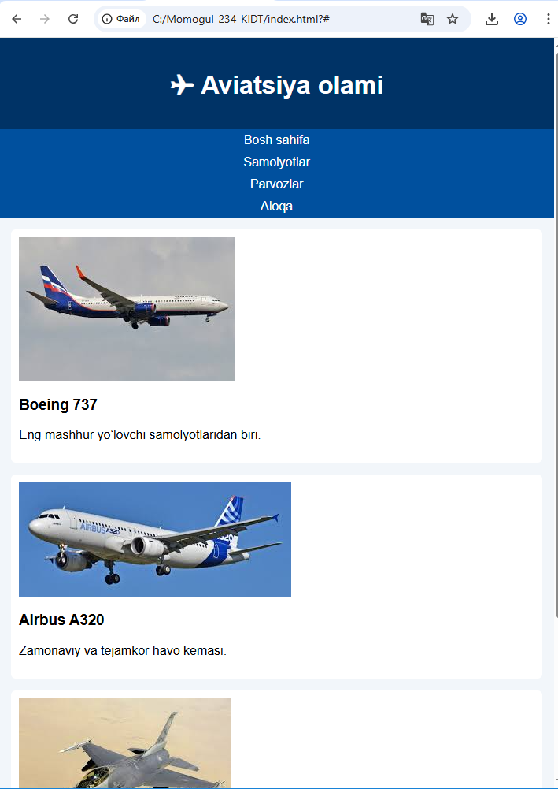

Bu noutbooklarda:
