**Laboratoriya ishi №6.**

**Mavzu:** **Formani yaratish va elementlarini ishlatish (input, textarea, select).**

**Maqsad:**

Veb sahifada foydalanuvchidan ma'lumot olish uchun formalarni yaratish, uning turli elementlari — <input>, <textarea>, <select> larni tushunish va ularni amaliyotda to‘g‘ri qo‘llash ko‘nikmalarini shakllantirish.

**Vazifasi:**

HTML da forma yaratish uchun <form> tegini ishlatishni o‘rganish.

Turli xil <input> elementlarini yaratish va ularning atributlarini o‘rganish (matn, parol, email, checkbox, radio).

Ko‘p qatorli matn maydoni yaratish uchun <textarea> elementidan foydalanish.

Ochiladigan ro‘yxat yaratish uchun <select> va <option> elementlarini ishlatishni o‘zlashtirish.

Formani to‘g‘ri yuborish va foydalanuvchi ma'lumotlarini yig‘ish uchun kerakli atributlarni qo‘llash.

**Nazariy qism:**

**1. Formalar (Forms) haqida umumiy ma'lumot**

Veb sahifalarda foydalanuvchilardan ma'lumot olish uchun formalar ishlatiladi. Forma — bu bir yoki bir nechta elementlardan tashkil topgan blok bo‘lib, unda foydalanuvchi turli xil ma'lumotlarni kiritadi va serverga yuboradi.

HTML tilida formalar <form> teg yordamida yaratiladi. Ushbu teg ichida foydalanuvchi bilan o‘zaro aloqada bo‘ladigan turli elementlar joylashtiriladi.

<form action="submit.php" method="post">

<!-- Forma elementlari shu yerda joylashadi -->

</form>

* action atributi — forma yuborilganda ma'lumot qaysi server manziliga yuborilishini belgilaydi.
* method atributi — yuborish usulini ko‘rsatadi (GET yoki POST).

**2. Formaning asosiy elementlari**

**a) <input> elementi**

<input> — eng ko‘p ishlatiladigan forma elementi bo‘lib, turli turdagi ma'lumotlarni kiritishga mo‘ljallangan. Uning turi type atributi orqali belgilanadi.

Misollar:

* type="text" — matn kiritish uchun (bir qator)
* type="password" — parol kiritish uchun
* type="email" — email manzil kiritish uchun
* type="checkbox" — tanlash uchun katakcha
* type="radio" — variantlardan bittasini tanlash uchun tugmalar
* type="submit" — formani yuborish tugmasi

<input type="text" name="username" placeholder="Foydalanuvchi nomi">

**b) <textarea> elementi**

<textarea> — ko‘p qatorli matn maydoni bo‘lib, foydalanuvchi uzoqroq matn yozishi uchun ishlatiladi. Bu element uchun rows va cols atributlari orqali maydon o‘lchami belgilanadi.

<textarea name="message" rows="4" cols="50" placeholder="Xabar matnini kiriting"></textarea>

**c) <select> elementi**

<select> — ochiladigan ro‘yxat yaratadi va foydalanuvchi undan bitta yoki bir nechta variantni tanlay oladi. <option> teglari yordamida ro‘yxat elementlari belgilanadi.

<select name="country">

<option value="uz">O‘zbekiston</option>

<option value="ru">Rossiya</option>

<option value="us">AQSh</option>

</select>

**3. Formani yuborish va serverga ma'lumot jo'natish**

Foydalanuvchi forma elementlariga ma'lumot kiritib, yuborish tugmasini bosganda, forma ma'lumotlari serverga yuboriladi. Server bu ma'lumotlarni qabul qilib, kerakli amallarni bajaradi.

Forma elementlarining name atributi har bir element uchun alohida kalit bo‘lib xizmat qiladi va ma'lumotlarni serverda to‘g‘ri qabul qilish uchun zarur.

**Amaliy qism:**

<!DOCTYPE html>

<html lang="uz">

<head>

    <meta charset="UTF-8" />

    <title>Forma yaratish va elementlarini ishlatish</title>

</head>

<body>

    <h2>Foydalanuvchi ma'lumotlarini kiriting</h2>

    <form action="submit.php" method="post">

        < Matnli input>

        <label for="username">Foydalanuvchi nomi:</label><br />

        <input type="text" id="username" name="username" placeholder="Foydalanuvchi nomi" required><br /><br />

        <Parol input>

        <label for="password">Parol:</label><br />

        <input type="password" id="password" name="password" placeholder="Parol" required><br /><br />

        < Email input>

        <label for="email">Email manzilingiz:</label><br />

        <input type="email" id="email" name="email" placeholder="example@mail.com" required><br /><br />

        <Checkbox input >

        <label>Qiziqishlar:</label><br />

        <input type="checkbox" id="news" name="interest[]" value="news">

        <label for="news">Yangiliklar</label><br />

        <input type="checkbox" id="sports" name="interest[]" value="sports">

        <label for="sports">Sport</label><br />

        <input type="checkbox" id="music" name="interest[]" value="music">

        <label for="music">Musiqa</label><br /><br />

        <Radio input>

        <label>Jinsingiz:</label><br />

        <input type="radio" id="male" name="gender" value="male" required>

        <label for="male">Erkak</label><br />

        <input type="radio" id="female" name="gender" value="female">

        <label for="female">Ayol</label><br /><br />

        <Textarea>

        <label for="message">Xabaringiz:</label><br />

        <textarea id="message" name="message" rows="4" cols="50" placeholder="Xabar matnini kiriting"></textarea><br /><br />

        <label for="country">Davlatni tanlang:</label><br />

        <select id="country" name="country" required>

            <option value="">--Tanlang--</option>

            <option value="uz">O‘zbekiston</option>

            <option value="ru">Rossiya</option>

            <option value="us">AQSh</option>

        </select><br /><br />

        <input type="submit" value="Yuborish">

    </form>

</body>

</html>

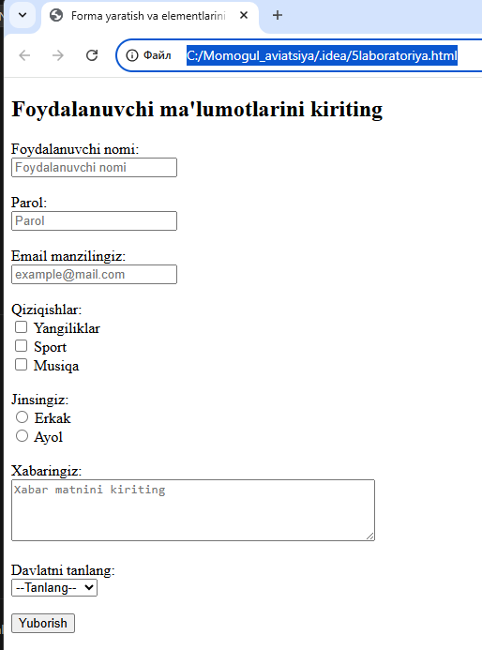

<!DOCTYPE html>

<html lang="uz">

<head>

  <meta charset="UTF-8" />

  <meta name="viewport" content="width=device-width, initial-scale=1.0" />

  <title>Aviatsiya Parvoz Formasi</title>

  <style>

    body {

      font-family: 'Segoe UI', Tahoma, Geneva, Verdana, sans-serif;

      background: linear-gradient(to right, #dfe9f3, #ffffff);

      margin: 0;

      padding: 0;

    }

    header {

      background-color: #1e3f66;

      color: white;

      padding: 20px 0;

      text-align: center;

      font-size: 28px;

      letter-spacing: 1px;

    }

    form {

      background-color: #ffffff;

      max-width: 600px;

      margin: 40px auto;

      padding: 30px;

      border-radius: 10px;

      box-shadow: 0 0 15px rgba(0, 0, 0, 0.1);

    }

    form h2 {

      text-align: center;

      color: #1e3f66;

      margin-bottom: 25px;

    }

    label {

      font-weight: bold;

      color: #1e3f66;

    }

    input[type="text"],

    input[type="password"],

    input[type="email"],

    select,

    textarea {

      width: 100%;

      padding: 10px;

      margin-top: 6px;

      margin-bottom: 20px;

      border: 1px solid #ccc;

      border-radius: 5px;

      box-sizing: border-box;

      transition: border-color 0.3s ease;

    }

    input[type="text"]:focus,

    input[type="password"]:focus,

    input[type="email"]:focus,

    select:focus,

    textarea:focus {

      border-color: #1e3f66;

      outline: none;

    }

    .checkbox-group,

    .radio-group {

      margin-bottom: 20px;

    }

    .checkbox-group label,

    .radio-group label {

      font-weight: normal;

      margin-left: 5px;

    }

    input[type="submit"] {

      background-color: #1e3f66;

      color: white;

      padding: 12px 20px;

      border: none;

      border-radius: 5px;

      cursor: pointer;

      font-size: 16px;

      transition: background-color 0.3s ease;

    }

    input[type="submit"]:hover {

      background-color: #163351;

    }

    footer {

      text-align: center;

      padding: 20px;

      font-size: 14px;

      color: #444;

      margin-top: 50px;

    }

  </style>

</head>

<body>

  <header>

    ✈️ Toshkent Xalqaro Parvoz Formasi

  </header>

  <form action="submit.php" method="post">

    <h2>Parvoz ma'lumotlarini to‘ldiring</h2>

    <label for="username">Yo‘lovchi ismi:</label>

    <input type="text" id="username" name="username" placeholder="Ismingizni kiriting" required>

    <label for="password">Parol:</label>

    <input type="password" id="password" name="password" placeholder="Profil paroli" required>

    <label for="email">Email manzilingiz:</label>

    <input type="email" id="email" name="email" placeholder="example@mail.com" required>

    <label>Qiziqishlaringiz (aviatsiya bo‘yicha):</label>

    <div class="checkbox-group">

      <input type="checkbox" id="planes" name="interest[]" value="planes">

      <label for="planes">Samolyotlar</label><br />

      <input type="checkbox" id="airports" name="interest[]" value="airports">

      <label for="airports">Aeroportlar</label><br />

      <input type="checkbox" id="routes" name="interest[]" value="routes">

      <label for="routes">Xalqaro yo‘nalishlar</label>

    </div>

    <label>Jinsingiz:</label>

    <div class="radio-group">

      <input type="radio" id="male" name="gender" value="male" required>

      <label for="male">Erkak</label><br />

      <input type="radio" id="female" name="gender" value="female">

      <label for="female">Ayol</label>

    </div>

    <label for="message">Parvozga oid savol yoki fikr:</label>

    <textarea id="message" name="message" rows="4" placeholder="Xabaringizni yozing..."></textarea>

    <label for="country">Parvoz boshlanadigan davlat:</label>

    <select id="country" name="country" required>

      <option value="">--Davlatni tanlang--</option>

      <option value="uz">O‘zbekiston</option>

      <option value="ru">Rossiya</option>

      <option value="us">AQSh</option>

      <option value="tr">Turkiya</option>

      <option value="ae">BAA</option>

    </select>

    <input type="submit" value="Parvoz ma'lumotlarini yuborish">

  </form>

  <footer>

    © 2025 Toshkent Xalqaro Aeroporti – Barcha huquqlar himoyalangan

  </footer>

</body>

</html>

