

Metax
Key Transfer Algorithm

Version 0.2
Last modified on` 30.10.2019
Number of pages` 6
Document History
Date | Description | Author(s)
25-Oct-2019 | Version 0.1: Initial version of the document | Marine
30-Oct-2019 | Version 0.2: Updated Terms, Acronyms and Abbreviations section | Marine

Table of Contents
1. Introduction 4
1.1. About the document 4
1.2. Terms, acronyms and abbreviations 4
1.3. References 4
2. Key Transfer Algorithm 4
3. Key Transfer Algorithm in Link 5
3.1. start_pairing request in Link 5
3.2. cancel_pairing request in Link 5
3.3. get_pairing_peers request in Link 5
3.4. request_keys request in Link 6

Introduction

About the Document
This document describes the key transfer algorithm of Metax. The algorithm is described for the Link layer.

Terms, Acronyms and Abbreviations
Link – Manages connections with peers
LAN (Local area network) - is a computer network that interconnects computers within a limited area
WI-FI - is a family of radio technologies commonly used for wireless local area networking (WLAN) of devices
network IP (Internet Protocol) – is an IP of a device connected to the network
subnet - is a logical subdivision of an IP network

References
- leviathan_whitepaper.odt
- leviathan_system_overview.odt
- metax_general_notes.txt
- leviathan_metax_api.odt

Key Transfer Algorithm

Device B
Requests the user keys from Device A
Device A
Has user keys

Connected to the same network

For transferring user keys i.e user public/private keys, user json encryption key from Device A to Device B the following steps should be performed:
- Device A starts pairing mode via start_pairing request. The request has a timeout parameter, which shows seconds count after which the pairing mode will be expired and the request returns a generated code (i.e an alpha-numeric random string containing 7 characters which is supposed to be used by 2 devices as a confirmation that they belong to the same user). The details of start_pairing request are described in [4].
- Device B requests for user keys from Device A via request_keys request. The request has an ip parameter (to pass Device A ip) and code parameter (to pass the generated code of Device A) and returns whether the transfer of user keys has succeeded or not. The details of request_keys request are described in [4].

If Device B does not have network IP of Device A a functionality is provided to get network IPs of all devices which are in the pairing mode and in the same network via get_pairing_peers request. The details of get_pairing_peers request are described in [4].
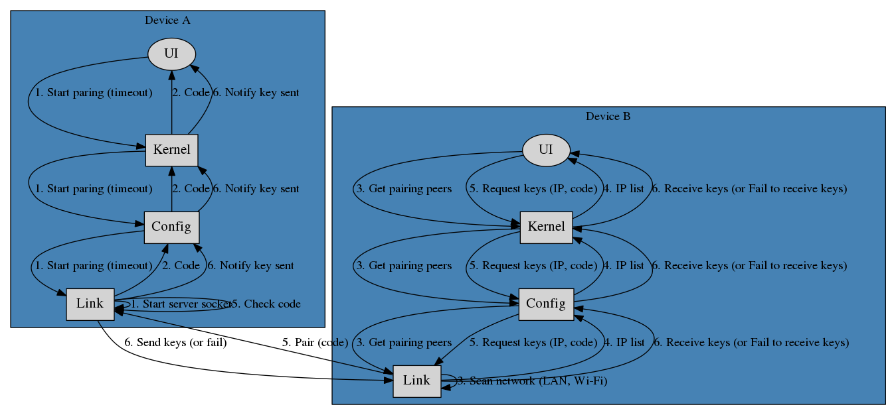
Also Device A could stop pairing mode via cancel_pairing request. Details of cancel_pairing request are described in [4].

Key Transfer Algorithm in Link
Key Transfer algorithm is organized via 4 requests described in Key Transfer Algorithm:
- start_pairing request
- cancel_pairing request
- get_pairing_peers request
- request_keys request

start_pairing request in Link
The following functionality is performed:
Returns “Server is already created” error message.
If server socket is already created:
True
Creates a server. If server is created properly:
Returns empty code.
Generates and returns a code. Then starts a timer, which will close the server after specified seconds (timeout is given in request).
False
True
False

cancel_pairing request in Link
Stops server and timer if they were started during start_pairing request, otherwise does nothing.

get_pairing_peers request in Link
The following functionality is performed:
- Gets all network IP addresses and subnet masks of all available(LAN or Wi-Fi) networks of the device.
- Iterate through all addresses in the same network and get IPs of the devices that are in pairing mode. Returns all those addresses.

request_keys request in Link
The following functionality is performed:
- Connects to the server (the ip of the server is given in request).
- Sends the code (the code is given in request) to server. If the code is correct server sends user public/private keys, user json encryption key sequentially. If the user keys are sent properly the server sends notification “Successfully send keys to <IP>" via 8001 port, where <IP> is the IP of the device which requested the keys.
- Receives the keys and save in corresponding files.
- Returns “Receive keys.” message if the keys are saved and “Fail to receive keys.” otherwise.

