

Metax
Save Algorithm

Version 0.3
Last modified on` 05.09.2018
Number of pages` 9
Document History
Date | Description | Author(s)
25-May-2018 | Version 0.1: Initial version of the document | Garik
30-May-2018 | Version 0.2: Completed general description of the save algorithm | Garik
05-Sep-2018 | Version 0.3: Updated section 2.1. picture, added notes | Garik

Table of Contents
1. Introduction 4
1.1. About the document 4
1.2. Terms, acronyms and abbreviations 4
1.3. References 4
2. Save Algorithm in Kernel 4
2.1. Kernel initiates save in response to client request 5
2.2. Data received from Storage 5
2.3. Data received from Router 6
3. Save Algorithm in Router 6
3.1. Data received from Kernel 7
3.2. Data received from Link 8
3.3. Periodic check of tender statuses 9

Introduction

About the document
This document describes the save algorithm of Metax. The algorithm is described for the Kernel, Storage and Router layers.

Terms, acronyms and abbreviations
Kernel – Layer in Metax architecture. It implements the core logic, like splitting files into chunks, generating shared/master objects, integrating files from pieces, deciding participation in tenders, etc.
Router – Performs routing of data between its own kernel to peers, or as an intermediate bridge for other peers
Link – Manages connections with peers
Storage – Stores files as key/value pairs. Can save file into hard drive with the given key (uuid) or retrieve file with the given key (uuid) from hard drive.
Key Manager – Generates and keeps track of users RSA keys and AES keys for data encryption. Performs all kind of encryption/decryption tasks.

References
- leviathan_whitepaper.odt
- leviathan_system_overview.odt
- metax_general_notes.txt
- leviathan_metax_api.odt

Save Algorithm in Kernel
Kernel performs the following tasks related to Save requests:
1) Splits file into pieces and ask storage to save them in local storage
2) Ask router to save data in remote peers and replies to the subsequent messages from router
3) Decides to participate in a remote tender and replies to subsequent messages from router

Kernel initiates save in response to client request
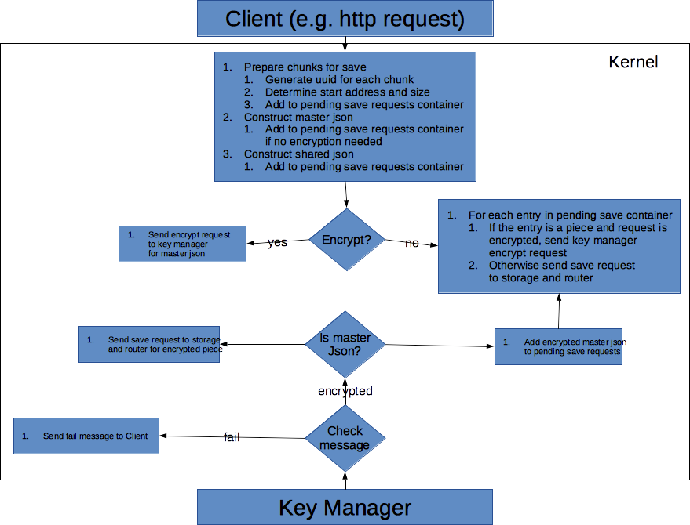
Notes:
Kernel splits the file into chunks of at most a predefined size (7MB). If the file size is equal or less than the predefined chunk size, then there will be one chunk containing the whole file.

Data received from Storage
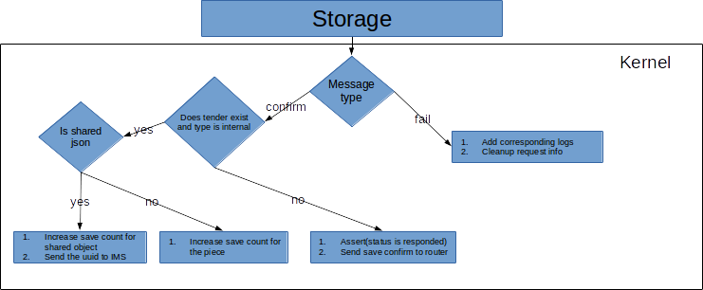

Data received from Router
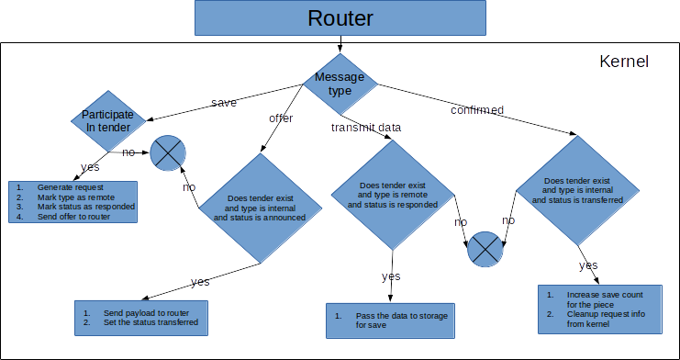

Save Algorithm in Router
Router performs tasks in there cases:
1) there is request/data from Kernel
2) there is data from Link layer
3) periodically checking for tender statuses
Below sections describe the algorithm in all these 3 cases

Data received from Kernel
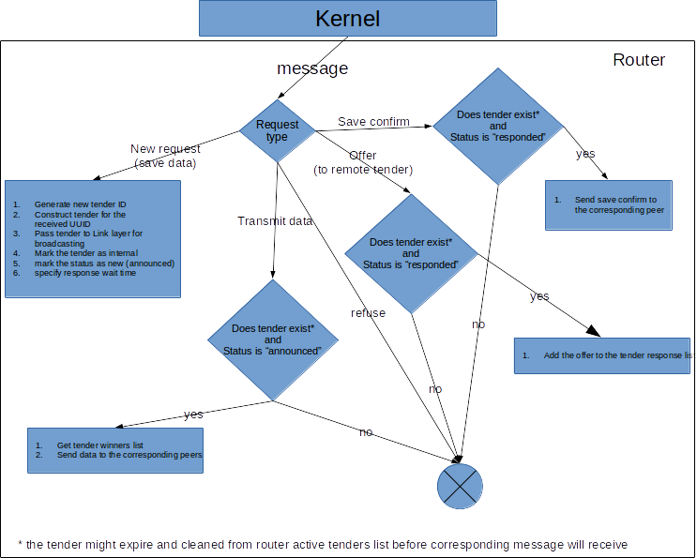

Data received from Link
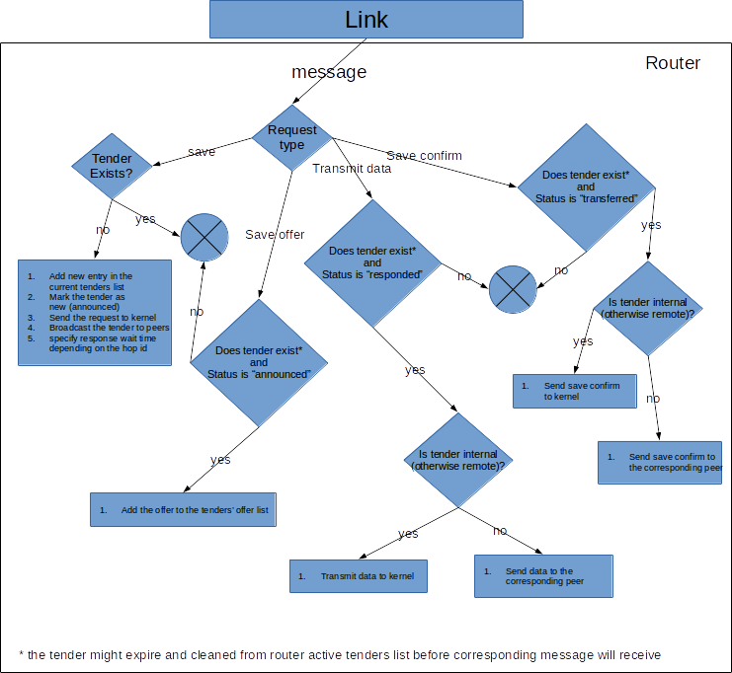

Periodic check of tender statuses
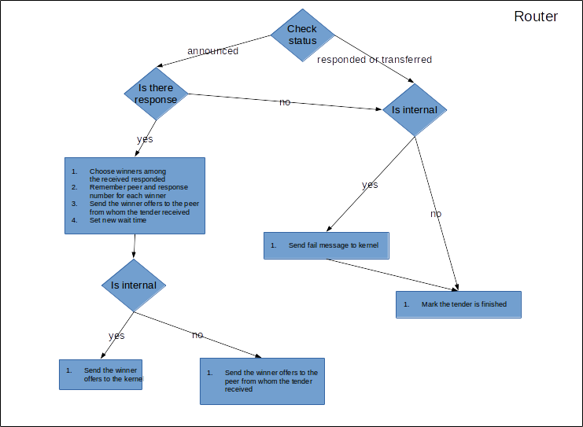
Checking of the tender status is performed periodically after expiring of some quantum of time. Each new tender upon entering in router is given some quantum of a time for collecting offers from the other peers. When the status checker wakes up it searches for the tenders which wait time is expired. The below diagram algorithm router runs on each tender with expired wait time.

FAQ
Q. Why we need master json.
A. Otherwise we need to keep the list of chunk UUIDs in share object.
Now consider the following situation:
- you have shared an encrypted file with a friend. Now he has his own share object pointing the to real file. Friend’s copy of share object also contains the list of os chunk UUIDs
- now you update your file and file size is changed, you need to split the file again and and give to chunk a UUID (the number of chunks also can be changed). That means you have to create new share object for the updated file with the new list of chunk UUDS.
In this situation your friends share object will point to the old version of the file and can be fixed by updating also the shared object of your friend.
The current implementation (chunk uuids are stored in separate master file, and share refers to master) updating shared files doesn’t invalidate friend’s share object.

