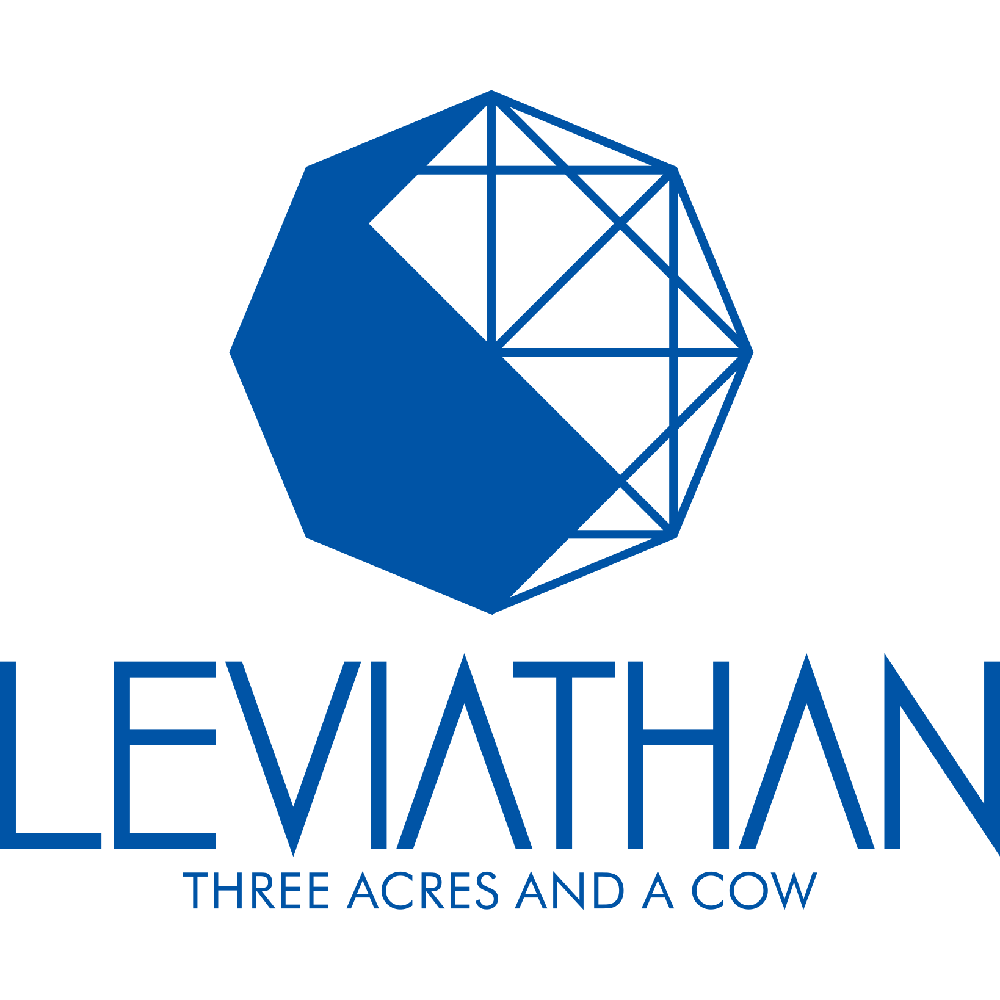

The Next Web: Global Giant Graph

version: 0.1
Last modified: 2018-07-04
Number of pages: 13
Contents
1. Introduction 4
1.1. Document Identifier 4
1.2. Definition of terms and abbreviations 4
1.3. Scope 4
1.4. References 4
2. History 4
2.1. TCP/IP 4
2.2. HTTP/HTML 4
2.3. Web 1.0 4
2.4. Web 2.0 4
2.5. Net neutrality attacks 4
2.6. Building walls in Internet 5
3. Status quo 5
3.1. Power usurpation 5
3.2. Extreme Capitalism 5
3.3. The economy of scale 5
3.4. National vs transnational 5
3.5. Cosmopolitan vs International 5
3.6. Art & Quality vs Pop and the "Good Enough" culture 5
3.7. Cost delegation 6
3.8. Catalog vs Advertisement 6
3.9. I vs We 6
4. Philosophy 6
4.1. Jobs Leviathan 6
4.2. Hobbes Leviathan 6
4.3. The Social Contract 6
4.4. Demographic supernova burst 7
4.5. "Western democracy" vs "North Korean democracy"? 7
4.6. Illich → delegate to lower circle (counter productivity of institutionalization) 7
5. The Leviathan manifest 7
5.1. SME-friendly Capitalism and Globalization 7
5.2. Internationalism 7
5.3. Equally grained world 7
6. The Structure of the Leviathan Metax Network 8
6.1. Introduction 8
6.2. Security 8
Secure Storage 8
Secure Routing 9
Access Control, Authentication and Identity Management 9
6.3. Caching mechanism 9
6.4. Micropayments Mechanisms 9
6.5. Resource Management Capabilities 9
Content Deletion and Update 10
Content Expiration 10
Content Versioning 10
Content Searching 10
Storage and bandwidth Management 10
6.6. User registration and accounting 10
6.7. Features and advantages of Leviathan platform 10
6.8. Applications hosted on Metax (ongoing) 10
6.9. The Hardware 11
6.10. The Firmware 12
6.11. The Kernel 12
6.12. The micro-payment system 12
6.13. The macro-payment system 13
6.14. Vostan-IMS 13
6.15. Vostan-HMI 13
7. Luma 13
7.1. Conceptual part 13
7.2. Technical part 13
8. Friend → trust – chain → device peering, rating = revenue 13
9. Like → crowd-funding (new social network culture) 13
10. TV = news + entertainment 13

Introduction

Document Identifier
This document specifies Leviathan - the next generation web that is built to overcome challenges faced by current Internet and World Wide Web, which was built in the age of cooperation, and is not any longer able to sustain the hostility of modern echonomy towards "undivided" web.

Definition of terms and abbreviations

Scope

References

History

TCP/IP
Internet (the worldwide IP network) started as a network protocol for computer-to-computer communication, to help researchers to connect with each other and share data.

HTTP/HTML
The Worldwide Web protocol was started as a cross-platform (OS-independent) format and protocol to share and cross-reference research documents and specifications.

Web 1.0
It was a peer-to-peer network, where the address space was globally maintained in the hierarchical fashion, but otherwise each node was administered by its independent owner and was free to connect with any other node for any type of communication. The traffic was routed through the network without filtering, maintaining absolute net neutrality. WWW pages were referring to each others forming a world-wide web of cross-linked documents, illustrations, offering data, image, video and audio files for download and on-line display of some formats within the web-page.
The classical viruses spread via executable and embedded scripting downloads where the first threat, as well as early versions of denial-of-service attacks.

Web 2.0
With Netscape inventing JavaScript the Web 2.0 was born – where the web-sites turned into content-management-systems, maintained by the web-site admins, while the content was created by the web-site visitors – the WWW community. Blogs, Forums and Social Networks were born. Java and JavaScript code quickly became a major tool for hackers to bring the attacks to a new level and scale. With e-commerce and e-banking the world-wide cyber-crime was born and spread.

Net neutrality attacks
The video-streaming and VoIP became major driving force for speeding up the interconnect and routing in the Internet, but also started the first major attacks to net neutrality. Content providers were commercially incentivising the Internet Service Providers to deliver their contents with higher priority compared to "regular traffic".

Building walls in Internet
The governments were reluctant to give up the power of controlling mass-media to social networks and instant messengers where regular people could connect and communicate peer-to-peer or in group chats and forums. Along with technical discussions many forums were born to discuss politics and government relations.

Status quo

Power usurpation
Today the legislation in many countries was and is being changed towards removing the Net Neutrality constraints, allowing the corporations to sign contracts with ISPs to deliver their traffic with higher priority and quality of service, and allowing the governments and other authorities to bypass regular jurisdiction by directly ordering the ISP to isolate or block certain web-sites or traffic in their territory, collect and analyze personal data of regular (non suspect) citizens and foreign citizens without legal permission, etc.

Extreme Capitalism
Internet is divided between few major social networks, e-commerce platforms, news & entertainment agencies and messaging/VoIP networks. The economy is highly favorable towards corporations, merge&acquisition and is extremely unfavorable towards small & medium enterprises and family businesses. The start-ups (synonyms of innovation) are bound to "exit strategy" that is M&A or IPO, but never to stay lean and useful SME with high quality (and not cheap) offering.

The economy of scale
The economy of scale was the direct consequence of struggling to minimize the prices (reduce margins in expense of increasing the volume). It moved from the tangible world into digital world and magnified to draconian level resulting in an economic gradient field where the optimum points are trans-national mega-corporations.

National vs transnational
The decline of national capital resulted in weakening the national states legislation: allowing transnational corporation to wipe away local production. The product was centralized in few spots on the planet and in few pockets, and the rest of the world was turned into consumers, and the only type of SME which is allowed to exist for some period is a reseller, a franchise or OEM IP vendor but not an end-product manufacturer.

Cosmopolitan vs International
To overcome the resilience of national capital the trans-national corporate machine promoted the ideas of cosmopolitanism, resulting in subtle substitution of the idea of Internationalism with the idea of Cosmopolitanism. Frequently it was done at the brute-force level of search&replace in textbooks, slogans, and public discussions.

Art & Quality vs Pop and the "Good Enough" culture
The Art and Crafts were hand in hand before the Industrial age. In post-modern age the "production pipeline" is a common term in "pop art industry". The economy of scale is the economy of good-enough, it is the economy of waste.

Cost delegation
Economically "unfair and unjust" essentially means "cost delegation of one group to another". In the age of "human rights activism" the rights of the most fragile group are being neglected: the rights of future generations. Economy of waste is the based on cost delegation to future generations and is obviously unsustainable.

Catalog vs Advertisement
The fight for attention of the consumer turned the catalog-based marketing into advertisement-based marketing, which is causing pollution in the digital space the same way the oil based industry is polluting the atmosphere. In the past when people wanted to buy something, they were paying for a catalog, then pro-actively searching for the item they need, and were ordering it from the store or via post. Now the information stream is being frequently interrupted to inject advertisement, which people have to bypass or bear with, as with piles of garbage on the streets.

I vs We
The result of advertisement based marketing is the idea that "you are the most important" that is being injected into human brain from the childhood. What you eat is important. How you loose weight is important. "Remember, that you are not that important", was the main lesson Audry Hepburn was getting from her mother in mid-XX. "I" became the primary concern and the primary issue of modern human being in XXI.

Philosophy

Jobs Leviathan
Chapter 41 in the book of Job is about the sea serpent Leviathan: “Can you pull in Leviathan with a fishhook or tie down with a rope? Can you put a cord through its nose or pierce its jaw with a hook? Will it keep begging you for mercy? Will it speak to you with gentle words? Will it make an agreement with you for you to take it as your slave for life? Can you make a pet of it like a bird?
This serves as a perfect allegory for individual's relation with a state. It is known that states (countries) largely impact and form the fate of people. But it is also conjectured that prominent people have equally great impact on the fate of nations. If a person tries to subdue the state to his will – is there any hope to succeed, or will he be annihilated. If he lays a hand on it, will he remember the struggle and never do it again?

Hobbes Leviathan
The 1651 book by Thomas Hobbes on political philosophy of a state was one of the earliest examples of the "social contract theory" written during the English Civil War and postulating strong government as the only hope against "war of all against all". The Leviathan as a synonym of a State was probably inspired by Job's book.

The Social Contract
The Social Contract is the peace treaty between person and the State (the Leviathan) which ideally should be based on the inner peace treaty between "I" and "We" in the person's heart.

Demographic supernova burst
We live in the middle of demographic burst. For many millennium population was < 1B and in one century it jumped to 7B and continues rising. Some are tempted to believe that it's not sustainable, and are openly looking for means to bring it back to 1B. Some claim that it can reach 20B and more.
How you see the sustainable future of the planet defines who you are from the point of view of the civilization and future of humanity.

"Western democracy" vs "North Korean democracy"?
The Morale (ethics) is the art of conflict management between the Ego and the Socium. The Christian solution to this is Love. The Distributive solution to this is "the three acres and a cow". Stop the economy of waste and the planet can sustain 20+ Billion of people.
If we go with western life-style, the planet cannot sustain more than 1B people – we have to find a way of (peaceful or forceful) reduction of population to the state of pre-XX age.
If we go with "the three acres and a cow" can we have capitalism, free market and globalization or is the North Korean life style the only solution?
Should we educate women in Africa with main goal to teach them family planning and maximize the age when they get married, or should we educate the world to consume less and create more, to pay more for higher quality and more artsy products produced locally?

Illich → delegate to lower circle (counter productivity of institutionalization)
Turkmenbashi - > social
Ojalan → end of national state
fresco

The Leviathan manifest

SME-friendly Capitalism and Globalization
We are not against capitalism or globalization, we are for SME-friendly capitalism and for SME-friendly globalization.

Internationalism
Nationalism is incompatible with Cosmopolitanism, however Nationalism is not against Internationalism. Vice versa, these two are in perfect harmony and are even preconditions of each other: know & respect yourself = know & respect others. We respect everybody's (fundamental) right to speak their own language, live according to their own traditions and beliefs, respect and care for their own house, parents, and graves of their ancestors. And this respect is incompatible with denial of own cultural identity and tolerance towards other cultures and identities that are different from ours: diversity which makes this world more interesting to live in, and also more resilient towards cataclysms.

Equally grained world
TODO:

The Structure of the Leviathan Metax Network

Introduction
Metax is peer-to-peer distributed system consisting of interconnected nodes/peers able to self-organize into network topologies with the purpose of sharing resources such as content, CPU cycles, storage and bandwidth, capable of adapting to failures and accommodating transient populations of nodes while maintaining acceptable connectivity and performance without requiring the intermediation or support of a global centralized server or authority.
Metax provides services for storing and transferring online data, access management and encryption services for users' personal data and for developers of cloud SW developers. Unlike the conventional cloud software platforms, Metax enables the developers to construct their own cloud infrastructure using exclusively open source code and SW published under a free license, as well as the computers of own data-center.
Published/stored/distributed content is meant to be accessible in a controlled manner by peers with appropriate privileges. The main focus is security and persistence, and also incorporates persistent content management (updating, removing, version control) facilities.
Metax allows to take advantage of the available peer computer processing power (CPU cycles). This is achieved by breaking down a computer-intensive task into small work units and distributing them to different peer computers connected to Metax network, which execute their corresponding work unit and return the results. In general all peers in the network perform exactly the same tasks, acting both as servers and clients, and there is no central coordination of their activities.

Security

Secure Storage
TODO:
Encryption and privacy
  - The access key of Leviathan platform user is a private key with highest encryption level and enables the user to store their data on Leviathan platform in a secure and private manner.
  - The applications executed on Leviathan platform use that possibility, thus acquiring a considerable competitive advantage over other cloud Applications that are executed on advanced cloud platforms and allow the owners of those platforms to access the private data of their subscribers. Due to the open source code of Leviathan, individuals and enterprises can build Leviathan's library out of the source code themselves on their private computers by firstly conducting penetration and back-door discovery tests and correction.
  - Particularly, it is provable that the private key is stored on only Subscriber's devices and is not uploaded onto the systems of the Developer and the Buyer.The possible negative effect of this kind of architecture in case the user loses the private key is the loss of all data of the user. The user should be informed about this and take care about saving a back-up copy of the private key.

Secure Routing
TODO

Access Control, Authentication and Identity Management
TODO

Caching mechanism
Metax rely on the replication of content on more than one nodes for improving the availability of content, enhancing performance and resisting censorship attempts.
When a search request succeeds in locating a file, the file is transferred through the network node by node back to the originator of the request. In the process, copies of the file are cached on all intermediated nodes, increasing its availability and location characteristics in future requests.
In metax cache data is being saved in disk, and not in RAM. The reason of saving cache data in device is to keep cache information when starting metax after termination.
TODO

Micropayments Mechanisms
TODO

- Service account management by Luma
  - To encourage contribution of own equipment to Leviathan by individuals Leviathan develops an accounting system by the use of Luma transferable value and crypto-currency.
  - Luma is a measurement unit, the equivalent of 1 byte-second: 1L = 1B*1s, which helps to execute the accounting for network storage service between the service users and service providers.
  - Although a cryptocurrency SW is used for accounting, Luma is not a cryptocurrency in the classical sense. Particularly, it does not assume an ICO or currency exchange management, but is a measurement unit for measuring the service for storing a particular amount of data (one copy) for a particular duration with a reliability of a contemporary hard disk.
  - The Developer will create a MW which will periodically provide a necessary amount of Luma for each valid subscriber of the Buyer. That will enable the given subscriber to save/store their data for the given period of time and implement their accounting on Leviathan platform in general, and on the Buyer's data-center equipment, in particular.
  - The Developer will create a server BE and admin page that will enable Buyer's accounting employees to control the application of data-center computers and network storages, and get statistic information to implement system management.

Resource Management Capabilities
TODO

Content Deletion and Update
TODO

Content Expiration
TODO

Content Versioning
TODO

Content Searching
TODO

Storage and bandwidth Management
TODO

User registration and accounting
  - Registration of Users on Leviathan platform is executed by the recommendation of already registered users. The existence of the recommenders and their rating determines the rating of the accounts they recommend for.
  - The developer will connect the accounting system of the Buyer's subscribers to the accounting system of Leviathan's subscribers. The Buyer's Leviathan account will warrant for the Leviathan account of the Buyer's subscribers. The management system of registration and permissions will use the data of Buyer's subscriber register to determine the type, volume and quality of the services provided to the subscriber.

  - In case the Buyer's subscription account has been frozen, the Subscriber's Leviathan platform account will be preserved, but the Subscriber will not be able to get credit (in the form of Luma) to store and process their Data in the Buyer's data-center as well as for executing the system. Particularly, the information created by the system will not be accessible unless the Subscriber has moved those data to another medium before termination of the service.

Features and advantages of Leviathan platform
The main feature is connecting distributed computer centers, personal computers, 24x7 connected disk-drives, into one decentralized cloud storage, content-delivery network,
and caching router. This can provide nation wide replacement for Amazon Data Center and similar services, for GoogleDrive & DropBox and similar services. Leviathan software is provided as open-source software, therefore code is available for security agencies to check for vulnerabilities, as well as to build & deploy from their own servers. Communication inside Leviathan platform is end-to-end encrypted, because all intermediate channels and storage boxes are assumed to be hostile, and therefore the privacy and security architecture is made with peer-to-peer technologies in mind.

Applications hosted on Metax (ongoing)
- Network of IT educational laboratories, which goal is to bring up IT education
network, including rural areas, to increase system level maturity, ability to use high-end modern IT solutions in different spheres of industry, culture, education, politics & law, including awareness of cyber security, treats, as well as handling of extreme situations. They use Metax for their self-made, self-maintained and self-configured peer-to-peer routing network, based on RF/WiFi/WiMax and other antennas and wiring, owned by each school or training center, in a distributed decentralized fashion, with self-healing peer-to-peer network & routing protocols, to enable connectivity independently of ISP's, foreign telecoms, etc in a secure, protected way.
- Data-storage and secure peer-to-peer communicator service, for a national
IPS/Telecom/IPTV company to replace GoogleTalk and GoogleDrive, which is helpful not only for ISP (as they keep traffic locally inside country, and pay less to international ISPs) but also it is good for the national security.
- Situational Awareness Center and Command-Control-Communication center
on top of Metax, which allows to use massive country-local cloud storage with military-grade security and encryption mechanisms to store massive amount of data (video streams, audio streams, documents, graph databases, etc) and access it in a very scalable fashion from multiple offices distributed across the country.
The Information Management System is using modern Semantical Network technologies to semantically annotate material, segments of videos, geo-location, and other domain-specific annotations, and display & navigate the storage with a special multi-dimensional control-center cock-pit GUI, which allows to filter data by (1) time, (2) geo-spacial coordinates and (3) semantical flags, such as "human", "building", "car", etc.
All information is shown on the map (google map, openstreetmap, own aerial photos layer, etc) not only for photos and records, but also for individual video frames (segments) of video recording, e.g. for the footage provided from the UAV's, indexed by GPS coordinate and angle of attack for the video camera.
- Social Networking Aggregator and Adapter layer, which helps the citizens to
migrate from foreign hosted cloud storage (Microsoft, Apple, Google, Amazon,
DropBox, etc) and social networking platforms (Facebook, Twitter, GooglePlus,
etc) and communication/chat/push-to-talk service platforms (Viber, WhatsApp,
Telegram, etc) smoothly and gradually, without disruption to networking&communication routine.

The Hardware
The Hardware is formed from legacy hardware. However we foresee several reasons for a fundamental paradigm shift in the HW architecture.
Today's HW is based on Von Neumann computer with shared-memory-architecture, requiring cache-coherent multi-core CPUs. The consequence is performance bottleneck caused by multiple threads trying to access the memory through the same Memory Controller (the Von Neumann bottleneck).
The more problematic consequence is fundamental security vulnerability due to multiple threads accessing the same memory location, causing multiple levels of security fencing in HW, FW and SW, which quickly raises the complexity of the system to the point where security assessment becomes impossible and unfixable vulnerabilities such as Specter and Meltdown put at risk multi-billion install-bases of cloud HW.

The Firmware
From NW operating system point of view such as Leviathan OS, the Firmware is anything that runs on a local computer and is bound to the address space of the local machine. This includes the entire operating system of the given local machine.
Leviathan can run on GNU/Linux, Windows, OSX, iOS, Android and other OS-es. All these OS-es are treated as underlying platform and are not distinguishable from the FW from Leviathan's perspective.

The Kernel
In the regular (single-machine) case the Kernel is responsible for mapping multiple processes (threads) onto multiple CPU cores which execute those processes, mapping the logical (virtual) memory addresses to physical (real) memory segments of RAM and Disk Drives (swapping), and for Inter-process-communication to organize processes into more complex hierarchical process networks.
In the Network OS such as Leviathan the Kernel performs the same task across the NW by forming a unified address space (addressation mechanism) for processes, data, and communication channels, and mapping them respectively to individual computers CPU-s, storage, and NW interfaces (uplink and downlink).
Metax is the daemon running in the given node, which connects with its peers running on other nodes to form the peer-to-peer network (cloud) and the above mentioned address space where Leviathan Apps can store data, execute their processes, and communicate via streams and datagrams.
It provides key-value storage service to the user-space layer, which is a universal means for both the storage of process data, and communication between the processes.

The micro-payment system
The Social Contract of Leviathan Network assumes that every node (computer, mobile device, etc) provides part of its CPU power, storage, and incoming and outgoing Internet bandwidth to the Network, and in return obtains credit to use other parties CPU power, storage and network connection.
The multiple thousands of store and load operations are performed in Metax Network every second, and nodes need to account the services they provide and use with the rest of the Network. The accounting mechanism is using the physical unit of byte-second (1 Luma = 1 byte * 1 second) as the currency to compute the balance between the given node and the Network.

The macro-payment system
News broker / media broker (ebay/amazon/itunes/Sony music) TV = news + entertainment.

Vostan-IMS
Non-SQL dbms for Web 3.0 / GGG

Vostan-HMI
Mind-map-based HMI
- touch-screen dominant market
- document → mind-map (free-mind)

Luma

Conceptual part
Measurement unit, mean of goods exchange, deferred exchange, store of exchange potential.
Negative interest-rate? Limited life time? Store of value may be a rudiment of the past. Potentially – the deferred exchange as well.

Technical part
Double spend error, minimization of transaction cost,

Friend → trust – chain → device peering, rating = revenue

Like → crowd-funding (new social network culture)

TV = news + entertainment

