

Metax
Sandbox Testing Instructions

Version 0.1
Last modified on` 13.04.2018
Number of pages` 8
Document History
Date | Description | Author(s)
12-Apr-2018 | Version 0.1: Created the initial version of the document | Ani

Table of Contents
1. Introduction 4
1.1. About the document 4
1.2. Terms, acronyms and abbreviations 4
1.3. References 4
2. What is Metax 4
2.1. Overview 4
2.2. Existing Applications Based on Metax 4
3. Metax Key Features Testing 5
3.1. Setup Virtual Machine 5
3.2. Connecting Metax Peers via config.xml file 5
3.3. Testing Unencrypted Data Save/Get 5
3.4. Testing Encrypted Data Save/Get 6
3.5. Sharing Encrypted Data 8

Introduction

About the document
This document is intended for the users of Metax sandbox environment. Instructions are provided to test key features of Metax.

References
- http://ggg.leviathan.am/#921

What is Metax

Overview
Metax is a fundamentally peer-to-peer, secure, self-configuring, self-optimizing cloud data storage, e-trading, communication and social networking platform.
It connects distributed computer centers, personal computers, 24/7 connected disk-drives, into one decentralized cloud storage, content-delivery network, and caching router.
The cloud deployment is based on novel distributed non-SQL database management system, next-generation W3C standards (RDF, Semantic Web) and search technologies.
The software is clean, and communication is end-to-end encrypted, and therefore the privacy and security architecture is made with P2P technologies.

Existing Applications Based on Metax

Data Storage
Metax offers a data-storage service to replace Google Drive, Dropbox and similar services.
This tool helps ISPs to keep the local traffic inside the country and reduce their costs by paying less to international ISPs.
"Metax File Transfer" tool can be used by following the link below for keeping any data in drive and sharing it with others.
https://filetransfer.leviathan.am

Websites
Metax distributed hosting services for websites enables to have permanently up and running websites with no single point of failure.
https://www.armath.am website which is hosted on Metax platform.

Network for educational laboratories
The goal is to bring up IT education network, including rural areas. They use Metax for their self-made, self-maintained and self-configured peer-to-peer routing network, owned by each school or training center, in a distributed decentralized fashion, with self-healing peer-to-peer network & routing protocols, to enable connectivity independent of ISPs, foreign telecoms in a secure and protected way.

Metax Key Features Testing

Setup Virtual Machine
- Download tar of the Virtual Machine image from the provided link and un-tar it.
- Setup 2 virtual machines (1st peer and 2nd peer) with VMPlayer.
- Setup networks of the virtual machines so they are visible to each other via IP address. This can be achieved by configuring virtual machines network as bridge.
- As a result Metax should be run automatically after booting of virtual machines. A crontab job is setup to start Metax automatically.

Connecting Metax Peers via config.xml file
Below instructions show how to connect Metax software running on virtual machines (Metax peers) to/form Metax network. At least one peer should be visible by the other peers through its IP address. E.g. below instructions show how to connect 2nd peer to the 1st one.
- We need to open 2nd peer’s Metax configuration xml file in a text editor. E.g, using vim through terminal:
$ sudo vim /opt/leviathan/config.xml
- Add entry in <peers> element, by specifying IP address and the “metax_port” number under which 1st peer Metax is running:
...
<peers>
<peer>peer1_ip_address:8000</peer>
</peers>
...
- Restart Metax, so the new configuration takes effect. Type the following in terminal:
$ killall metax
wait for some time (at most 1 minute), so the Metax is launched by crontab (crontab is setup for checking metax run every 60 seconds and launches it if it is not running).

Testing Unencrypted Data Save/Get
Below instructions demonstrate how to save any data into already connected Metax peers (Metax network) via one of the peers and get the saved data from another peer. i.e. the upload is done into the Metax of the 1st peer, and download is done through the Metax of the 2nd peer.
- Open browser (Firefox is available on Ubuntu VMs by default) on the 1st peer and type http://localhost:8001/db/get?id=f750bcc4-e97d-4d19-b077-de7b506af7a2 in the address bar
- Uncheck “encrypt” checkbox to save data unencrypted
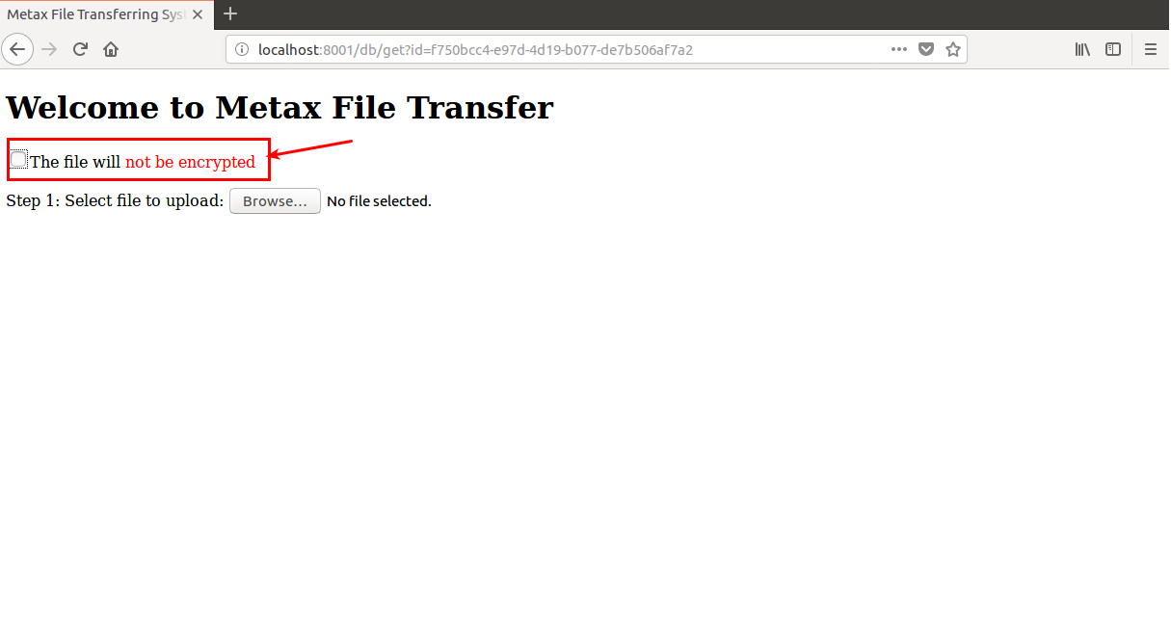
- Press “Browse...” button and choose some file to upload
- After uploading is complete a URL will be generated though which the file can be retrieved from Metax
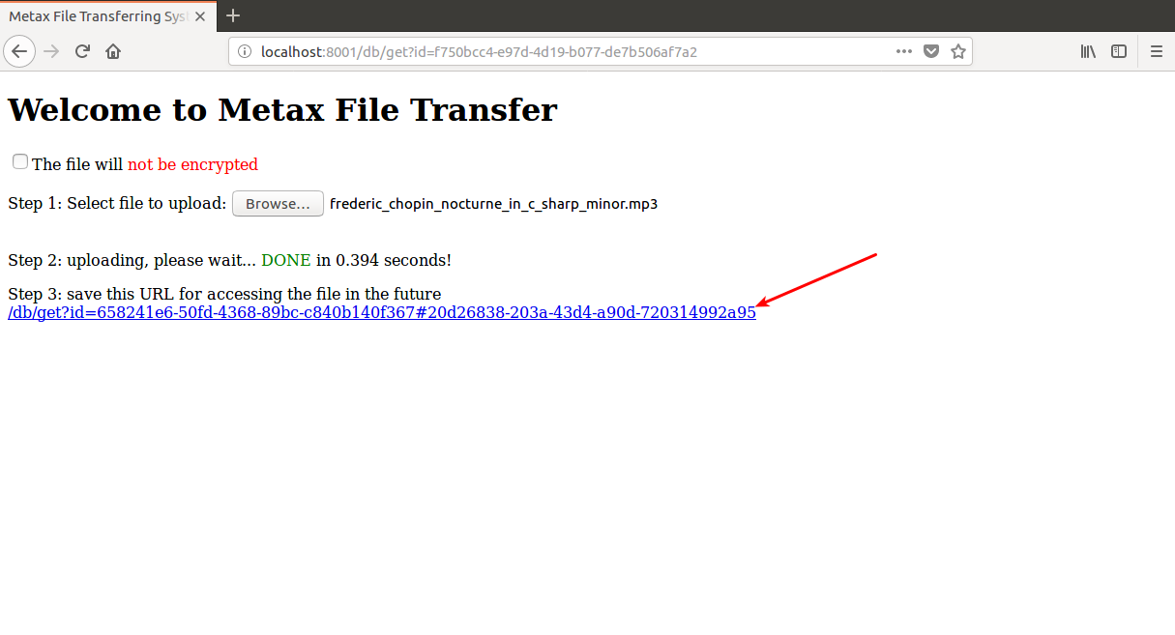
- Copy the generated URL and paste in the browser’s address bar on the 2nd virtual machine
- A page will be opened showing info about the uploaded file and also “Download” button will be available for downloading the file
- Press on “Download” button to download the file into the 2nd peers hard-drive

Testing Encrypted Data Save/Get
Below instructions demonstrate how to save encrypted data into already connected Metax peers (Metax network) with the 1st peer’s public key, and make sure that other peers are not able to see the encrypted data.
- Open browser (Firefox is available on Ubuntu VMs by default) on 1st peer and type http://localhost:8001/db/get?id=f750bcc4-e97d-4d19-b077-de7b506af7a2 in the address bar
- Make sure “encrypt” checkbox is set to save data encrypted.
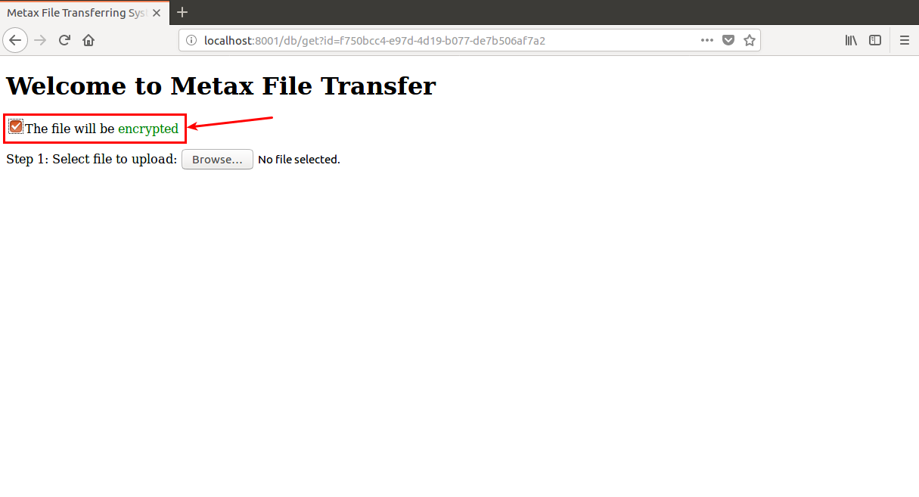
- Press “Browse...” button and choose some file to upload into Metax network
- After uploading is complete a URL will be generated though which the file can be retrieved from Metax
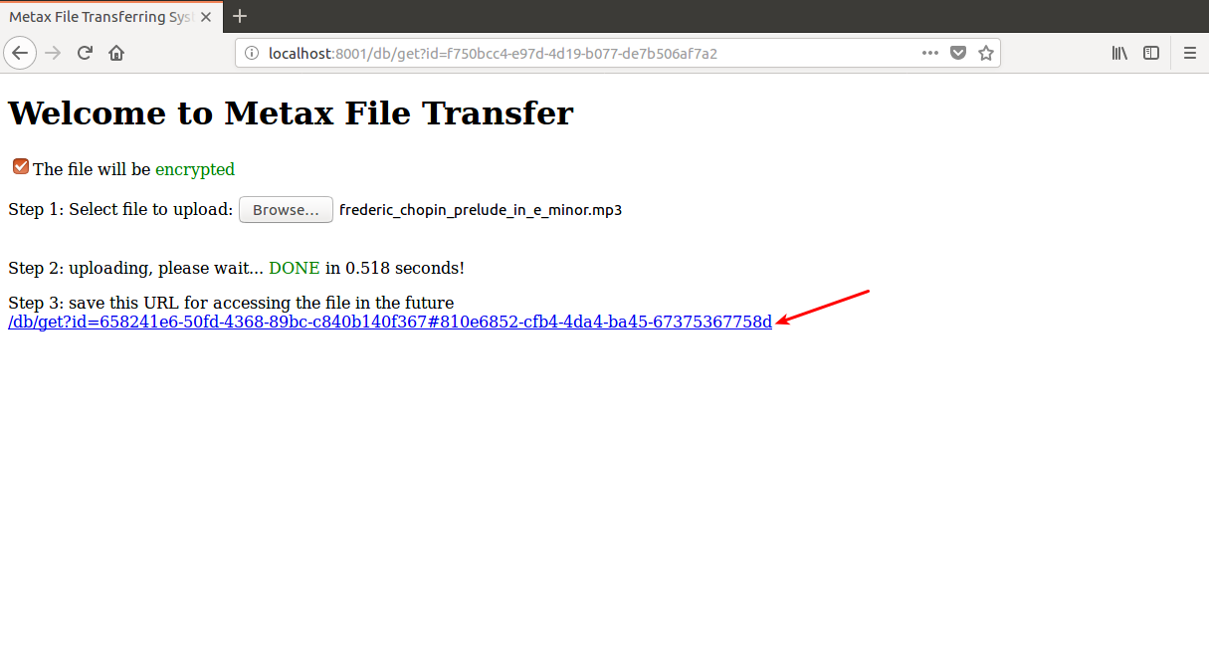
- The encrypted data can be simply downloaded by just clicking on the “Download” button available after opening generated url content in a new tab-bar of the same 1st virtual machine browser

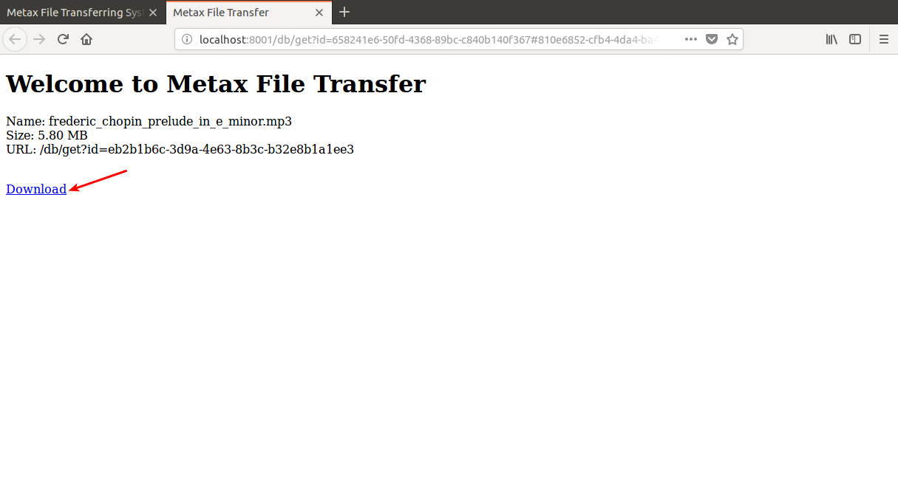
- In order to get assured that encrypted data is not visible for the 2nd peer just copy the generated URL and paste in the 2nd virtual machine’s browser address bar
- “Decryption failed” error message should be displayed, which correctly specifies that the 2nd peer is not able to decrypt data encrypted by the 1st peer’s public key

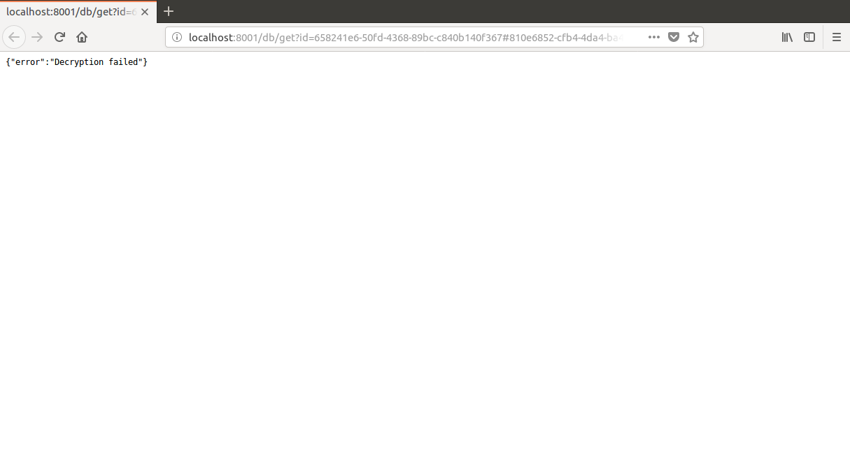

Sharing Encrypted Data
Below instructions demonstrate how to make encrypted data accessible to the 2nd peer. The data encrypted by the 1st peer, will be shared with the public key of the 2nd peer.
TODO steps will be provided later.

