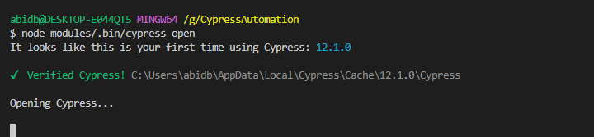  
  
npm install cypress –save –dev