|  |  |  |  |
| --- | --- | --- | --- |
| **Name: Muhammed Baki Almacı** | **ID:21627983** | **Date: 12/02/2019** | **#3** |

**HACETTEPE UNIVERSITY**

**ELECTRICAL AND ELECTRONICS ENGINEERING**

**ELE227 FUNDAMENTALS OF DIGITAL SYSTEMS LABORATORY  
FALL 2019**

**1) Circuit Diagram**

**VHDL Implementation:**

**library IEEE;**

**use IEEE.STD_LOGIC_1164.ALL;**

**entity fullSubtractor is**

**Port ( a : in STD_LOGIC;**

**b : in STD_LOGIC;**

**cIn : in STD_LOGIC;**

**borrow : out STD_LOGIC;**

**result : out STD_LOGIC);**

**end fullSubtractor;**

**architecture Behavioral of fullSubtractor is**

**signal inSign:std_logic_vector (2 downto 0);**

**signal resSign:std_logic_vector (7 downto 0);**

**component three_to_eight_decoder is**

**Port ( input : in STD_LOGIC_VECTOR (2 downto 0);**

**output : out STD_LOGIC_VECTOR (7 downto 0));**

**end component;**

**begin**

**inSign(0) <= cIn;**

**inSign(1) <= b;**

**inSign(2) <= a;**

**decoder1:three_to_eight_decoder port map(inSign,resSign);**

**result <= (resSign(1) or resSign(2) or resSign(4) or resSign(7));**

**borrow <= (resSign(1) or resSign(2) or resSign(3) or resSign(7));**

**end Behavioral;**

**RTL Schematic:**

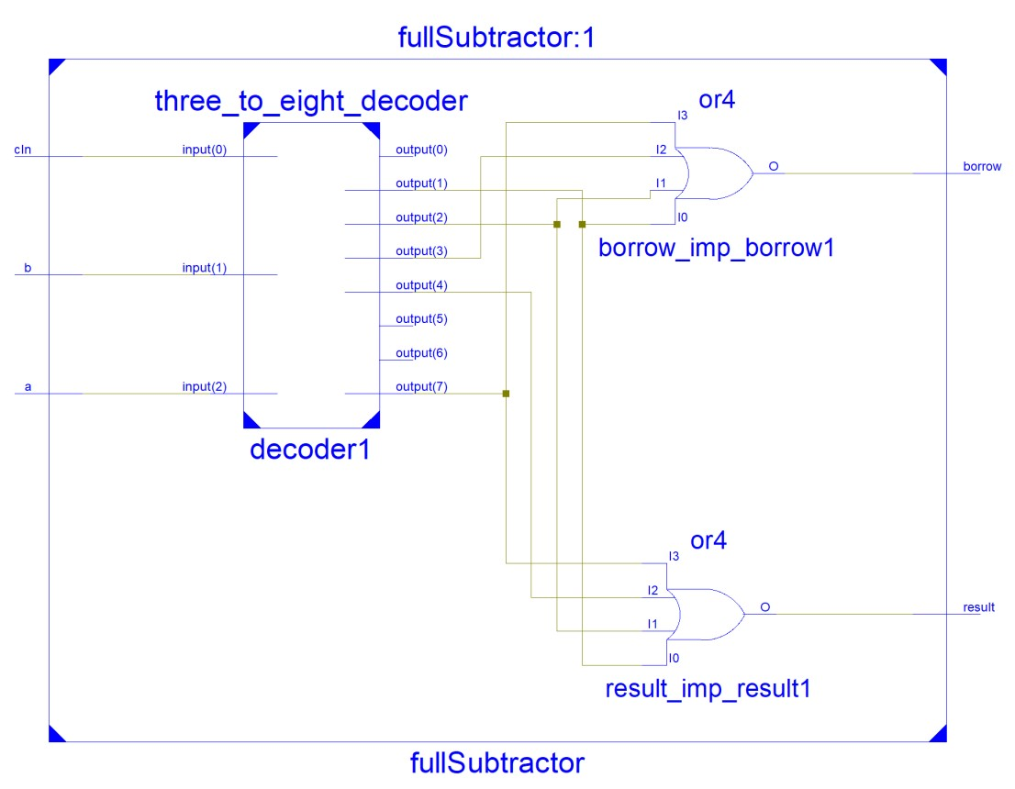

**Test Bench Input:**

**stim_proc: process**

**begin**

**a <= '0';**

**b <= '0';**

**cIn <= '0';**

**wait for 100 ns;**

**a <= '0';**

**b <= '0';**

**cIn <= '1';**

**wait for 100 ns;**

**a <= '0';**

**b <= '1';**

**cIn <= '0';**

**wait for 100 ns;**

**a <= '0';**

**b <= '1';**

**cIn <= '1';**

**wait for 100 ns;**

**a <= '1';**

**b <= '0';**

**cIn <= '0';**

**wait for 100 ns;**

**a <= '1';**

**b <= '0';**

**cIn <= '1';**

**wait for 100 ns;**

**a <= '1';**

**b <= '1';**

**cIn <= '0';**

**wait for 100 ns;**

**a <= '1';**

**b <= '1';**

**cIn <= '1';**

**wait for 100 ns;**

**wait;**

**end process;**

**Test Bench Result:**

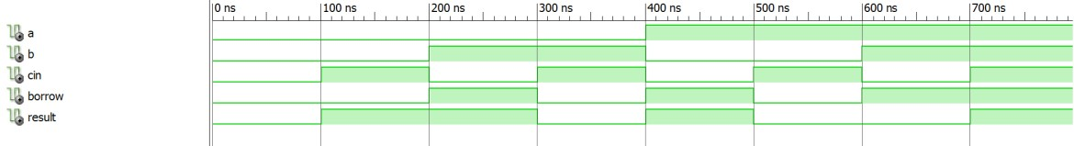

**2) Circuit Diagram**

**VHDL Implementation:**

**library IEEE;**

**use IEEE.STD_LOGIC_1164.ALL;**

**entity func is**

**Port ( x : in STD_LOGIC;**

**y : in STD_LOGIC;**

**z : in STD_LOGIC;**

**result : out STD_LOGIC);**

**end func;**

**architecture Behavioral of func is**

**component mux is**

**Port ( d3 : in STD_LOGIC;**

**d2 : in STD_LOGIC;**

**d1 : in STD_LOGIC;**

**d0 : in STD_LOGIC;**

**s1 : in STD_LOGIC;**

**s0 : in STD_LOGIC;**

**output : out STD_LOGIC);**

**end component;**

**signal xSign,ySign,zSign,rSign:std_logic;**

**begin**

**xSign <= x;**

**ySign <= y;**

**zSign <= z;**

**result <= rSign;**

**mux1:mux port map('0','1',zSign,'1',xSign,ySign,rSign);**

**end Behavioral;**

**RTL Schematic:**

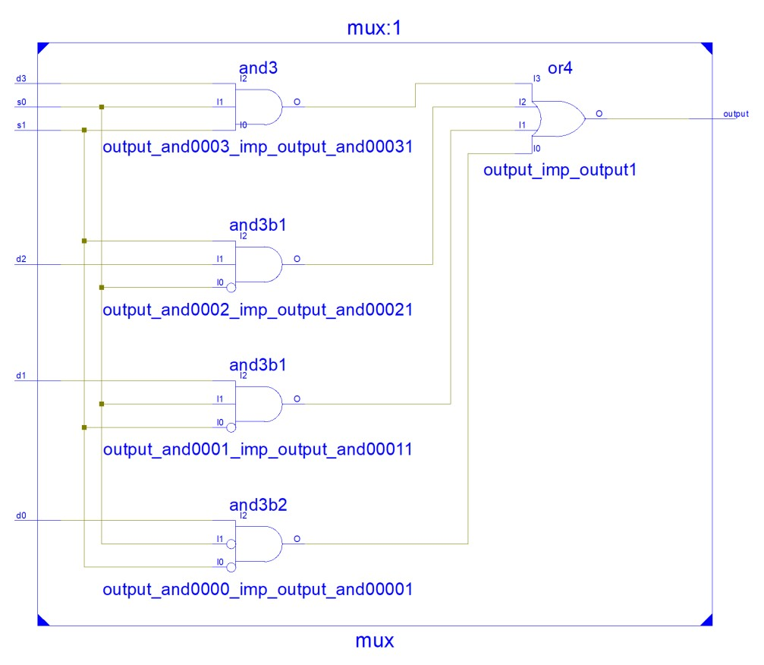

**Test Bench Input:**

**stim_proc: process**

**begin**

**x <= '0';**

**y <= '0';**

**z <= '0';**

**wait for 100 ns;**

**x <= '0';**

**y <= '0';**

**z <= '1';**

**wait for 100 ns;**

**x <= '0';**

**y <= '1';**

**z <= '0';**

**wait for 100 ns;**

**x <= '0';**

**y <= '1';**

**z <= '1';**

**wait for 100 ns;**

**x <= '1';**

**y <= '0';**

**z <= '0';**

**wait for 100 ns;**

**x <= '1';**

**y <= '0';**

**z <= '1';**

**wait for 100 ns;**

**x <= '1';**

**y <= '1';**

**z <= '0';**

**wait for 100 ns;**

**x <= '1';**

**y <= '1';**

**z <= '1';**

**wait;**

**end process;**

**Test Bench Result:**

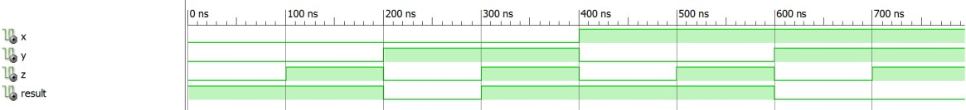

**3) Circuit Diagram**

**VHDL Implementation:**

**library IEEE;**

**use IEEE.STD_LOGIC_1164.ALL;**

**entity comparator is**

**Port ( a : in STD_LOGIC_VECTOR (1 downto 0);**

**b : in STD_LOGIC_VECTOR (1 downto 0);**

**g : out STD_LOGIC;**

**e : out STD_LOGIC;**

**l : out STD_LOGIC);**

**end comparator;**

**architecture Behavioral of comparator is**

**component decodertwo is**

**Port ( x : in STD_LOGIC_VECTOR (1 downto 0);**

**result : out STD_LOGIC_VECTOR (3 downto 0));**

**end component;**

**signal aDec,bDec : std_logic_vector(3 downto 0);**

**begin**

**decoder1 : decodertwo port map (a,aDec);**

**decoder2 : decodertwo port map (b,bDec);**

**g <= (aDec(3) and (bDec(0) or bDec(1) or bDec(2))) or (aDec(2) and (bDec(0) or bDec(1))) or (aDec(1) and bDec(0));**

**e <= (aDec(0) and bDec(0)) or (aDec(1) and bDec(1)) or (aDec(2) and bDec(2)) or (aDec(3) and bDec(3));**

**l <= (aDec(0) and (bDec(1) or bDec(2) or bDec(3))) or (aDec(1) and (bDec(2) or bDec(3))) or (aDec(2) and bDec(3));**

**end Behavioral;**

**RTL Schematic:**

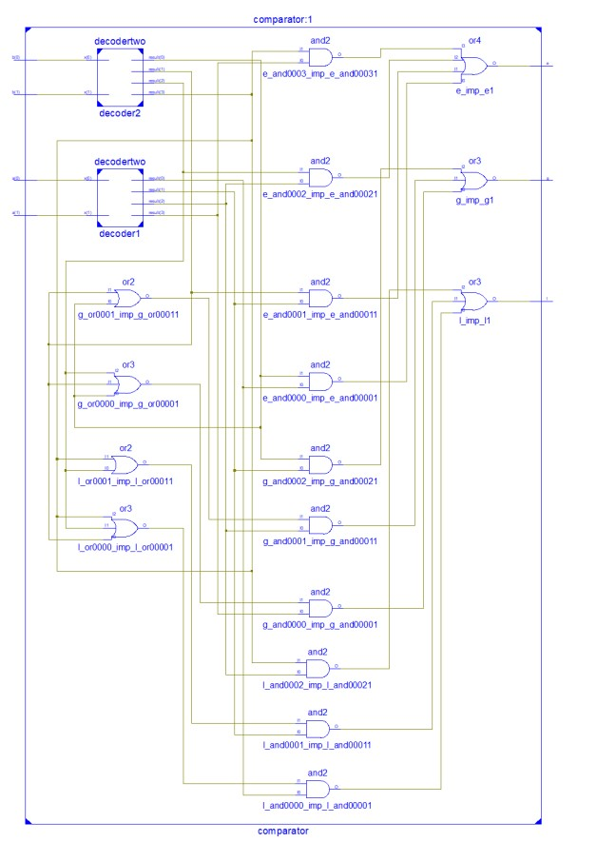

**Test Bench Input:**

**stim_proc: process**

**begin**

**a <= "00";**

**b <= "00";**

**wait for 100 ns;**

**a <= "00";**

**b <= "01";**

**wait for 100 ns;**

**a <= "00";**

**b <= "10";**

**wait for 100 ns;**

**a <= "00";**

**b <= "11";**

**wait for 100 ns;**

**a <= "01";**

**b <= "00";**

**wait for 100 ns;**

**a <= "01";**

**b <= "01";**

**wait for 100 ns;**

**a <= "01";**

**b <= "11";**

**wait for 100 ns;**

**a <= "11";**

**b <= "11";**

**wait;**

**end process;**

**Test Bench Result:**

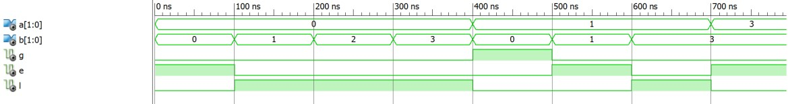

**4) Circuit Diagram**

**VHDL Implementation:**

**library IEEE;**

**use IEEE.STD_LOGIC_1164.ALL;**

**entity bin2bcd is**

**Port ( d : in STD_LOGIC_VECTOR (5 downto 0);**

**result : out STD_LOGIC_VECTOR (7 downto 0));**

**end bin2bcd;**

**architecture Behavioral of bin2bcd is**

**component shifter is**

**Port ( input : in STD_LOGIC_VECTOR (3 downto 0);**

**output : out STD_LOGIC_VECTOR (3 downto 0));**

**end component;**

**signal sgn:std_logic_vector(5 downto 0);**

**begin**

**result(0) <= d(0);**

**result(7) <= '0';**

**shifter1:shifter port map( input(3) => sgn(3), input(2) => sgn(4), input(1) => sgn(5), input(0) => d(1), output => result(4 downto 1));**

**shifter2:shifter port map( input(3) => sgn(0),**

**input(2) => sgn(1),**

**input(1) => sgn(2),**

**input(0) => d(2),**

**output(3) => result(5),**

**output(2) => sgn(3),**

**output(1) => sgn(4),**

**output(0) => sgn(5));**

**shifter3:shifter port map( input(3) => '0',**

**input(2) => d(5),**

**input(1) => d(4),**

**input(0) => d(3),**

**output(3) => result(6),**

**output(2) => sgn(0),**

**output(1) => sgn(1),**

**output(0) => sgn(2));**

**end Behavioral;**

**RTL Schematic:**

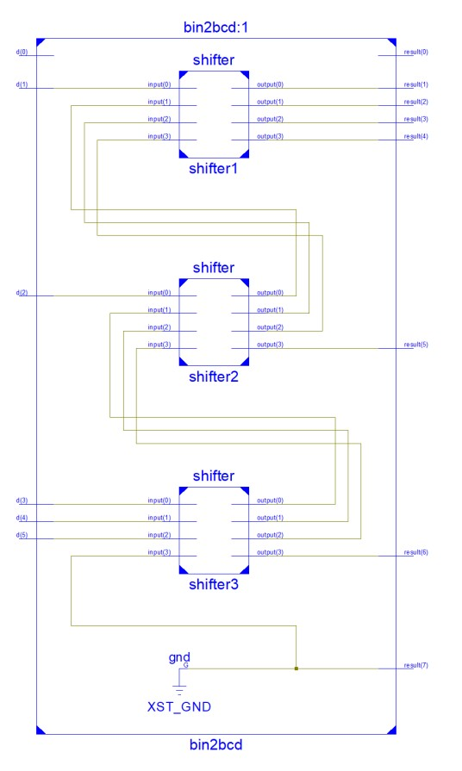

**Test Bench Input:**

**stim_proc: process**

**begin**

**d <= "000000";**

**wait for 100 ns;**

**d <= "000001";**

**wait for 100 ns;**

**d <= "000100";**

**wait for 100 ns;**

**d <= "000101";**

**wait for 100 ns;**

**d <= "001000";**

**wait for 100 ns;**

**d <= "010000";**

**wait for 100 ns;**

**d <= "100101";**

**wait for 100 ns;**

**d <= "111111";**

**wait;**

**end process;**

**Test Bench Result:**

