Spring 2016 - CPSC 1302 – Computer Science II

ASSIGNMENT 3: Interfaces + Recursion.

This assignment is due by 11:59 p.m. EST on Monday, April 18, 2016. Late submissions will be graded as described in the syllabus. Assignments submitted at or after 12:01 a.m. EST, Friday, April 22, will not be accepted. Please start working on your assignment early. Please work in individually.

- Use the following as references to complete the assignment
- Lewis' Chapter 9 (Polymorphism)
- Lewis' Chapter 17 (Recursion)
- The Interfaces example (Crypto) and In Class Lab that we did in class
- The Recursion example and In Class Lab that we did in class

Main Topics: Interfaces, Polymorphism, Dynamic Method Look up, Recursion (Base Case, Recursive Step)
Lab
Implement a Java program that solves the following problem.
“A Columbus, GA company is hiring new programmers to write recursive code that is equivalent to what the company already has. The company has supplied a BlueJ project that contains an interface called RequiredBehaviors (attached to this assignment). They only expect the applicants to create one class that has four methods and that implements the company's required interface recursively. The company will use its own tester (included in the attached BlueJ project) to test the applicant's code.”

You are applying for this position.

1) Write a YourNameRecursiveImplementation class that implements the RequiredBehaviors interface. (Place your class in the attached project. Edit your class and compile it within the attached project.)
2) Test your class. (Hint: You, or the company's hiring manager, will only have to modify the first line of the main () method in order to make sure that your methods work correctly. Interfaces make testing and integration easy! The employer will also look at your YourNameRecursiveImplementation file to make sure that your four implementations are recursive.)

Your class must satisfy the following
- (@5 points for each of the required four methods)
(2 points) The required method is recursive.
(1 point) The required method has a correct base case.
(2 points) The required method correctly implements the required behavior (passes the tester).
- We are free to add extra methods to YourNameRecursiveImplementation.java

Zybooks:
Go over the first Chapters 11 and 18.
(10 activities @ 0.5 points each)
Complete the following Participation Activities:
11.5.1; 11.5.2; 18.2.218.3.1; 18.4.2; 18.5.1; 18.5.4
Complete the following Challenge Activities:
18.2.1; 18.5.1; 18.6.1

For each of the above Zybooks activities, paste a screen snapshot, below, showing that you have completed the activity and was able to produce the desired output.

Deliverables:
- Your BlueJ folder, zipped or gzipped.

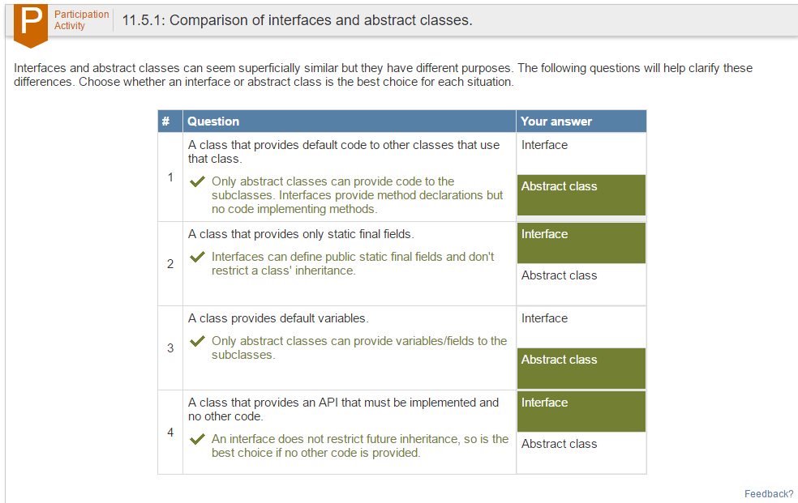

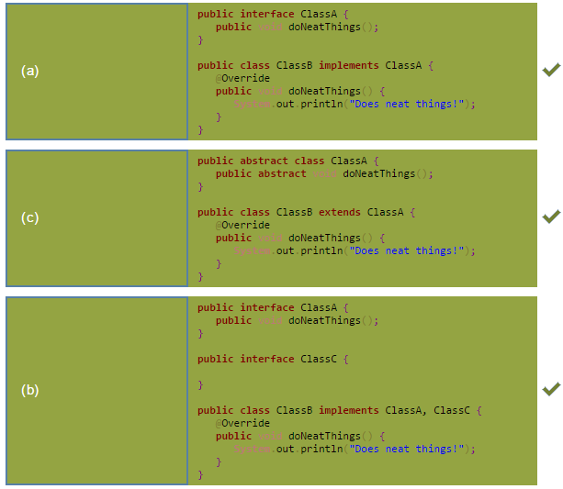
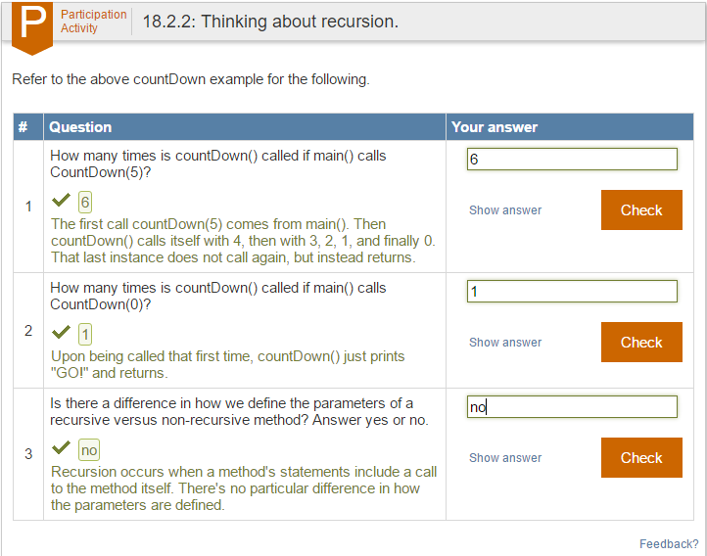

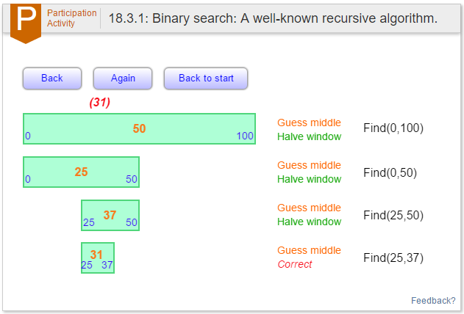
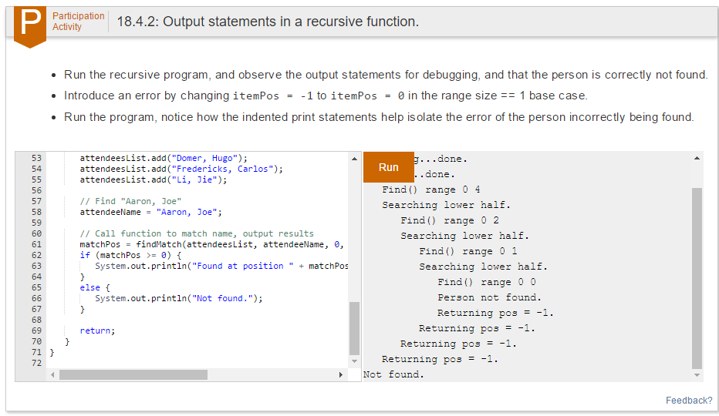
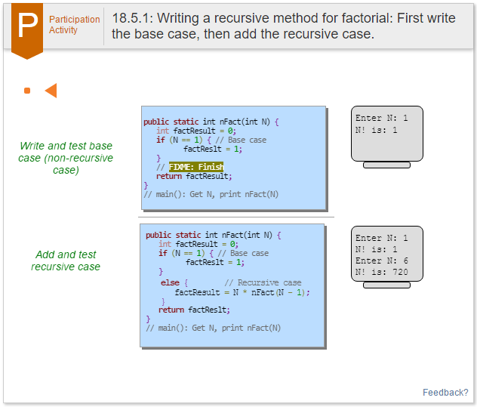

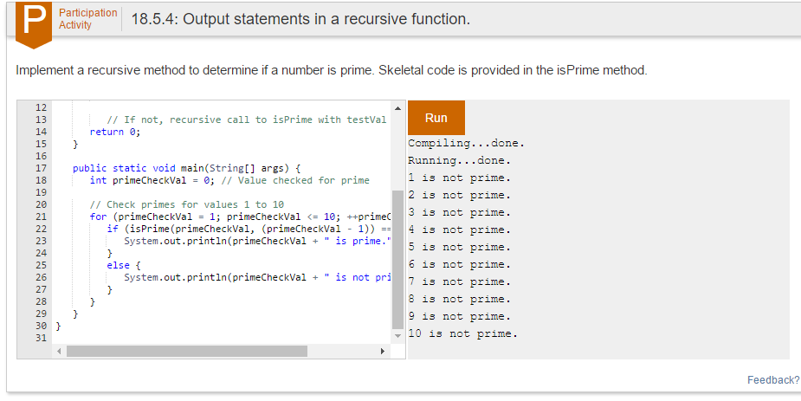
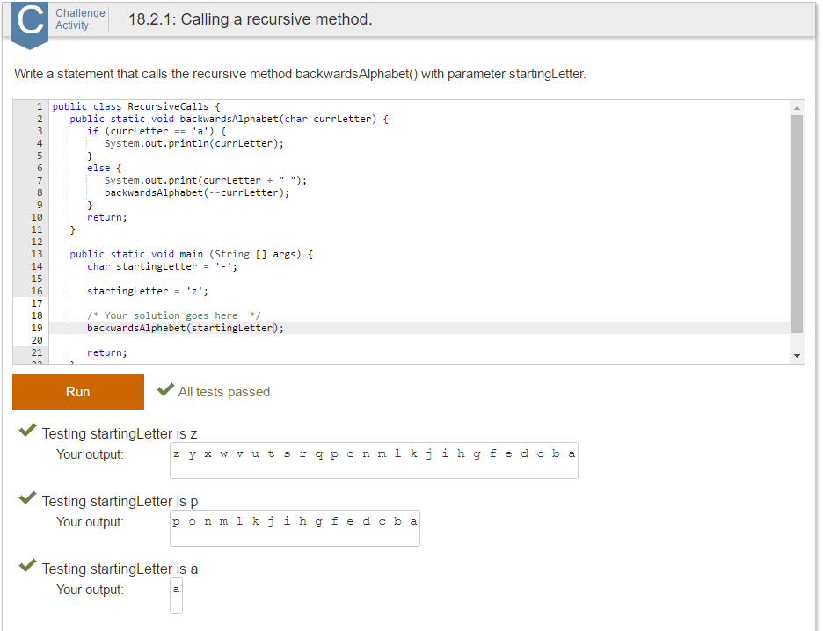
- This document with your snapshots for the Zybooks labs.

