Technological developments since the beginning of the 90s have led to significant changes in our lives. With these changes, new concepts have entered our lives. Perhaps the most important of these is e-commerce. The use of e-commerce in Turkey has started to increase in recent years. This increase has been even greater during the covid 19 pandemic process, and many people have changed their shopping preferences.

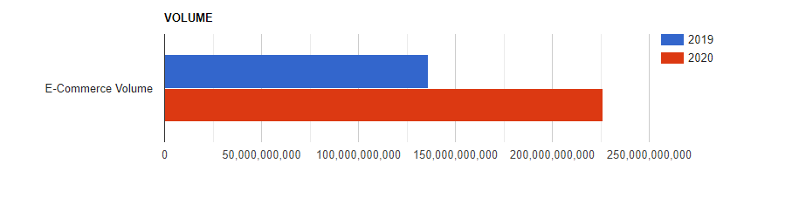

Many businesses have started to give more importance to e-commerce operations. During the pandemic period, many new businesses participated in e-commerce, and some of them later opened to the foreign market. While many sectors were negatively affected by the pandemic, the e-commerce sector was positively affected. 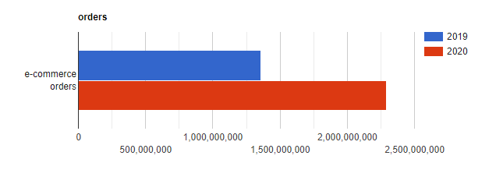

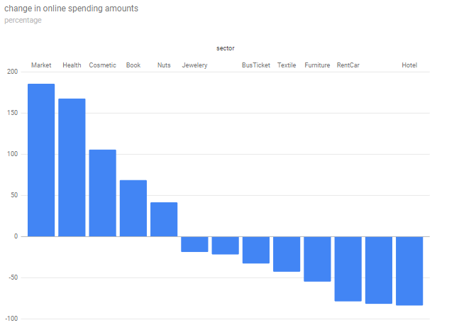

There are many conveniences that e-commerce provides to both the customer and the producer. Not having to go to the store to buy products, being able to compare prices, and saving time and energy are some of the main reasons. If we think from a manufacturer's point of view, opening a store, getting rid of employee and store expenses, and reaching too many people are some of the main reasons.

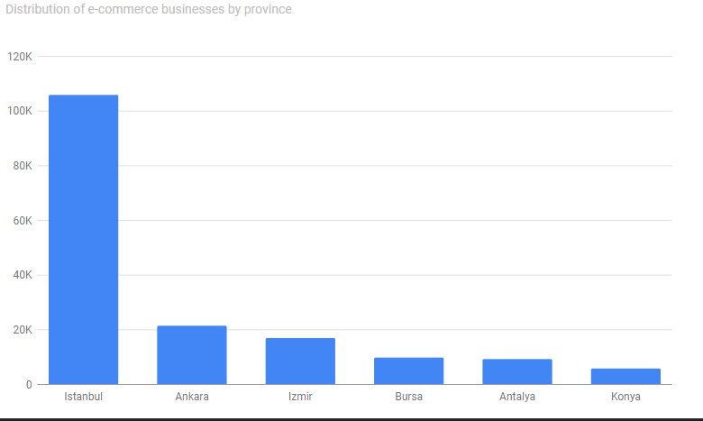

There are many conveniences that e-commerce provides to both the customer and the producer. Not having to go to the store to buy products, being able to compare prices, and saving time and energy are some of the main reasons. If we think from a manufacturer's point of view, opening a store, getting rid of employee and store expenses, and reaching too many people are some of the main reasons. Compared to e-commerce retail, the cost for companies is much cheaper than the cost of opening a physical store; it also saves on stock and store operating costs. However, since customers do not buy products by trying them, the return rate in e-commerce is higher than in traditional commerce. In addition, commission payments are made on sales made from the marketplaces. These conditions reduce the profit rate.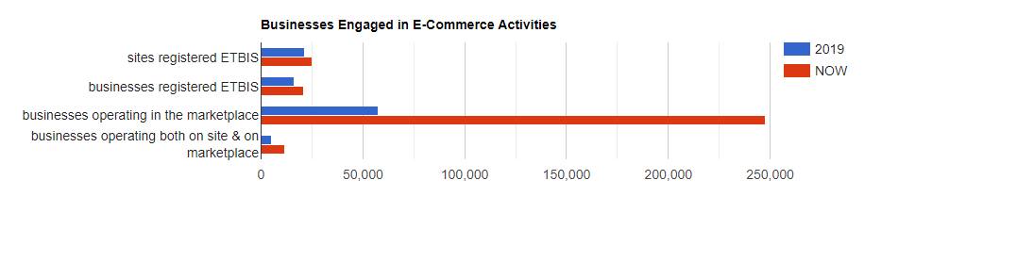

From the moment the covid 19 pandemic emerged, cases have multiplied rapidly and therefore the time people spend at home has increased. With the increase in the cases, the government took various measures and each sector was affected in different ways by these measures. Cafe, restaurant, etc. businesses only did takeaway, markets, stores, public institutions, etc. Business hours have changed. people are directed to alternatives such as online shopping, online meeting, online service. In this process, the highest increase was seen in the market, health and cosmetics sectors, while the highest decrease was seen in the tourism sectors such as hotels, airplanes and car rentals.

The pandemic period has been a difficult period for people and still continues to be. Many people have been spending more time on social media and have engaged in hobbies such as cooking, gardening and balcony design. they have carried out all their social activities online and have changed their shopping habits to a great extent. In this process, businesses that follow consumer behaviors and analyze them well have been much more successful. The pandemic process has shown us that people are fast and practical, as well as that e-commerce develops very quickly due to reasons such as social distance and makes a very serious contribution to the country's economy. Also ,considering that the youth unemployment is high in Turkey and the digital and entrepreneurial abilities of the young people are higher than the middle and older age groups, it can be expected that the developments in e-commerce and e-export will increase employment and income in the coming years.

**REFERENCES**

[**https://webrazzi.com/2020/04/07/covid-19-la-birlikte-turkiye-de-online-harcama-tutarinda-nasil-bir-degisim-yasandi/**](https://webrazzi.com/2020/04/07/covid-19-la-birlikte-turkiye-de-online-harcama-tutarinda-nasil-bir-degisim-yasandi/)

[**https://www.eticaret.gov.tr/istatistikler**](https://www.eticaret.gov.tr/istatistikler)

[**https://dergipark.org.tr/tr/download/article-file/1227430**](https://dergipark.org.tr/tr/download/article-file/1227430)

[**https://dergipark.org.tr/en/pub/adyusbd/issue/61867/790752**](https://dergipark.org.tr/en/pub/adyusbd/issue/61867/790752)**,**

[**https://www.aa.com.tr/tr/analiz/e-ticaret-pandemi-doneminde-buyuk-bir-ivme-kazandi/2094385**](https://www.aa.com.tr/tr/analiz/e-ticaret-pandemi-doneminde-buyuk-bir-ivme-kazandi/2094385)