A Visual Language for SmartThings

Author information should be omitted for double-blind review

Abstract—In this paper, we designed a visual programming language for IoT, especially for SmartThings, so that users can write their own SmartApp in this language easily, even though they are not expert programmers. We design a visual programming language for SmartThings based on IoTa calculus, which is a core calculus for Internet of Things Automation that generalizes existing Event-Condition-Action(ECA) rule systems for home automation. We implement the visual programming language with Blockly, one of a growing number of visual programming environment for creating visual block programming languages.
Keywords—Visual Programming; ECA rule; Blockly; SmartThings; SmartApp

Introduction
Interest in the Internet of Things (IoT) application development is continuously growing along with the development of Smart Homes, devices, and other automations. The IoT enables end users to not only remotely control their homes from their smartphones but also to automate certain everyday tasks [1].
SmartThings is one of the most widely-used open developer platforms for IoT with a high number of applications among currently available platforms. It also supports a wide range of Smart Devices which work through a central hub. A mobile application called SmartApp, which is a small Groovy-based program, allows users to automate their homes using the capabilities of the devices [4].
A visual programming language can let users make programs easily by manipulating program elements graphically rather than by specifying them textually [2]. So end users who are not expert programmers could program more easily. This idea can also be applied to programming IoT applications.
In this paper, we designed a visual programming language for IoT, especially for SmartThings, so that users can write their own SmartApps in this language easily, even though they are not expert programmers.
We design a visual programming language for SmartThings based on IOTA calculus, which is a core calculus for Internet of Things Automation that generalizes existing Event-Condition-Action(ECA) rule systems for home automation [1]. ECA rules can specify which actions are triggered by events, given the existence of specific conditions. It is also shown that most home automation applications in general purpose languages from app stores are expressible in ECA rule system [1].
By dragging and dropping visual blocks in this visual language, users can make a SmarApp easily, and users can generate executable Groovy code of the SmartApp. A visual SmartApp program in this language consists of two parts, ECA rules and preferences. ECA rules specify the actual task of SmartApp, and preferences specify the construction of the installed page in SmartApp, which configures SmartApp to utilize Smart Devices and its capabilities.
We implement the visual programming language with Blockly, one of a growing number of visual programming environments which can be used for creating visual block programming languages and environment. With Blockly Developer tool, we design custom blocks for the visual language and implement code generator, which translates custom blocks into Groovy text code.
We present the visual programming language for IoT, specially for SmartThings, which to the best of our knowledge, is the first visual language for the domain of home automation. We compare the visual language with other visual languages.

Background

SmartThings
SmartThings is one of the most widely-used open developer platforms for Internet of Things with high number of applications. It supports a wide range of Smart Devices which work through a central hub as shown in figure 1. A mobile application for SmartThings is called SmartApp. It is a small Groovy-based program that allows users to automate their homes using the capabilities of the devices. A typical SmartApp is composed of four sections: ‘Definition’, ‘Preferences’, ‘Predefined Callbacks’ and ‘Event Handlers’. Smart Devices include lights, cameras, locks, thermostats, and sensors. Along with these, there is SmartThings Developer Workspace, which provides SmartThings developers with a set of tools to manage their SmartThings account, and build and publish custom SmartApps [4].
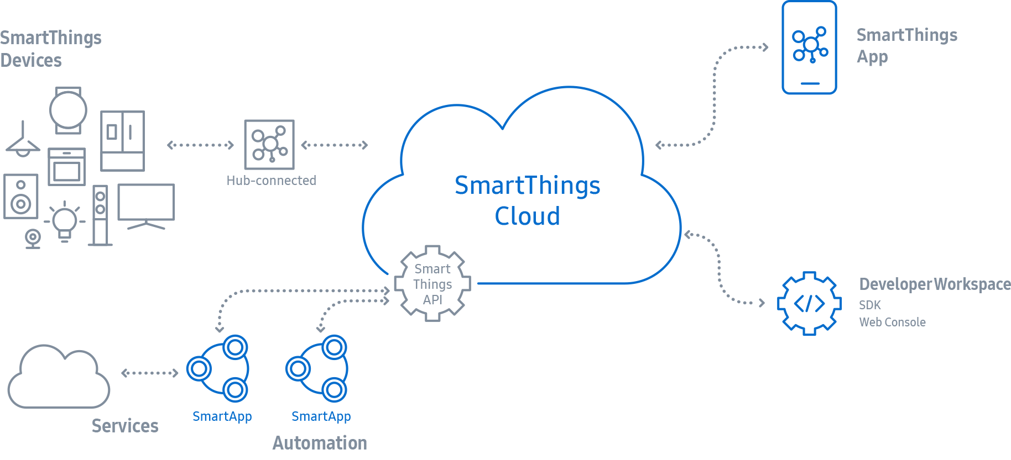
- Structure of SmartThings

IOTA Calculus and ECA rule
IOTA calculus is a core calculus for Internet of Things Automation that generalizes Event-Condition-Action(ECA) rule systems for home automation [1]. Simple ECA rule systems have emerged as a popular, practical means for non-technical users to configure and control home automation systems. Such rule-based systems are easier to learn than general purpose programming.
ECA rules can be used to describe which actions to perform in response to events, provided that stated conditions hold. Such a rule traditionally consists of three parts:
- The event part specifies the signal that triggers the invocation of the rule.
- The condition part is a logical test that, if satisfied, causes the action to be carried out.
- The action part consists of updates or invocations on the local data [5].
For example,
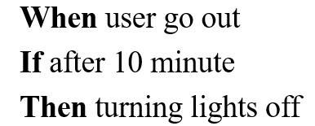
- Example of ECA rule
Although general purpose programming platforms clearly provide the more expressive power, it is shown that most home automation applications in general purpose languages from app stores are expressible in ECA rule system [1].

Blockly
Blockly is a visual programming environment by Google, which is a JavaScript library for creating visual block programming languages and environment. Blockly Developer Tool is a web-based developer tool that automates parts of the Blockly configuration process, including creating custom blocks, building toolbox, and configuring web Blockly workspace [6].
The developer can define interlocking, graphical blocks to represent code concepts like variables, logical expressions, loops, and more, and can also create the code generator to export the new block to a programming language such as JavaScript, Python, PHP, Lua, or Dart on Blockly Developer Tool [6].
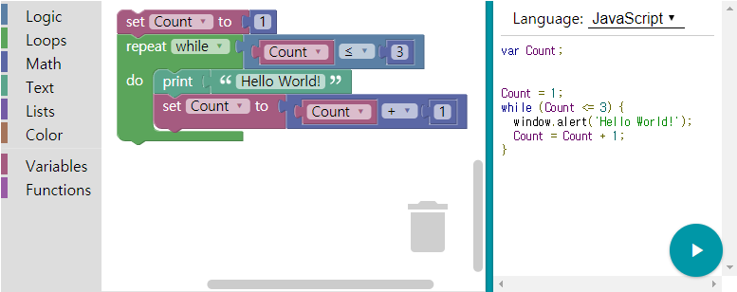
- Google Blockly

visual block Language
We designed the visual block language. By dragging and dropping block language, users write SmartApp. On fig 4, there is the completed ECA rule which could create SmartApp. SmartApp is generated by the blocks, which is built according to ECA rule. These blocks are ECA bock, EA block, Event block, Condition block and Action block.
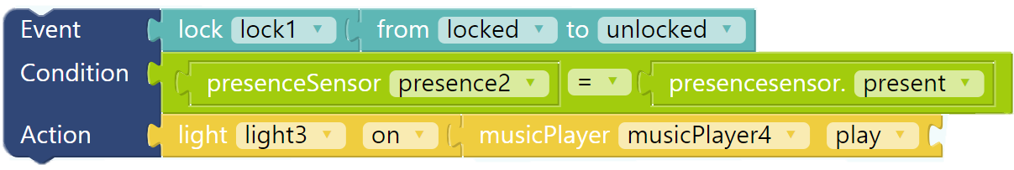
- Completed ECA block representing ECA rule
In fig 5, there is ECA block which stands for ECA rule. It could connect with Event Block, Condition Block and Action Block. Also, ECA block can be connected to ECA Block and EA Block up and down.
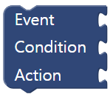
- ECA Block
Event block indicate the event on SmartDevice. Moreover, by using Event Handler block, we are able to scribe a change of state on SmartDevice. Event block in fig 6 stand for lock device. This block means the signal of Event is a being locked of SmartDevice named lock1.
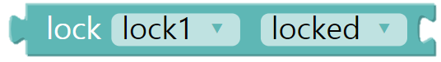
- Event Block
Condition block represent a Boolean algebra over a state on SmartDevice. An attribute of SmartDevice is compared with the value of some attribute on some SmartDevice and constants. There are few SmartDevice having more than two attribute. We omit the name of an attribute if SmartDevice have only one attribute. Condition blocks in fig 7 try to compare the value of attribute on present Sensor named presence2 with present, which is the value of attribute on present Sensor.
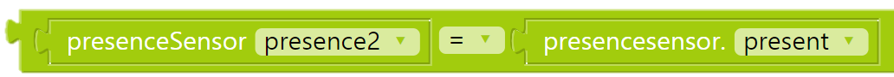
- Condition Blocks
Action block represents the task that SmartDevice is going to perform. To perform the tasks listed by Action block, each block has to be linked in a line. To serve as much as the number of task, users should link Action blocks to the next side. Action block in fig 8 represents light device. This block means SmartDevice named light 3 will turn on.
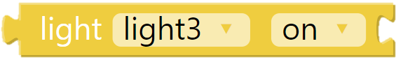
- Action Block

visual programing environment
We designed and implemented visual programming environment called Smart Block for SmartThings. By dragging and dropping blocks, users write SmartApp on Smart Block. It is divided into two parts: Rule and Preferences tool. An automatic service of SmartApp will be described on Rule tool by using ECA block, EA block, Event block, Condition blocks and Action blocks. On Preferences tool, the installation page will be constructed by using Page blocks, Section blocks, Input blocks and Option block.
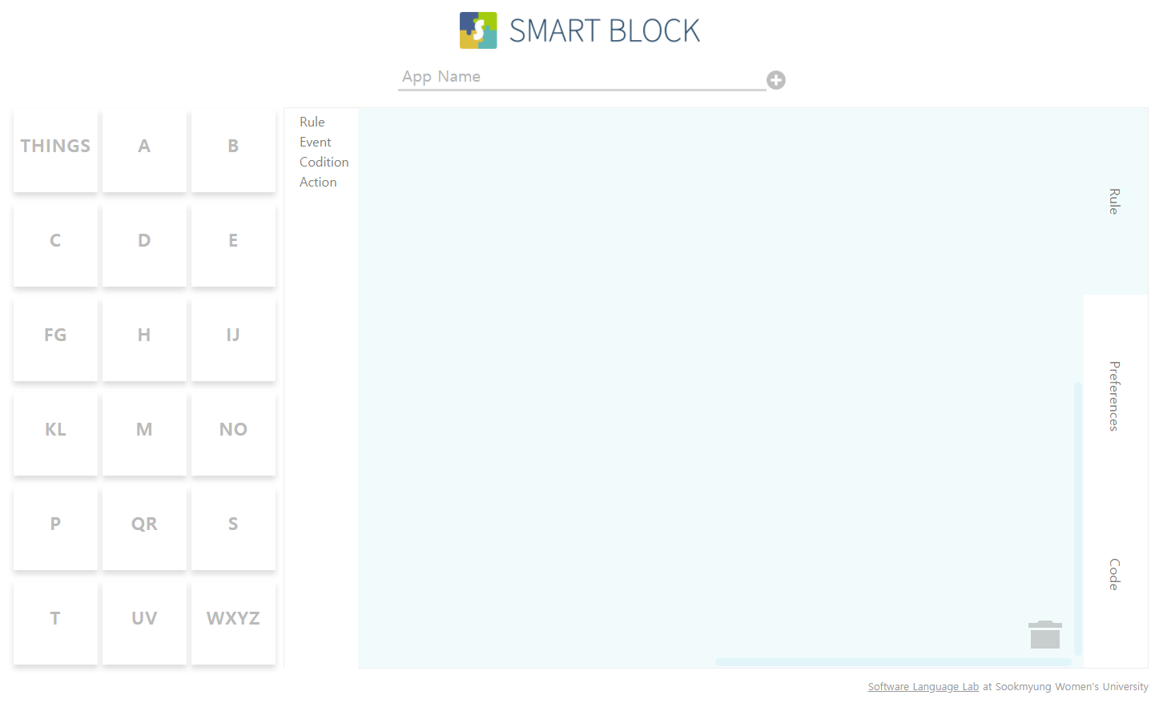
- Smart Block for SmartThings

Rule tool
On Rule tool, users determine the actual tasks of SmartApp by dragging and dropping ECA block, EA block, Event blocks, Condition blocks and Action blocks. Therefore, Rule tool has to help users to express what they want to be served easily. On toolbox, ECA block, EA block, Event blocks, Condition blocks and Action blocks are provided. The completed ECA block and EA block define and generate ECA rule. The difference between ECA block and EA block is whether it connects Condition Block or not. EA block always generates the condition of the rule as true by default.
To create SmartApp, we should construct more than one completed ECA block or EA block like fig 4 on workspace. To complete ECA block and EA block, users have to connect one Event block and one or more Action block with ECA block or EA block.

Preferences tool
On Preferences tool, users build Page blocks for the installation page. During the installation of SmartApp, users is prompted to provide what kinds of Smart Devices and other information is needed in order for the application to run in the installation page [4]. The installation page is described by Preferences section of SmartApp script. Therefore, on Preferences tool, users write Preferences method in Preferences section.
Preferences method is made up of one or more Page methods. Page method is composed of one or more Section methods. Section method consists of one or more Input methods.
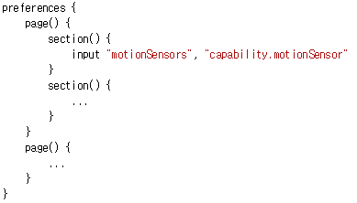
- Preferences section
On Preferences tool, by dragging and dropping Page blocks, Section blocks, Input blocks and Option blocks, users can generate the code about Preferences method. These blocks placed on toolbox of Preferences tool. The set of Page blocks, which are connected up and down, generate Preferences method. Page block stand for Page method. Section block stand for Section method. Therefore, each block generates each method. Input blocks represents Smart Device, which used on Rule tool. So, Input blocks are created automatically on toolbox based on previous ECA rules of Rule tool. Option block represents the configuration option of Page method, Section method and Input method. Furthermore, there are 3 sample pack of blocks which will generate Preferences method. We offer these to help and diminish the user’s hardship.
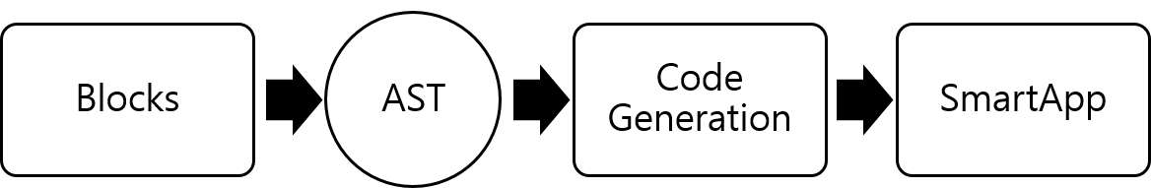
- Compiling process of SmartApp
After building blocks on Rule tool and Preference tool, the tree generator parse the completed blocks and return the AST of the completed blocks. Then the actual SmartApp code is generated through the AST of the blocks. It is not efficient to generate actual code directly by parsing the completed blocks like other Blockly application such as JavaScript because each block influences more than one section of SmartApp script. It is better to generate SmartApp text code by parsing the AST.
To generate SmartApp text code by parsing the AST of blocks, we implemented new Code generator. Code generator creates Preferences section of SmartApp according to Smart Devices, which composed of ECA node Also it generates Subscribe method taking the name and the signal of Event block as parameters. Subscribe is the most important method on Predefined Callbacks section. In addition, by referencing Condition nodes and Action nodes of the AST, Code generator produces Event Handlers section of SmartApp.

Implementation
Blockly comes with a large number of predefined blocks. Everything from mathematical functions to looping structures [6]. However, in order to adjust to writing SmartApp, we have created many new custom blocks. Typically, we designed ECA block, EA block, Event block, Condition block and Action block. Using Blockly Developer Tools is the easiest way to design custom block and get a generator stub. Also Blockly Developer Tools makes it easy to configure a workspace consisted of a toolbox placing blocks. The toolbox is the side menu from whence we created new blocks [6]. By referencing the xml code of toolbox and workspace provided with Blockly Developer Tools, we implemented Smart Block for SmartThings to create Smart App by dragging and dropping block on toolbox in workspace.
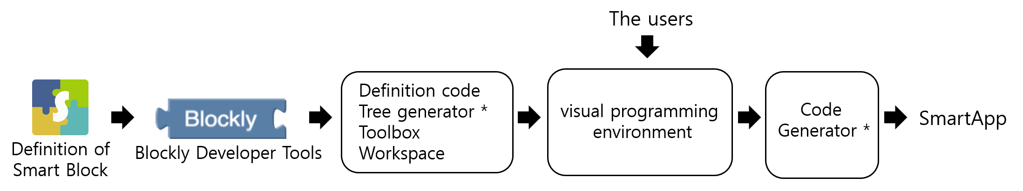
- Imprementing process of Smart Block
First, we create new custom blocks specifying its shape, fields, and connection points. On Blockly Developer Tools, we can describe how a block looks and behaves, including the text, the color, the shape, and what other blocks it can connect to [6]. To implement a custom block, we drag and drop input blocks, field blocks and type blocks on workspace of Blockly Developer Tools. Then we could construct the internal organization of the custom block and obtain a definition code of the custom block from Blockly Developer Tools.
In fig 13, there is the internal design of ECA block. To connect Event Block, Condition Block and Action Block as a value input Block to ECA block, it has three value input blocks and set their name and type as Event, Condition, and Action. To link ECA Block with ECA Block and EA Block up and down, the top and bottom type of ECA block should be ECA and EA.
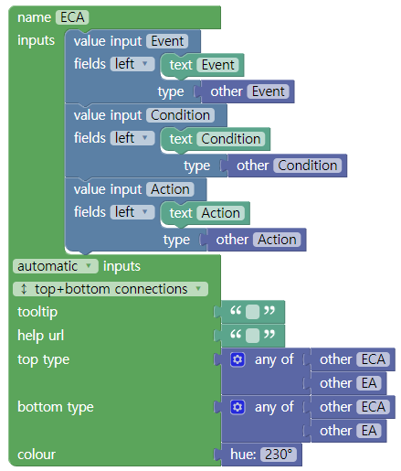
- Internal organization of ECA custom block
In fig 14, there is the definition code of ECA block. In the definition code, we can see that ECA block appending Event block, Condition block and Action block as value input. In addition, we set up to check that whether the type of value input block is correct or not. To link ECA Block with ECA Block and EA Block up and down, call setPreviousStatement method and setNextSatatement method having ECA and EA as parameter.
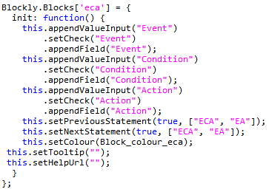
- Defintion code of ECA custom block
After writing a definition code, we create a new generator for SmartApp. We implemented the tree generator which parses the completed Blocks and return the AST of Blocks. To return the AST of Blocks representing SmartApp, we have changed the workspace generator to handle not only String but also Object. The workspace generator is the default generator that Google Blockly offer, which is the core generator of Blockly. In addition, we create new generator of custom block. Blockly Developer Tools provide a generator stub for each custom block. By referencing a generator stub, we developed the specific generators of each custom block to return Object and String value.
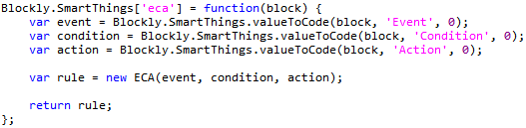
- Generator of ECA block
In fig 15, a generator of ECA block creates an ECA object, which denote the AST of ECA block by utilizing Event object, Condition object and Action object as node. Each Object is made by each generator of Block.
The workspace generator calls a generator of ECA block. An ECA generator calls a generator for Event, Condition, and Action block. It also composes ECA object representing one ECA rule by utilizing Event object, Condition object, and Action object. Each generator organizes each Object as an Event generator creates Event object. Finally, the workspace generator returns the AST of SmartApp like fig 16.
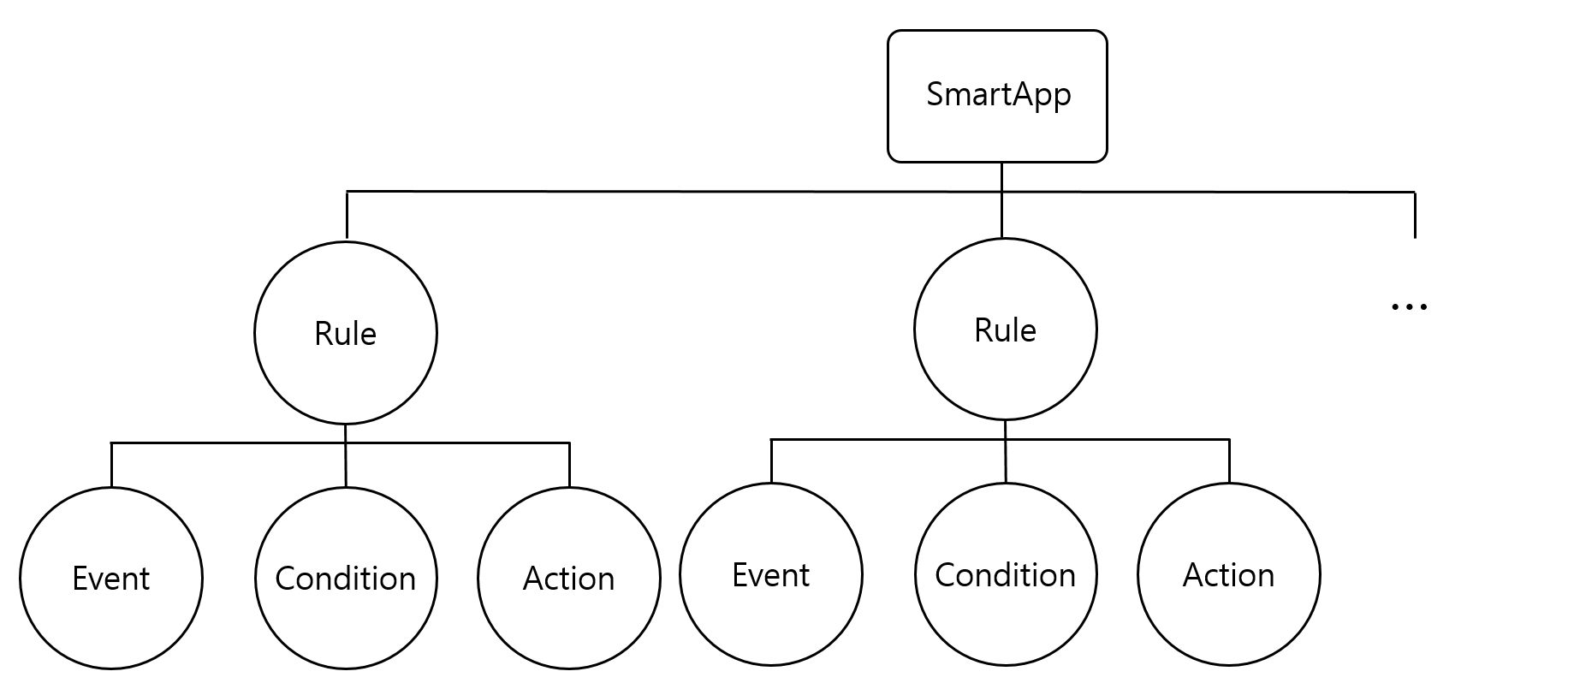
- AST of SmartApp
After creating custom blocks and generators, finally, we implemented a visual programming environment called Smart Block for SmartThings. It consists of two tool and one section, which is displaying and saving the Smart App code. On Smart Block, one tool is Rule tool to build ECA blocks for ECA rules. Another is Preferences tool to build Page blocks configuring the installation of SmartApp. Every tool have a toolbox keeping blocks and workspace, which is the interspace where can build the completed blocks. On Blockly Developer Tools, we construct a toolbox and automatically generate its toolbox XML using a visual interface. The structure of the toolbox is specified with XML, which may be either a tree of nodes, or a string representation. This XML is passed when it is injected into the page [6]. Also with Blockly Developer Tools, we can configure the workspace and make the workspace to be suitable. Thus, users can find the blocks on a toolbox and build blocks at workspace.

Example
We have implemented a visual programming environment called Smart Block for SmartThings [9]. Smart Block helps user to write their own SmartApp according to user’s habit. Therefore, they can build their own Smart home proving the customized task.
First, to write a SmartApp on Smart Block, users have to select what capabilities of Smart Devices to use. To use Smart Devices, users should press the button, which represent the capabilities. We classify a capability button in the alphabetical order because the kinds of capability is more than a hundred. Classifying a capability button is effective and convenient. In addition, some of capabilities, which probably be used often, allocate to ‘Things’ category.
After selecting capabilities, users can see Event Block, Condition block and Action block, which means the specific Smart Device. Users click, drag and drop Event Block, Condition block and Action block to build the completed ECA block representing one ECA rule.
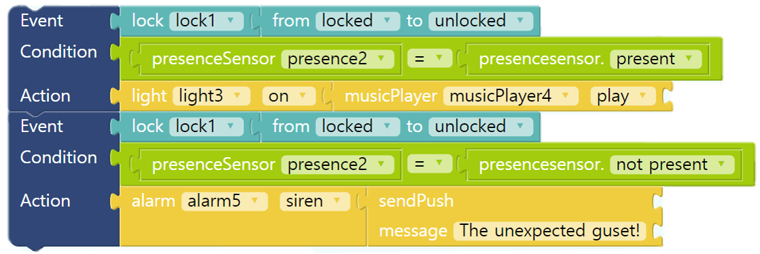
- example of ECA rules on SmartApp
There is an example of completed ECA blocks representing two ECA rules above fig 17. We wrote a SmartApp to welcome users when they come back and secure them against the robbery when they go out. When the door is unlocked, if users come back to home, the light will turn on and music start to play. That rule write as ECA block located in the top in fig 17. When the door is unlocked, if users are not at home, we assume that there are someone we did not expected. Thus, SmartApp send the push message to alert that robber is at home and rings siren. That rule write as ECA block located in bottom in fig 17.
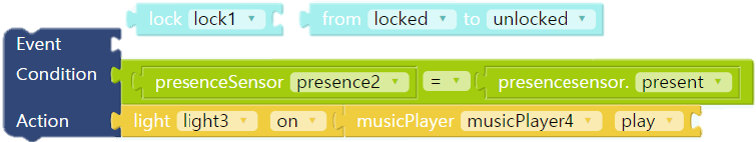
- erroneous ECA block
To make sure that block is connected, we implemented a color of block become blurry like fig 18 if the block is not connected with other block. Therefore, users easily notice which a block is unconnected.
After building ECA blocks, users construct the installed page in SmartApp by utilizing blocks on Preference tool. On preference tool, there are Page block, Section block, Input blocks and Option blocks. By clicking, dragging and dropping these blocks, we write the code about Preference method constructing the installed page.
Preference method generate the set of Page blocks, which is connected up and down. Each Page block has to bring one or more Section block inside like Page method is made up of one or more Section method. Section block has to link Input blocks inside. Input block represents Event block, Condition, Action block that we used to create ECA rules. We can distinguish these three blocks by names and colors. There are three different kind of color to fill Input block: blue, green and yellow. Input block colored by blue represent Smart Device handling the event of ECA rules. Input block colored by green signify Smart Devices using to calculate the result of Boolean logic. Input block colored by yellow represent Smart Devices performing the tasks. Option block should connect to Page block, Section block and Input block. For example, multiple block, which is kind of Option blocks connects to Input block, it means that this Input block representing Smart Device allows selection of multiple devices of the input type if users have more than one.
In fig 19, by using Page block, Section block, Input blocks and Option blocks, we build the completed Page blocks to generate code about Preferences method. As Section method is called inside of Page method, Section block is assigned as statement value of Page block. As Input method is called inside of Section method, Input block is assigned as statement value of Section block. Option block is connected to Page block or Section block or Input block to set a parameter of each method. In fig 20, there is the installed page build by blocks of fig19.
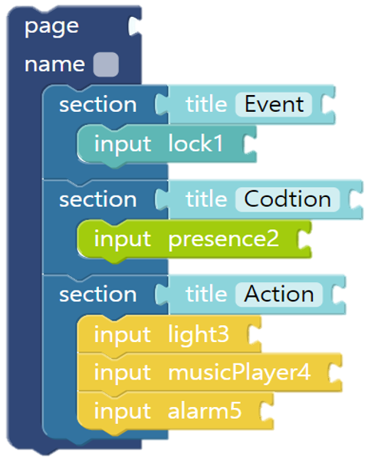
- example of page block for SmartApp
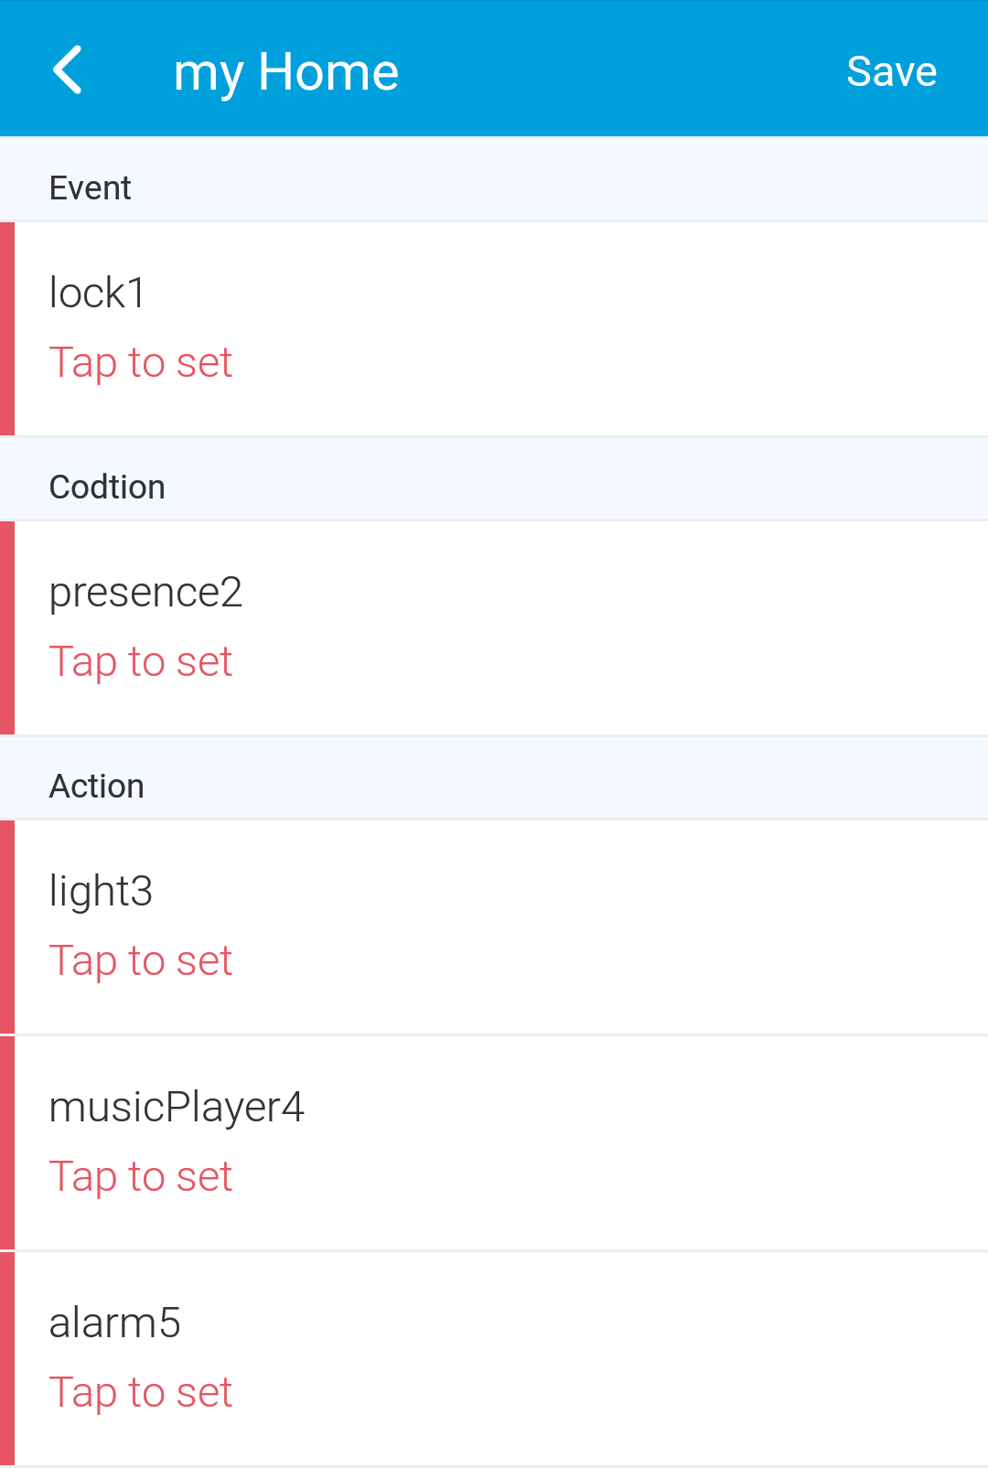
- the installed page
In addition, users have a choice whether to build Page blocks or not. If they do not build blocks on Preference tool, it will automatically generate the code about Preference method constructing the installed page.
After building blocks on Rule tool and Preference tool, users need to specify the name and configuration of SmartApp to write definition section of SmartApp. Only the name of application has to be specify. The others could be set by default.
Finally, users can obtain the code about SmartApp like fig. 21. It is generated by completed ECA blocks and Page blocks of examples of fig17, fig19. There are five Input methods for Smart Devices representing Event block, Condition block, Action block. In addition, we could see Subscribe method having Event block and the handler method as parameter. The handler method checks that a previous state of Smart Device represented by Event handler block. Then it calculates the result of Boolean logic over Condition block. If the result is true, the tasks for Action block will perform. The rule1 handler method is wrote by ECA rule of fig 17 in the top. The rule2 handler method is wrote by ECA rule in the bottom.
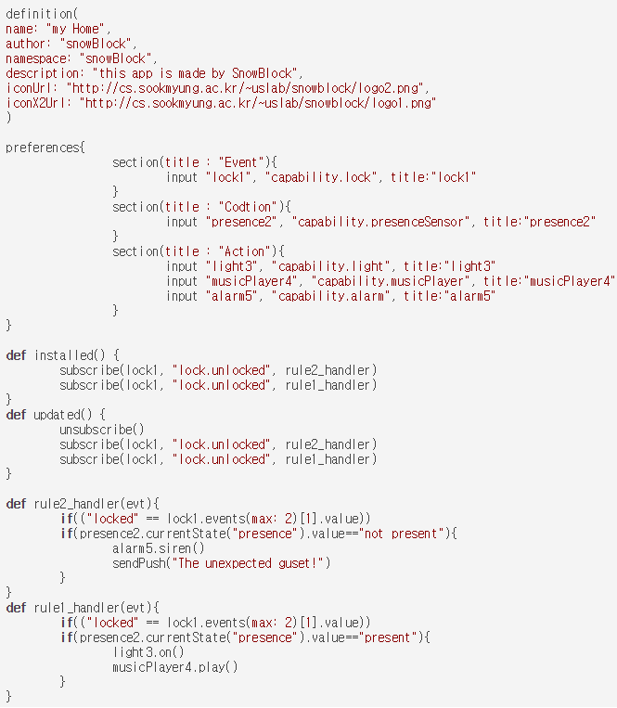
- generated Smart App Code

Related work

Node-RED
Node-RED is a visual flow-based programming environment for wiring together hardware devices, APIs and online services as part of the Internet of Things. Node-RED is built on Node.js, taking full advantage of its event-driven, non-blocking model.
Node-RED provides a browser-based flow editor that makes it easy to wire together flows using the wide range of nodes in the palette. Hardware devices such as Raspberry Pi, and Arduino can be nodes. Programs in Node-RED are built up from premade blocks of code called Nodes. Users drag Nodes onto a workspace or write their own code in JavaScript in a text editor, then wire them together to define the logical relationships of programs [10].

Scratch for Arduino(S4A)
Scratch for Arduino is a Scratch modification that allows for simple programming of the Arduino open source hardware platform. It provides new blocks for managing sensors and actuators connected to Arduino [11]. Users drag and drop blocks onto a workspace, then Scratch for Arduino will generate the Arduino code.

BlocklyDuino
BlocklyDuino is a web-based visual programming editor for Arduino. BlocklyDuino is based on Blockly, the web-based, graphical programming editor. It provides static type language blocks and code generators for Arduino programming [12].
Most visual languages are for programming IoT devices such as Arduino and Raspberry Pi. The proposed visual language is for SmartThngs, which to the best of our knowledge, is the first visual language for the domain of home automation. It is designed based on high-level concept of ECA rules, so that users can make SmartApps, even though they don’t know programming details of SmartApp.

conclusion
We implemented a visual programming environment called Smart Block for SmartThings. Smart Block help users to write SmartApp by dragging and dropping many blocks. Thus, users who are not even expert programmer can build their own Smart Home easily depending on their habits and service they want.
However, we could not implement some features such as a timer and a grouping device, unfortunately. We are going to design and implement new blocks to get close to the perfection of SmartApp. Therefore, users can be provided with SmartApp with more various service. Moreover, we are planning to extend Smart Block to not only for supporting SmartThings but also for other IoT platform.

References
- Julie L. Newcomb, Satish Chandra, Jean-Baptiste Jeannin, Cole Schlesinger, Manu Sridharan, F.: IoTa: A Calculus for Internet of Things Automation
- Beate Jost, Markus Ketterl, Reinhard Budde, Thorsten Leimbach, Graphical Programming Environments for Educational Robots:Open
- Roberta - Yet another One?, IEEE International Symposium on Multimedia 2014, pp. 381-386(2014).
- SmartThings Developer Documentation Homepage, http://docs.smartthings.com, last accessed 2018/01/24.
- https://en.wikipedia.org/
- https://developers.google.com/blockly/
- Fernandes, E., Jung, J., and Prakash, A.: Security Analysis of Emerging Smart Home Applications. In: IEEE Symposium on Security and Privacy 2016, pp. 636-654 (2016).
- George Papamarkos, Alexandra Poulovassilis, Peter T. Wood, Event-Condition-Action Rule Languages for the Semantic Web
- https://github.com/baknayeon/snow
- https://nodered.org/about/
- http://s4a.cat/
- https://blocklyduino.github.io/BlocklyDuino/blockly/apps/blocklyduino/

