Smart Block: A Visual Block Language for SmartThings

Author information should be omitted for double-blind review

Abstract—In this paper, we proposed a visual block language Smart Block for IoT, especially for SmartThings. We also developed a visual programming environment for Smart Block so that users can write their own SmartApps in this language easily, even though they are not expert programmers. We designed the language based on IOTA calculus, a core calculus for Internet of Things Automation that generalizes existing Event-Condition-Action(ECA) rules for home automation. We implemented Smart Block with Blockly, a visual programming environment for creating visual block languages.
Keywords—Visual Block Language; ECA rule; Blockly; SmartThings; SmartApp

Introduction
Interest in the Internet of Things (IoT) application development is continuously growing along with the development of Smart Homes, devices, and other automations. The IoT enables end users to not only remotely control their homes from their smartphones but also to automate certain everyday tasks [1].
SmartThings is one of the most widely-used open developer platforms for IoT with a high number of applications among currently available platforms. It also supports a wide range of Smart Devices which work through a central hub. A mobile application called SmartApp, which is a small Groovy-based program, allows users to automate their homes using the capabilities of the devices [4].
A visual programming language can let users make programs easily by manipulating program elements graphically rather than by specifying them textually [2]. So end users who are not expert programmers could program more easily. This idea can also be applied to programming IoT applications.
In this paper, we propose a visual block language called Smart Block for IoT, especially for SmartThings. We also developed a visual programming environment for Smart Block so that users can write their own SmartApps in the language easily, even though they are not expert programmers.
The language is designed based on IOTA calculus, a core calculus for Internet of Things Automation that generalizes existing Event-Condition-Action (ECA) rule systems for home automation [1]. ECA rules can specify which actions are triggered by events, given the existence of specific conditions. It is shown that most home automation apps in general purpose languages from app stores are expressible in ECA rules [1].
By dragging and dropping visual blocks in the environment, users can make a SmartApp easily, and can generate executable Groovy code of the SmartApp. A visual SmartApp in the block language consists of two parts: ECA rule blocks and the preferences. ECA rule blocks specify the actual task of SmartApp, and the preferences specify the construction of the installation page of SmartApp, which configures SmartApp to utilize Smart Devices and their capabilities.
We implemented the visual block language with Blockly, a visual programming environments which can be used for creating visual block languages and environment. We designed custom blocks for the block language with Blockly Developer Tool and implemented code generator, which translates custom blocks into Groovy code.
To the best of our knowledge, the visual block language for SmartThings is the first visual block language for the domain of home automation like SmartThings. We compare this language with other visual block languages.
The rest of this paper is organized as follows. Section 2 presents background on SmartThings, IOTA calculus and Blockly. Section 3 describes the design of Smart Block. Section 4 describes the visual programming environment and Section 5 describes the implementation of Smart Block. Section 6 presents related work on visual block programming and Section 7 concludes the paper.

Background

SmartThings
SmartThings is one of the most widely-used open developer platforms for Internet of Things with high number of applications. It supports a wide range of Smart Devices which work through a central hub as shown in Figure 1. Smart Devices include lights, cameras, locks, thermostats, and sensors.
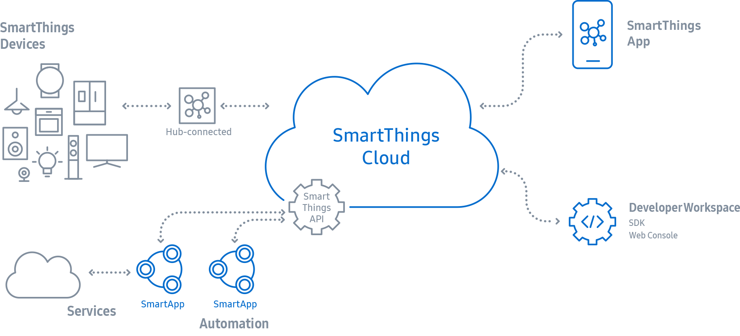
- Structure of SmartThings
A mobile application for SmartThings is called SmartApp, which is a small Groovy-based program that allows users to automate their homes using the capabilities of the devices. A typical SmartApp is composed of four sections: ‘Definition’, ‘Preferences’, ‘Predefined Callbacks’ and ‘Event Handlers’. Definition provides metadata about the SmartApp itself. Preferences defines a screen or page, where users can choose real devices that the SmartApp will use at install time. Every SmartApp must define predefined callback methods installed() and updated(). SmartApps interact with the devices through events, and have to subscribe to events generated by devices. It operates using a subscription model which allows apps to subscribe to an event and take action by invoking its event handler when the event happens [4].
Along with these, SmartThings Developer Workspace provides SmartThings developers with a set of tools to manage their SmartThings account, and build and publish custom SmartApps [4].

IOTA Calculus and ECA rule
IOTA calculus is a core calculus for Internet of Things Automation that generalizes Event-Condition-Action (ECA) rule for home automation. Simple ECA rule is a popular, practical means for non-technical users to configure and control home automation systems. Such rule-based systems are easier to learn than general purpose programming. Although general purpose programming clearly provide with the more expressive power, it is shown that most home automation apps from app stores are expressible in ECA rule system [1].
ECA rules can be used to describe which actions to perform in response to events, provided that stated conditions hold. ECA rule consists of three parts, Event, Condition and Action. The event specifies the signal that triggers the invocation of the rule, the condition is a logical test that, if satisfied, causes the action to be carried out, and the action consists of updates or invocations on the local data [5]. For example, the following can be directly expressed in ECA rule:
When the lock is unlocked from locked,
if a user is present,
then turn the light on and play music
- Example of ECA rule

Blockly
Blockly is a client-side JavaScript library for creating visual block programming languages and environment. Blockly Developer Tool is a web-based developer tool that automates parts of the Blockly configuration process, including creating custom blocks, building toolbox, and configuring web Blockly workspace [6].
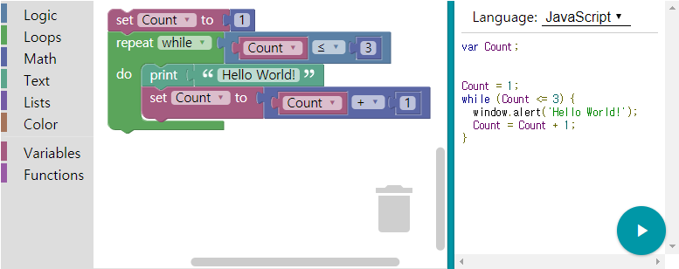
- Google Blockly
Blockly comes with a number of pre-defined blocks from mathematical functions to looping structures. The developer can define new custom blocks to represent new programming concepts like ECA rule, and can also create the code generator to export the new block to a programming language such as JavaScript, Python, or PHP on Blockly Developer Tool [6].

visual block Language
We designed a visual block language Smart Block for SmartThings. By dragging and dropping blocks, users can write SmartApp easily. We first designed ECA block as in Fig. 4, which can be connected with Event block, Condition block and Action block.

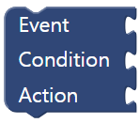
- ECA Block
For example, Fig. 5 shows an ECA block connected with Event block, Condition block and Action block, which represents the ECA rule in Fig. 2. Users can create a SmartApp with a number of ECA blocks, which are connected up and down (See Fig. 11 for example).

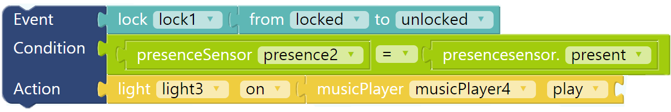
- A completed ECA block representing ECA rule
Let’s take a look at each block. Event block in Fig 6 stands for an event from a lock device, and it means an event of being unlocked from locked on the device named lock1.
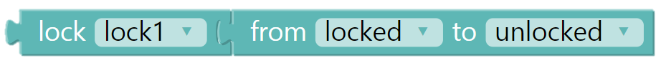
- Event Block
Condition block represent a Boolean algebra over a state on devices. An attribute of a device can be compared with the value of some attribute on another device or constants. There are few devices having more than two attributes. We omit the name of an attribute if a device has only one attribute. Condition block in Fig. 7 checks if the value of PresenceSensor named presence2 is present.
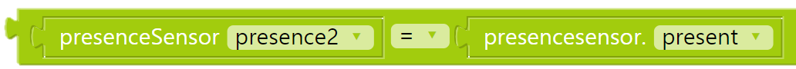
- Condition Blocks
Action block represents an action to perform with a device. Action block in Fig 8 means turning on a device light 3. Action blocks can be linked together in a line as in Fig. 5, which will be performed in sequence.
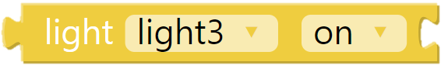
- Action Block

visual programing environment
We designed a visual programming environment for Smart Block, and implemented it as a web application built on top of HTML, JavaScript, and CSS. By dragging and dropping blocks, users can create SmartApp on this environment. It is divided into two parts: Smart Devices on the left and workspace on the right. Available Smart Devices are grouped on the left and users can select Smart Devices they are going to use.
Workspace consist of tools for Rule, Preferences, and Code. Users can create ECA blocks connecting Event blocks, Condition blocks and Action blocks on Rule tool, and users can construct the installation page on Preferences tool. Code tool shows the generated Groovy code for the SmartApp.
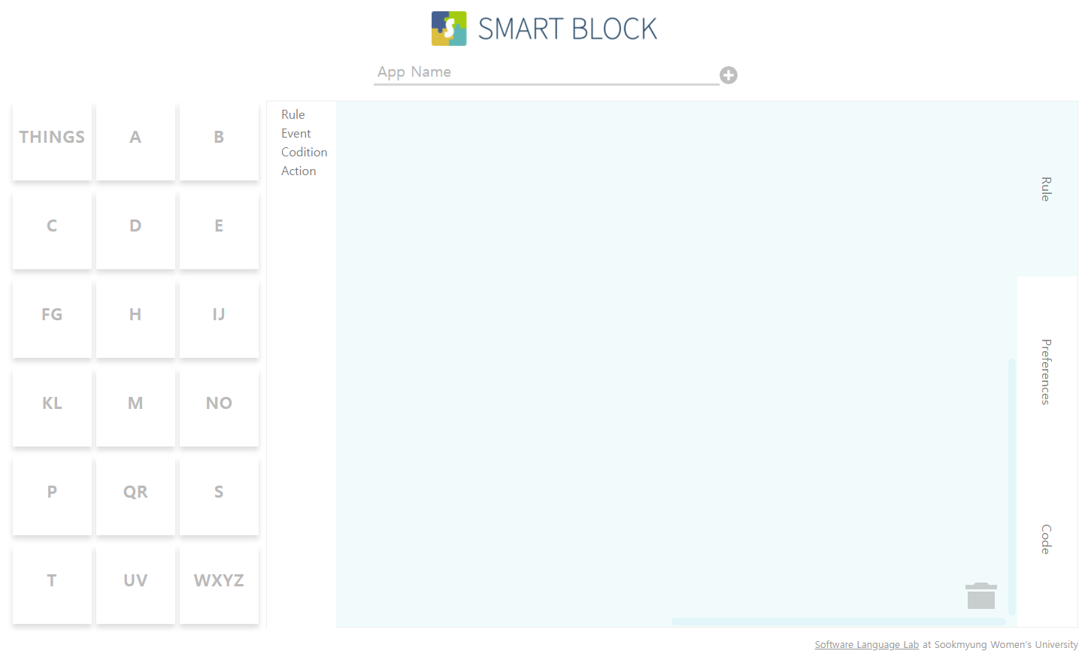
- A Visual Programming Environment for Smart Block

Rule Tool
On Rule tool, users determine the actual tasks of SmartApp by dragging and dropping ECA blocks, EA blocks (an ECA block without condition), Event blocks, Condition blocks and Action blocks. Rule tool helps users to express what they want to be served easily. On toolbox, ECA block, EA block, Event blocks, Condition blocks and Action blocks are provided.
To complete ECA block, users have to connect one Event block, Condition blocks and Action blocks with it. To make sure that block is well connected, a color of block is implemented to become blurry as in Fig. 10 if the block is not connected with other block.
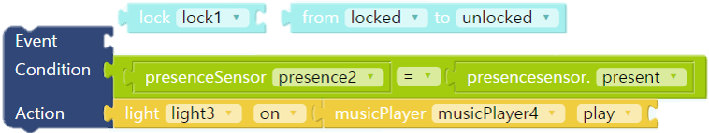
- erroneous ECA block
Users can create a SmartApp with a number of completed ECA or EA blocks on workspace. For example, Fig. 11 shows two ECA blocks. The first one means that when the locked door is unlocked, if users come back to home, the light will turn on and music start to play. The second one means that when the locked door is unlocked, if users are not at home, there is someone unexpected. Thus, SmartApp send the push message to alert that robber is at home and rings siren.
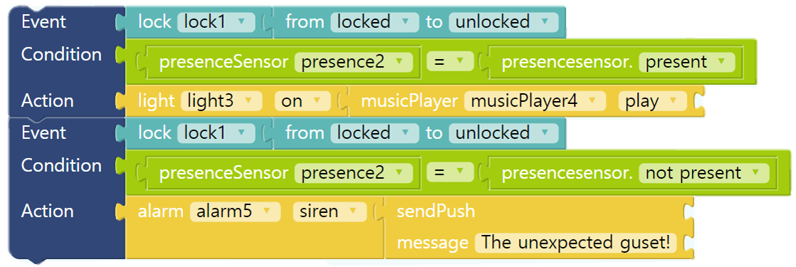
- Example of ECA rules on SmartApp

Preferences Tool
The preferences method defines a screen or the installation page, where users can choose real devices that the SmartApp will use at install time. A page can contain one or more sections, and a section can contain one or more inputs.
Users can build the installation page by dragging and dropping page blocks, section blocks, input blocks on Preferences tool. Fig. 12 shows the page block, which contains 3 section blocks, which contain input blocks.

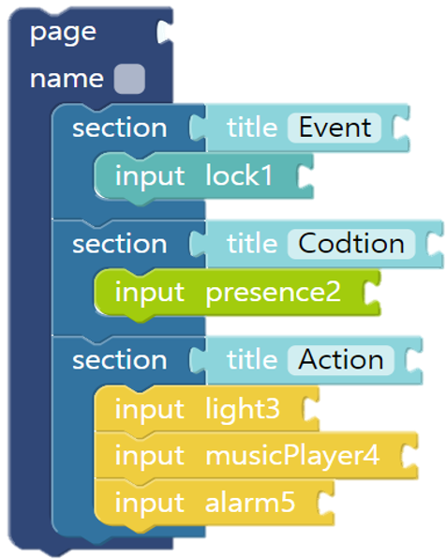
- Example of page block for SmartApp
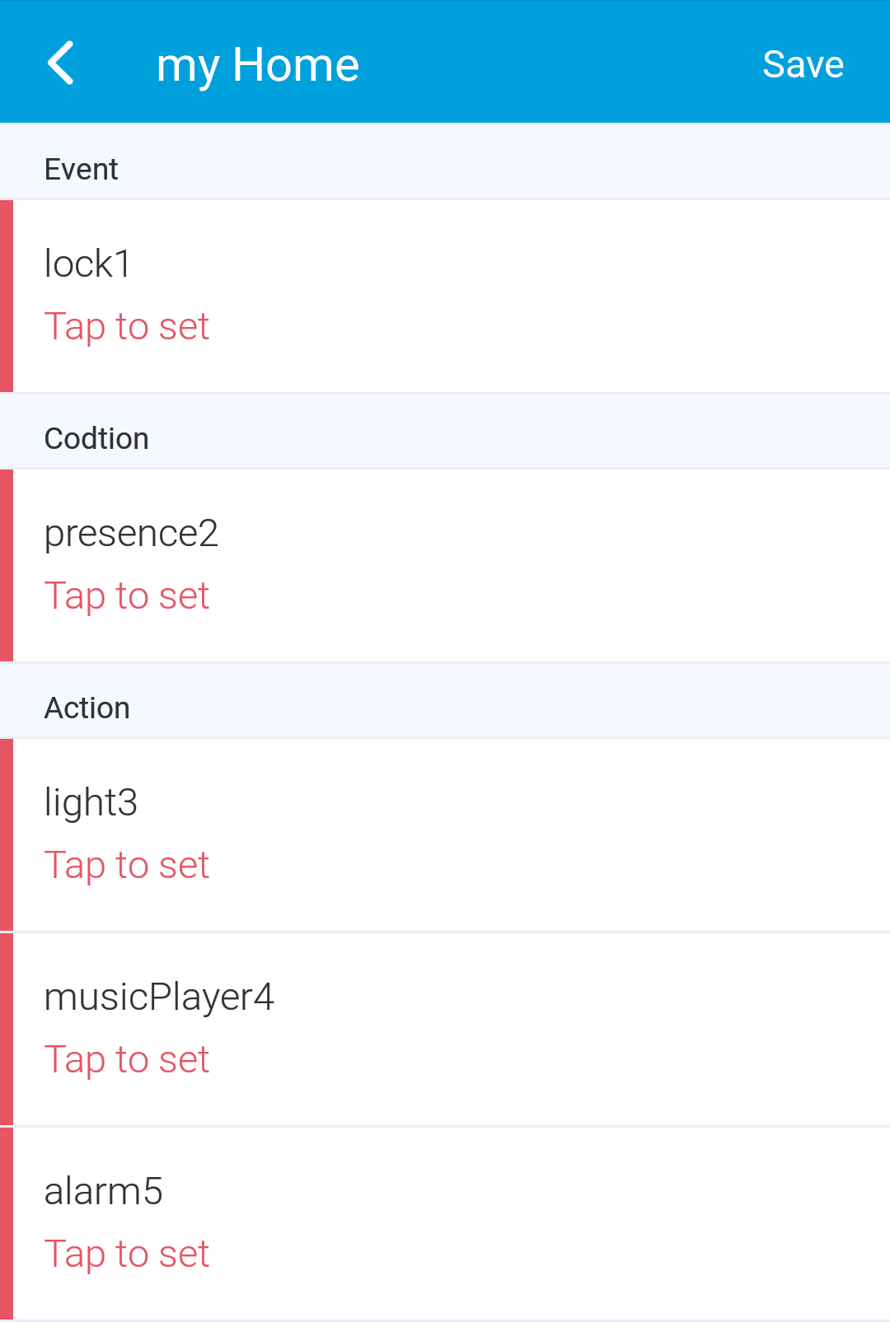
- the installation page
Fig. 13 shows the installation page which can be directly generated by the page block in Fig.12. The page will appear when the Smart App is installed first.

Compiling Process
After building blocks for SmartApp on Rule tool, AST for the built blocks are generated as shown in Fig. 14. Then the code generator generates actual Groovy code for SmartApp traversing the AST.

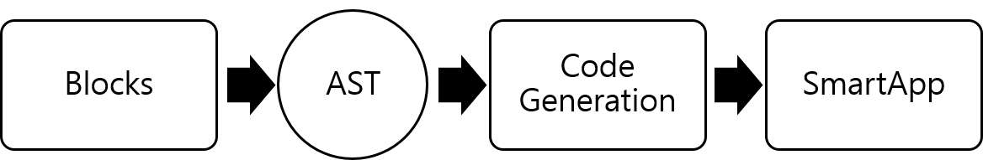
- Compiling process of SmartApp
In case of simple Blockly application, it is possible to generate actual code directly from blocks. However, ECA block influences more than one part of SmartApp code, so we take a two-pass approach, where AST is generated first and then Groovy code is generated traversing the AST.

Implementation
Blockly comes with a large number of predefined blocks from mathematical functions to looping structures [6]. We created new custom blocks for Smart Block, which are for ECA, EA(ECA without Condition), Event, Condition and Action.
We designed and implemented custom blocks for Smart Block using Blockly Developer Tools, which produces the definition code, code generator, XML code for toolbox and workspace for custom blocks as shown in Fig. 15. Blockly Developer Tools makes it easy to configure a workspace with a toolbox, which shows the side menu for blocks in the visual programming environment.
With the XML code of toolbox and workspace provided by Blockly Developer Tools, we implemented a visual programming environment for Smart Block, where users can create Smart App by dragging and dropping blocks from toolbox in workspace.

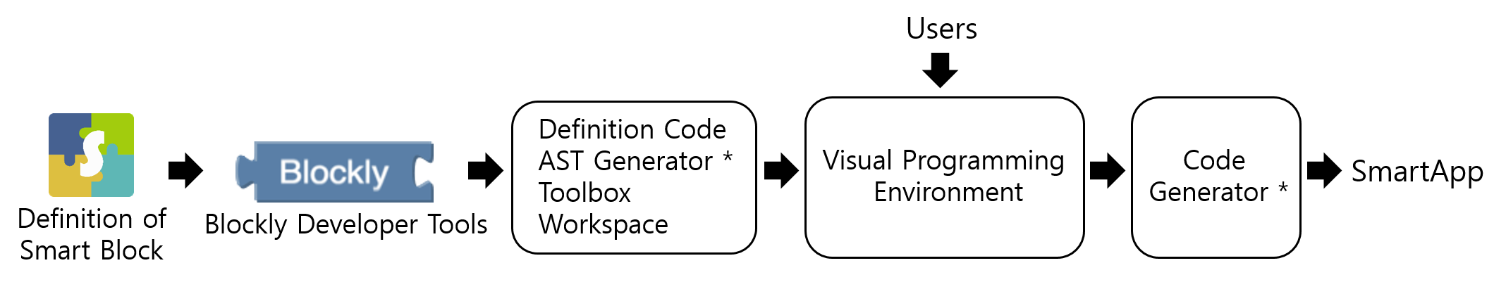
- Imprementing process of Smart Block

Custom blocks
New blocks require a block definition and a generator. The definition describes the block's appearance (user interface) and the generator describes the block's translation to executable code [5].
First, we create new custom blocks specifying its shape, fields, and connection points using Blockly Developer Tools. We describe how a block looks and behaves, including the text, the color, the shape, and what other blocks it can connect to. We design or define a custom block by dragging and dropping input blocks, field blocks and type blocks on workspace of Blockly Developer Tools. Then we construct the internal organization of the custom block and obtain its definition code from Blockly Developer Tools.
Fig. 16 shows the internal design of ECA block, which has three input blocks for Event, Condition, and Action. Each of them sets its name and block type as Event, Condition, and Action. To link ECA Block with ECA block and EA block vertically, the top and bottom type of ECA block should be ECA and EA.

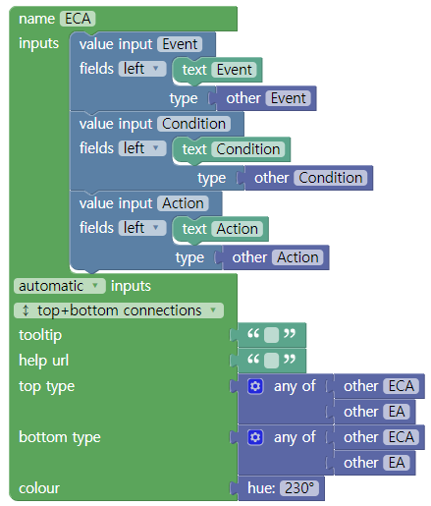
- Internal organization of ECA custom block
Blockly Developer Tools produces the definition code of custom blocks. For example, Fig. 17 shows ECA block appending Event block, Condition block and Action block as value input. In addition, we set up to check whether the type of input block is correct or not. Method calls setPreviousStatement and setNextSatatement with ECA and EA as parameter express possible vertical linking of ECA Block with ECA Block and EA Block.
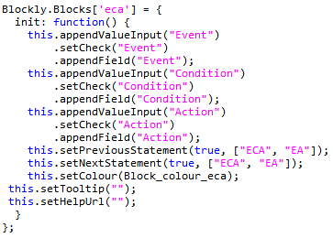
- Defintion code of ECA custom block

Code Generator
In case of simple Blockly application, it is possible to generate actual codes directly by parsing blocks and assemble them. However, ECA block influences more than one part of SmartApp code, so we take a two-pass approach, where AST is generated first and then Groovy code is generated traversing the AST
We implemented generators for custom blocks, which parses the completed blocks and generates their ASTs. For example, Fig. 18 shows that the generator for ECA block returns AST for ECA block, which is made up of ASTs for Event, Condition and Action.

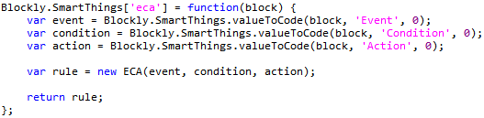
- AST Generator of ECA block
To generate the AST for a SmartApp consisting of ECA blocks, we reimplemented the workspace generator, the default top generator that Blockly Developer Tools offers. It calls generators of ECA blocks, each of which calls generators for Event, Condition, and Action blocks. The workspace generator returns the AST for a SmartApp like Fig. 19.
We implemented the code generator, which generates actual Groovy code traversing the AST. The code generator first generates code for the preferences section according to the page block in the preference tool. Then, it generates code for the subscribe method call taking the device, event and its handler as parameters in the predefined callback methods installed() and updated(). By referencing Event nodes, Condition nodes and Action nodes in the AST, it produces code for two event handlers of the SmartApp, which first check the previous state of the device, and then check the condition. If the condition is true, each action is performed. Fig. 20 shows the generated code for two ECA blocks in Fig. 11 and one page block in Fig. 12.

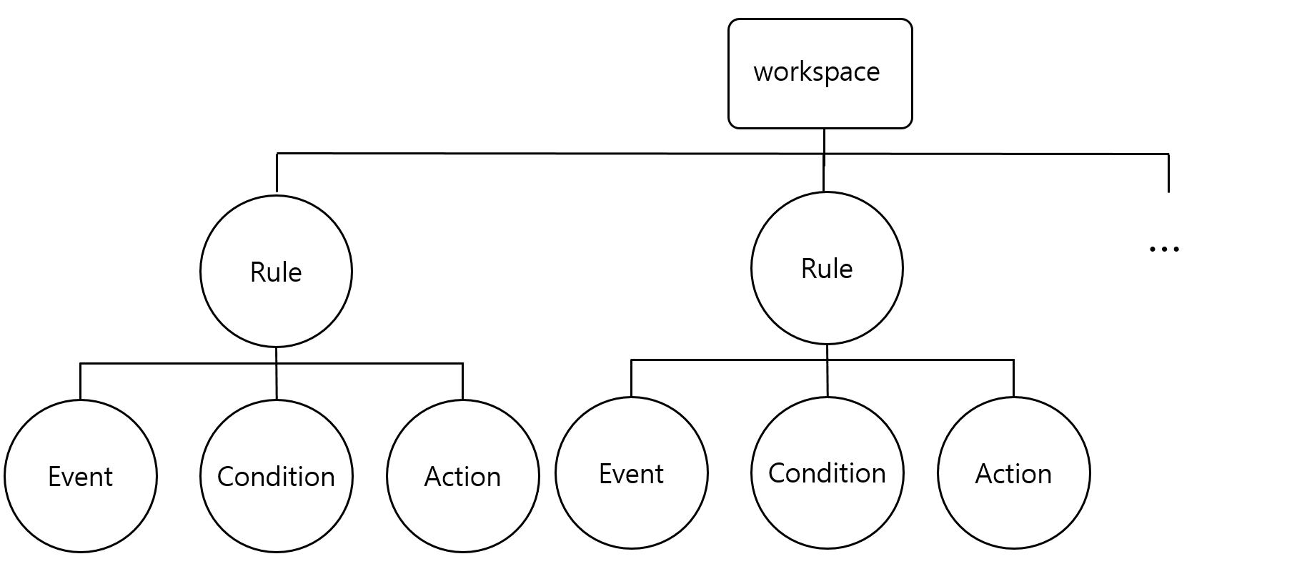
- AST of SmartApp

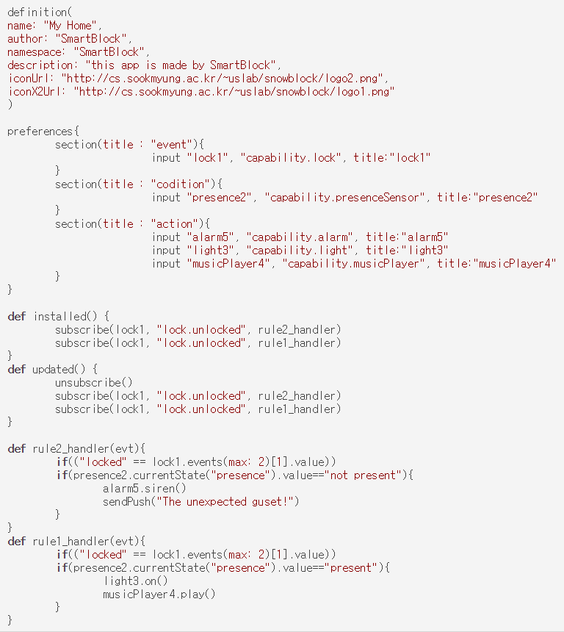
- generated Smart App Code

Related work

Node-RED
Node-RED is a visual flow-based programming environment for wiring together hardware devices, APIs and online services as part of the IoT. Node-RED is built on Node.js, taking full advantage of its event-driven, non-blocking model.
Node-RED provides a browser-based flow editor that makes it easy to wire together flows using the wide range of nodes in the palette. Hardware devices such as Raspberry Pi, and Arduino can be nodes. Programs in Node-RED are built up from premade blocks of code called Nodes [9].

Scratch for Arduino(S4A)
Scratch for Arduino is a Scratch modification that allows for simple programming of the Arduino open source hardware platform. It provides new blocks for managing sensors and actuators connected to Arduino [10]. Users drag and drop blocks onto a workspace, then Scratch for Arduino will generate the Arduino code.

BlocklyDuino
BlocklyDuino is a web-based visual programming editor for Arduino. BlocklyDuino is based on Blockly, the web-based, graphical programming editor. It provides static type language blocks and code generators for Arduino programming [11].

Visual DSL
A visual DSL is a programming language based on visual blocks which are translatable into host programming languages. A visual domain-specific languages (visual DSLs) and their environments are developed, which includes blocks, an editor of blocks, and a translator that outputs textual code, and it is applied to Processing, an educational programming language for media art [3].
The visual languages in the related works are for programming experimental IoT devices such as Arduino and Raspberry Pi, and media art. On the other hand, we proposed a visual block language Smart Block for SmartThings, a practical IoT platform for home automation. We also developed a visual programming environment for Smart Block. Smart Block is designed based on high-level concept of ECA rules, so that users can make SmartApps, even though they do not know programming details of SmartApp.

example
In this chapter, we are going to introduce two SmartApp built by Smart Block. Frist SmartApp in Fig 21 offers the service turning the lights on when motion is detected. In addition, we can see the generated groovy code in Fig 23. This SmartApp is provided with SmartThings Developer Workspace as a template.
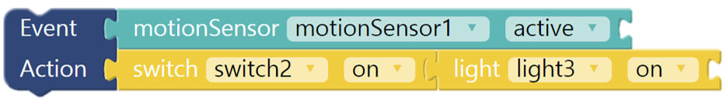
- Example of ECA rules on SmartApp
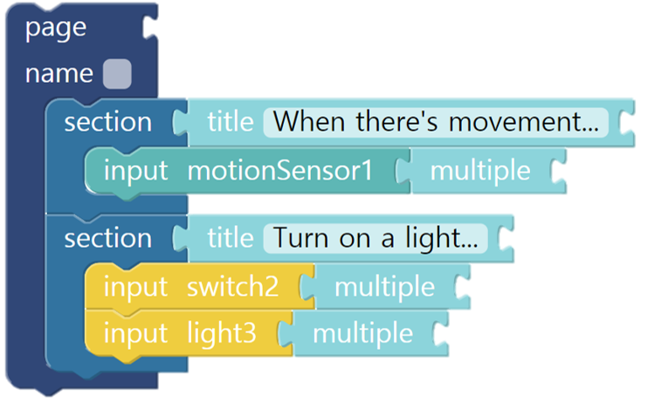
- Example of page block for SmartApp
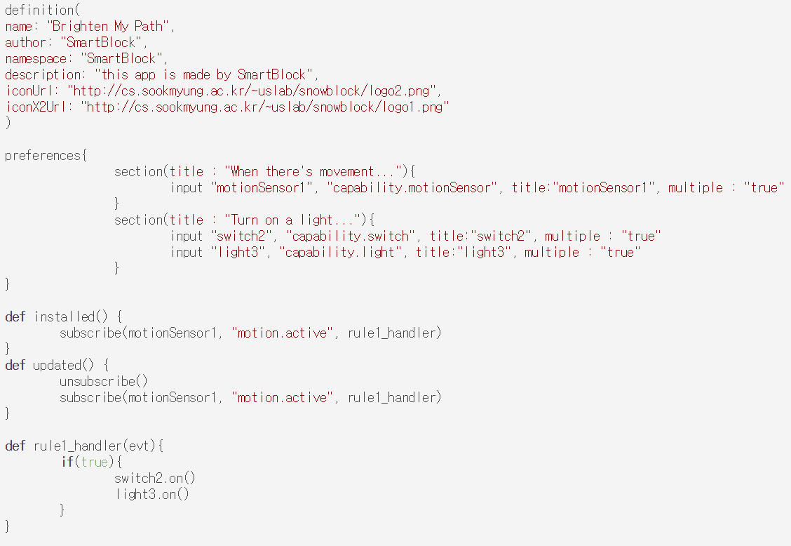
- generated Smart App Code
Second example of SmartApp in Fig 24 offers the service opening the door and star to play music when user is present. We can see the generated groovy code in Fig 26.
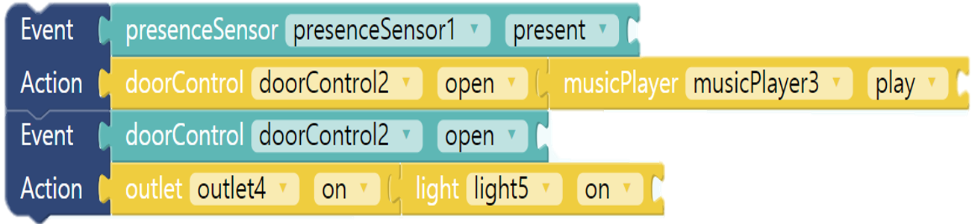
- Example of ECA rules on SmartApp
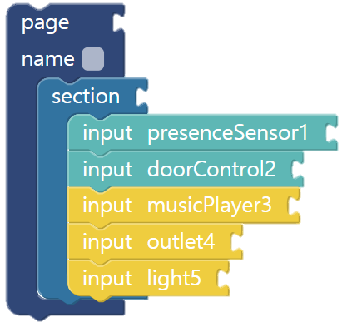
- Example of page block for SmartApp
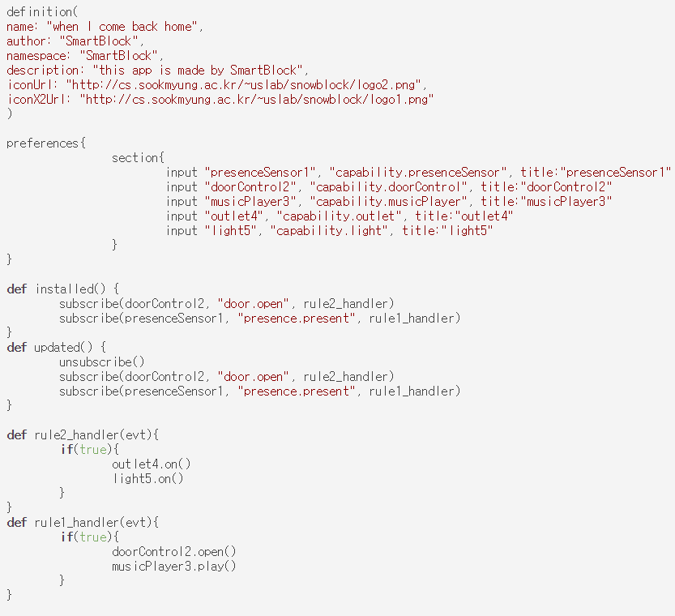
- generated Smart App Code

CONCLUSION
We developed a visual programming environment for Smart Block, which is a visual block language for SmartThings. Users can build SmartApps by dragging and dropping blocks in the environment, even though they are not familiar with programming. To the best of our knowledge, Smart Block is the first visual block language for the domain of home automation like SmartThings.
Some features such as a timer and device grouping are being implemented. We are going to design and implement new blocks for them. Moreover, we are planning to extend Smart Block to not only supporting SmartThings but also other IoT platforms.

References
- J. L. Newcomb, S. Chandra, J.-B. Jeannin, C. Schlesinger, M. Sridharan, IoTa: A Calculus for Internet of Things Automation, Onward! 2017.
- B. Jost, M. Ketterl, R. Budde, T. Leimbach, Graphical Programming Environments for Educational Robots:Open Roberta - Yet another One?, In Proceedigns of the 2014 IEEE International Symposium on Multimedia, pp. 381-386.
- A. Kuihara, A. Sasaki, K. Wakita and H. Hosobe, A Programming Environment for Visual Block-Based Domain-Specific Languages, In Proceedings of the 2015 Int. Conference on Soft computing and Software Engineering pp. 287-296.
- SmartThings Developer Documentation Homepage, URL: http://docs.smartthings.com.
- Wikipedia, /https://en.wikipedia.org/wiki/Blockly
- Blockly: A library for building visual programming editors. URL:https://developers.google.com/blockly/
- E. Fernandes, J. Jung, and A. Prakash: Security Analysis of Emerging Smart Home Applications. In Proceedings of the 2016 IEEE Symposium on Security and Privacy, pp. 636-654.
- G. Papamarkos, A. Poulovassilis, P. T. Wood, Event-Condition-Action Rule Languages for the Semantic Web. In Proceedings of the 2006 International Conference on Extending Database Technology 2006, pp. 855-864
- https://nodered.org/about/
- http://s4a.cat/
- https://blocklyduino.github.io/BlocklyDuino/blockly/apps/blocklyduino/

