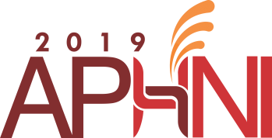

**ASIA-PASIFIC PARTNERSHIP ON HEALTH AND NUTRITIONAL IMPROVEMENT 2019**

**PRESENTATION GUIDELINE**

**A. ORAL PRESENTATION**

1. Oral presentation should be prepared in English.

2. Time alocated for each presentation is 10-12 minutes (discussion session will be done in panel excluding the time for presentation).

3. The presentation can be done using Power Point.

4. Please bring the presentation slides in USB flash drive to our staffs at least one-hour before your presentation session.

5. A computer, monitor and microphone will be prepared in all the session rooms.

6. Please use sufficient font size, figure and contrast to ensure your text can be seen clearly from the back of the room.

**B. POSTER PRESENTATION**

1. Poster presentation should be prepared in English.

2. The recommended size for poster is A1.

3. Poster numbers will be provided by the Secretariat.

4. Posters should be displayed on the poster boards using pins that will be available at the poster session room.

Poster

Number

Recommended

Poster Size : A1

≈ 183cm



≈ 122cm

