GLOBAL SALES AND FINANCIAL PERFORMANCE
INTERACTIVE SALES BOARD
Using Microsoft Power BI
Project Report
Submitted By
Name: Akshayaa Balaji
Tool Used: Microsoft Power BI Desktop

1. Introduction
For this project, I built an interactive sales board in Power BI to analyse global sales and financial performance. The underlying model is a proper star schema — a FactSales table joined to DimCustomer, DimDate, DimEmployee, DimGeography, and DimProduct — which meant I could slice the same sales figures by time, geography, product category, and salesperson without duplicating any data.
The workbook is spread across five pages: a DAX Validation page to sanity-check the totals, a KPI Cards page, a Visualisation page, a combined Dashboard page, and a Sales Tooltips page. Building it this way let me validate the numbers first and then layer the visuals and interactivity on top with confidence that the underlying measures were correct.

2. Objectives
Going in, I set out with a few clear goals for what I wanted the board to do:
- Validate that the core DAX measures tie back to the raw fact table before building any visuals.
- Summarise total sales, profit, cost, and order volume in a single glance.
- Break sales down by product category, month, region, and salesperson.
- Let a user filter the whole board by year, region, and category.
- Surface simplified, tooltip-style cards for quick reference.

3. Dataset Description
The data model is built around a central fact table with several supporting dimension tables:
- FactSales — the transactional sales records, including sales, profit, cost, and quantity.
- DimDate — the calendar table used to slice sales by year and month.
- DimProduct — product and category information.
- DimCustomer — customer-level detail.
- DimEmployee — the salesperson associated with each transaction.
- DimGeography — region information used for the geographic breakdown.

4. Data Preparation
Before building the report pages, I focused on getting the model right:
- Connected each dimension table to FactSales on its correct key.
- Confirmed Date, Region, and Category fields were recognised as the right data types.
- Built a DAX Validation page listing sales, profit, and quantity by product so the totals could be checked against the source data before trusting any visual built on top of them.

5. DAX Measures Used
I created a core set of measures to drive every card and chart in the workbook:
- Total Sales
- Total Profit
- Total Cost
- Total Quantity
- Average Sales
- Order Count
These SUM, AVERAGE, and COUNT-based measures feed every KPI card and chart in the workbook, so getting them right once meant every page downstream was reliable.

6. Dashboard Components
The workbook is organised into five pages, each covering a different part of the analysis.

DAX Validation
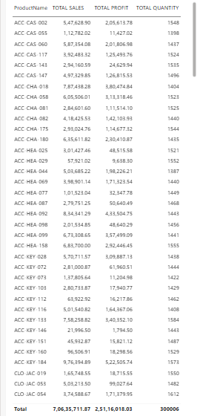
Figure 1 — Product-level table used to validate the sales, profit, and quantity totals.
A detail table lists Total Sales, Total Profit, and Total Quantity for every product, with a grand total row at the bottom. I built this page first, before any of the visuals, so I had a row-level reference to check the KPI cards and charts against — the totals here (7,06,35,711.87 in sales, 2,51,16,018.03 in profit, 300006 units) match the rounded KPI figures used everywhere else on the board.

KPI Cards
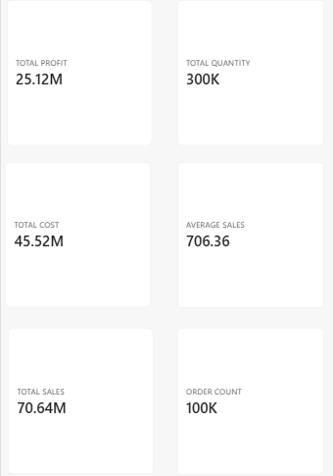
Figure 2 — The six core KPI cards: Total Profit, Total Quantity, Total Cost, Average Sales, Total Sales, and Order Count.
This page lays out six cards in a grid: Total Profit (25.12M), Total Quantity (300K), Total Cost (45.52M), Average Sales (706.36), Total Sales (70.64M), and Order Count (100K). Keeping these on their own page made it easy to check every headline number at once before folding a smaller subset of them into the combined dashboard.

Visualisation
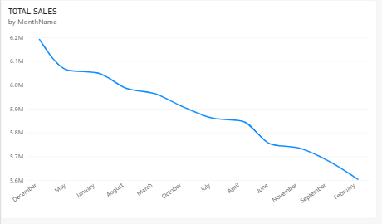
Figure 3 — Total sales by month.
A line chart tracks total sales by month, ordered from December down to February. The trend is a fairly steady decline across the period shown, dropping from a high of about 6.2M in December to roughly 5.6M by February, with no sharp spikes — a much smoother pattern than a typical holiday-driven sales curve.
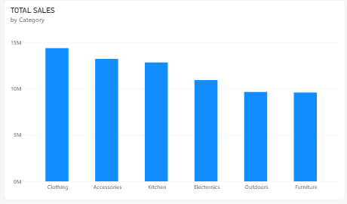
Figure 4 — Total sales by product category.
A column chart breaks total sales down by category. Clothing leads at close to 15M, followed closely by Accessories and Kitchen, while Outdoors and Furniture trail the pack at just under 10M each — so the top three categories account for a clearly larger share of sales than the bottom three.
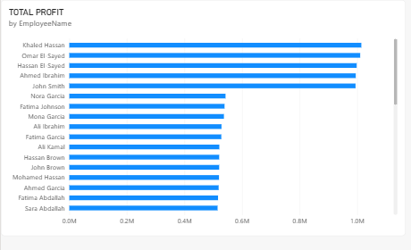
Figure 5 — Total profit by salesperson.
A horizontal bar chart ranks every salesperson by total profit. Khaled Hassan, Omar El Sayed, Hassan El Sayed, and Ahmed Ibrahim sit at the top of the list, each bringing in close to 1.0M in profit, while the rest of the team clusters much closer together around the 0.5M mark.
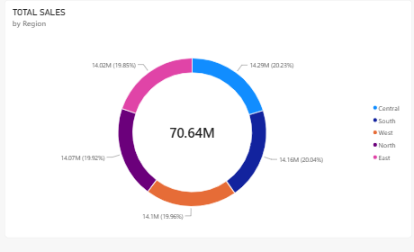
Figure 6 — Total sales by region.
A donut chart splits the 70.64M in total sales across five regions — Central, South, West, North, and East. The split is remarkably even, with each region landing somewhere between 19.85% and 20.23% of the total, so no single region is dominating overall performance.

Dashboard
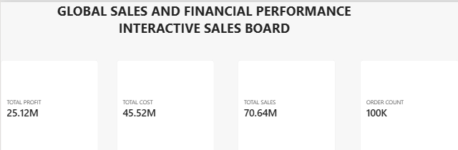
Figure 7 — The combined dashboard header and KPI row.
The Dashboard page pulls the most important pieces from the other pages onto a single screen: Total Profit, Total Cost, Total Sales, and Order Count sit across the top, under a header that reads "Global Sales and Financial Performance Interactive Sales Board."
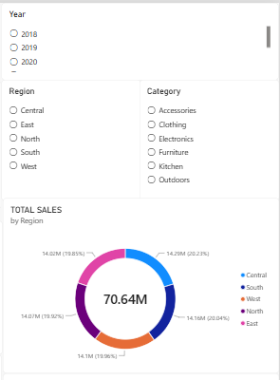
Figure 8 — Year, Region, and Category filters alongside the Total Sales by Region donut.
To the right of the KPI row, Year, Region, and Category filter panels let a user narrow the whole page down to a single year, region, or product category, with the Total Sales by Region donut chart sitting just beneath them so the regional split stays visible while filtering.
Below the header, the page repeats the Total Sales by Category, Total Sales by MonthName, and Total Profit by EmployeeName visuals from the Visualisation page, plus the same product-level detail table from the DAX Validation page — so a user can go from the big picture straight down to individual product rows without leaving this one screen.

Sales Tooltips
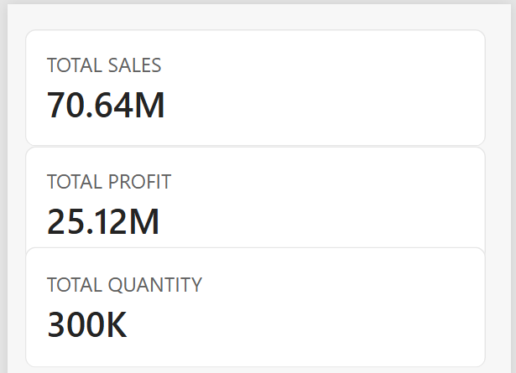
Figure 9 — Simplified Total Sales, Total Profit, and Total Quantity cards used as tooltip content.
The last page holds three large, stripped-back cards — Total Sales (70.64M), Total Profit (25.12M), and Total Quantity (300K). Rather than being a page a user browses directly, this is built as report-page tooltip content, so these three figures can pop up on hover elsewhere in the report without cluttering the main visuals.

7. Slicers Used
The Dashboard page is interactive through three filter panels:
- Year — select 2018, 2019, or 2020.
- Region — Central, East, North, South, or West.
- Category — Accessories, Clothing, Electronics, Furniture, Kitchen, or Outdoors.
These are set to Keep all filters, so any combination narrows every card, chart, and the detail table on the page together.

8. Key Findings
A few things stood out once the workbook was complete:
- Total sales across the dataset come to 70.64M, against a total cost of 45.52M and total profit of 25.12M.
- Average sales per order sit at 706.36, across roughly 100K orders and 300K units sold.
- Clothing, Accessories, and Kitchen are the strongest categories by sales; Outdoors and Furniture are the weakest.
- Monthly sales trend gently downward from December through February, without a sharp holiday spike.
- Sales are split almost evenly across the five regions, each contributing close to a fifth of the total.
- Profit by salesperson is led by a top group of four, with the rest of the team performing at roughly half that level.

9. Conclusion
This project reinforced how much a clean data model matters before the visuals even come into play — having FactSales properly linked to five dimension tables made every chart on this board a simple drag-and-drop exercise rather than a wrestling match with the data. Building the DAX Validation page first, before anything else, was a habit that paid off: it gave me a row-level total to check every KPI card and chart against as I built them.
Adding the Year, Region, and Category filters turned the Dashboard page from a static snapshot into something a user can genuinely interrogate, and the separate Sales Tooltips page showed me how the same measures can be reused as lightweight hover content elsewhere in a report. Altogether, the project gave me a much better sense of how to structure a multi-page Power BI workbook end to end.

10. References
- Microsoft Power BI Desktop
- Global Sales and Financial Performance Dataset
- Microsoft Power BI Documentation

