WALMART SALES PERFORMANCE DASHBOARD
Using Microsoft Power BI
Project Report
Submitted By
Name: Akshayaa Balaji
Tool Used: Microsoft Power BI Desktop

1. Introduction
For this project, I built a sales performance dashboard in Power BI using Walmart's weekly sales data. I picked this dataset mainly because it has a good mix of numerical and categorical fields — store-level sales, dates, fuel prices, and a holiday flag — so it gave me enough room to try out different chart types instead of just building a single summary table.
The idea behind the dashboard was to turn a fairly large, unfiltered spreadsheet into something a manager could actually glance at and understand in a minute. The page shown in this report is the main DASHBOARD view of the workbook, which sits alongside separate KPI Cards and Financial Visualisation pages. This view lets a user filter by store and date while the KPI cards, trend, and comparison visuals update together.

2. Objectives
Going in, I set out with a few clear goals for what I wanted the dashboard to do:
- Analyse Walmart's weekly sales at the store level.
- Build something interactive rather than a static report.
- Compare sales on holiday weeks versus regular weeks.
- Track how sales moved across the years covered by the dataset.
- Check whether fuel prices had any real effect on weekly sales.

3. Dataset Description
The dataset I used contains weekly sales records collected across Walmart's stores. The fields I actually worked with were:
- Store — store identifier
- Date — the week the sales were recorded
- Weekly Sales — total sales for that store in that week
- Fuel Price — average fuel price for that week
- Holiday Flag — whether that week included a holiday

4. Data Preparation
Before building any visuals, I spent some time cleaning up the dataset. Here's roughly what I did:
- Imported the source file into Power BI Desktop.
- Corrected the date format so Power BI would read it as a proper date field.
- Checked that Weekly Sales and Fuel Price were recognised as numeric fields.
- Set up the DAX measures needed to drive the KPI cards.

5. DAX Measures Used
I created the core measures needed to power the KPI cards at the top of the dashboard:
- Total Sales
- Average Sales
- Transaction Count
These are simple SUM, AVERAGE, and COUNT-style measures built off the Weekly Sales column, but they're what make the top row of the dashboard readable at a glance.

6. Dashboard Components
The finished DASHBOARD page is made up of the following visuals, arranged so the KPI summary sits at the top and the supporting charts fill the rest of the page.

KPI Cards
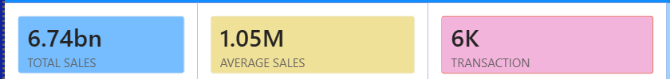
Figure 1 — Total Sales, Average Sales, and Transaction count.
Three cards sit at the top of the page: Total Sales (6.74bn), Average Sales (1.05M), and Transaction count (6K). This was the first thing I built, since it gave me a quick sanity check that my measures were working before I moved on to the more complex charts. A Filter Store dropdown and Date and Holiday Status slicers sit to the right of these cards, so any selection made there recalculates all three figures immediately.

Stock Wise Weekly Sales
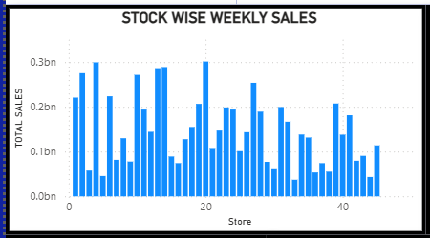
Figure 2 — Total weekly sales broken out by store.
A column chart plots total sales for each store. Laying every store out side by side makes it easy to see which ones are pulling in noticeably more revenue than the rest — a handful of stores clear the 0.25bn mark while several others sit closer to 0.05bn, so the spread across the chain is wide.

Weekly Sales Trend
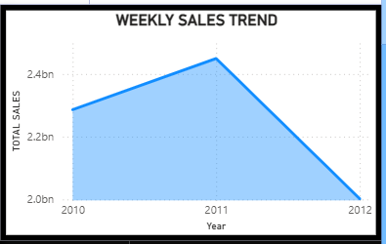
Figure 3 — Total sales by year.
A line chart tracks total sales across the years covered by the dataset (2010–2012). Sales rise from just under 2.3bn in 2010 to a peak of roughly 2.45bn in 2011, then fall back sharply to around 2.0bn by 2012, so the year-over-year shape is a clear rise and fall rather than a steady climb.

Average Sales by Store
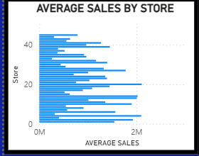
Figure 4 — Average weekly sales per store.
A horizontal bar chart ranks all the stores by average sales rather than total sales, which is a fairer comparison since it isn't skewed by how many weeks of data each store has. It's a useful companion to the Stock Wise chart above — a store can rank highly on total sales just by having more data points, but this view strips that effect out.

Total Sales by Fuel Price vs Weekly Sales
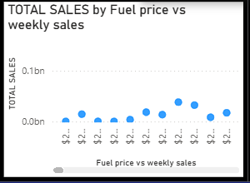
Figure 5 — Fuel price plotted against weekly sales.
A scatter chart plots fuel price against weekly sales to check for any relationship between the two. The points sit in a fairly narrow band with no obvious upward or downward slope, which told me fuel price isn't a strong driver of sales in this dataset — the same conclusion the fuel-price scatter on the Financial Visualisation page reaches.

Holiday vs Non-Holiday Sales
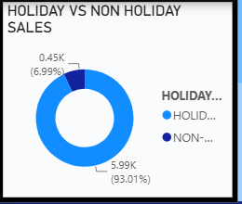
Figure 6 — Share of sales from holiday and non-holiday weeks.
A donut chart splits total sales between holiday and non-holiday weeks: 93.01% of sales (5.99K) come from non-holiday weeks against 6.99% (0.45K) from holiday weeks. That's expected given how few weeks in a year are actual holidays, but it's still a useful check that holiday weeks aren't being under- or over-counted relative to the rest of the calendar.

7. Slicers Used
To make the dashboard interactive rather than a fixed report, this page includes:
- Filter Store — a dropdown to narrow every visual down to a single store.
- Date — a scrollable list of individual weeks to select from.
- Holiday Status — a checklist to isolate Holiday or Non-Holiday weeks.
These let a user narrow the entire page down to a specific store, week, or holiday status, and every visual on the page updates together.

8. Key Findings
A few things stood out once this page of the dashboard was complete:
- Total sales across the dataset come to roughly $6.74 billion.
- Average weekly sales sit around $1.05 million, across about 6,000 transactions.
- Sales performance varies quite a bit from store to store, both in total and average terms.
- Sales rose from 2010 into 2011 before falling back by 2012.
- Non-holiday weeks account for the large majority (93.01%) of total sales, simply because there are far more of them.
- Fuel price doesn't show any strong relationship with weekly sales in this dataset.

9. Conclusion
Working on this project gave me a much better feel for how Power BI turns a plain spreadsheet into something people can actually use to make decisions. Picking the right chart for each question mattered more than I expected going in — the store-level bar charts and the donut chart told a very different story from the yearly trend line, even though they all came from the same underlying numbers.
Adding the Store, Date, and Holiday Status filters was probably the most satisfying part, since it changed the dashboard from something you just look at into something you can actually explore. Overall, this project helped me understand not just Power BI as a tool, but how a well-built dashboard can make Walmart's sales performance genuinely easier to read and act on.

10. References
- Microsoft Power BI Desktop
- Walmart Sales Dataset
- Microsoft Power BI Documentation

