B.AKSHITHA --2520090014

BANK DATABASE - SQL VIEWS
- CREATE / SELECT DATABASE
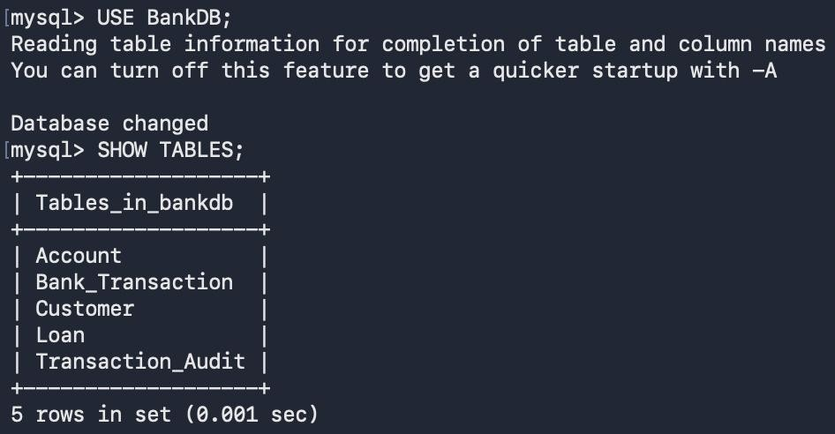

- CHECK EXISTING CUSTOMER DATA
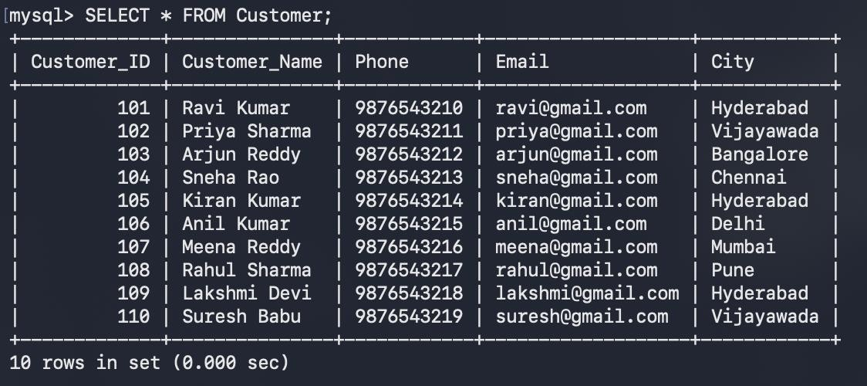

- ADD THE ADDITIONAL ACCOUNT DATA
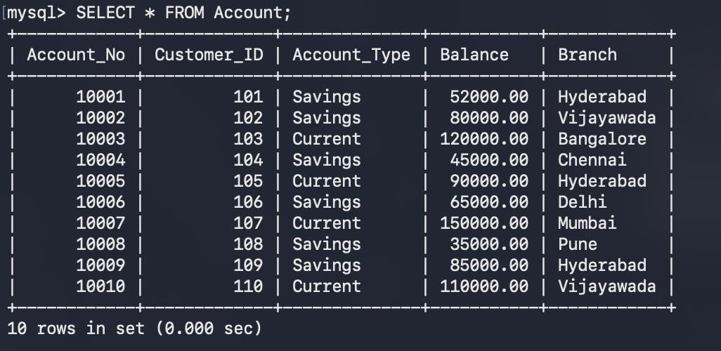

- ADD THE ADDITIONAL TRANSACTION DATA
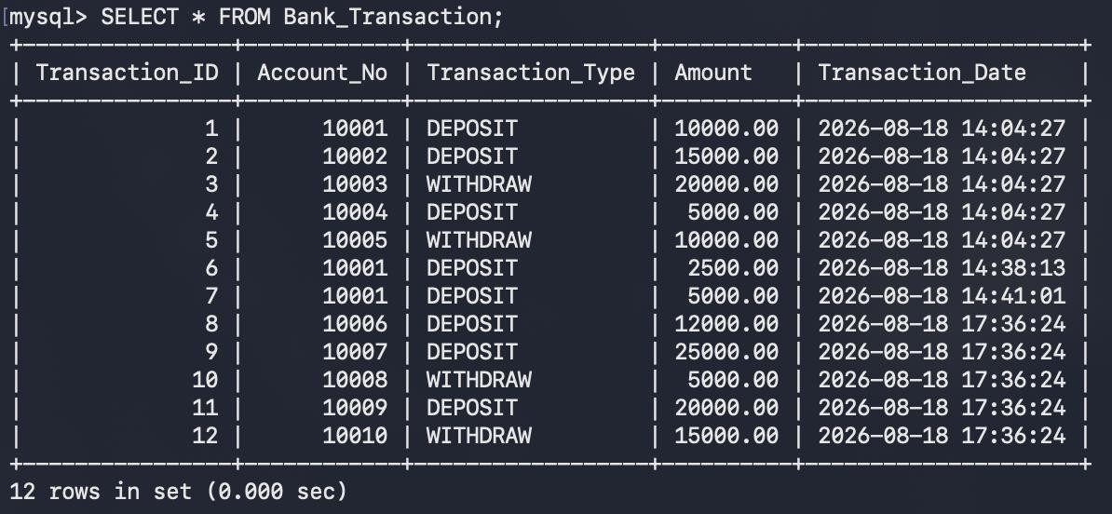

- ADD THE ADDITIONAL LOAN DATA
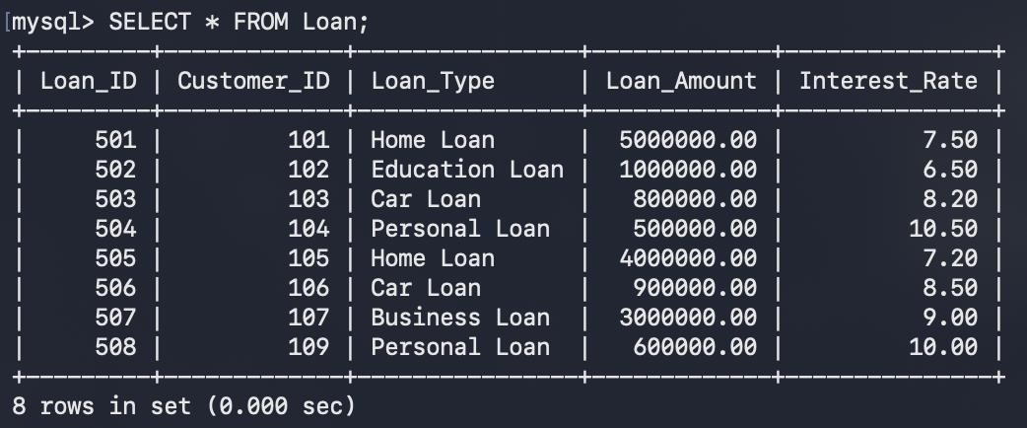

- DISPLAY ORIGINAL TABLES

- Customer Table
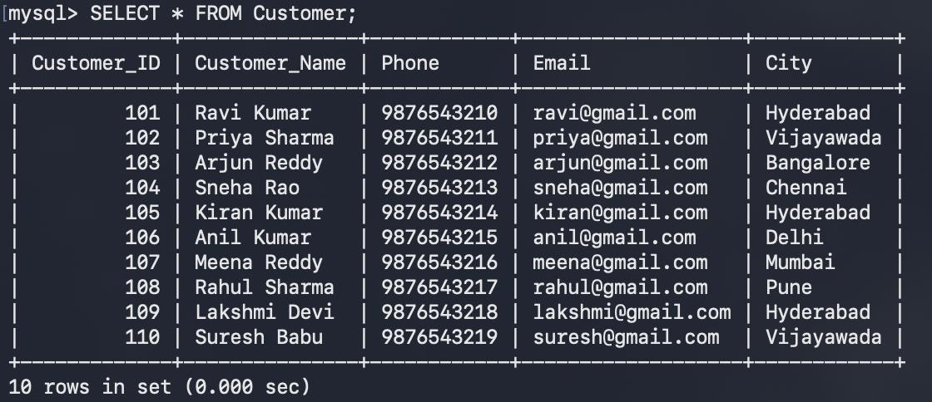

- Account Table
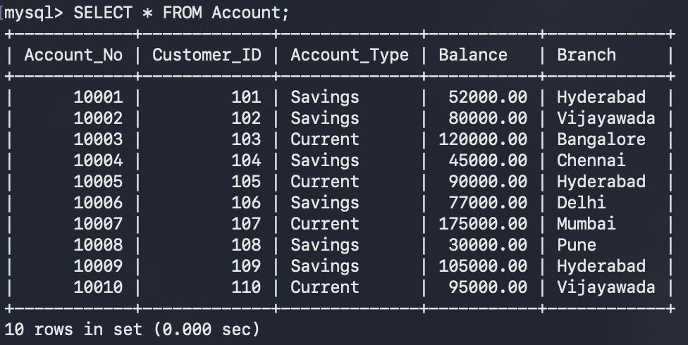

- Bank Transaction Table
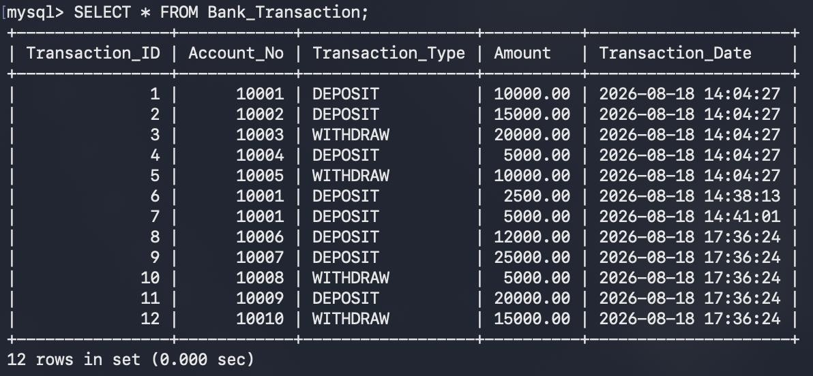

- Loan Table
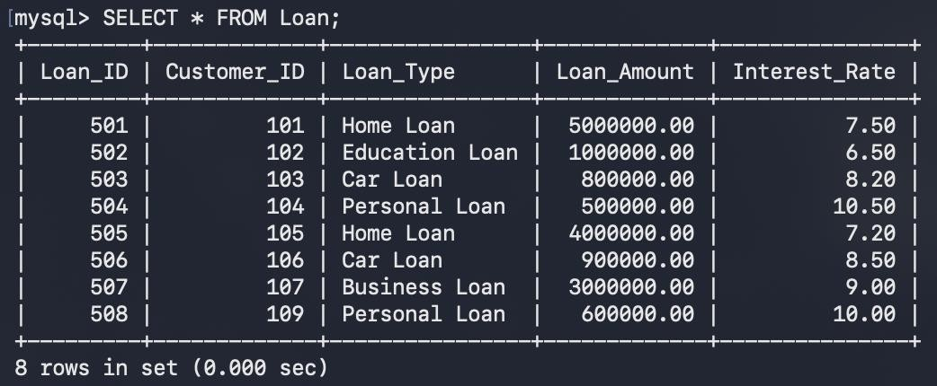

PART A - SIMPLE VIEWS

- CREATE A VIEW FOR ALL CUSTOMERS
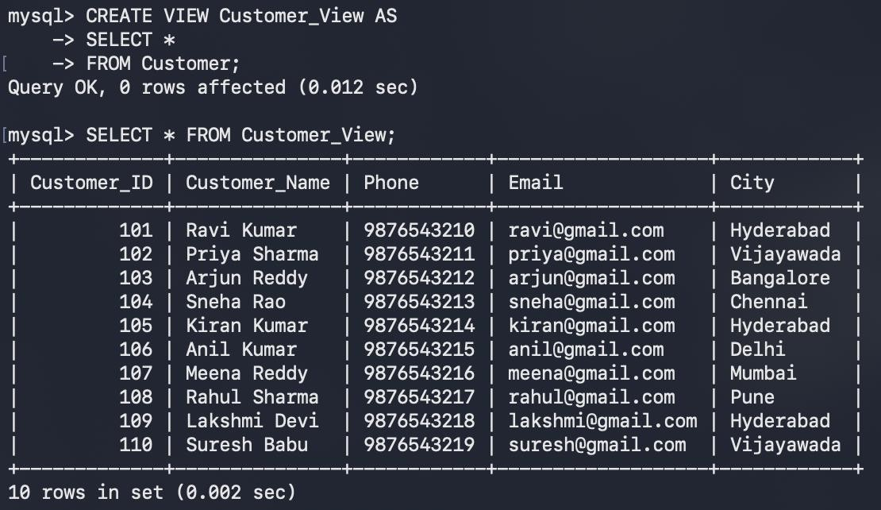

- CREATE A VIEW FOR CUSTOMER BASIC INFORMATION
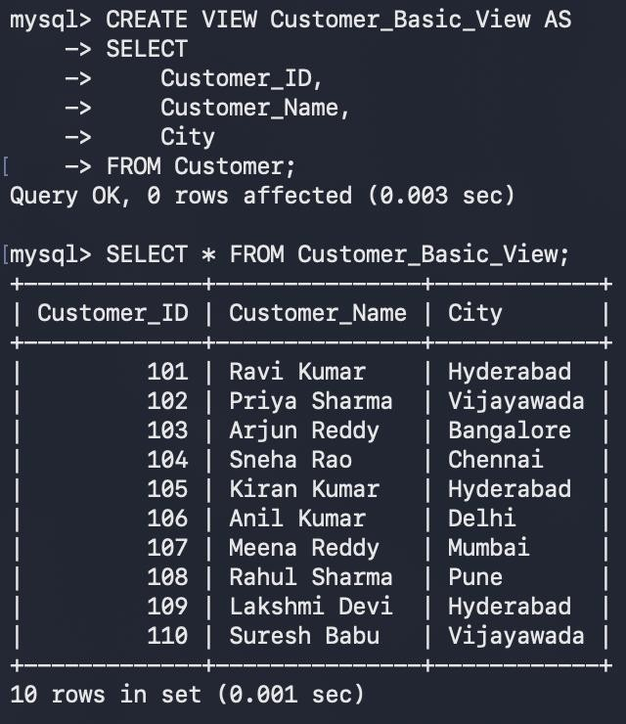

- CREATE A VIEW FOR ACCOUNT INFORMATION
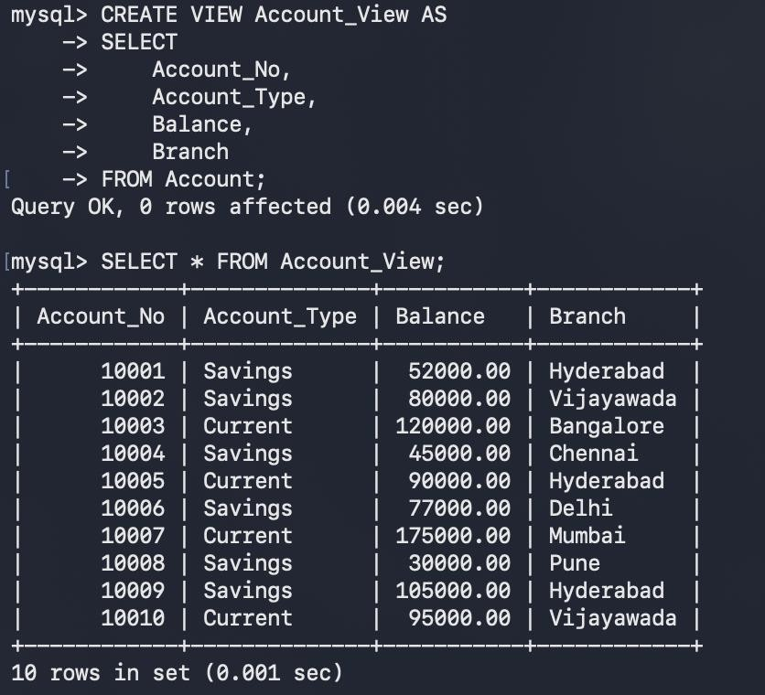
- CREATE A VIEW FOR SAVINGS ACCOUNTS
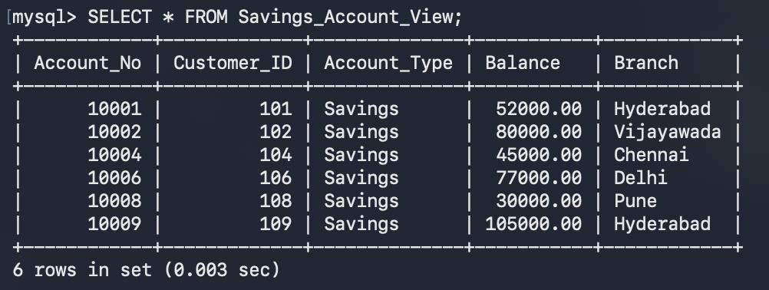

- CREATE A VIEW FOR CURRENT ACCOUNTS
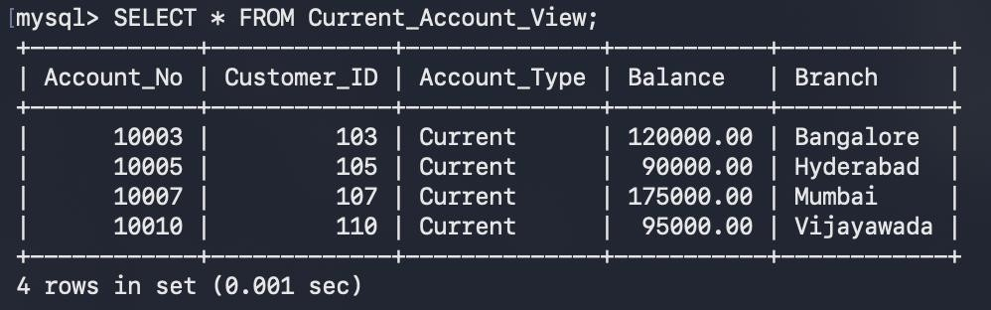

PART B — VIEWS WITH CONDITIONS
- HIGH BALANCE ACCOUNT VIEW
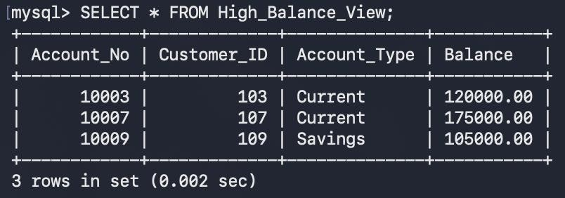

- HYDERABAD ACCOUNT VIEW
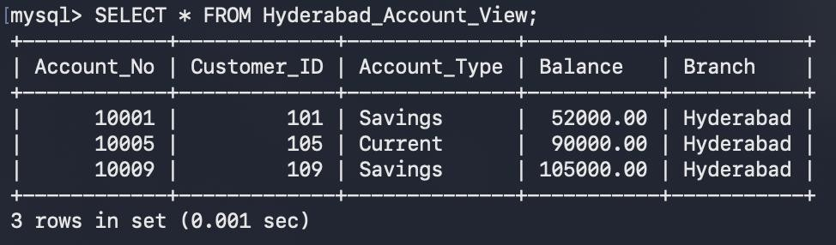

- LOW BALANCE ACCOUNT VIEW
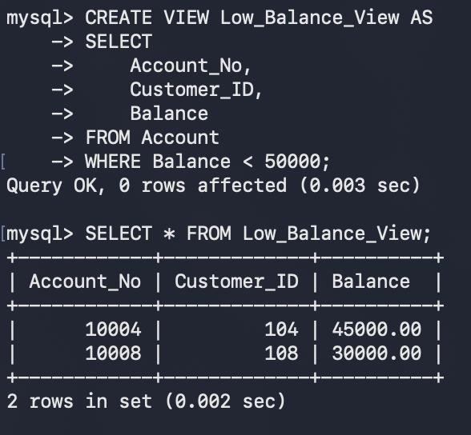

PART C — VIEWS USING JOINS

- CUSTOMER + ACCOUNT VIEW
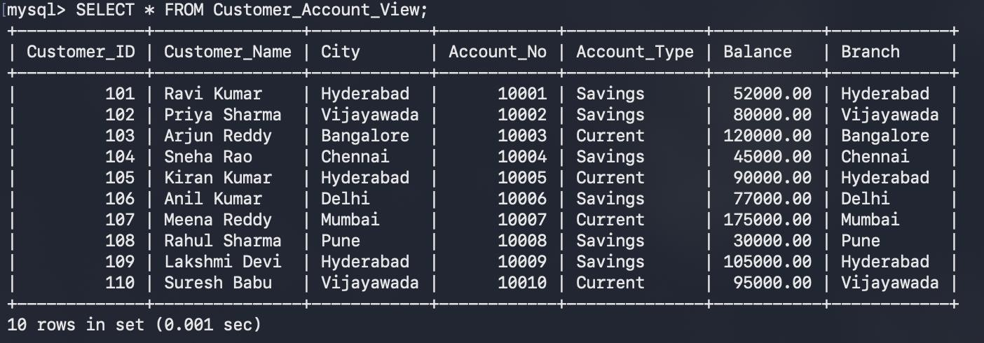

- HYDERABAD CUSTOMER ACCOUNT VIEW
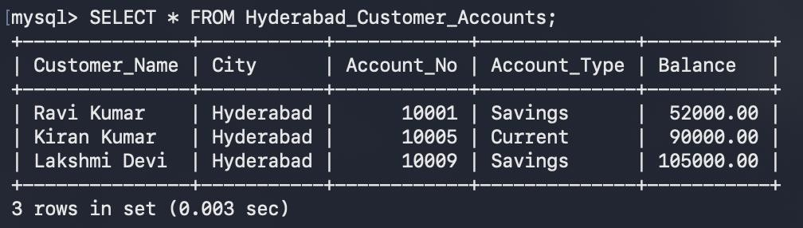

- CUSTOMER LOAN VIEW
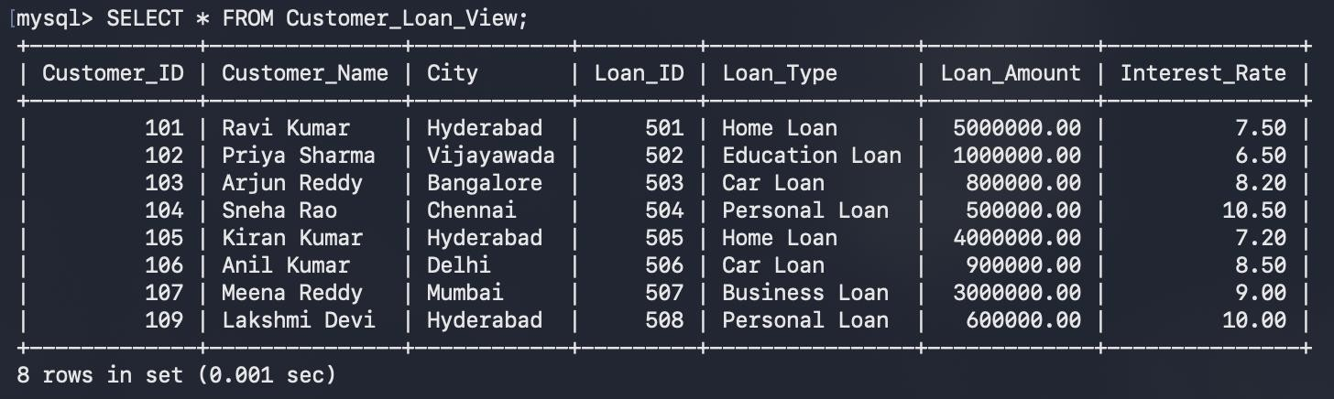

- COMPLETE CUSTOMER BANKING VIEW
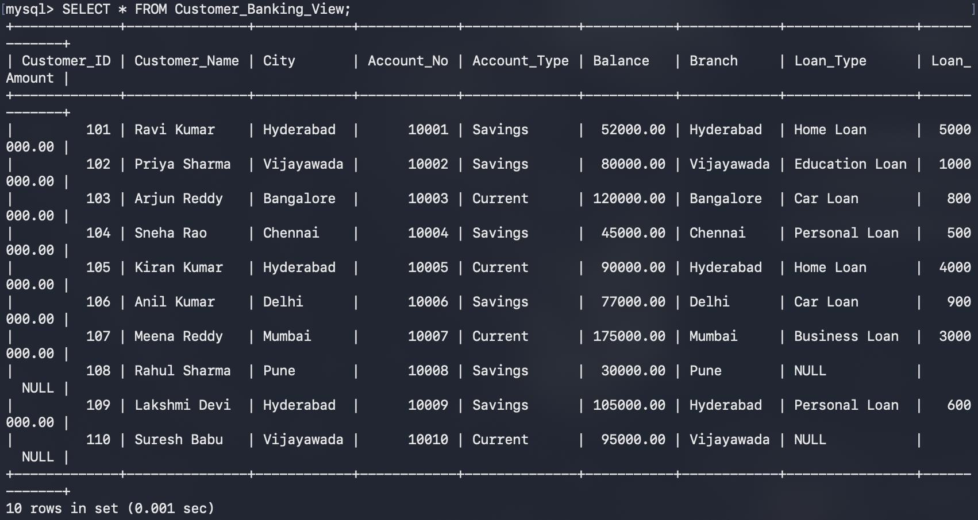

PART D — VIEWS USING AGGREGATE FUNCTIONS
- TOTAL BANK BALANCE
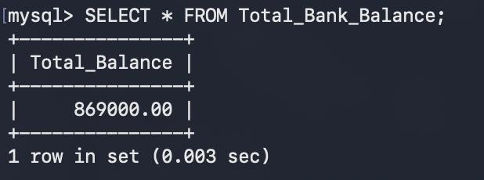

- AVERAGE ACCOUNT BALANCE
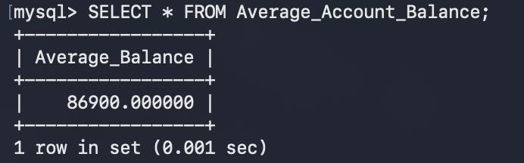

- MAXIMUM ACCOUNT BALANCE
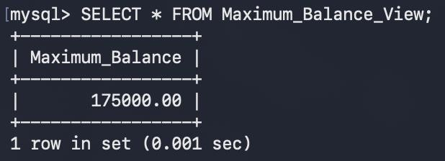

- MINIMUM ACCOUNT BALANCE
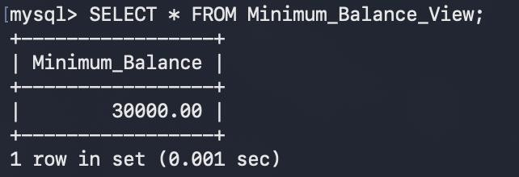

- TOTAL NUMBER OF ACCOUNTS
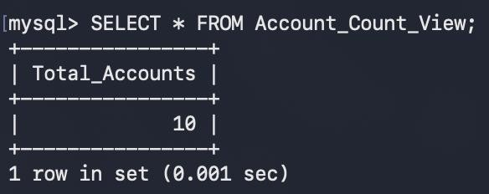

PART E — GROUP BY VIEWS

- BRANCH-WISE ACCOUNT COUNT
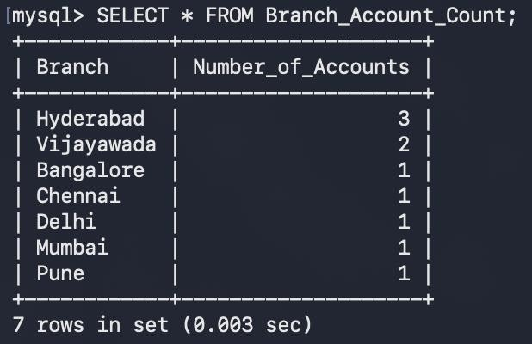

- BRANCH-WISE TOTAL BALANCE
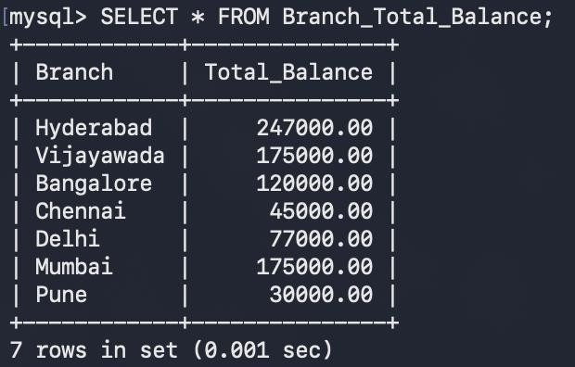

- ACCOUNT TYPE COUNT
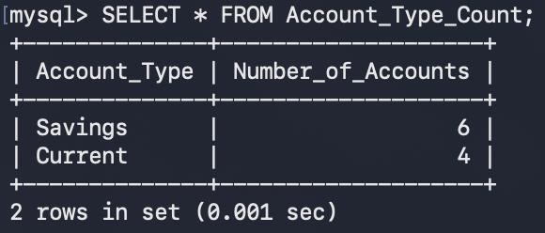
- ACCOUNT TYPE TOTAL BALANCE
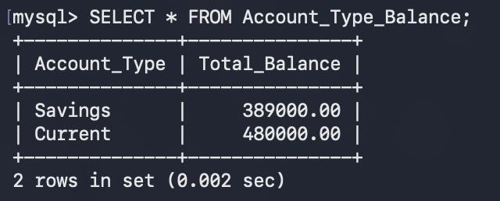

PART F — HAVING IN VIEWS

- BRANCHES WITH MORE THAN ONE ACCOUNT
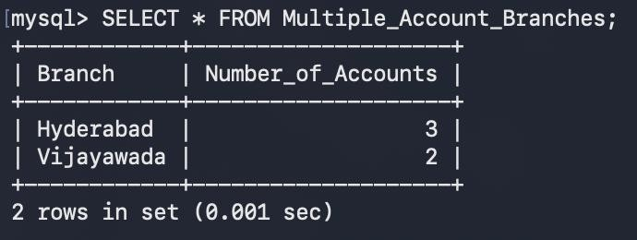

- BRANCHES WITH TOTAL BALANCE ABOVE 100000
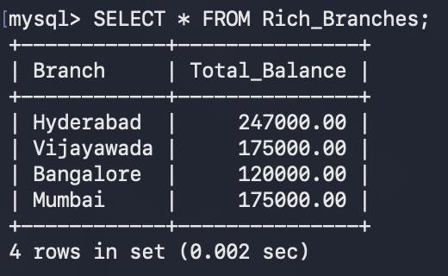

PART G — TRANSACTION VIEWS
- DEPOSIT TRANSACTION VIEW
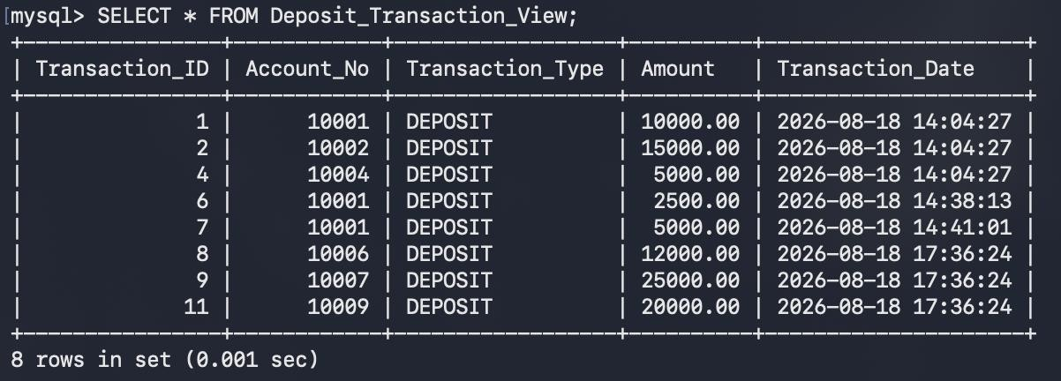

WITHDRAWAL TRANSACTION VIEW
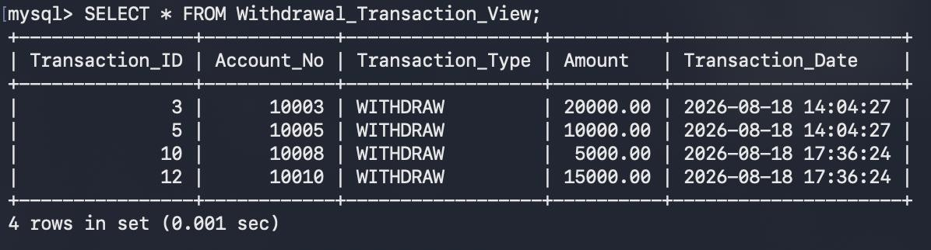
- TRANSACTION DETAILS WITH CUSTOMER
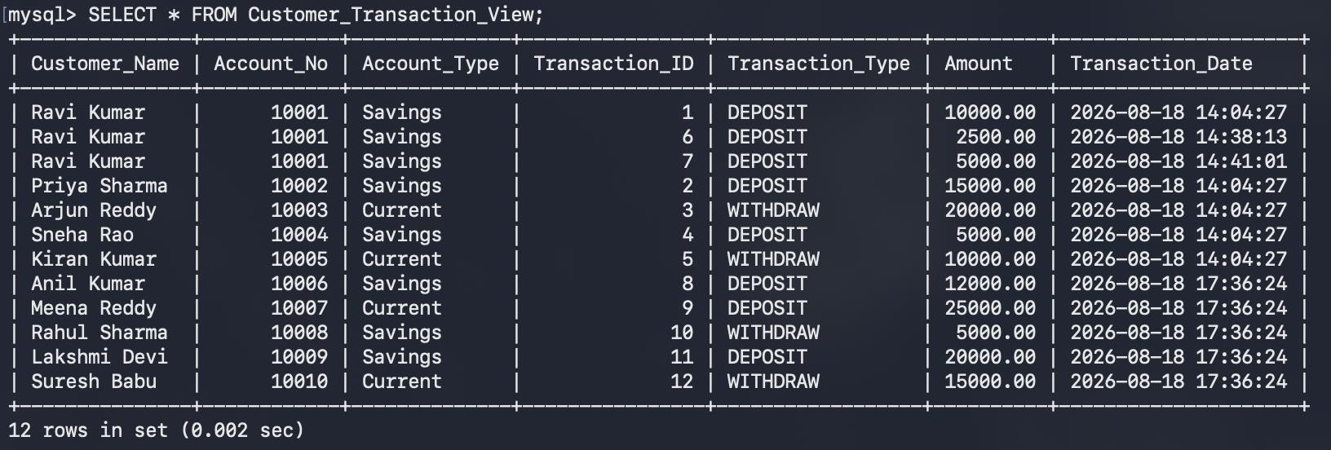

- HIGH VALUE TRANSACTION VIEW
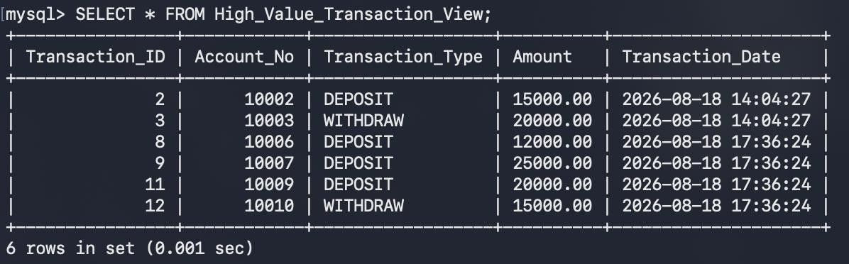

PART H — VIEWS WITH ORDER BY

- ACCOUNTS ORDERED BY BALANCE
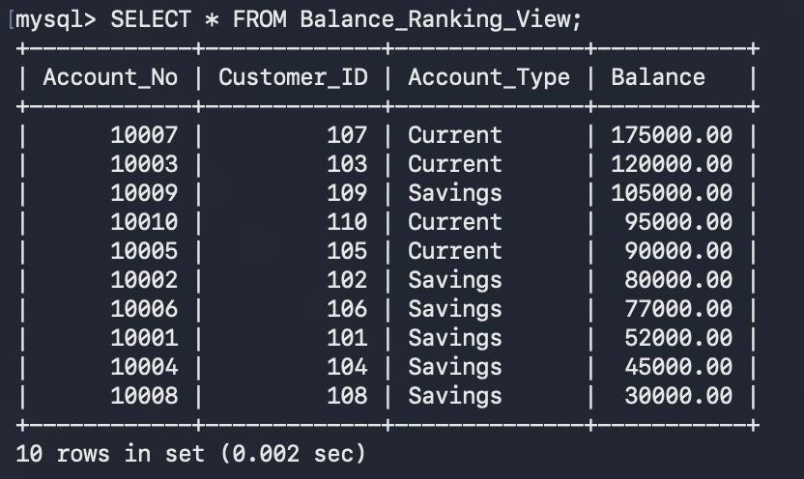

- CUSTOMERS ORDERED BY NAME
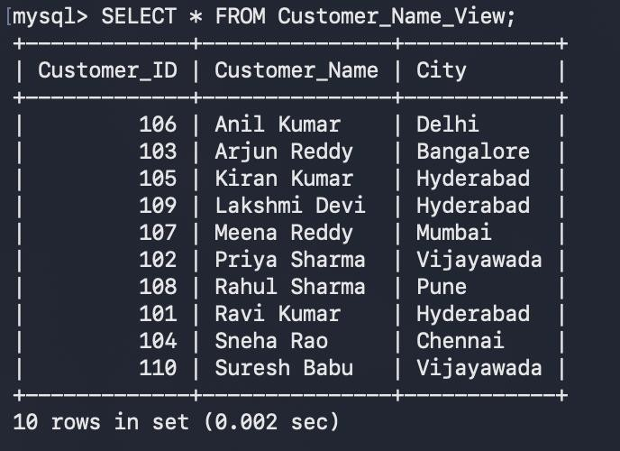

PART I — VIEW WITH CALCULATED COLUMN

- LOAN INTEREST CALCULATION VIEW
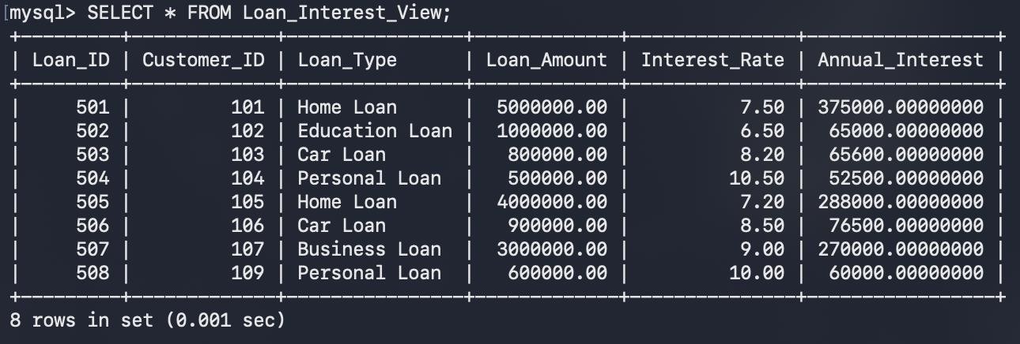

- LOAN TOTAL AMOUNT VIEW
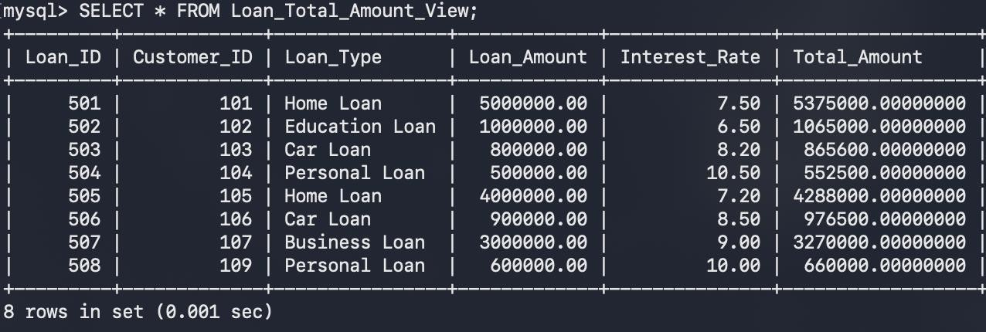

PART J — USING VIEW WITH QUERIES

- DISPLAY HIGH BALANCE ACCOUNTS FROM VIEW
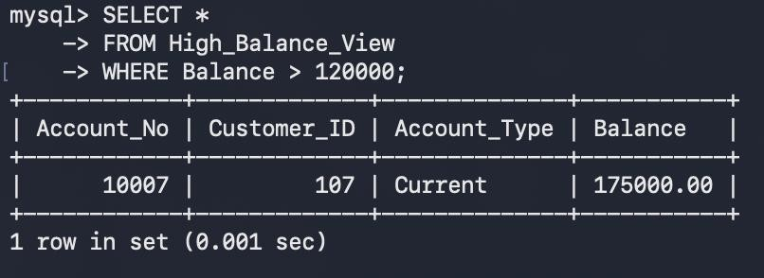

- DISPLAY SAVINGS ACCOUNTS ABOVE 60000
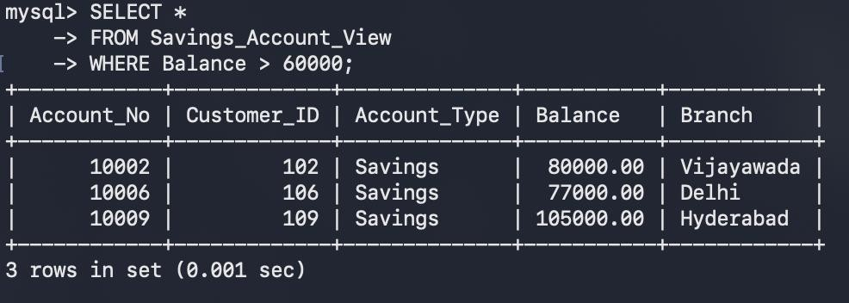

- DISPLAY HYDERABAD ACCOUNTS ABOVE 50000
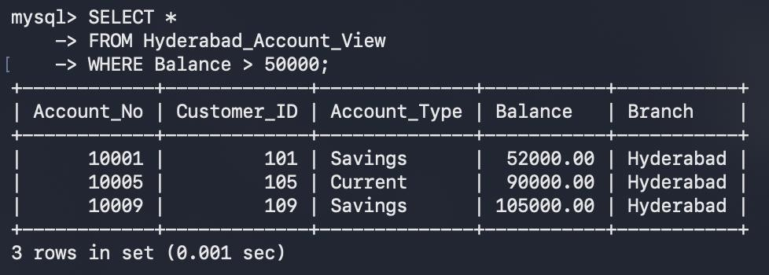

- DISPLAY CUSTOMERS FROM HYDERABAD
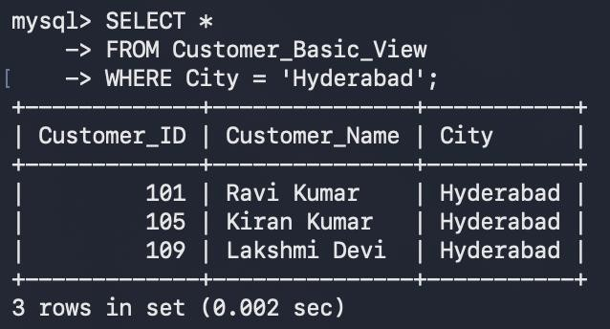

- DISPLAY CUSTOMER ACCOUNTS ORDERED BY BALANCE
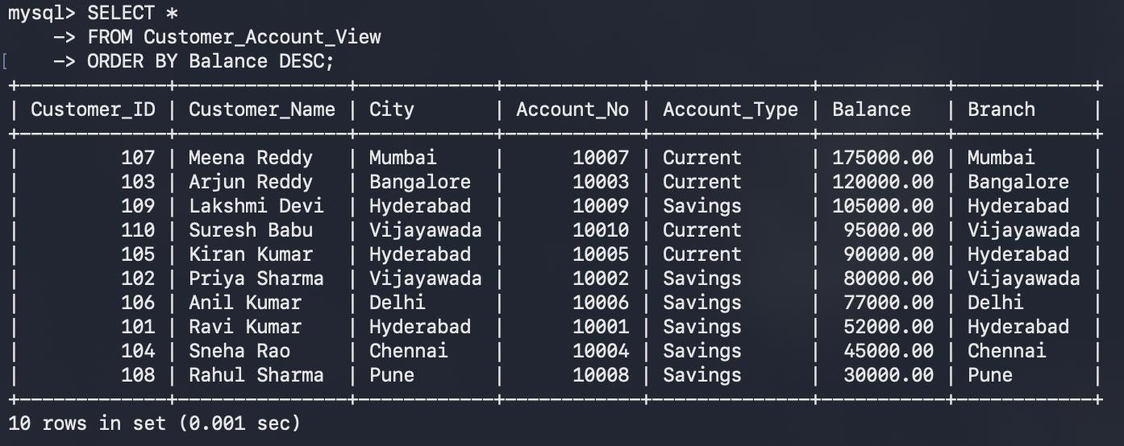
- DISPLAY LOANS ABOVE 1000000
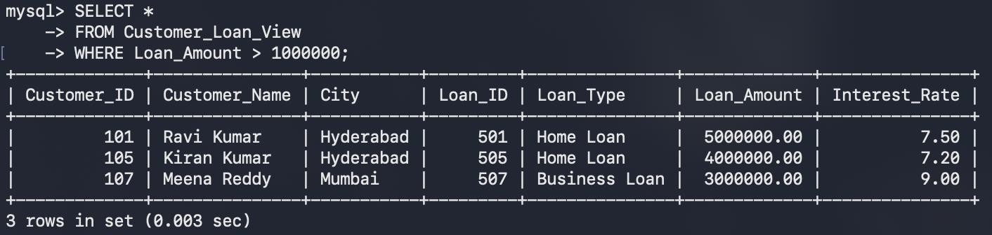

PART K — UPDATING A VIEW

- UPDATE ACCOUNT BALANCE THROUGH VIEW
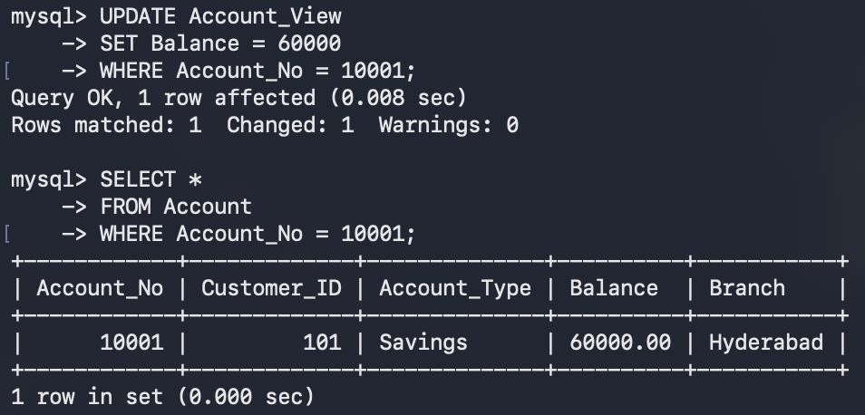

PART L — INSERT THROUGH VIEW

- INSERT USING SIMPLE VIEW
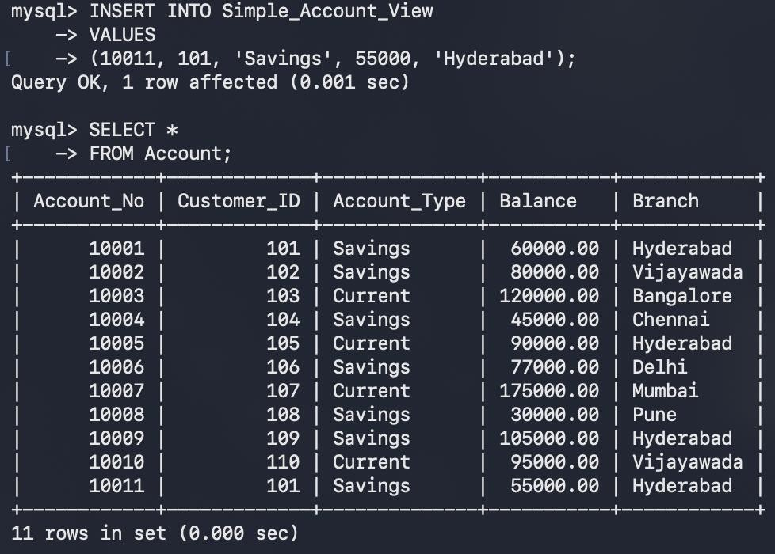

PART M — DELETE THROUGH VIEW

- DELETE USING SIMPLE VIEW
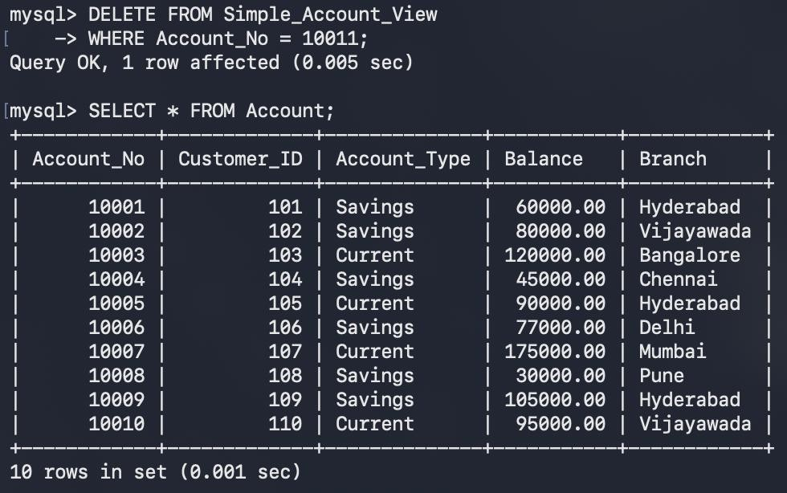

PART N — VIEW INFORMATION
- SHOW ALL VIEWS
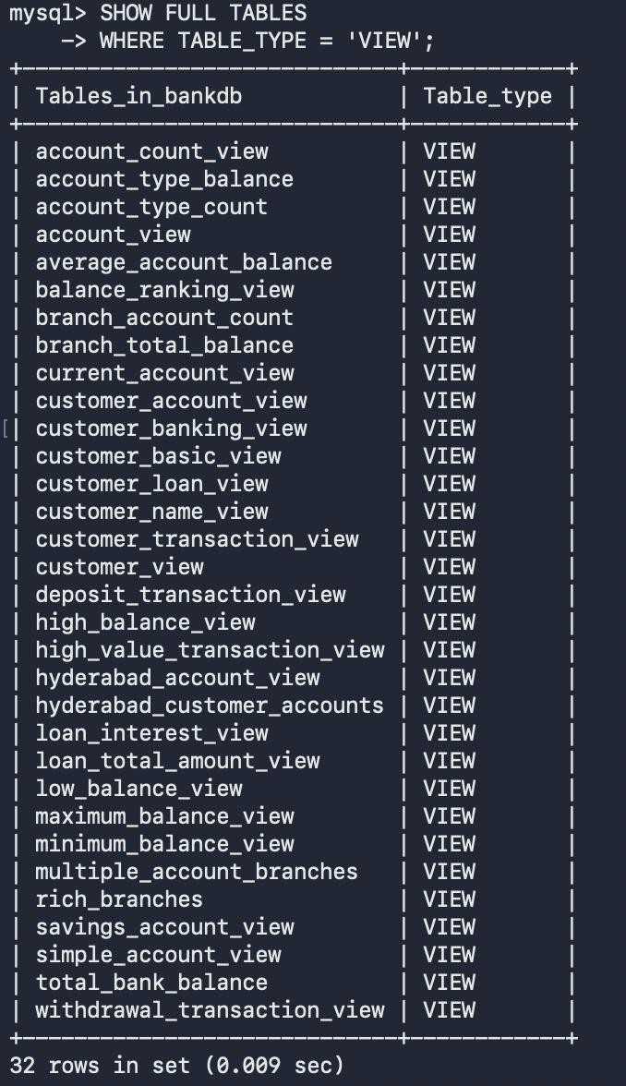

- SHOW VIEW DEFINITION
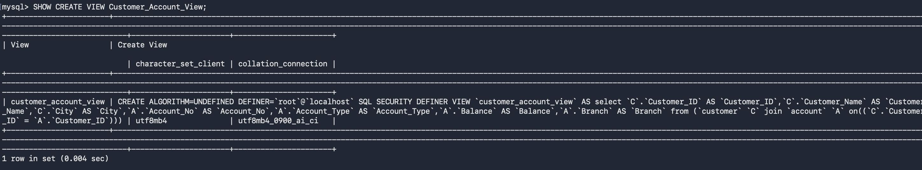

- DESCRIBE VIEW
