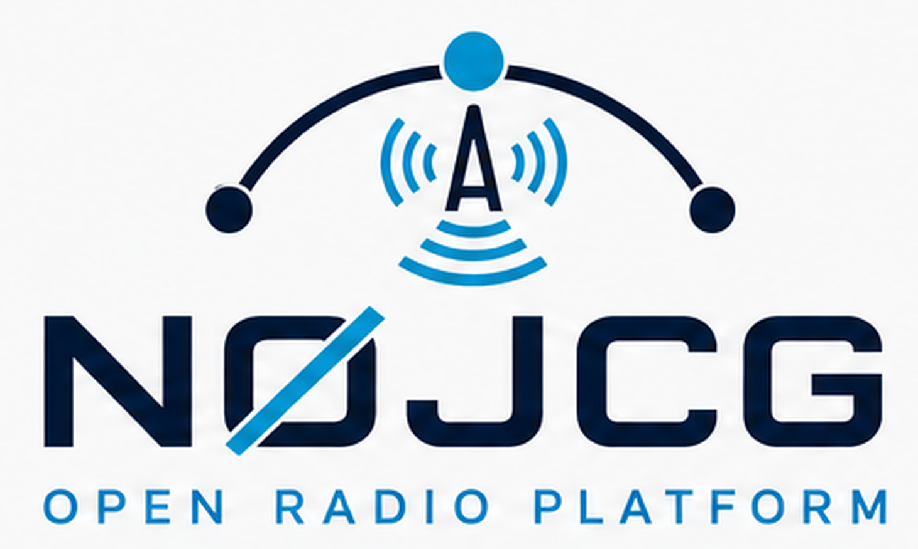
N0JCG AIR TRAFFIC CENTER
END USER GUIDE
Operate the map, traffic sources, weather radar, and receive-only aviation audio
Version 1.0.0 | Status: Release baseline | Owner: N0JCG Open Radio Platform | August 7, 2026
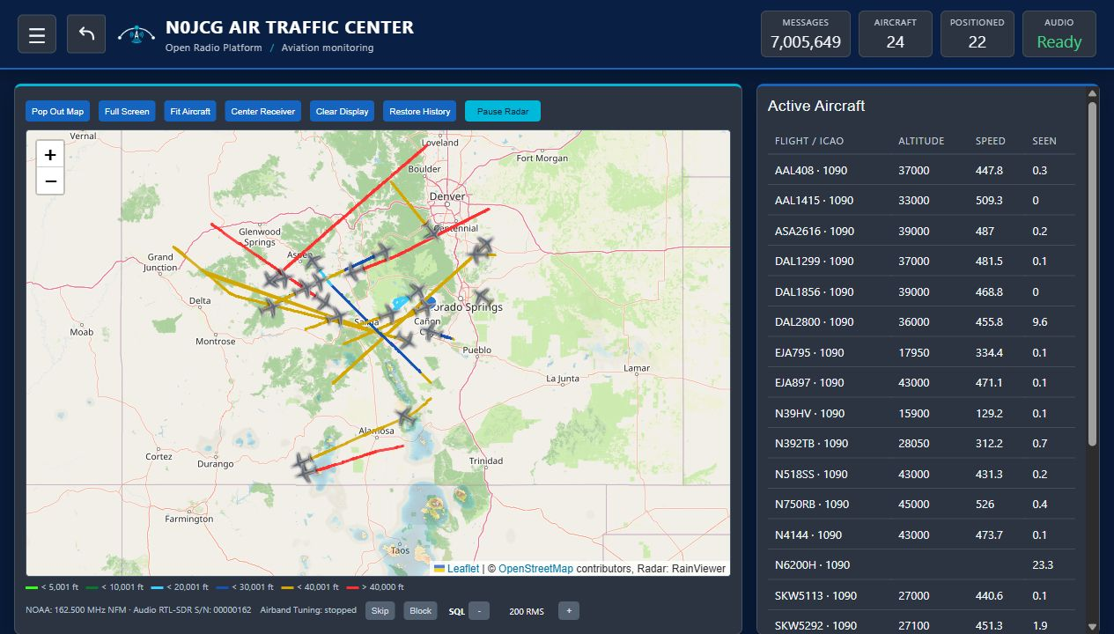
Live dashboard overview captured from the ROC test deployment | N0JCG Air Traffic Center v1.0.0
SCOPE This guide is for normal operation of the browser interface. Pi installation, receiver ownership, and recovery procedures are included for maintainers; browser screenshots show UI state only and do not by themselves prove antenna, decoder, or audio hardware health.

At a glance
N0JCG Air Traffic Center is a Raspberry Pi 5 browser application for receive-only aviation monitoring. It combines aircraft traffic from ADS-B and optional UAT, a weather radar overlay, NOAA Weather Radio and civil Airband controls, and a detail view for aircraft enrichment.
Item | Value
Default browser URL | http://<pi-lan-ip>:8090
Service | pi-air-traffic-tracker.service
Product version | 1.0.0
Primary platform | Raspberry Pi 5 / Linux
Operating boundary | Receive-only monitoring; not a navigation or safety-of-flight system

Contents
- 1. Understand the dashboard
- 2. Before you begin
- 3. Open and validate the app
- 4. Operate traffic and audio sources
- 5. Use the aircraft detail view
- 6. Weather radar and map controls
- 7. Maintenance and recovery
- 8. Operator checklist and limitations
QUICK START Open the browser URL, confirm the header status reads Audio Ready when audio is expected, check the traffic counters, and select an aircraft row to inspect its details. Use the menu for receiver controls and the ROC back button to return to the parent dashboard.

1. Understand the dashboard
The dashboard is state-first: the header and status cards expose what the app believes is active, while the map and table provide the operational view. A live deployment can have no aircraft, incomplete enrichment, or unavailable audio while the web page itself remains reachable.

Dashboard: branded header, status cards, map, aircraft trails, and active-aircraft list | N0JCG Air Traffic Center v1.0.0
Area | What to look for
Header | N0JCG identity, menu control, and the back button to the ROC dashboard.
Status cards | Messages, aircraft count, positioned count, and audio readiness.
Map | Aircraft markers, trails, receiver location, and optional radar overlay.
Active aircraft | Rows can be selected to open a detail card; values depend on decoded and enriched data.
EXPECTED RESULT The page loads without a blank shell, the map has a usable base layer, and the status cards update as the backend publishes data.

2. Before you begin
The normal operator only needs a browser on the same LAN as the Pi. Maintainers working on the Pi should confirm the receiver labels and serials before starting or changing services.
Role | Receiver / source | Permanent serial
NOAA / Airband | Nooelec NESDR Nano2+; 162 MHz NFM and civil Airband AM | 00000162
ADS-B 1090 | Nooelec FlyCatcher ADS-B side; application-owned readsb | 00001090
UAT 978 | Nooelec FlyCatcher UAT side; dump978-fa when enabled | 00000978
SAFETY BOUNDARY Do not swap serial assignments casually. Stop receiver-owning services before EEPROM work, back up each EEPROM, fully power-cycle after writes, and never run a second readsb service beside the application-owned decoder.

Receiver ownership
- The VHF antenna belongs on the Nano2+ assigned 00000162.
- The 1090 MHz antenna belongs on the FlyCatcher ADS-B side assigned 00001090.
- The 978 MHz antenna belongs on the FlyCatcher UAT side assigned 00000978.
- NOAA and Airband share 00000162 and cannot own that receiver simultaneously.

3. Open and validate the app

Open the browser interface
Use the current LAN address of the Pi. The default port is 8090.
http://<pi-lan-ip>:8090
For a known installation, the URL may look like:
http://192.168.68.137:8090

Validate the Pi service
These checks are for a maintainer with shell access. Run them on the Pi, not in the browser address bar.
sudo systemctl status pi-air-traffic-tracker.service --no-pager
curl -fsS http://127.0.0.1:8090/api/status | jq
- Confirm the service is active and the API returns JSON.
- Confirm receiver_roles identify 00000162, 00001090, and 00000978 as configured.
- If the service is active but the UI is empty, inspect the service journal and receiver ownership before changing browser settings.
RECOVERY A browser refresh is safe for a stale page. A service restart is an administrative action and can interrupt active receiver and audio sessions; use it only when the service or backend requires recovery.

4. Operate traffic and audio sources

Use the operator menu
Select the menu button in the header. The drawer groups operational controls below the app identity and keeps the map visible behind a dimmed backdrop.
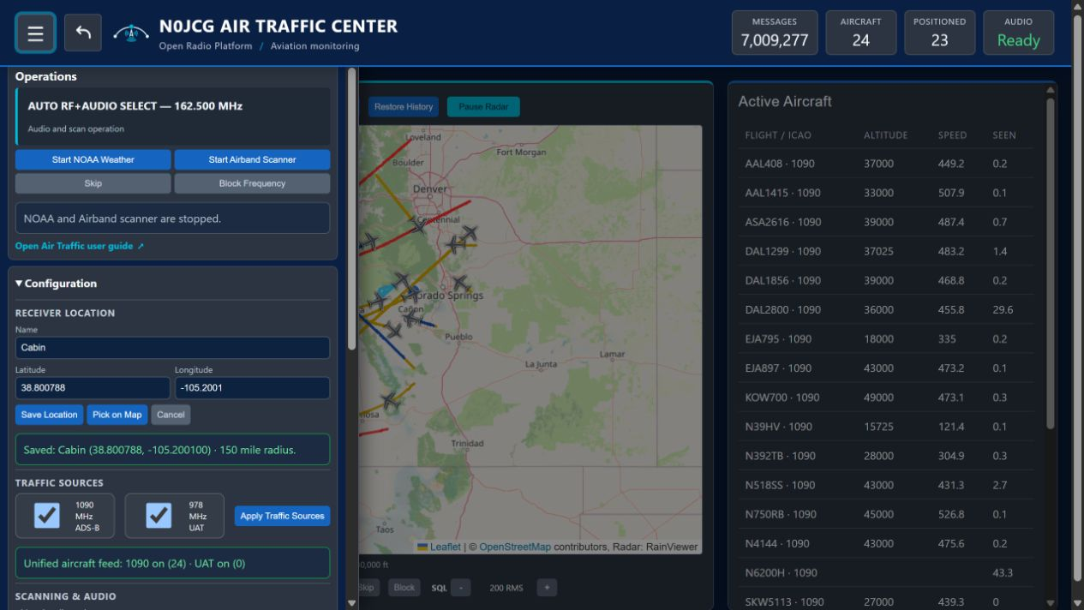
Operator menu: navigation, user guide link, audio controls, receiver location, and traffic sources | N0JCG Air Traffic Center v1.0.0
The menu includes the user guide link and the back button target used to return to the ROC dashboard. Close the drawer with the menu button or its normal close action.

NOAA Weather Radio
- Open the NOAA Weather controls from the menu.
- Select Start NOAA Weather and choose a scan or frequency as provided by the deployment.
- Confirm the UI reports an active state before expecting audio.
- Stop NOAA before starting civil Airband, because both share receiver 00000162.

Civil Airband
- Stop NOAA if it is active.
- Open Airband controls and start the receive-only audio mode.
- Use squelch and skip/block controls to manage the listening experience; the exact controls available depend on the current UI state.
EXPECTED RESULT Audio readiness is explicit in the header/status area. An enabled control is not the same as confirmed RF reception; verify with the active state, service logs, and the connected audio path when troubleshooting.

5. Use the aircraft detail view
Select an aircraft marker or active-aircraft row to open its detail card. The card presents the data currently available from decoded traffic and optional enrichment services.
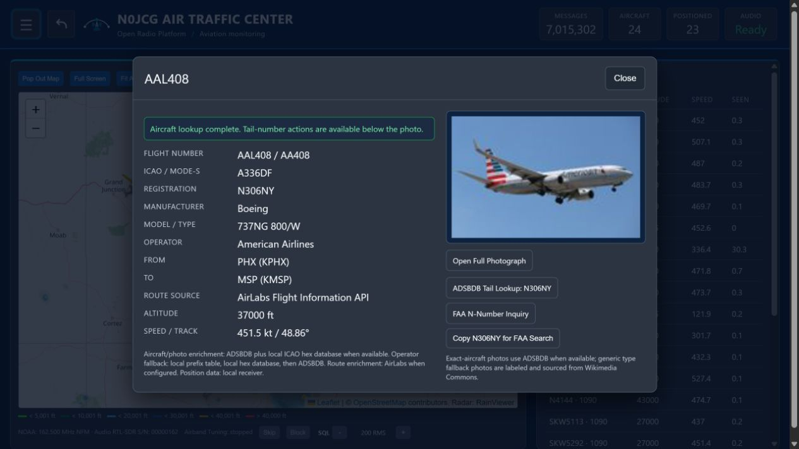
Aircraft detail card: identity, route, position, and available enrichment | N0JCG Air Traffic Center v1.0.0
Field group | Meaning
Identity | Flight, ICAO address, registration, type, and operator when available.
Route | Departure and destination codes when enrichment has a matching route.
Position | Altitude, speed, track, and last-update information from decoded traffic.
Photo / enrichment | Optional external data; availability and accuracy depend on the configured service.
INTERPRETATION Missing route, photo, or registration data is not automatically a decoder failure. Treat decoded position and enrichment as separate data paths and use the live status/API when diagnosing gaps.

6. Weather radar and map controls
Weather radar is a browser-side overlay and requires internet access from the browser. The application keeps the displayed frame visible while the next frame loads, so a slow network should not create a distracting blank or fade between frames.
- Use the Weather Radar menu to enable the overlay and adjust opacity.
- Use the map controls to pan and zoom without changing receiver configuration.
- Aircraft trails and radar are separate layers; disabling one should not remove the other.
- If radar is unavailable while the map works, check browser internet access and external tile/radar availability before restarting the Pi service.
EXPECTED RESULT The last usable radar frame remains visible during a normal frame transition. A browser or external tile failure may still prevent new frames from loading.

7. Maintenance and recovery

Routine service commands
sudo systemctl restart pi-air-traffic-tracker.service
sudo systemctl stop pi-air-traffic-tracker.service
sudo systemctl start pi-air-traffic-tracker.service
sudo journalctl -u pi-air-traffic-tracker.service -n 200 --no-pager

Common symptoms
Symptom | First checks | Recovery
Receiver busy | Check competing readsb/dump1090 services and USB ownership. | Stop the conflicting service; keep the app-owned decoder as the owner.
No aircraft | Check receiver_roles, antenna connection, decoder logs, and recent messages. | Correct ownership/configuration, then restart the app service if needed.
No NOAA scan | Confirm VHF antenna and serial 00000162; inspect USB claim errors. | Stop other audio mode and retry after service health is confirmed.
Radar blank | Check browser internet and radar/tile availability. | Refresh or disable/re-enable the overlay; do not change receiver settings.

Update workflow
- Back up local configuration and note the current version.
- Deploy the intended standalone repo revision to the Pi.
- Run the project installer/validator and confirm the service starts.
- Open the browser URL and compare status, map, traffic list, and menu behavior.
- Record any receiver or audio validation separately from browser UI validation.

8. Operator checklist and limitations
Use this short checklist after a deployment, reboot, or significant configuration change.
- The browser opens at the current Pi LAN address on port 8090.
- The N0JCG header, menu, ROC back button, and user guide link are visible.
- Status cards update and the API is reachable on the Pi.
- ADS-B 1090 is owned by serial 00001090; UAT 978 is 00000978 when enabled.
- NOAA/Airband ownership is 00000162 and only one VHF audio mode is active at a time.
- Aircraft rows open detail cards without confusing missing enrichment for missing RF data.
- Radar behavior is checked from the browser network path, not inferred from receiver state.
LIMITATIONS N0JCG Air Traffic Center is a receive-only monitoring tool. It is not a certified navigation, separation, emergency, weather-warning, or safety-of-flight system. Do not use its display as a substitute for official aviation information or operational procedures.

Reference paths
Resource | Location
Source repository | N0JCG-AIR-TRAFFIC-CENTER (legacy checkout: PI-AIR-TRAFFIC-TRACKER)
Service | pi-air-traffic-tracker.service
API status | http://127.0.0.1:8090/api/status on the Pi
Detailed maintainer guide | docs/PI_AIR_TRAFFIC_TRACKER_USER_GUIDE.md
Release scope | docs/RELEASE_V1_0_0.md
Screenshot note: the screenshots in this publication were captured from the ROC test deployment on August 7, 2026. Live traffic values, aircraft identities, radar frames, and enrichment results will change over time.

