
N0JCG WINLINK EMAIL SERVER
End User Guide
Client-side Winlink email for the N0JCG Open Radio Platform
PRODUCT ROLE
A Raspberry Pi client appliance for private Winlink mailbox access through an external Packet RMS gateway. The appliance is not an RMS gateway.

Version 1.0 | Host role: PI-WINLINK

At a glance
N0JCG Winlink Email Server places the operator console, Winlink Client mailbox, local drafts and queues, and the webmail experience on one Raspberry Pi appliance. The external radio and Packet RMS gateway provide the radio transport.
THE OPERATING MODEL
Browser -> N0JCG webmail and operator console -> N0JCG management layer -> Winlink Client mailbox and transport -> DigiRig Mobile -> radio -> external Packet RMS gateway.

Surface | Use it for | Address
Operator console | Configuration, status, diagnostics, and safety controls | http://PI-IP:8096/ui/
User webmail | Inbox, compose, drafts, folders, signature, and queue | http://PI-IP:8096/webmail/
Deployment helper | Install and upgrade from MSYS2 Bash | ./deploy/push_to_pi.sh

Capability boundary
- The appliance can be installed and configured before the radio is connected.
- USB detection is evidence that the operating system saw a device; it is not proof of audio, PTT, packet, or RF operation.
- Transmission stays disabled until the operator explicitly configures and verifies the radio path.

1. Getting started

Required hardware
- Raspberry Pi 4 with 64-bit Debian/Raspberry Pi OS and reliable power
- microSD card with the operating system installed
- DigiRig Mobile audio/PTT interface and USB cable
- Compatible amateur radio with packet/data audio and PTT connections
- Radio-specific interface cables
- Ethernet or Wi-Fi network connection
- A workstation on the same network running MSYS2 Bash, Git, OpenSSH, and sshpass

Helpful accessories
- Powered USB hub for multiple peripherals
- Keyboard and display for recovery
- Labeled cables
- UPS or clean 5 V power for unattended use
PRE-RADIO SETUP
Software, branding, accounts, and webmail can be prepared before the radio is connected. Complete the software setup first, then bring up the radio as a controlled receive-first procedure.

2. Install from MSYS2 Bash
The official deployment helper copies the complete application to the Pi, runs the installer, and verifies that the webmail service is active.

Prepare the workstation
1. Open MSYS2 UCRT64 or MSYS2 MSYS Bash.
2. Install the deployment tools with: pacman -S --needed git openssh sshpass
3. Clone the repository: git clone https://github.com/bakstaaj/N0JCG-WINLINK-EMAIL-SERVER.git
4. Enter the repository: cd N0JCG-WINLINK-EMAIL-SERVER

Run the guided deployment
./deploy/push_to_pi.sh
The helper prompts for the Raspberry Pi IP address, SSH username, and SSH password. The default address is 192.168.68.149 and the default SSH username is pi, but these values are intended to be changed for another installation.

Operator authentication
During the initial install, the installer asks for an Nginx operator-console username, password, and password confirmation. Existing operator authentication is preserved during normal upgrades.
RECONFIGURE OPERATOR AUTH
Use ./deploy/push_to_pi.sh PI-IP PI-USER --configure-operator-auth when the operator account must be intentionally changed.

Verify
1. Open http://PI-IP:8096/ui/ from a workstation on the same network.
2. Open http://PI-IP:8096/webmail/.
3. Confirm the deployment helper reports that the API was deployed and n0jcg-webmail.service is active.

3. First-time setup

Operator console
Sign in to the operator console with the credentials created by the installer. Review the host identity, service state, DigiRig/USB detection, Winlink Client readiness, radio profile, Packet settings, and diagnostics before connecting RF equipment.

Webmail account
Open the webmail address and select Sign in with Winlink. Enter the user’s Winlink email address and secure-login password. The appliance validates the credentials against Winlink before opening the private local mailbox for that callsign.
PRIVATE MAILBOX MODEL
Mailbox access is isolated by callsign. A user cannot select another user’s mailbox from a URL or browser control.

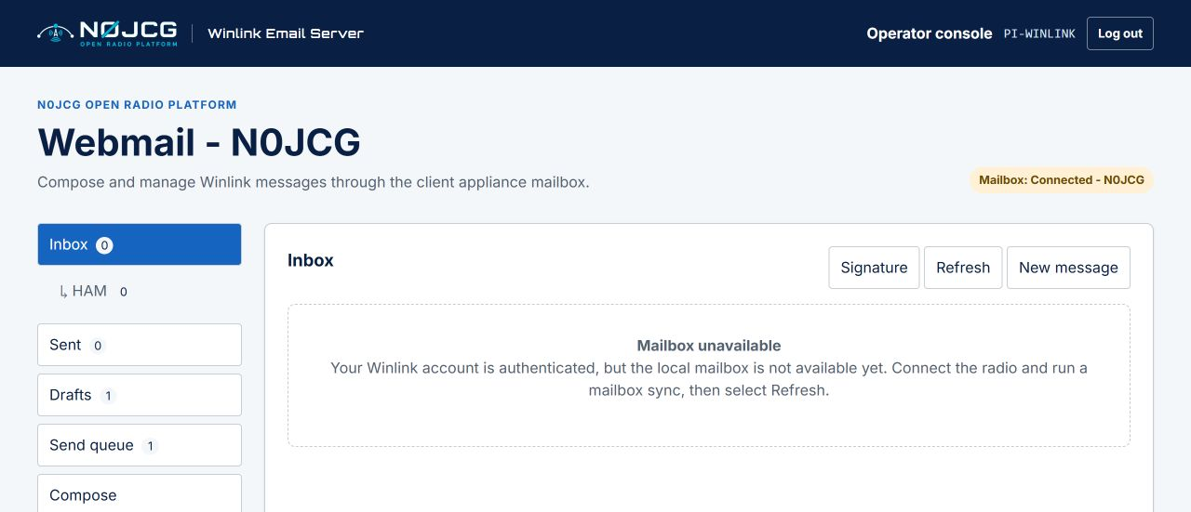
Figure 1. N0JCG webmail inbox and mailbox status on the client appliance.

4. Everyday webmail

Compose a message
Select New message to open a blank form. Enter the Winlink recipient, subject, and message body. Select Save draft when work should remain local, or use the send control when the operator has enabled a verified transport path.
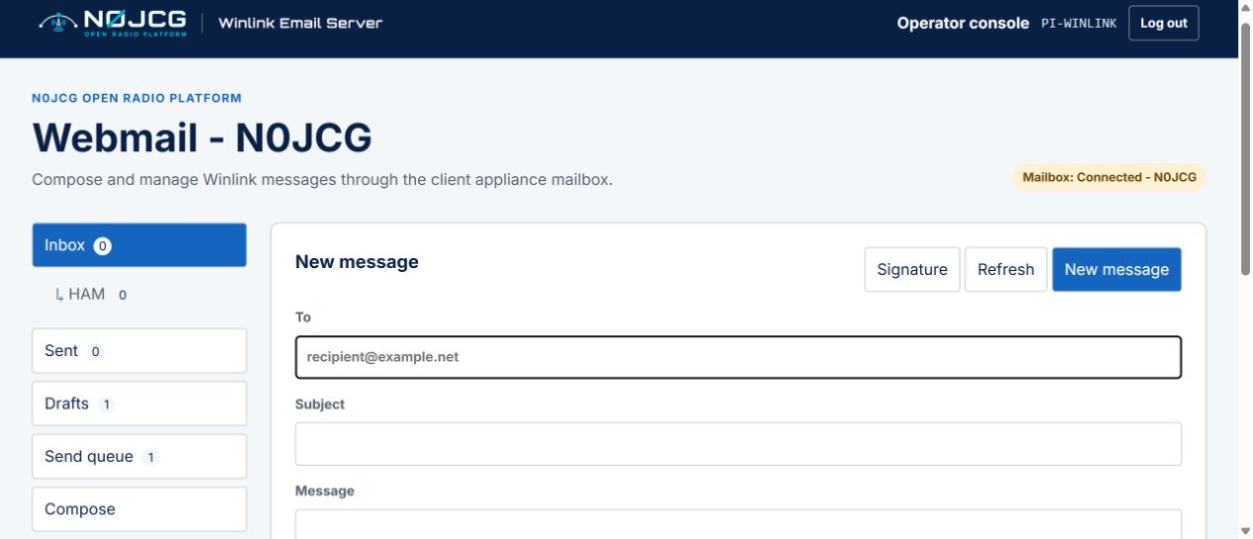
Figure 2. New message panel with attachment controls and the N0JCG navigation shell.

Drafts, attachments, and signature
- The Drafts counter updates after saving. Open a draft to continue editing or delete it from the Drafts panel.
- Attachments are limited to 100 KB. A warning appears above 10 KB because packet-radio transfer may be slow.
- Select Signature to save a per-user signature. It is restored after the next login for that Winlink callsign.
- Use Log out when leaving a shared workstation.

Folders
Custom folders are shown indented under Inbox. Create and delete folders from Manage folders, then drag an Inbox message onto a folder to organize it.

5. Connect and verify the radio
1. Power off the radio and Raspberry Pi before changing audio/PTT cabling.
2. Connect the DigiRig Mobile to the radio with the correct radio-specific cables.
3. Connect the DigiRig Mobile directly to a Raspberry Pi USB 3 port or powered USB hub.
4. Power the radio, DigiRig Mobile, and Raspberry Pi.
5. Confirm the operator console reports expected USB/audio/serial devices as Detected.
6. Configure the radio profile, audio levels, PTT method, and selected Packet RMS gateway.
7. Perform receive-only checks before enabling transmit behavior.
8. Enable transmission only after the operator has verified the radio path and local regulations.
SAFETY RULE
Do not enable transmit merely because a DigiRig or USB device is present. Detection is hardware evidence only; PTT and RF behavior require separate verification.

What the gateway means here
The Packet RMS gateway is an external Winlink service reached over the radio path. This product is the client-side email server and does not host or replace that gateway.

6. Troubleshooting

Mailbox unavailable
This means the Winlink account was authenticated, but the local mailbox service is not currently available. It is not a request for the user to type a command. Connect the radio and run a mailbox synchronization, then select Refresh. If the message persists, the operator should review the client service and diagnostics.

Login fails
Confirm the Winlink address and secure-login password. Check the Pi network connection and system time. Repeated failed attempts are rate-limited for protection.

Device detected but not ready
Check the correct radio cable, audio routing, serial/PTT configuration, and radio power. Do not enable transmit based on USB detection alone.

Deployment verification fails
Rerun the deployment helper from MSYS2 Bash and confirm the Pi IP address, SSH username, and SSH password. Use the diagnostic helper for a status report:
./deploy/inspect_pi_webmail.sh

Quick reference
Task | Location
Deploy or upgrade | ./deploy/push_to_pi.sh in MSYS2 Bash
Diagnostics | ./deploy/inspect_pi_webmail.sh
Operator console | http://PI-IP:8096/ui/
User webmail | http://PI-IP:8096/webmail/
Default SSH user | pi
Product host role | PI-WINLINK
Maximum attachment | 100 KB
Attachment warning | Above 10 KB

SUPPORT CHECKLIST
When requesting help, include the appliance IP address, the page being used, the exact visible message, whether the radio is connected, and the output of inspect_pi_webmail.sh. Never include passwords.

