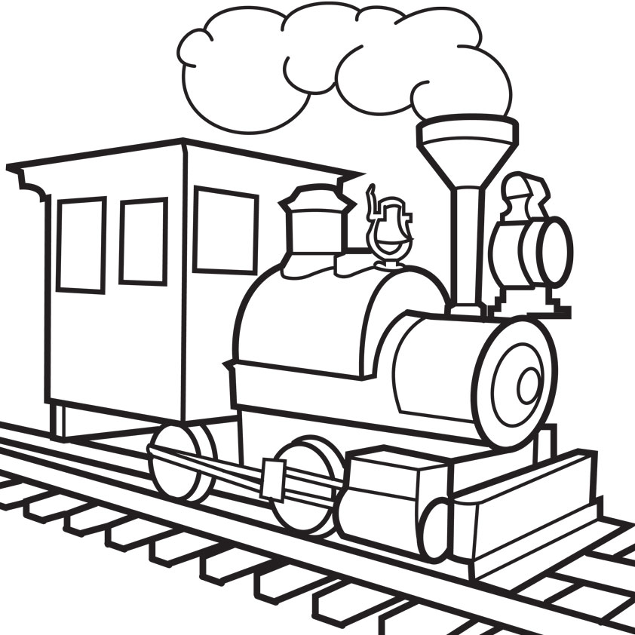
TRAIN 1, 2, 3 OSE
games for the Atari 5200 console
© 2020 BAHA Software
Petr Postava & Michael Kalouš

Gameplay
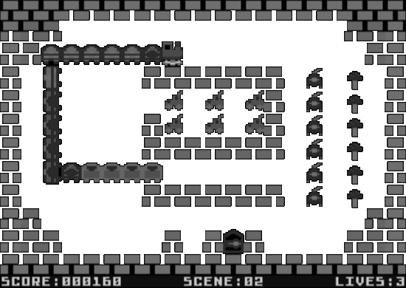
You are a cargo train driver and your mission is to load all cargo on screen. For every piece of cargo loaded, your train is elongated by one carriage. You must not collide with any obstacle or with your own train. After loading of all items, a gate that allows you to go to the next screen is opened. The goal of the game is to finish all screens and maximize your score. The difficulty of the screens increases. In the later stages of the game, it is recommended to plan a safe route before starting your locomotive.

Lives and Scoring
You begin the game with three lives. For every item loaded, you get 10 points. After finishing a screen, you will get 200 points for every remaining life. If you lose a life, you lose 300 points. A new life is awarded for every 5000 points. The game ends after losing all lives. A new game can be started from any screen that has been reached already.

Controls
Use joystick or keypad to control the locomotive or to make a selection.
Stick | Keypad | Action
Stick LEFT | 4 | Move left
Stick RIGHT | 6 | Move right
Stick UP | 2 | Move up
Stick DOWN | 5 or 8 | Move down
FIRE |  | Faster/Select
 | START | Start game
 | RESET | Return to menu

Menu and Scene Selection
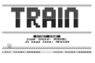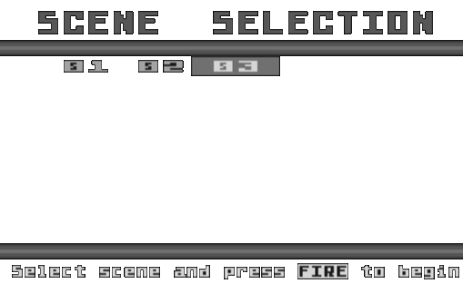
In the main menu, you can start game, change game speed, and select the size of the joystick’s dead zone.
You can begin the game from any screen you have already reached. Position the cursor on the desired screen number and then press FIRE.

Technical Information
The cartridge is designed for the Atari 5200 console with 16 KB of RAM, original Atari 5200 joystick or a fully compatible 3rd party controller.
The cartridge is a 32-KB non-bankswitching diagnostic cartridge. The code was written using the CC65 toolkit – http://cc65.github.io/.

Contact Author
Send e-mail to zylon@post.cz.

