EPID674 Epidemiologic Data Analysis using R

Hypothesis Testing in R

Kelly Bakulski, Lauren Middleton

Last compiled on November 21, 2022

### Install new packages

### Load packages

# Load these packages for the current session  
library(here)  
library(ggcorrplot)  
library(gtsummary)  
library(epiDisplay)  
library(sjlabelled)  
library(tidyverse)

# Load data

# Check the file path  
here("nhanes_class_dataset.rda")

[1] "/cloud/project/nhanes_class_dataset.rda"

# Load the saved R data  
load(here("nhanes_class_dataset.rda"), verbose = TRUE)

Loading objects:  
 nhanes

# Hypothesis testing in R

## Before you begin: Remember to check your distributions/assumptions

# Select the continuous variables to check and transform dataset to long form  
longer_data <- nhanes %>%  
 select(RIDAGEYR,  
 INDFMPIR,  
 LBDLYMNO,  
 LBDNENO,  
 LBXRBCSI,  
 LBXWBCSI,  
 nlr,  
 LBXBCD,  
 LBXBPB,  
 LBXCOT,  
 LBXIRN,  
 URXUAS) %>%  
 remove_all_labels() %>%  
 pivot_longer(everything(), names_to = "variable", values_to = "value")   
  
head(longer_data)

# A tibble: 6 × 2  
 variable value  
 <chr> <dbl>  
1 RIDAGEYR 2  
2 INDFMPIR 5  
3 LBDLYMNO NA  
4 LBDNENO NA  
5 LBXRBCSI NA  
6 LBXWBCSI NA

# Plot the distributions of the raw values  
longer_data %>%  
 ggplot(aes(x = value)) +  
 geom_density() +  
 facet_wrap(~ variable, scales = "free")

Warning: Removed 25934 rows containing non-finite values (stat_density).

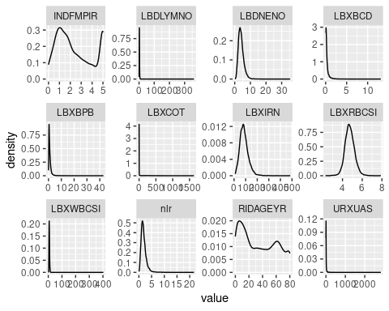

# Are any of these distributions normal?  
  
  
# Plot the distributions of the log transformed values  
longer_data %>%  
 ggplot(aes(x = log(value))) +  
 geom_density() +  
 facet_wrap(~ variable, scales = "free")

Warning: Removed 26382 rows containing non-finite values (stat_density).

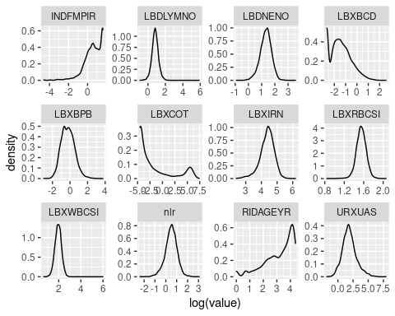

# Are any of the log transformed distributions normal?  
  
# Be sure to use your understanding of the distributions when deciding between parametric and non-parametric tests

## Correlation tests: Comparing two continuous variables

# Correlation test between two continuous variables (default method is Pearson, a parametric test)  
cor.test(nhanes$LBXIRN, nhanes$LBXRBCSI)

Pearson's product-moment correlation  
  
data: nhanes$LBXIRN and nhanes$LBXRBCSI  
t = 10.89, df = 5917, p-value < 2.2e-16  
alternative hypothesis: true correlation is not equal to 0  
95 percent confidence interval:  
 0.1151102 0.1650627  
sample estimates:  
 cor   
0.1401757

# Can request spearman, a non-parametric test for non-normally distributed variables  
cor.test(nhanes$RIDAGEYR, nhanes$INDFMPIR, method = "spearman")

Warning in cor.test.default(nhanes$RIDAGEYR, nhanes$INDFMPIR, method =  
"spearman"): Cannot compute exact p-value with ties

Spearman's rank correlation rho  
  
data: nhanes$RIDAGEYR and nhanes$INDFMPIR  
S = 7.2895e+10, p-value < 2.2e-16  
alternative hypothesis: true rho is not equal to 0  
sample estimates:  
 rho   
0.1530888

## Correlation matrix

# Select the columns of interest  
nhanes_chems <- nhanes %>%  
 select(LBXIRN,  
 LBXCOT,  
 LBXBCD,  
 LBXBPB,  
 LBXWBCSI,  
 LBXRBCSI)  
  
  
# Calculate the correlations, use spearman for non-normally distributed variables  
chem_correlations <- cor(nhanes_chems,  
 use = "pairwise.complete.obs",  
 method = "spearman")  
  
# View the correlation matrix  
chem_correlations

LBXIRN LBXCOT LBXBCD LBXBPB LBXWBCSI  
LBXIRN 1.00000000 -0.01926272 -0.02056100 0.06665300 -0.15056021  
LBXCOT -0.01926272 1.00000000 0.27129009 0.14709065 0.07444648  
LBXBCD -0.02056100 0.27129009 1.00000000 0.46261731 -0.01119554  
LBXBPB 0.06665300 0.14709065 0.46261731 1.00000000 -0.05077459  
LBXWBCSI -0.15056021 0.07444648 -0.01119554 -0.05077459 1.00000000  
LBXRBCSI 0.15953053 0.02781844 -0.06204764 0.02625293 0.08120104  
 LBXRBCSI  
LBXIRN 0.15953053  
LBXCOT 0.02781844  
LBXBCD -0.06204764  
LBXBPB 0.02625293  
LBXWBCSI 0.08120104  
LBXRBCSI 1.00000000

# Plot the correlations with ggcorrplot  
ggcorrplot(chem_correlations,  
 type = "lower",  
 outline.col = "white",  
 lab = TRUE)

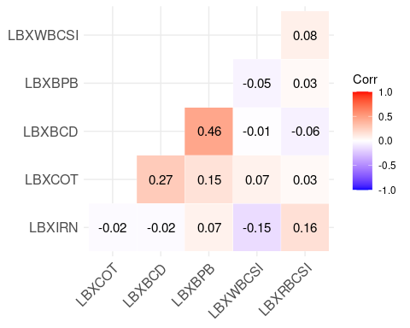

## Check your understanding

What is the relationship between urinary arsenic (URXUAS) and neutrophil/lymphocyte ratio (nlr)? * Make a new code chunk * What type of variables are they? What are their distributions? * What is the appropriate test to run? * Run the test and interpret the output * Does this match your expectations?

# Comparing 1 categorical and 1 continuous variable

## T-test: Independent variable dichotomous, dependent variable continuous, parametric test

# The relationship between sex and iron concentration:  
# What do you expect?  
  
# Calculate mean of iron concentration by sex  
nhanes %>%  
 group_by(sex) %>%  
 summarise(mean_iron = mean(LBXIRN, na.rm = TRUE)) %>%  
 ungroup()

# A tibble: 2 × 2  
 sex mean_iron  
 <fct> <dbl>  
1 Male 93.8  
2 Female 79.1

# T-test of iron and sex: Parametric test with normally distributed dependent variable  
t.test(nhanes$LBXIRN ~ nhanes$sex) #What do you get?

Welch Two Sample t-test  
  
data: nhanes$LBXIRN by nhanes$sex  
t = 15.678, df = 5901.7, p-value < 2.2e-16  
alternative hypothesis: true difference in means between group Male and group Female is not equal to 0  
95 percent confidence interval:  
 12.83508 16.50353  
sample estimates:  
 mean in group Male mean in group Female   
 93.8048 79.1355

# Do they match?  
  
# Calculated within a bivariate table  
nhanes %>%  
 select(sex,  
 LBXIRN) %>%  
 tbl_summary(by = sex, #stratify by sex  
 statistic = all_continuous() ~ "{mean} ({sd})",  
 missing_text = "Missing (n)"  
 ) %>%  
 add_p(LBXIRN ~ "t.test") %>%  
 modify_header(label ~ "**Variable**") %>%  
 bold_labels()

Table printed with {flextable}, not {gt}. Learn why at  
https://www.danieldsjoberg.com/gtsummary/articles/rmarkdown.html  
To suppress this message, include `message = FALSE` in the code chunk header.

**Table** **:** Iron levels by sex

| Variable | Male, N = 4,5571 | Female, N = 4,6971 | p-value2 |
| --- | --- | --- | --- |
| **Iron frozen, Serum (ug/dL)** | 94 (36) | 79 (36) | <0.001 |
| Missing (n) | 1,683 | 1,649 |  |
| 1Mean (SD) | | | |
| 2Welch Two Sample t-test | | | |

## Working with a non-normally distributed variable

## T-test and Wilcoxon test: Independent variable dichotomous, dependent variable continuous

# The relationship between sex and blood Pb  
nhanes %>%  
 group_by(sex) %>%  
 summarise(mean_lead = mean(LBXBPB, na.rm = TRUE),  
 mean_log_lead = mean(log(LBXBPB), na.rm = TRUE)) %>%  
 ungroup()

# A tibble: 2 × 3  
 sex mean_lead mean_log_lead  
 <fct> <dbl> <dbl>  
1 Male 1.25 -0.100  
2 Female 0.924 -0.374

# T-test: Be sure to log transform blood Pb variable before calculating parametric test statistics  
t.test(log(nhanes$LBXBPB) ~ nhanes$sex)

Welch Two Sample t-test  
  
data: log(nhanes$LBXBPB) by nhanes$sex  
t = 15.17, df = 6837, p-value < 2.2e-16  
alternative hypothesis: true difference in means between group Male and group Female is not equal to 0  
95 percent confidence interval:  
 0.2383423 0.3090824  
sample estimates:  
 mean in group Male mean in group Female   
 -0.1004491 -0.3741614

# Wilcoxon test: Non parametric test, no need to transform variables  
wilcox.test(nhanes$LBXBPB ~ nhanes$sex)

Wilcoxon rank sum test with continuity correction  
  
data: nhanes$LBXBPB by nhanes$sex  
W = 7127720, p-value < 2.2e-16  
alternative hypothesis: true location shift is not equal to 0

## ANOVA: Independent variable 3+ categories, dependent variable continuous, parametric test

# The relationship between age and blood Pb:  
nhanes %>%  
 group_by(age_groups) %>%  
 summarise(mean_lead = mean(LBXBPB, na.rm = TRUE),  
 mean_log_lead = mean(log(LBXBPB), na.rm = TRUE)) %>%  
 ungroup()

# A tibble: 5 × 3  
 age_groups mean_lead mean_log_lead  
 <fct> <dbl> <dbl>  
1 [0,16] 0.566 -0.760  
2 (16,32] 0.738 -0.601  
3 (32,48] 1.03 -0.277  
4 (48,64] 1.45 0.143  
5 (64,80] 1.64 0.292

# ANOVA test  
aov(log(nhanes$LBXBPB) ~ nhanes$age_groups)

Call:  
 aov(formula = log(nhanes$LBXBPB) ~ nhanes$age_groups)  
  
Terms:  
 nhanes$age_groups Residuals  
Sum of Squares 1177.830 2798.378  
Deg. of Freedom 4 6879  
  
Residual standard error: 0.6378089  
Estimated effects may be unbalanced  
2370 observations deleted due to missingness

anova(aov(log(nhanes$LBXBPB) ~ nhanes$age_groups))

Analysis of Variance Table  
  
Response: log(nhanes$LBXBPB)  
 Df Sum Sq Mean Sq F value Pr(>F)   
nhanes$age_groups 4 1177.8 294.457 723.84 < 2.2e-16 ***  
Residuals 6879 2798.4 0.407   
---  
Signif. codes: 0 '***' 0.001 '**' 0.01 '*' 0.05 '.' 0.1 ' ' 1

# How do we interpret the p-value from an ANOVA test?  
  
# Pairwise t-test  
pairwise.t.test(log(nhanes$LBXBPB), nhanes$age_groups)

Pairwise comparisons using t tests with pooled SD   
  
data: log(nhanes$LBXBPB) and nhanes$age_groups   
  
 [0,16] (16,32] (32,48] (48,64]  
(16,32] 9e-11 - - -   
(32,48] <2e-16 <2e-16 - -   
(48,64] <2e-16 <2e-16 <2e-16 -   
(64,80] <2e-16 <2e-16 <2e-16 5e-10   
  
P value adjustment method: holm

# Pairwise t-test with bonferroni adjustment  
pairwise.t.test(log(nhanes$LBXBPB), nhanes$age_groups,  
 p.adj = "bonferroni")

Pairwise comparisons using t tests with pooled SD   
  
data: log(nhanes$LBXBPB) and nhanes$age_groups   
  
 [0,16] (16,32] (32,48] (48,64]  
(16,32] 4.5e-10 - - -   
(32,48] < 2e-16 < 2e-16 - -   
(48,64] < 2e-16 < 2e-16 < 2e-16 -   
(64,80] < 2e-16 < 2e-16 < 2e-16 5.0e-09  
  
P value adjustment method: bonferroni

# Comparing two categorical variables

## Chi-square test: Parametric test

# The relationship between sex and education:  
table(nhanes$sex, nhanes$education)

Less than high school Less than 5th grade High school or GED  
 Male 1050 570 745  
 Female 1005 572 735  
   
 More than high school  
 Male 1480  
 Female 1705

# Chi-square test  
chisq.test(nhanes$sex, nhanes$education)

Pearson's Chi-squared test  
  
data: nhanes$sex and nhanes$education  
X-squared = 13.195, df = 3, p-value = 0.004234

# Calculated within a bivariate table  
nhanes %>%  
 select(sex,  
 education) %>%  
 tbl_summary(by = sex, #stratify by sex  
 digits = list(all_categorical() ~ c(0, 1)),  
 missing_text = "Missing (n)",  
 label = education ~ "Educational attainment"  
 ) %>%  
 add_p() %>%  
 modify_header(label ~ "**Variable**") %>%  
 bold_labels()

Table printed with {flextable}, not {gt}. Learn why at  
https://www.danieldsjoberg.com/gtsummary/articles/rmarkdown.html  
To suppress this message, include `message = FALSE` in the code chunk header.

**Table** **:** Education by sex

| Variable | Male, N = 4,5571 | Female, N = 4,6971 | p-value2 |
| --- | --- | --- | --- |
| **Educational attainment** |  |  | 0.004 |
| Less than high school | 1,050 (27.3%) | 1,005 (25.0%) |  |
| Less than 5th grade | 570 (14.8%) | 572 (14.2%) |  |
| High school or GED | 745 (19.4%) | 735 (18.3%) |  |
| More than high school | 1,480 (38.5%) | 1,705 (42.4%) |  |
| Missing (n) | 712 | 680 |  |
| 1n (%) | | | |
| 2Pearson's Chi-squared test | | | |

## Fisher’s test: Non-parametric test

# The relationship between sex and iron status:  
table(nhanes$sex, nhanes$iron_status)

Deficient Excessive Normal  
 Male 427 91 2356  
 Female 949 51 2048

# Fisher exact test  
fisher.test(nhanes$sex, nhanes$iron_status)

Fisher's Exact Test for Count Data  
  
data: nhanes$sex and nhanes$iron_status  
p-value < 2.2e-16  
alternative hypothesis: two.sided

# Calculated within a bivariate table  
nhanes %>%  
 select(sex,  
 iron_status) %>%  
 tbl_summary(by = sex, #stratify by sex  
 statistic = list(all_categorical() ~ "{n} ({p}%)"),   
 digits = all_categorical() ~ c(0,1),  
 missing_text = "Missing (n)"  
 ) %>%  
 add_p(iron_status ~ "fisher.test") %>%  
 modify_header(label ~ "**Variable**") %>%  
 bold_labels()

Table printed with {flextable}, not {gt}. Learn why at  
https://www.danieldsjoberg.com/gtsummary/articles/rmarkdown.html  
To suppress this message, include `message = FALSE` in the code chunk header.

**Table** **:** Iron status by sex

| Variable | Male, N = 4,5571 | Female, N = 4,6971 | p-value2 |
| --- | --- | --- | --- |
| **iron_status** |  |  | <0.001 |
| Deficient | 427 (14.9%) | 949 (31.1%) |  |
| Excessive | 91 (3.2%) | 51 (1.7%) |  |
| Normal | 2,356 (82.0%) | 2,048 (67.2%) |  |
| Missing (n) | 1,683 | 1,649 |  |
| 1n (%) | | | |
| 2Fisher's exact test | | | |

## Check your understanding

What is the relationship between education (education) and poverty income ratio (INDFMPIR)? * Make a new code chunk * What type of variables are they? What are their distributions? * What is the appropriate test to run? * Run the test and interpret the output * Does this match your expectations?

# Calculate odds ratios from 2x2 table

# Simplify iron into two categories  
nhanes_iron <- nhanes %>%  
 filter(!iron_status == "Excessive") %>%  
 droplevels()   
table(nhanes_iron$iron_status)

Deficient Normal   
 1376 4404

levels(nhanes$iron_status)

[1] "Deficient" "Excessive" "Normal"

levels(nhanes_iron$iron_status)

[1] "Deficient" "Normal"

# The relationship between iron status (normal and deficient) and sex  
  
# Make 2x2 table  
nhanes_iron %>%  
 select(sex,  
 iron_status) %>%  
 tbl_summary(by = sex,  
 digits = all_categorical() ~ c(0,1)  
 ) %>%  
 modify_header(label ~ "**Variable**") %>%  
 bold_labels()

Table printed with {flextable}, not {gt}. Learn why at  
https://www.danieldsjoberg.com/gtsummary/articles/rmarkdown.html  
To suppress this message, include `message = FALSE` in the code chunk header.

**Table** **:** Iron status by sex

| Variable | Male, N = 2,7831 | Female, N = 2,9971 |
| --- | --- | --- |
| **iron_status** |  |  |
| Deficient | 427 (15.3%) | 949 (31.7%) |
| Normal | 2,356 (84.7%) | 2,048 (68.3%) |
| 1n (%) | | |

# Calculate odds ratio  
cc(outcome = relevel(nhanes_iron$iron_status, ref= "Normal"),  
 exposure = nhanes_iron$sex)

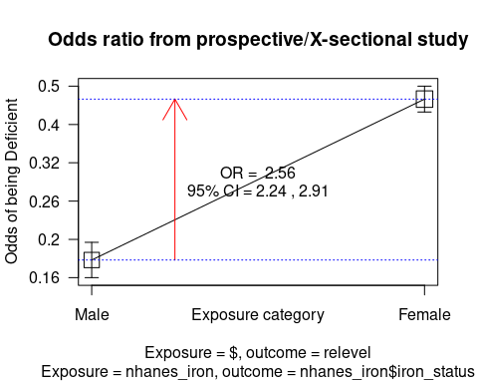

nhanes_iron$sex  
relevel(nhanes_iron$iron_status, ref = "Normal") Male Female Total  
 Normal 2356 2048 4404  
 Deficient 427 949 1376  
 Total 2783 2997 5780  
  
OR = 2.56   
95% CI = 2.25, 2.91   
Chi-squared = 211.93, 1 d.f., P value = 0  
Fisher's exact test (2-sided) P value = 0

# Create fake data for graphing odds ratio results

## Assuming that you obtained ORs and want to compare the results to what was found in other studies.  
## Let's create a data frame for these ORs and 95% CIs.  
  
study <- c("Overall", "Study 1", "Study 2", "Study 3", "Study 4")  
or <- c(1.5, 1.1, 2.0, 1.4, 1.6)  
or_lower_lim <- c(1.2, 0.9, 1.65, 0.95, 1.3)  
or_upper_lim <- c(1.85, 1.35, 2.4, 2.05, 2.0)  
results <- data.frame(study, or, or_lower_lim, or_upper_lim)  
results$study <- factor(results$study,  
 levels = results$study)

# Plot odds ratios with a forest plot

# Forest plot, ggplot2 package  
ggplot(results,  
 aes(x = or,  
 y = study,  
 xmin = or_lower_lim,  
 xmax = or_upper_lim,  
 color = study)) +  
 geom_pointrange() +  
 labs(x = "Odds Ratio", y = NULL) +  
 geom_vline(xintercept = 1,  
 linetype = 2) +  
 guides(color = guide_legend(reverse = TRUE))

