EPID674 Epidemiologic Data Analysis using R

Regression in R

Kelly Bakulski

Last compiled on February 23, 2021

# Set up options

# Install new packages

# Load packages

# Specify file directories

directory <- "/cloud/project" # Class option when coding on RStudio Cloud  
# Will need to update if working on personal computer

# Load data, remake useful variables

# Check the file path  
file.path(directory, "nhanes3.rda")

## [1] "/cloud/project/nhanes3.rda"

# Load the saved R data  
load(file.path(directory, "nhanes3.rda"))  
  
  
# Remake a few variables from last class if they are no longer in your environment  
sex1 <- factor(nhanes$sex, levels = c(1, 2), labels = c("male", "female"))  
AGE5b <- cut(nhanes$age, quantile(nhanes$age, c(0, .2, .4, .6, .8, 1)), include.lowest = T) # quintiles  
AGE5c <- cut(nhanes$age, breaks = c(19, 40, 50, 60, 70, 90))  
age5c <- unclass(AGE5c)  
nhanes <- cbind(nhanes, sex1, AGE5b, AGE5c, age5c)  
  
  
# Clean up the dataset. Make sure NaN are NA for key covariates  
table(nhanes$educ, useNA = "always")

##   
## 1 2 3 NaN <NA>   
## 2032 2349 660 33 0

nhanes$educ[is.nan(nhanes$educ)] <- NA  
table(nhanes$educ, useNA = "always")

##   
## 1 2 3 <NA>   
## 2032 2349 660 33

table(nhanes$alc, useNA = "always")

##   
## 0 1 NaN <NA>   
## 2753 2189 132 0

nhanes$alc[is.nan(nhanes$alc)] <- NA  
table(nhanes$alc, useNA = "always")

##   
## 0 1 <NA>   
## 2753 2189 132

### 6.1. Linear Models: Association between systolic blood pressure (SBP) and blood lead (bpb)

## Does the distribution of log(sbp) look closer to the normal distribution?  
par(mfrow = c(2, 1))  
hist(nhanes$sbp, nclass = 20, col = "darkorchid")  
hist(log(nhanes$sbp), nclass = 20, col = "seagreen3")

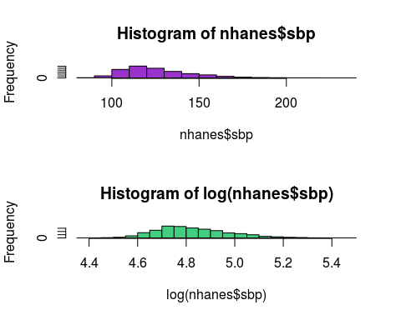

## Let's start with non-log transformed SBP first. Look at bivariate association between sbp and continuous covariates  
par(mfrow = c(1, 1))  
plot(nhanes$age, nhanes$sbp, pch = 20, cex = 0.7, col = "dodgerblue", cex.lab = 1.2, las = 1, ylab = "SBP", xlab = "Age (years)")  
lines(smooth.spline(nhanes$age, nhanes$sbp, df = 10), col = "dodgerblue", lwd = 3)

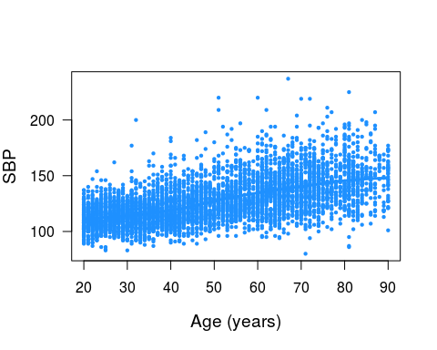

plot(nhanes$bmi, nhanes$sbp, pch = 20, cex = 0.7, col = "dodgerblue", cex.lab = 1.2, las = 1, ylab = "SBP", xlab = "BMI (kg/m2)")  
lines(smooth.spline(na.omit(nhanes$bmi), nhanes$sbp[na.omit(nhanes$bmi)], df = 3, ), col = "grey60", lwd = 3)

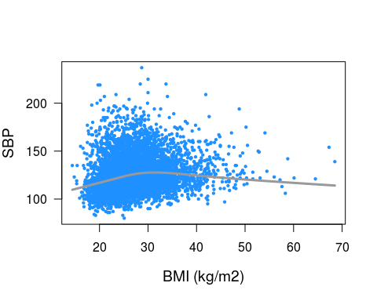

plot(nhanes$bpb, nhanes$sbp, pch = 20, cex = 0.7, col = "dodgerblue", cex.lab = 1.2, las = 1, ylab = "SBP", xlab = "Blood lead level (ug/dL)")  
lines(smooth.spline(nhanes$bpb, nhanes$sbp, df = 10), col = "grey60", lwd = 3)

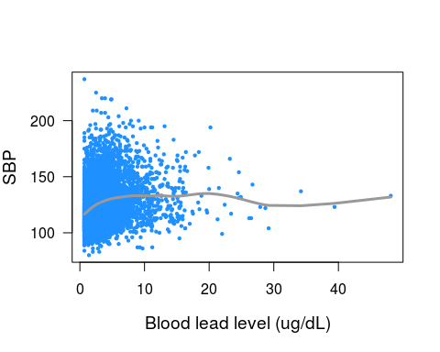

# Simple linear regression

## Start creating a simple regression model for systolic blood pressure,  
## including only blood lead (bpb) (crude model).  
sbp.model <- lm(sbp ~ bpb, na.action = na.omit, data = nhanes)  
sbp.model

##   
## Call:  
## lm(formula = sbp ~ bpb, data = nhanes, na.action = na.omit)  
##   
## Coefficients:  
## (Intercept) bpb   
## 121.666 1.162

summary(sbp.model) # Is blood lead associated with SBP? Is this the direction you would expect?

##   
## Call:  
## lm(formula = sbp ~ bpb, data = nhanes, na.action = na.omit)  
##   
## Residuals:  
## Min 1Q Median 3Q Max   
## -51.586 -13.964 -3.757 10.612 114.521   
##   
## Coefficients:  
## Estimate Std. Error t value Pr(>|t|)   
## (Intercept) 121.66581 0.43552 279.36 <2e-16 ***  
## bpb 1.16166 0.08528 13.62 <2e-16 ***  
## ---  
## Signif. codes: 0 '***' 0.001 '**' 0.01 '*' 0.05 '.' 0.1 ' ' 1  
##   
## Residual standard error: 19.6 on 5072 degrees of freedom  
## Multiple R-squared: 0.03529, Adjusted R-squared: 0.0351   
## F-statistic: 185.6 on 1 and 5072 DF, p-value: < 2.2e-16

summary.aov(sbp.model)

## Df Sum Sq Mean Sq F value Pr(>F)   
## bpb 1 71318 71318 185.6 <2e-16 ***  
## Residuals 5072 1949387 384   
## ---  
## Signif. codes: 0 '***' 0.001 '**' 0.01 '*' 0.05 '.' 0.1 ' ' 1

anova(sbp.model)

## Analysis of Variance Table  
##   
## Response: sbp  
## Df Sum Sq Mean Sq F value Pr(>F)   
## bpb 1 71318 71318 185.56 < 2.2e-16 ***  
## Residuals 5072 1949387 384   
## ---  
## Signif. codes: 0 '***' 0.001 '**' 0.01 '*' 0.05 '.' 0.1 ' ' 1

## Add age in the model  
sbp.model1 <- lm(sbp ~ bpb + age, na.action = na.omit, data = nhanes)  
summary(sbp.model1) # Does anything change with age in the model?

##   
## Call:  
## lm(formula = sbp ~ bpb + age, data = nhanes, na.action = na.omit)  
##   
## Residuals:  
## Min 1Q Median 3Q Max   
## -62.405 -10.431 -1.427 8.470 101.240   
##   
## Coefficients:  
## Estimate Std. Error t value Pr(>|t|)   
## (Intercept) 95.00660 0.63062 150.655 < 2e-16 ***  
## bpb 0.46641 0.07063 6.604 4.41e-11 ***  
## age 0.60338 0.01181 51.077 < 2e-16 ***  
## ---  
## Signif. codes: 0 '***' 0.001 '**' 0.01 '*' 0.05 '.' 0.1 ' ' 1  
##   
## Residual standard error: 15.93 on 5071 degrees of freedom  
## Multiple R-squared: 0.363, Adjusted R-squared: 0.3628   
## F-statistic: 1445 on 2 and 5071 DF, p-value: < 2.2e-16

# Add categorical variables linear regression

## Add race, which should be a categorical variable. We can use factor() or as.factor() to create indicator variables for each value of race  
table(nhanes$race)

##   
## 1 2   
## 3634 1440

sbp.model2 <- lm(sbp ~ bpb + age + factor(race), na.action = na.omit, data = nhanes)  
summary(sbp.model2)

##   
## Call:  
## lm(formula = sbp ~ bpb + age + factor(race), data = nhanes, na.action = na.omit)  
##   
## Residuals:  
## Min 1Q Median 3Q Max   
## -61.773 -10.420 -1.257 8.525 101.680   
##   
## Coefficients:  
## Estimate Std. Error t value Pr(>|t|)   
## (Intercept) 93.88241 0.66373 141.446 < 2e-16 ***  
## bpb 0.42848 0.07080 6.052 1.53e-09 ***  
## age 0.61400 0.01195 51.378 < 2e-16 ***  
## factor(race)2 2.66690 0.50308 5.301 1.20e-07 ***  
## ---  
## Signif. codes: 0 '***' 0.001 '**' 0.01 '*' 0.05 '.' 0.1 ' ' 1  
##   
## Residual standard error: 15.89 on 5070 degrees of freedom  
## Multiple R-squared: 0.3665, Adjusted R-squared: 0.3661   
## F-statistic: 977.8 on 3 and 5070 DF, p-value: < 2.2e-16

#### Change the reference level for a factor variable  
# Method 1: Make a new (or alter the old) variable  
table(nhanes$race)

##   
## 1 2   
## 3634 1440

race2 <- relevel(factor(nhanes$race), ref = 2)  
table(race2)

## race2  
## 2 1   
## 1440 3634

sbp.model2 <- lm(sbp ~ bpb + age + factor(race2), na.action = na.omit, data = nhanes)  
summary(sbp.model2)

##   
## Call:  
## lm(formula = sbp ~ bpb + age + factor(race2), data = nhanes,   
## na.action = na.omit)  
##   
## Residuals:  
## Min 1Q Median 3Q Max   
## -61.773 -10.420 -1.257 8.525 101.680   
##   
## Coefficients:  
## Estimate Std. Error t value Pr(>|t|)   
## (Intercept) 96.54931 0.69301 139.319 < 2e-16 ***  
## bpb 0.42848 0.07080 6.052 1.53e-09 ***  
## age 0.61400 0.01195 51.378 < 2e-16 ***  
## factor(race2)1 -2.66690 0.50308 -5.301 1.20e-07 ***  
## ---  
## Signif. codes: 0 '***' 0.001 '**' 0.01 '*' 0.05 '.' 0.1 ' ' 1  
##   
## Residual standard error: 15.89 on 5070 degrees of freedom  
## Multiple R-squared: 0.3665, Adjusted R-squared: 0.3661   
## F-statistic: 977.8 on 3 and 5070 DF, p-value: < 2.2e-16

# Method 2: Change the contrasts in the lm() statement  
sbp.model2 <- lm(sbp ~ bpb + age + C(factor(race), contr.treatment(2, base = 2)), na.action = na.omit, data = nhanes)  
summary(sbp.model2)

##   
## Call:  
## lm(formula = sbp ~ bpb + age + C(factor(race), contr.treatment(2,   
## base = 2)), data = nhanes, na.action = na.omit)  
##   
## Residuals:  
## Min 1Q Median 3Q Max   
## -61.773 -10.420 -1.257 8.525 101.680   
##   
## Coefficients:  
## Estimate Std. Error t value  
## (Intercept) 96.54931 0.69301 139.319  
## bpb 0.42848 0.07080 6.052  
## age 0.61400 0.01195 51.378  
## C(factor(race), contr.treatment(2, base = 2))1 -2.66690 0.50308 -5.301  
## Pr(>|t|)   
## (Intercept) < 2e-16 ***  
## bpb 1.53e-09 ***  
## age < 2e-16 ***  
## C(factor(race), contr.treatment(2, base = 2))1 1.20e-07 ***  
## ---  
## Signif. codes: 0 '***' 0.001 '**' 0.01 '*' 0.05 '.' 0.1 ' ' 1  
##   
## Residual standard error: 15.89 on 5070 degrees of freedom  
## Multiple R-squared: 0.3665, Adjusted R-squared: 0.3661   
## F-statistic: 977.8 on 3 and 5070 DF, p-value: < 2.2e-16

# R provides Type I sequential SS, not the default Type III marginal SS reported by SAS and SPSS.  
# We can use the drop1() function to produce the familiar Type III results.  
# It will compare each term with the full model.  
anova(sbp.model2)

## Analysis of Variance Table  
##   
## Response: sbp  
## Df Sum Sq Mean Sq F value  
## bpb 1 71318 71318 282.470  
## age 1 662217 662217 2622.848  
## C(factor(race), contr.treatment(2, base = 2)) 1 7095 7095 28.102  
## Residuals 5070 1280075 252   
## Pr(>F)   
## bpb < 2.2e-16 ***  
## age < 2.2e-16 ***  
## C(factor(race), contr.treatment(2, base = 2)) 1.199e-07 ***  
## Residuals   
## ---  
## Signif. codes: 0 '***' 0.001 '**' 0.01 '*' 0.05 '.' 0.1 ' ' 1

drop1(sbp.model2, test = "F")

## Single term deletions  
##   
## Model:  
## sbp ~ bpb + age + C(factor(race), contr.treatment(2, base = 2))  
## Df Sum of Sq RSS AIC  
## <none> 1280075 28070  
## bpb 1 9247 1289322 28104  
## age 1 666469 1946544 30195  
## C(factor(race), contr.treatment(2, base = 2)) 1 7095 1287170 28096  
## F value Pr(>F)   
## <none>   
## bpb 36.625 1.535e-09 ***  
## age 2639.688 < 2.2e-16 ***  
## C(factor(race), contr.treatment(2, base = 2)) 28.102 1.199e-07 ***  
## ---  
## Signif. codes: 0 '***' 0.001 '**' 0.01 '*' 0.05 '.' 0.1 ' ' 1

# Compare regression models

## Add other covariates to the model: which variables are biologically important?  
## Add sex, BMI, educ and smk.  
sbp.model3 <- lm(sbp ~ bpb + age + factor(race) + factor(sex) + bmi + factor(educ) + factor(smk), na.action = na.omit, data = nhanes)  
summary(sbp.model3) # What covariates are associated with SBP? Do they make sense biologically?

##   
## Call:  
## lm(formula = sbp ~ bpb + age + factor(race) + factor(sex) + bmi +   
## factor(educ) + factor(smk), data = nhanes, na.action = na.omit)  
##   
## Residuals:  
## Min 1Q Median 3Q Max   
## -59.202 -9.583 -1.317 7.926 101.116   
##   
## Coefficients:  
## Estimate Std. Error t value Pr(>|t|)   
## (Intercept) 83.160324 1.346404 61.765 < 2e-16 ***  
## bpb 0.277763 0.075759 3.666 0.000249 ***  
## age 0.615200 0.012258 50.189 < 2e-16 ***  
## factor(race)2 2.024195 0.498277 4.062 4.93e-05 ***  
## factor(sex)2 -3.912620 0.476734 -8.207 2.85e-16 ***  
## bmi 0.530437 0.038131 13.911 < 2e-16 ***  
## factor(educ)2 -0.003008 0.484418 -0.006 0.995046   
## factor(educ)3 -2.675500 0.711182 -3.762 0.000170 ***  
## factor(smk)2 -1.991441 0.562961 -3.537 0.000408 ***  
## factor(smk)3 -0.270575 0.559123 -0.484 0.628459   
## ---  
## Signif. codes: 0 '***' 0.001 '**' 0.01 '*' 0.05 '.' 0.1 ' ' 1  
##   
## Residual standard error: 15.45 on 5021 degrees of freedom  
## (43 observations deleted due to missingness)  
## Multiple R-squared: 0.3977, Adjusted R-squared: 0.3966   
## F-statistic: 368.4 on 9 and 5021 DF, p-value: < 2.2e-16

# See output from models 1,2,and 3 side by side  
stargazer(sbp.model1, sbp.model2, sbp.model3, type = "text", dep.var.labels = "Systolic Blood Pressure (mmHg)")

##   
## ==============================================================================================================================  
## Dependent variable:   
## -------------------------------------------------------------------------------  
## Systolic Blood Pressure (mmHg)   
## (1) (2) (3)   
## ------------------------------------------------------------------------------------------------------------------------------  
## bpb 0.466*** 0.428*** 0.278***   
## (0.071) (0.071) (0.076)   
##   
## age 0.603*** 0.614*** 0.615***   
## (0.012) (0.012) (0.012)   
##   
## C(factor(race), contr.treatment(2, base = 2))1 -2.667***   
## (0.503)   
##   
## factor(race)2 2.024***   
## (0.498)   
##   
## factor(sex)2 -3.913***   
## (0.477)   
##   
## bmi 0.530***   
## (0.038)   
##   
## factor(educ)2 -0.003   
## (0.484)   
##   
## factor(educ)3 -2.675***   
## (0.711)   
##   
## factor(smk)2 -1.991***   
## (0.563)   
##   
## factor(smk)3 -0.271   
## (0.559)   
##   
## Constant 95.007*** 96.549*** 83.160***   
## (0.631) (0.693) (1.346)   
##   
## ------------------------------------------------------------------------------------------------------------------------------  
## Observations 5,074 5,074 5,031   
## R2 0.363 0.367 0.398   
## Adjusted R2 0.363 0.366 0.397   
## Residual Std. Error 15.932 (df = 5071) 15.890 (df = 5070) 15.445 (df = 5021)   
## F Statistic 1,444.936*** (df = 2; 5071) 977.807*** (df = 3; 5070) 368.374*** (df = 9; 5021)  
## ==============================================================================================================================  
## Note: *p<0.1; **p<0.05; ***p<0.01

### Check if alcohol consumption is a confounder  
sbp.model4 <- lm(sbp ~ bpb + age + factor(race) + factor(sex) + bmi + factor(educ) + factor(smk) + factor(alc), na.action = na.omit, data = nhanes)  
summary(sbp.model4) # Is alcohol associated with sbp?

##   
## Call:  
## lm(formula = sbp ~ bpb + age + factor(race) + factor(sex) + bmi +   
## factor(educ) + factor(smk) + factor(alc), data = nhanes,   
## na.action = na.omit)  
##   
## Residuals:  
## Min 1Q Median 3Q Max   
## -58.495 -9.580 -1.311 7.928 101.235   
##   
## Coefficients:  
## Estimate Std. Error t value Pr(>|t|)   
## (Intercept) 82.33776 1.41399 58.231 < 2e-16 ***  
## bpb 0.24874 0.07705 3.228 0.001253 **   
## age 0.61361 0.01276 48.106 < 2e-16 ***  
## factor(race)2 2.00975 0.50657 3.967 7.37e-05 ***  
## factor(sex)2 -3.87208 0.49390 -7.840 5.50e-15 ***  
## bmi 0.55795 0.03860 14.454 < 2e-16 ***  
## factor(educ)2 0.02761 0.49227 0.056 0.955279   
## factor(educ)3 -2.71562 0.72412 -3.750 0.000179 ***  
## factor(smk)2 -2.07944 0.56937 -3.652 0.000263 ***  
## factor(smk)3 -0.20883 0.57141 -0.365 0.714779   
## factor(alc)1 0.41798 0.49359 0.847 0.397144   
## ---  
## Signif. codes: 0 '***' 0.001 '**' 0.01 '*' 0.05 '.' 0.1 ' ' 1  
##   
## Residual standard error: 15.38 on 4891 degrees of freedom  
## (172 observations deleted due to missingness)  
## Multiple R-squared: 0.3967, Adjusted R-squared: 0.3954   
## F-statistic: 321.6 on 10 and 4891 DF, p-value: < 2.2e-16

summary(sbp.model4)$coef # Pull out relevant information from the output: Coefficient table

## Estimate Std. Error t value Pr(>|t|)  
## (Intercept) 82.3377552 1.41399277 58.23067609 0.000000e+00  
## bpb 0.2487418 0.07704799 3.22840133 1.253061e-03  
## age 0.6136075 0.01275532 48.10601736 0.000000e+00  
## factor(race)2 2.0097527 0.50656503 3.96741297 7.369686e-05  
## factor(sex)2 -3.8720755 0.49390486 -7.83971931 5.502517e-15  
## bmi 0.5579520 0.03860066 14.45446563 2.100456e-46  
## factor(educ)2 0.0276076 0.49227488 0.05608169 9.552790e-01  
## factor(educ)3 -2.7156205 0.72411551 -3.75025867 1.786946e-04  
## factor(smk)2 -2.0794440 0.56937030 -3.65218209 2.627418e-04  
## factor(smk)3 -0.2088304 0.57140734 -0.36546680 7.147788e-01  
## factor(alc)1 0.4179774 0.49359253 0.84680655 3.971444e-01

summary(sbp.model4)$coef[2, 1] # Pull out just the beta coefficient blood Pb

## [1] 0.2487418

# 10% guideline for confounders: Does the addition of the new variable change the beta coefficient of interest by >10%?  
(summary(sbp.model4)$coef[2, 1] - summary(sbp.model3)$coef[2, 1]) / summary(sbp.model3)$coef[2, 1] # Calculate the percent change in the blood Pb coefficient before and after alcohol in the model

## [1] -0.1044827

# Does alcohol meet the guideline for a confounder?

# Reporting regression results for untransformed linear data

## Compute difference in SBP and 95% CI per one unit increase and IQR increase in bpb  
# For one unit increase in exposure  
summary(sbp.model4)$coef[2, 1] # Beta coefficient

## [1] 0.2487418

summary(sbp.model4)$coef[2, 1] - 1.96 * summary(sbp.model4)$coef[2, 2] # Lower confidence interval

## [1] 0.09772778

summary(sbp.model4)$coef[2, 1] + 1.96 * summary(sbp.model4)$coef[2, 2] # Upper confidence interval

## [1] 0.3997559

regress.display(sbp.model4) # Alternative: Convenience function to show all of the CI with the beta coefficients

##   
## Coeff lower095ci upper095ci Pr>|t|  
## (Intercept) 82.3377552 79.56569429 85.1098161 0.000000e+00  
## bpb 0.2487418 0.09769317 0.3997905 1.253061e-03  
## age 0.6136075 0.58860131 0.6386136 0.000000e+00  
## factor(race)2 2.0097527 1.01665770 3.0028476 7.369686e-05  
## factor(sex)2 -3.8720755 -4.84035080 -2.9038001 5.502517e-15  
## bmi 0.5579520 0.48227733 0.6336266 2.100456e-46  
## factor(educ)2 0.0276076 -0.93747225 0.9926875 9.552790e-01  
## factor(educ)3 -2.7156205 -4.13521210 -1.2960289 1.786946e-04  
## factor(smk)2 -2.0794440 -3.19566554 -0.9632225 2.627418e-04  
## factor(smk)3 -0.2088304 -1.32904543 0.9113846 7.147788e-01  
## factor(alc)1 0.4179774 -0.54968566 1.3856404 3.971444e-01

# To improve communication of findings, report association for an IQR increase in exposure   
IQR(nhanes$bpb)

## [1] 3.1

IQR(nhanes$bpb) * summary(sbp.model4)$coef[2, 1] # Per IQR increase in exposure, beta coefficient

## [1] 0.7710997

l95ci.iqr <- IQR(nhanes$bpb) * (summary(sbp.model4)$coef[2, 1] - 1.96 * summary(sbp.model4)$coef[2, 2]) # Per IQR increase in exposure, lower confidence interval  
u95ci.iqr <- IQR(nhanes$bpb) * (summary(sbp.model4)$coef[2, 1] + 1.96 * summary(sbp.model4)$coef[2, 2]) # Per IQR increase in exposure, upper confidence interval  
regress.display(sbp.model4)$table[2, ] * IQR(nhanes$bpb) # Multiply the convenience table by the IQR

## Coeff lower095ci upper095ci Pr>|t|   
## 0.77109973 0.30284884 1.23935061 0.00388449

# Compare regression results

## Does the variable packyrs give a better estimate than smk?  
sbp.model5 <- lm(sbp ~ bpb + age + factor(race) + factor(sex) + bmi + factor(educ) + packyrs + factor(alc), na.action = na.omit, data = nhanes)  
summary(sbp.model5)

##   
## Call:  
## lm(formula = sbp ~ bpb + age + factor(race) + factor(sex) + bmi +   
## factor(educ) + packyrs + factor(alc), data = nhanes, na.action = na.omit)  
##   
## Residuals:  
## Min 1Q Median 3Q Max   
## -59.679 -9.666 -1.233 8.026 101.502   
##   
## Coefficients:  
## Estimate Std. Error t value Pr(>|t|)   
## (Intercept) 82.04513 1.42080 57.746 < 2e-16 ***  
## bpb 0.24963 0.07906 3.157 0.001602 **   
## age 0.61464 0.01317 46.658 < 2e-16 ***  
## factor(race)2 2.22727 0.51892 4.292 1.81e-05 ***  
## factor(sex)2 -3.70826 0.50585 -7.331 2.68e-13 ***  
## bmi 0.55073 0.03930 14.012 < 2e-16 ***  
## factor(educ)2 0.04590 0.50476 0.091 0.927547   
## factor(educ)3 -2.60357 0.73817 -3.527 0.000424 ***  
## packyrs -0.02462 0.01097 -2.244 0.024860 *   
## factor(alc)1 0.32565 0.49934 0.652 0.514333   
## ---  
## Signif. codes: 0 '***' 0.001 '**' 0.01 '*' 0.05 '.' 0.1 ' ' 1  
##   
## Residual standard error: 15.42 on 4677 degrees of freedom  
## (387 observations deleted due to missingness)  
## Multiple R-squared: 0.3952, Adjusted R-squared: 0.394   
## F-statistic: 339.6 on 9 and 4677 DF, p-value: < 2.2e-16

AIC(sbp.model4)

## [1] 40722.09

AIC(sbp.model5)

## [1] 38957.68

## Which model has the lower AIC? The one with smk (model 4) or the one with packyrs (model 5)?   
## Model 5 also dropped 215 more people. This is an analyst judgment call (no perfect answer). I would probably stick with model 4 since the AIC are close, to keep the people in the study.  
  
## Run two models: One with age and one adding age as a quadratic function.  
## Does the quadratic term improve the fit of the model?  
sbp.model6 <- lm(sbp ~ bpb + age + factor(race) + factor(sex) + bmi + factor(educ) + factor(smk) + factor(alc) + I(age^2), na.action = na.omit, data = nhanes)  
summary(sbp.model6) # Is the age squared term significant?

##   
## Call:  
## lm(formula = sbp ~ bpb + age + factor(race) + factor(sex) + bmi +   
## factor(educ) + factor(smk) + factor(alc) + I(age^2), data = nhanes,   
## na.action = na.omit)  
##   
## Residuals:  
## Min 1Q Median 3Q Max   
## -59.724 -9.518 -1.413 7.689 101.809   
##   
## Coefficients:  
## Estimate Std. Error t value Pr(>|t|)   
## (Intercept) 87.0142129 1.8737032 46.440 < 2e-16 ***  
## bpb 0.2582957 0.0769837 3.355 0.000799 ***  
## age 0.3452699 0.0718091 4.808 1.57e-06 ***  
## factor(race)2 2.0928803 0.5063451 4.133 3.64e-05 ***  
## factor(sex)2 -3.7960138 0.4936354 -7.690 1.77e-14 ***  
## bmi 0.5913718 0.0395399 14.956 < 2e-16 ***  
## factor(educ)2 0.0989887 0.4919604 0.201 0.840541   
## factor(educ)3 -2.4208295 0.7272801 -3.329 0.000879 ***  
## factor(smk)2 -1.8118191 0.5729428 -3.162 0.001575 **   
## factor(smk)3 0.0969062 0.5762782 0.168 0.866465   
## factor(alc)1 0.4773454 0.4931648 0.968 0.333131   
## I(age^2) 0.0026033 0.0006856 3.797 0.000148 ***  
## ---  
## Signif. codes: 0 '***' 0.001 '**' 0.01 '*' 0.05 '.' 0.1 ' ' 1  
##   
## Residual standard error: 15.36 on 4890 degrees of freedom  
## (172 observations deleted due to missingness)  
## Multiple R-squared: 0.3984, Adjusted R-squared: 0.3971   
## F-statistic: 294.4 on 11 and 4890 DF, p-value: < 2.2e-16

## Use the anova function to compare the 2 models and  
## see if the quadratic term improves the model.  
anova(sbp.model4, sbp.model6, test = "F")

## Analysis of Variance Table  
##   
## Model 1: sbp ~ bpb + age + factor(race) + factor(sex) + bmi + factor(educ) +   
## factor(smk) + factor(alc)  
## Model 2: sbp ~ bpb + age + factor(race) + factor(sex) + bmi + factor(educ) +   
## factor(smk) + factor(alc) + I(age^2)  
## Res.Df RSS Df Sum of Sq F Pr(>F)   
## 1 4891 1157606   
## 2 4890 1154203 1 3403 14.418 0.0001482 ***  
## ---  
## Signif. codes: 0 '***' 0.001 '**' 0.01 '*' 0.05 '.' 0.1 ' ' 1

## We'll use sbp.model6 as our final model  
## What is the relationship between bpb and sbp?

# Regression diagnostics

### Regression Diagnostics  
## In the case of linear model, the plot of the model gives diagnostic plots  
par(mfrow = c(1, 1))  
plot(sbp.model6)

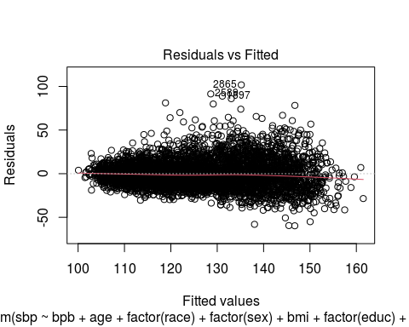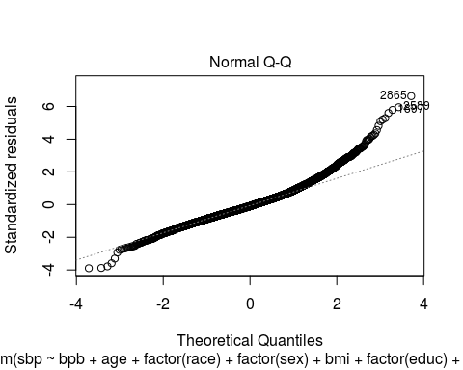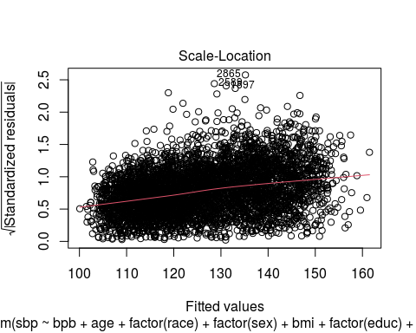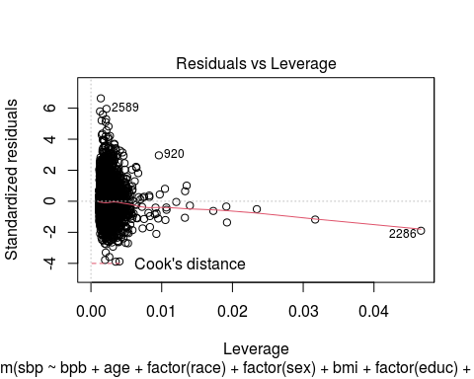

par(mfrow = c(2, 2))  
plot(sbp.model6, id.n = 5, cex = 0.1)

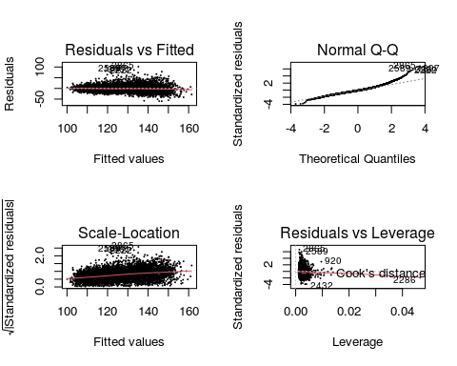

# plot.lm(sbp.model6)  
  
par(mfrow = c(1, 1))  
plot(sbp.model6, which = 1) # Can ask for the four plots one at a time



plot(sbp.model6, which = 2)



plot(sbp.model6, which = 3)



plot(sbp.model6, which = 5)



plot(sbp.model6, which = 4) # There is an extra, hidden plot you can call out individually

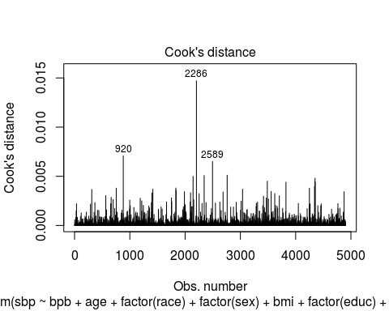

## How about log(sbp)?  
## Check how diagnostic plots using log-transformed sbp look like  
  
sbp.model6.log <- lm(log(sbp) ~ bpb + age + factor(race) + factor(sex) + bmi + factor(educ) + factor(smk) + factor(alc) + I(age^2), na.action = na.omit, data = nhanes)  
summary(sbp.model6.log)

##   
## Call:  
## lm(formula = log(sbp) ~ bpb + age + factor(race) + factor(sex) +   
## bmi + factor(educ) + factor(smk) + factor(alc) + I(age^2),   
## data = nhanes, na.action = na.omit)  
##   
## Residuals:  
## Min 1Q Median 3Q Max   
## -0.53660 -0.07304 -0.00487 0.06676 0.57499   
##   
## Coefficients:  
## Estimate Std. Error t value Pr(>|t|)   
## (Intercept) 4.505e+00 1.401e-02 321.638 < 2e-16 ***  
## bpb 1.974e-03 5.755e-04 3.430 0.000609 ***  
## age 3.281e-03 5.368e-04 6.113 1.06e-09 ***  
## factor(race)2 1.535e-02 3.785e-03 4.054 5.11e-05 ***  
## factor(sex)2 -3.504e-02 3.690e-03 -9.496 < 2e-16 ***  
## bmi 4.864e-03 2.956e-04 16.455 < 2e-16 ***  
## factor(educ)2 1.928e-03 3.678e-03 0.524 0.600129   
## factor(educ)3 -1.837e-02 5.437e-03 -3.379 0.000734 ***  
## factor(smk)2 -1.415e-02 4.283e-03 -3.303 0.000964 ***  
## factor(smk)3 5.033e-04 4.308e-03 0.117 0.906992   
## factor(alc)1 5.098e-03 3.687e-03 1.383 0.166742   
## I(age^2) 1.389e-05 5.125e-06 2.710 0.006758 **   
## ---  
## Signif. codes: 0 '***' 0.001 '**' 0.01 '*' 0.05 '.' 0.1 ' ' 1  
##   
## Residual standard error: 0.1148 on 4890 degrees of freedom  
## (172 observations deleted due to missingness)  
## Multiple R-squared: 0.4159, Adjusted R-squared: 0.4146   
## F-statistic: 316.5 on 11 and 4890 DF, p-value: < 2.2e-16

plot(sbp.model6.log)

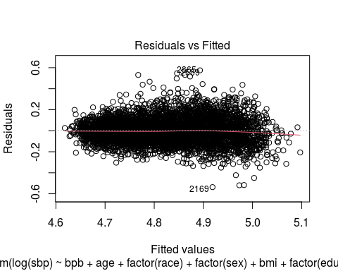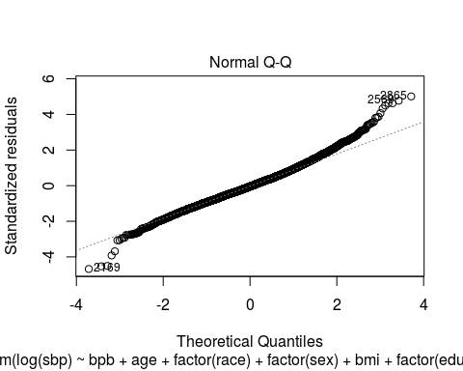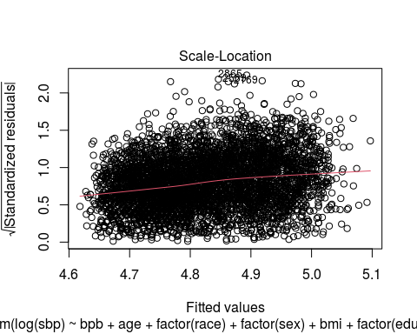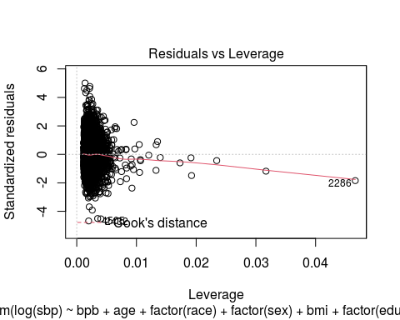

hist(residuals(sbp.model6.log), nclass = 20)

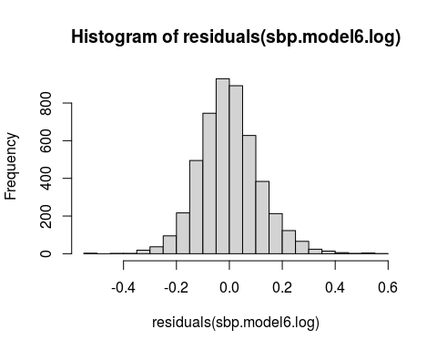

par(mfrow = c(2, 2))  
plot(sbp.model6, which = 1)  
plot(sbp.model6.log, which = 1)  
hist(residuals(sbp.model6), main = "Histogram of res(SBP)")  
hist(residuals(sbp.model6.log), main = "Histogram of res(log(SBP))")

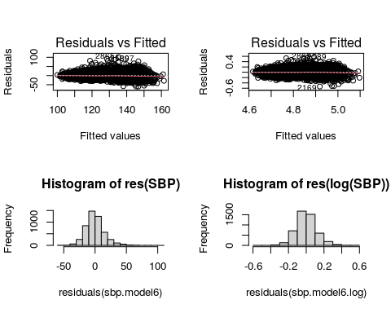

par(mfrow = c(1, 1))  
  
### Partial Residual Plots  
## Plot sbp vs. bpb given that other variables are in the model (adjusted)  
  
## This can be done by 'termplot'  
termplot(sbp.model6, partial.resid = TRUE, col.res = "gray30", cex = 0.3, smooth = panel.smooth)

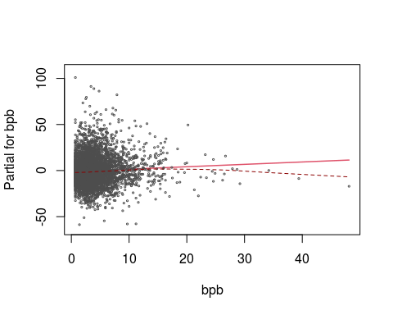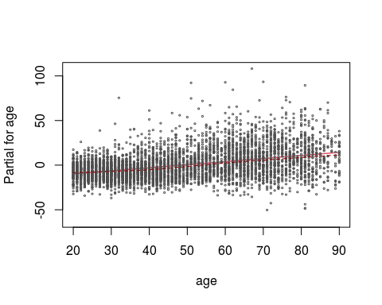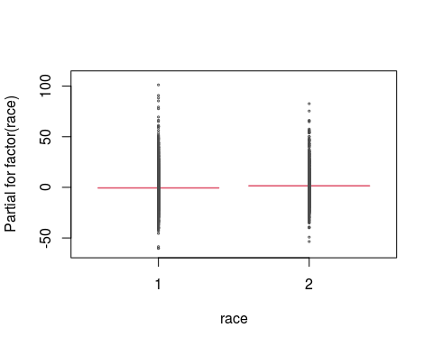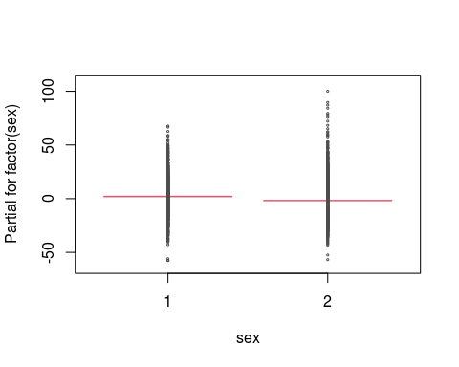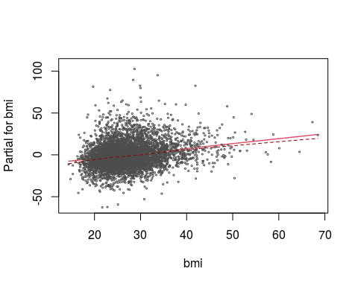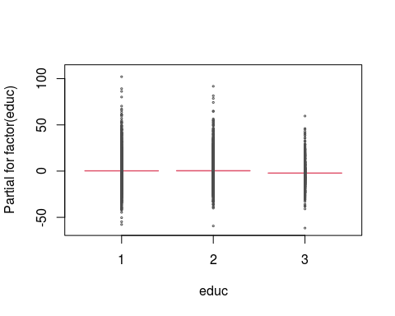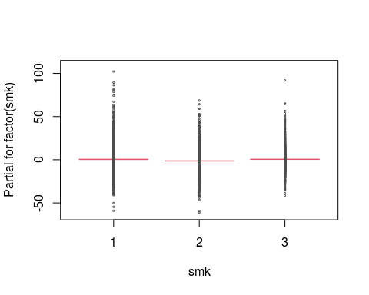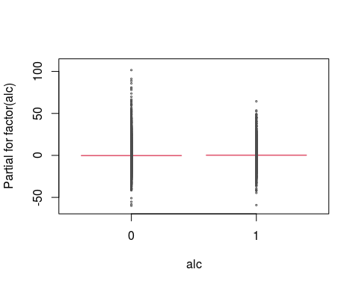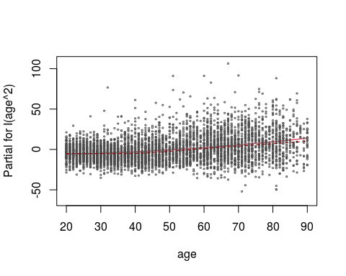

## Suppose you decide to go with log transformed SBP.

## Compute percent increase in SBP and 95% CI per one unit increase and IQR increase in bpb

## what to report if y is log-transformed?

## percent increase (difference) vs. absolute increase (difference)?

## Compute percent increase in SBP and 95% CI per one unit increase and IQR increase in bpb

summary(sbp.model6.log)$coef

## Estimate Std. Error t value Pr(>|t|)  
## (Intercept) 4.504957e+00 1.400631e-02 321.6375700 0.000000e+00  
## bpb 1.973727e-03 5.754686e-04 3.4297737 6.090800e-04  
## age 3.281259e-03 5.367875e-04 6.1127716 1.055187e-09  
## factor(race)2 1.534593e-02 3.785033e-03 4.0543714 5.105082e-05  
## factor(sex)2 -3.504012e-02 3.690025e-03 -9.4959008 3.321831e-21  
## bmi 4.863685e-03 2.955687e-04 16.4553462 2.932179e-59  
## factor(educ)2 1.927926e-03 3.677504e-03 0.5242485 6.001295e-01  
## factor(educ)3 -1.836873e-02 5.436567e-03 -3.3787365 7.338916e-04  
## factor(smk)2 -1.414501e-02 4.282864e-03 -3.3026976 9.644763e-04  
## factor(smk)3 5.033236e-04 4.307797e-03 0.1168401 9.069915e-01  
## factor(alc)1 5.098266e-03 3.686508e-03 1.3829529 1.667424e-01  
## I(age^2) 1.388725e-05 5.125029e-06 2.7096926 6.758042e-03

summary(sbp.model6.log)$coef[2, 1]

## [1] 0.001973727

summary(sbp.model6.log)$coef[2, 2]

## [1] 0.0005754686

exp(summary(sbp.model6.log)$coef[2, 1])

## [1] 1.001976

# exp(sbp.model6.log$coef[2])  
100 * (exp(summary(sbp.model6.log)$coef[2, 1]) - 1) # Per one unit increase in blood Pb, percent change in systolic blood pressure

## [1] 0.1975676

100 * (exp(summary(sbp.model6.log)$coef[2, 1] - 1.96 * summary(sbp.model6.log)$coef[2, 2]) - 1) # Lower confidence interval

## [1] 0.08461663

100 * (exp(summary(sbp.model6.log)$coef[2, 1] + 1.96 * summary(sbp.model6.log)$coef[2, 2]) - 1) # Upper confidence interval

## [1] 0.310646

IQR(nhanes$bpb)

## [1] 3.1

100 * (exp(IQR(nhanes$bpb) * summary(sbp.model6.log)$coef[2, 1]) - 1) # Per IQR unit increase in blood Pb, percent change in systolic blood pressure

## [1] 0.613731

100 * (exp(IQR(nhanes$bpb) * (summary(sbp.model6.log)$coef[2, 1] - 1.96 * summary(sbp.model6.log)$coef[2, 2])) - 1) # Lower confidence interval

## [1] 0.2625447

100 * (exp(IQR(nhanes$bpb) * (summary(sbp.model6.log)$coef[2, 1] + 1.96 * summary(sbp.model6.log)$coef[2, 2])) - 1) # Upper confidence interval

## [1] 0.9661474

## linearity assumption

# Non-linear associations

# What if the relationship between blood lead and sbp is non-linear?   
library(mgcv)

## Loading required package: nlme

## This is mgcv 1.8-33. For overview type 'help("mgcv-package")'.

##   
## Attaching package: 'mgcv'

## The following object is masked from 'package:nnet':  
##   
## multinom

sbp.model6.gam <- gam(sbp ~ s(bpb) + age + factor(race) + factor(sex) + bmi + factor(educ) + factor(smk) + factor(alc) + I(age^2), na.action = na.omit, data = nhanes)  
summary(sbp.model6.gam)

##   
## Family: gaussian   
## Link function: identity   
##   
## Formula:  
## sbp ~ s(bpb) + age + factor(race) + factor(sex) + bmi + factor(educ) +   
## factor(smk) + factor(alc) + I(age^2)  
##   
## Parametric coefficients:  
## Estimate Std. Error t value Pr(>|t|)   
## (Intercept) 88.2143968 1.8617921 47.381 < 2e-16 ***  
## age 0.3363437 0.0718470 4.681 2.93e-06 ***  
## factor(race)2 2.0313316 0.5062947 4.012 6.11e-05 ***  
## factor(sex)2 -3.5783017 0.5001717 -7.154 9.67e-13 ***  
## bmi 0.5931173 0.0395125 15.011 < 2e-16 ***  
## factor(educ)2 0.1625592 0.4919648 0.330 0.741090   
## factor(educ)3 -2.2564780 0.7288554 -3.096 0.001973 **   
## factor(smk)2 -1.8333930 0.5724650 -3.203 0.001371 **   
## factor(smk)3 -0.0462355 0.5780681 -0.080 0.936254   
## factor(alc)1 0.4435799 0.4929664 0.900 0.368262   
## I(age^2) 0.0026407 0.0006852 3.854 0.000118 ***  
## ---  
## Signif. codes: 0 '***' 0.001 '**' 0.01 '*' 0.05 '.' 0.1 ' ' 1  
##   
## Approximate significance of smooth terms:  
## edf Ref.df F p-value   
## s(bpb) 2.36 3.014 6.61 0.000184 ***  
## ---  
## Signif. codes: 0 '***' 0.001 '**' 0.01 '*' 0.05 '.' 0.1 ' ' 1  
##   
## R-sq.(adj) = 0.398 Deviance explained = 40%  
## GCV = 236.21 Scale est. = 235.57 n = 4902

plot(sbp.model6.gam)

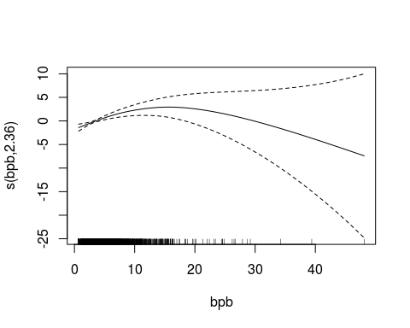

plot(sbp.model6.gam, xlab = "Blood lead (ug/dL)", ylab = "Change in log(SBP)") # Does this relationship look linear?

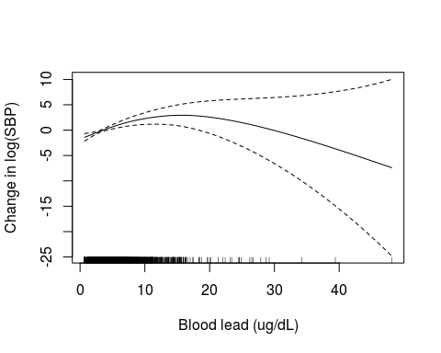

# Option to log transform the exposure  
sbp.model7 <- lm(sbp ~ log(bpb) + age + factor(race) + factor(sex) + bmi + factor(educ) + factor(smk) + factor(alc) + I(age^2), na.action = na.omit, data = nhanes)  
summary(sbp.model7)

##   
## Call:  
## lm(formula = sbp ~ log(bpb) + age + factor(race) + factor(sex) +   
## bmi + factor(educ) + factor(smk) + factor(alc) + I(age^2),   
## data = nhanes, na.action = na.omit)  
##   
## Residuals:  
## Min 1Q Median 3Q Max   
## -59.464 -9.543 -1.339 7.746 103.034   
##   
## Coefficients:  
## Estimate Std. Error t value Pr(>|t|)   
## (Intercept) 86.8708956 1.8722723 46.399 < 2e-16 ***  
## log(bpb) 1.4222563 0.3526023 4.034 5.58e-05 ***  
## age 0.3316940 0.0719935 4.607 4.18e-06 ***  
## factor(race)2 2.0361714 0.5066138 4.019 5.93e-05 ***  
## factor(sex)2 -3.5467680 0.5053567 -7.018 2.55e-12 ***  
## bmi 0.5902534 0.0394943 14.945 < 2e-16 ***  
## factor(educ)2 0.1417779 0.4914805 0.288 0.77300   
## factor(educ)3 -2.2839018 0.7293924 -3.131 0.00175 **   
## factor(smk)2 -1.8271820 0.5726692 -3.191 0.00143 **   
## factor(smk)3 -0.0474241 0.5795115 -0.082 0.93478   
## factor(alc)1 0.4312724 0.4933101 0.874 0.38203   
## I(age^2) 0.0026700 0.0006858 3.893 0.00010 ***  
## ---  
## Signif. codes: 0 '***' 0.001 '**' 0.01 '*' 0.05 '.' 0.1 ' ' 1  
##   
## Residual standard error: 15.36 on 4890 degrees of freedom  
## (172 observations deleted due to missingness)  
## Multiple R-squared: 0.399, Adjusted R-squared: 0.3977   
## F-statistic: 295.2 on 11 and 4890 DF, p-value: < 2.2e-16

summary(sbp.model6)

##   
## Call:  
## lm(formula = sbp ~ bpb + age + factor(race) + factor(sex) + bmi +   
## factor(educ) + factor(smk) + factor(alc) + I(age^2), data = nhanes,   
## na.action = na.omit)  
##   
## Residuals:  
## Min 1Q Median 3Q Max   
## -59.724 -9.518 -1.413 7.689 101.809   
##   
## Coefficients:  
## Estimate Std. Error t value Pr(>|t|)   
## (Intercept) 87.0142129 1.8737032 46.440 < 2e-16 ***  
## bpb 0.2582957 0.0769837 3.355 0.000799 ***  
## age 0.3452699 0.0718091 4.808 1.57e-06 ***  
## factor(race)2 2.0928803 0.5063451 4.133 3.64e-05 ***  
## factor(sex)2 -3.7960138 0.4936354 -7.690 1.77e-14 ***  
## bmi 0.5913718 0.0395399 14.956 < 2e-16 ***  
## factor(educ)2 0.0989887 0.4919604 0.201 0.840541   
## factor(educ)3 -2.4208295 0.7272801 -3.329 0.000879 ***  
## factor(smk)2 -1.8118191 0.5729428 -3.162 0.001575 **   
## factor(smk)3 0.0969062 0.5762782 0.168 0.866465   
## factor(alc)1 0.4773454 0.4931648 0.968 0.333131   
## I(age^2) 0.0026033 0.0006856 3.797 0.000148 ***  
## ---  
## Signif. codes: 0 '***' 0.001 '**' 0.01 '*' 0.05 '.' 0.1 ' ' 1  
##   
## Residual standard error: 15.36 on 4890 degrees of freedom  
## (172 observations deleted due to missingness)  
## Multiple R-squared: 0.3984, Adjusted R-squared: 0.3971   
## F-statistic: 294.4 on 11 and 4890 DF, p-value: < 2.2e-16

## compare model6 and model7  
AIC(sbp.model6, sbp.model7) # Which model has the lower AIC? The spline term or the log term for blood Pb?

## df AIC  
## sbp.model6 13 40709.65  
## sbp.model7 13 40704.64

# Effect modification by sex

# What if the relationship between blood Pb and sbp varies by sex?  
table(nhanes$sex)

##   
## 1 2   
## 2335 2739

### Stratified by sex  
## Male (sex==1)  
sbp.model6.male <- lm(sbp ~ bpb + age + factor(race) + bmi + factor(educ)  
 + factor(smk) + factor(alc) + I(age^2), data = nhanes, subset = (sex == 1))  
summary(sbp.model6.male) # What is the beta coefficient for blood Pb in males?

##   
## Call:  
## lm(formula = sbp ~ bpb + age + factor(race) + bmi + factor(educ) +   
## factor(smk) + factor(alc) + I(age^2), data = nhanes, subset = (sex ==   
## 1))  
##   
## Residuals:  
## Min 1Q Median 3Q Max   
## -55.951 -9.164 -1.214 7.452 67.763   
##   
## Coefficients:  
## Estimate Std. Error t value Pr(>|t|)   
## (Intercept) 94.0698502 2.7370216 34.369 < 2e-16 ***  
## bpb 0.2201841 0.0907801 2.425 0.015367 *   
## age 0.0247105 0.1020797 0.242 0.808748   
## factor(race)2 2.6271948 0.7251217 3.623 0.000298 ***  
## bmi 0.7190556 0.0667827 10.767 < 2e-16 ***  
## factor(educ)2 -0.1580127 0.6931503 -0.228 0.819696   
## factor(educ)3 -1.9583250 0.9739884 -2.011 0.044485 *   
## factor(smk)2 -0.2674489 0.7894817 -0.339 0.734818   
## factor(smk)3 1.5625824 0.8126909 1.923 0.054641 .   
## factor(alc)1 -0.1923135 0.6709470 -0.287 0.774422   
## I(age^2) 0.0043354 0.0009734 4.454 8.84e-06 ***  
## ---  
## Signif. codes: 0 '***' 0.001 '**' 0.01 '*' 0.05 '.' 0.1 ' ' 1  
##   
## Residual standard error: 14.6 on 2240 degrees of freedom  
## (84 observations deleted due to missingness)  
## Multiple R-squared: 0.3134, Adjusted R-squared: 0.3103   
## F-statistic: 102.3 on 10 and 2240 DF, p-value: < 2.2e-16

## Female (sex==2)  
sbp.model6.female <- lm(sbp ~ bpb + age + factor(race) + bmi + factor(educ)  
 + factor(smk) + factor(alc) + I(age^2), data = nhanes, subset = (sex == 2))  
summary(sbp.model6.female) # What is the beta coefficient for blood Pb in females? Is it similar to that in males?

##   
## Call:  
## lm(formula = sbp ~ bpb + age + factor(race) + bmi + factor(educ) +   
## factor(smk) + factor(alc) + I(age^2), data = nhanes, subset = (sex ==   
## 2))  
##   
## Residuals:  
## Min 1Q Median 3Q Max   
## -57.975 -9.454 -1.348 7.659 99.869   
##   
## Coefficients:  
## Estimate Std. Error t value Pr(>|t|)   
## (Intercept) 77.0605375 2.4865167 30.991 < 2e-16 ***  
## bpb 0.2931960 0.1343263 2.183 0.02914 *   
## age 0.5576526 0.0990458 5.630 1.99e-08 ***  
## factor(race)2 2.0982646 0.6949672 3.019 0.00256 **   
## bmi 0.5305908 0.0492797 10.767 < 2e-16 ***  
## factor(educ)2 0.3947007 0.6828269 0.578 0.56329   
## factor(educ)3 -2.1735912 1.0641023 -2.043 0.04119 *   
## factor(smk)2 -1.4335988 0.8458868 -1.695 0.09023 .   
## factor(smk)3 -0.5512632 0.8104050 -0.680 0.49642   
## factor(alc)1 0.6533917 0.7063162 0.925 0.35501   
## I(age^2) 0.0016206 0.0009452 1.715 0.08655 .   
## ---  
## Signif. codes: 0 '***' 0.001 '**' 0.01 '*' 0.05 '.' 0.1 ' ' 1  
##   
## Residual standard error: 15.66 on 2640 degrees of freedom  
## (88 observations deleted due to missingness)  
## Multiple R-squared: 0.4611, Adjusted R-squared: 0.4591   
## F-statistic: 225.9 on 10 and 2640 DF, p-value: < 2.2e-16

### Use interaction model  
sbp.model6.int <- lm(sbp ~ bpb + factor(sex) + bpb * factor(sex) + age + factor(race) + bmi + factor(educ)  
 + factor(smk) + factor(alc) + I(age^2), data = nhanes)  
# below is the same  
sbp.model6.int <- lm(sbp ~ bpb * factor(sex) + age + factor(race) + bmi + factor(educ)  
 + factor(smk) + factor(alc) + I(age^2), data = nhanes)  
summary(sbp.model6.int) # Is the interaction term significant?

##   
## Call:  
## lm(formula = sbp ~ bpb * factor(sex) + age + factor(race) + bmi +   
## factor(educ) + factor(smk) + factor(alc) + I(age^2), data = nhanes)  
##   
## Residuals:  
## Min 1Q Median 3Q Max   
## -58.894 -9.530 -1.369 7.642 102.461   
##   
## Coefficients:  
## Estimate Std. Error t value Pr(>|t|)   
## (Intercept) 87.8854794 1.9054676 46.123 < 2e-16 ***  
## bpb 0.1317420 0.0923617 1.426 0.153825   
## factor(sex)2 -5.1875500 0.7476820 -6.938 4.49e-12 ***  
## age 0.3385020 0.0718234 4.713 2.51e-06 ***  
## factor(race)2 2.0885416 0.5060825 4.127 3.74e-05 ***  
## bmi 0.5905818 0.0395204 14.944 < 2e-16 ***  
## factor(educ)2 0.1078127 0.4917151 0.219 0.826458   
## factor(educ)3 -2.4434079 0.7269556 -3.361 0.000782 ***  
## factor(smk)2 -1.7832085 0.5727587 -3.113 0.001860 **   
## factor(smk)3 0.1024602 0.5759802 0.178 0.858818   
## factor(alc)1 0.4787710 0.4929064 0.971 0.331436   
## I(age^2) 0.0026405 0.0006854 3.853 0.000118 ***  
## bpb:factor(sex)2 0.3796814 0.1532848 2.477 0.013284 *   
## ---  
## Signif. codes: 0 '***' 0.001 '**' 0.01 '*' 0.05 '.' 0.1 ' ' 1  
##   
## Residual standard error: 15.36 on 4889 degrees of freedom  
## (172 observations deleted due to missingness)  
## Multiple R-squared: 0.3992, Adjusted R-squared: 0.3977   
## F-statistic: 270.7 on 12 and 4889 DF, p-value: < 2.2e-16

Exercise 6A

# This is your last homework assignment for the semester.

### 6.3. Generalized Linear Models: Association between hypertension (htn) and blood lead (bpb)

## Logistic regression for hypertension  
## Look at hypertension status (htn)  
tab1(nhanes$htn, graph = F)

## nhanes$htn :   
## Frequency Percent Cum. percent  
## 0 3135 61.8 61.8  
## 1 1939 38.2 100.0  
## Total 5074 100.0 100.0

htn.model <- glm(htn ~ bpb + age + factor(sex) + factor(race) + bmi + factor(educ) + factor(smk) + factor(alc),  
 family = binomial,  
 na.action = na.omit, data = nhanes)  
summary(htn.model)

##   
## Call:  
## glm(formula = htn ~ bpb + age + factor(sex) + factor(race) +   
## bmi + factor(educ) + factor(smk) + factor(alc), family = binomial,   
## data = nhanes, na.action = na.omit)  
##   
## Deviance Residuals:   
## Min 1Q Median 3Q Max   
## -2.4998 -0.7949 -0.4272 0.8959 2.5147   
##   
## Coefficients:  
## Estimate Std. Error z value Pr(>|z|)   
## (Intercept) -6.635396 0.261535 -25.371 < 2e-16 ***  
## bpb 0.023959 0.011750 2.039 0.0414 *   
## age 0.061698 0.002235 27.602 < 2e-16 ***  
## factor(sex)2 0.063134 0.077426 0.815 0.4148   
## factor(race)2 0.494599 0.080020 6.181 6.37e-10 ***  
## bmi 0.097071 0.006285 15.446 < 2e-16 ***  
## factor(educ)2 0.075786 0.076618 0.989 0.3226   
## factor(educ)3 -0.085220 0.114171 -0.746 0.4554   
## factor(smk)2 -0.037067 0.086530 -0.428 0.6684   
## factor(smk)3 0.080902 0.091358 0.886 0.3759   
## factor(alc)1 0.008554 0.077201 0.111 0.9118   
## ---  
## Signif. codes: 0 '***' 0.001 '**' 0.01 '*' 0.05 '.' 0.1 ' ' 1  
##   
## (Dispersion parameter for binomial family taken to be 1)  
##   
## Null deviance: 6500.8 on 4901 degrees of freedom  
## Residual deviance: 5080.9 on 4891 degrees of freedom  
## (172 observations deleted due to missingness)  
## AIC: 5102.9  
##   
## Number of Fisher Scoring iterations: 4

# Compute ORs  
logistic.display(htn.model)

##   
## OR lower95ci upper95ci Pr(>|Z|)  
## bpb 1.0242485 1.0009304 1.048110 4.143898e-02  
## age 1.0636409 1.0589913 1.068311 1.040118e-167  
## factor(sex)2 1.0651698 0.9151960 1.239720 4.148329e-01  
## factor(race)2 1.6398400 1.4018069 1.918292 6.372658e-10  
## bmi 1.1019384 1.0884485 1.115596 8.036933e-54  
## factor(educ)2 1.0787320 0.9283169 1.253519 3.225922e-01  
## factor(educ)3 0.9183104 0.7341876 1.148609 4.554123e-01  
## factor(smk)2 0.9636111 0.8132928 1.141712 6.683781e-01  
## factor(smk)3 1.0842650 0.9065078 1.296879 3.758574e-01  
## factor(alc)1 1.0085903 0.8669650 1.173351 9.117772e-01

# Regression diagnostics  
par(mfrow = c(2, 2))  
plot(htn.model)

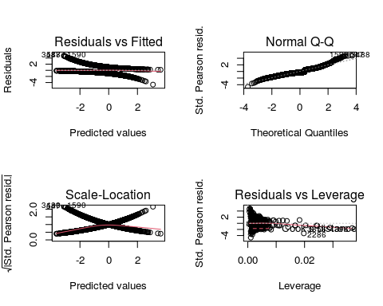

par(mfrow = c(1, 1))  
termplot(htn.model, se = T, partial.resid = T)

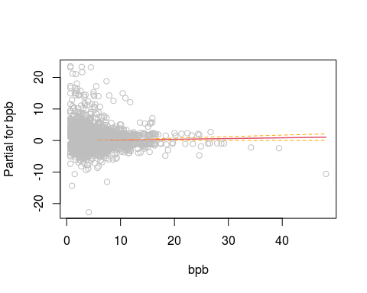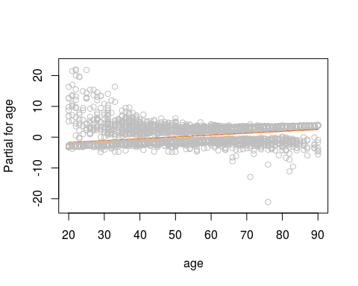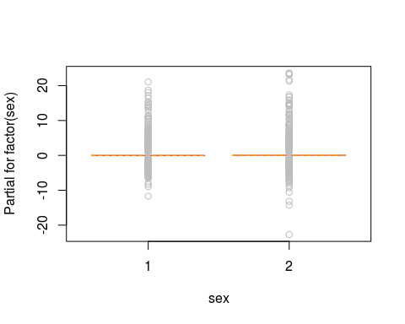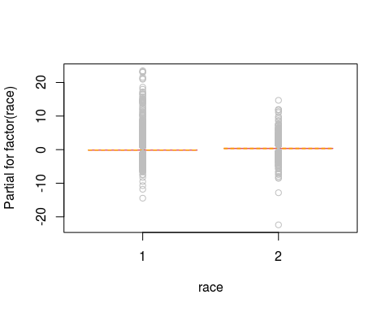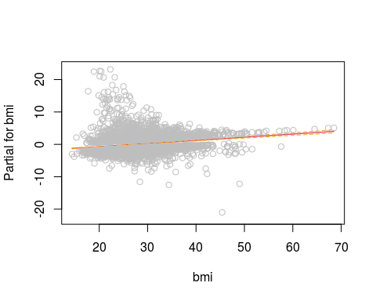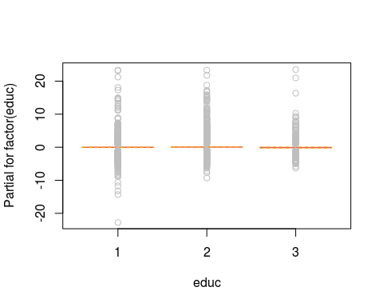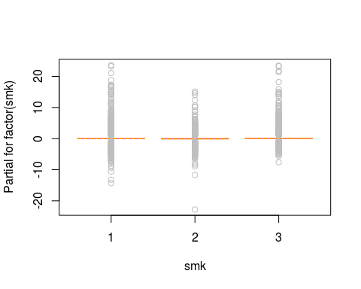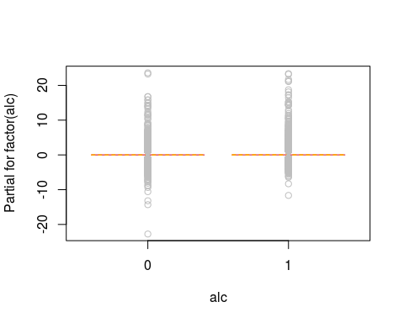

# Stepwise variable selection

# Poisson Regression for count outcomes.

# Code is available, but we will skip going through this during class

# ## Poisson regression for respiratory death: Montana dataset from epiDisplay  
# data(Montana)  
# summ(Montana)  
# head(Montana, 10)  
# hist(Montana$respdeath)  
#   
# par(mfrow = c(2, 2))  
# tab1(Montana$agegr)  
# tab1(Montana$period)  
# tab1(Montana$start)  
# tab1(Montana$arsenic)  
#   
# ## label categorical variables  
# Montana$agegr <- factor(Montana$agegr, labels = c("40-49", "50-59", "60-69", "70-79"))  
# Montana$period <- factor(Montana$period, labels = c("1938-1949", "1950-1959", "1960-1969", "1970-1977"))  
# Montana$start <- factor(Montana$start, labels = c("pre-1925", "1925 & after"))  
# Montana$arsenic <- factor(Montana$arsenic, labels = c("<1 year", "1-4 years", "5-14 years", "15+ years"))  
#   
# tab1(Montana$agegr, missing = F)  
# tab1(Montana$period, missing = F)  
# tab1(Montana$start, missing = F)  
# tab1(Montana$arsenic, missing = F)  
# par(mfrow = c(1, 1))  
#   
# ## Compute incidence rate by age and period  
# table.pyears <- tapply(Montana$personyrs, list(Montana$period, Montana$agegr), sum)  
# table.deaths <- tapply(Montana$respdeath, list(Montana$period, Montana$agegr), sum)  
# table.inc10000 <- table.deaths / table.pyears * 10000  
# table.inc10000  
#   
# ## create a time-series plot of the incidence  
# plot.ts(table.inc10000, plot.type = "single", xlab = "", ylab = "#/10,000 person-years", xaxt = "n", col = c("black", "blue", "red", "green"), lty = c(2, 1, 1, 2), las = 1)  
# points(rep(1:4, 4), table.inc10000, pch = 22, cex = table.pyears / sum(table.pyears) * 20)  
# title(main = "Incidence by age and period")  
# axis(side = 1, at = 1:4, labels = levels(Montana$period))  
# legend("topleft", legend = levels(Montana$agegr)[4:1], col = c("green", "red", "blue", "black"), bg = "white", lty = c(2, 1, 1, 2))  
#   
# ## check arsenic  
# tab1(Montana$arsenic)  
# tapply(Montana$respdeath, Montana$arsenic, mean)  
# tapply(Montana$personyrs, Montana$arsenic, mean)  
#   
# ## Poisson model  
# resp.mode11 <- glm(respdeath ~ period, offset = log(personyrs), family = poisson, data = Montana)  
# summary(resp.mode11)  
#   
# resp.mode12 <- glm(respdeath ~ agegr, offset = log(personyrs), family = poisson, data = Montana)  
# summary(resp.mode12)  
#   
# resp.mode13 <- glm(respdeath ~ period + agegr, offset = log(personyrs), family = poisson, data = Montana)  
# summary(resp.mode13)  
#   
# AIC(resp.mode11, resp.mode12, resp.mode13)  
# ## model2 is better  
#   
# resp.mode14 <- glm(respdeath ~ agegr + arsenic, offset = log(personyrs), family = poisson, data = Montana)  
# summary(resp.mode14)  
#   
# ## is there a linear trend across arsenic exposure?  
# resp.mode14.lin <- glm(respdeath ~ agegr + as.numeric(arsenic), offset = log(personyrs), family = poisson, data = Montana)  
# summary(resp.mode14.lin)  
#   
# ## compute IRR  
# idr.display(resp.mode14)

Optional: Exercise 6B

# Not a graded assignment. Optional.

### 6.5. Matched Case-Control Study: VC1to1 from epiDisplay

# Matched case-control dataset available in the epiDisplay package (packages can contain practice data as well as functions)  
data(VC1to1)  
summ(VC1to1) # What is the shape/structure of this dataset?

##   
## No. of observations = 52  
##   
## Var. name obs. mean median s.d. min. max.   
## 1 matset 52 13.5 13.5 7.57 1 26   
## 2 case 52 0.5 0.5 0.5 0 1   
## 3 smoking 52 0.81 1 0.4 0 1   
## 4 rubber 52 0.33 0 0.47 0 1   
## 5 alcohol 52 0.52 1 0.5 0 1

head(VC1to1) # 1 case matched to 1 control

## matset case smoking rubber alcohol  
## 1 1 1 1 0 0  
## 2 1 0 1 0 0  
## 3 2 1 1 0 1  
## 4 2 0 1 1 0  
## 5 3 1 1 1 0  
## 6 3 0 1 1 0

# Reshape the data to facilitate data exploration  
# function 'reshape' converts wide to long or vice versa  
wide <- reshape(VC1to1, timevar = "case", v.names = c("smoking", "rubber", "alcohol"), idvar = "matset", direction = "wide")  
head(wide, 3)

## matset smoking.1 rubber.1 alcohol.1 smoking.0 rubber.0 alcohol.0  
## 1 1 1 0 0 1 0 0  
## 3 2 1 0 1 1 1 0  
## 5 3 1 1 0 1 1 0

table(wide$smoking.1, wide$smoking.0, dnn = c("smoking in case", "smoking in control"))

## smoking in control  
## smoking in case 0 1  
## 0 0 5  
## 1 5 16

# dnn: dimnames names  
  
# matchTab() is for the conditional OR (McNemar's OR)  
matchTab(VC1to1$case, VC1to1$smoking, strata = VC1to1$matset) # Is smoking exposure associated with cancer?

##   
## Exposure status: $ = 1   
##   
## Exposure status: VC1to1 = 1   
##   
## Exposure status: smoking = 1   
##   
## Total number of match sets in the tabulation = 26   
##   
## Number of controls = 1   
## No. of controls exposed  
## No. of cases exposed 0 1  
## 0 0 5  
## 1 5 16  
##   
## Odds ratio by Mantel-Haenszel method = 1   
##   
## Odds ratio by maximum likelihood estimate (MLE) method = 1   
## 95%CI= 0.29 , 3.454   
##

matchTab(VC1to1$case, VC1to1$rubber, strata = VC1to1$matset) # Is working in the rubber industry associated with cancer?

##   
## Exposure status: $ = 1   
##   
## Exposure status: VC1to1 = 1   
##   
## Exposure status: rubber = 1   
##   
## Total number of match sets in the tabulation = 26   
##   
## Number of controls = 1   
## No. of controls exposed  
## No. of cases exposed 0 1  
## 0 13 5  
## 1 4 4  
##   
## Odds ratio by Mantel-Haenszel method = 0.8   
##   
## Odds ratio by maximum likelihood estimate (MLE) method = 0.8   
## 95%CI= 0.215 , 2.979   
##

matchTab(VC1to1$case, VC1to1$alcohol, strata = VC1to1$matset) # Is alcohol consumption associated iwth cancer?

##   
## Exposure status: $ = 1   
##   
## Exposure status: VC1to1 = 1   
##   
## Exposure status: alcohol = 1   
##   
## Total number of match sets in the tabulation = 26   
##   
## Number of controls = 1   
## No. of controls exposed  
## No. of cases exposed 0 1  
## 0 7 2  
## 1 9 8  
##   
## Odds ratio by Mantel-Haenszel method = 4.5   
##   
## Odds ratio by maximum likelihood estimate (MLE) method = 4.5   
## 95%CI= 0.972 , 20.827   
##

## look at the full dataset VC1to6  
data(VC1to6) # 1 case matched to up to 6 controls  
summ(VC1to6)

##   
## No. of observations = 119  
##   
## Var. name obs. mean median s.d. min. max.   
## 1 matset 119 15.75 17 6.96 1 26   
## 2 case 119 0.22 0 0.41 0 1   
## 3 smoking 119 0.7 1 0.46 0 1   
## 4 rubber 119 0.37 0 0.48 0 1   
## 5 alcohol 119 0.42 0 0.5 0 1

VC1to6[, ]

## matset case smoking rubber alcohol  
## 1 1 1 1 0 0  
## 2 1 0 1 0 0  
## 3 2 1 1 0 1  
## 4 2 0 1 1 0  
## 5 3 1 1 1 0  
## 6 3 0 1 1 0  
## 7 4 1 1 0 0  
## 8 4 0 1 1 1  
## 9 4 0 0 1 1  
## 10 5 1 0 0 1  
## 11 5 0 1 0 0  
## 12 5 0 1 0 0  
## 13 6 1 1 0 1  
## 14 6 0 0 0 0  
## 15 6 0 0 0 0  
## 16 7 1 1 0 1  
## 17 7 0 1 0 0  
## 18 7 0 1 0 1  
## 19 7 0 1 1 0  
## 20 8 1 1 0 0  
## 21 8 0 1 0 0  
## 22 8 0 1 0 1  
## 23 8 0 0 1 0  
## 24 9 1 1 1 1  
## 25 9 0 1 1 0  
## 26 9 0 1 1 0  
## 27 9 0 0 1 0  
## 28 10 1 0 0 0  
## 29 10 0 1 1 0  
## 30 10 0 0 0 0  
## 31 10 0 1 0 0  
## 32 11 1 1 0 1  
## 33 11 0 1 0 1  
## 34 11 0 0 0 0  
## 35 11 0 1 0 1  
## 36 12 1 1 0 0  
## 37 12 0 1 0 1  
## 38 12 0 1 0 0  
## 39 12 0 0 0 0  
## 40 13 1 1 1 0  
## 41 13 0 0 0 0  
## 42 13 0 0 0 0  
## 43 13 0 0 0 0  
## 44 14 1 1 0 1  
## 45 14 0 1 0 1  
## 46 14 0 0 0 0  
## 47 14 0 1 1 0  
## 48 14 0 1 0 1  
## 49 15 1 1 0 1  
## 50 15 0 1 0 0  
## 51 15 0 0 0 0  
## 52 15 0 1 0 0  
## 53 15 0 1 0 1  
## 54 16 1 1 0 1  
## 55 16 0 0 0 1  
## 56 16 0 1 0 1  
## 57 16 0 1 0 1  
## 58 16 0 1 1 0  
## 59 17 1 1 1 1  
## 60 17 0 1 0 1  
## 61 17 0 1 1 1  
## 62 17 0 1 0 0  
## 63 17 0 0 1 0  
## 64 18 1 1 0 1  
## 65 18 0 1 0 1  
## 66 18 0 0 1 0  
## 67 18 0 0 1 0  
## 68 18 0 1 0 0  
## 69 18 0 1 0 1  
## 70 19 1 0 0 0  
## 71 19 0 1 0 0  
## 72 19 0 0 0 0  
## 73 19 0 0 0 0  
## 74 19 0 0 1 0  
## 75 19 0 0 0 0  
## 76 20 1 1 1 1  
## 77 20 0 0 0 0  
## 78 20 0 0 0 0  
## 79 20 0 0 0 0  
## 80 20 0 1 0 0  
## 81 20 0 0 0 0  
## 82 21 1 1 1 1  
## 83 21 0 1 1 1  
## 84 21 0 1 1 1  
## 85 21 0 1 0 1  
## 86 21 0 1 1 1  
## 87 21 0 1 1 1  
## 88 21 0 1 1 1  
## 89 22 1 0 0 1  
## 90 22 0 1 1 1  
## 91 22 0 0 0 1  
## 92 22 0 1 1 0  
## 93 22 0 0 0 0  
## 94 22 0 0 1 0  
## 95 22 0 1 0 0  
## 96 23 1 1 1 1  
## 97 23 0 1 1 1  
## 98 23 0 1 1 1  
## 99 23 0 1 1 0  
## 100 23 0 1 1 1  
## 101 23 0 1 1 0  
## 102 23 0 1 1 0  
## 103 24 1 1 1 1  
## 104 24 0 1 0 0  
## 105 24 0 1 0 0  
## 106 24 0 0 1 1  
## 107 24 0 1 0 0  
## 108 24 0 1 0 1  
## 109 24 0 1 0 0  
## 110 25 1 0 0 0  
## 111 25 0 1 1 0  
## 112 25 0 1 1 1  
## 113 25 0 1 0 1  
## 114 25 0 1 0 0  
## 115 26 1 1 0 1  
## 116 26 0 0 0 0  
## 117 26 0 1 1 0  
## 118 26 0 0 0 0  
## 119 26 0 1 1 1

# what is the effect of smoking?  
matchTab(VC1to6$case, VC1to6$smoking, strata = VC1to6$matset) # Is smoking exposure associated with cancer?

##   
## Exposure status: $ = 1   
##   
## Exposure status: VC1to6 = 1   
##   
## Exposure status: smoking = 1   
##   
## Total number of match sets in the tabulation = 26   
##   
## Number of controls = 1   
## No. of controls exposed  
## No. of cases exposed 0 1  
## 0 0 0  
## 1 0 3  
##   
## Number of controls = 2   
## No. of controls exposed  
## No. of cases exposed 0 1 2  
## 0 0 0 1  
## 1 1 1 0  
##   
## Number of controls = 3   
## No. of controls exposed  
## No. of cases exposed 0 1 2 3  
## 0 0 0 1 0  
## 1 1 0 4 1  
##   
## Number of controls = 4   
## No. of controls exposed  
## No. of cases exposed 0 1 2 3 4  
## 0 0 0 0 0 1  
## 1 0 0 1 4 0  
##   
## Number of controls = 5   
## No. of controls exposed  
## No. of cases exposed 0 1 2 3 4 5  
## 0 0 1 0 0 0 0  
## 1 0 1 0 1 0 0  
##   
## Number of controls = 6   
## No. of controls exposed  
## No. of cases exposed 0 1 2 3 4 5 6  
## 0 0 0 0 1 0 0 0  
## 1 0 0 0 0 0 1 2  
##   
## Odds ratio by Mantel-Haenszel method = 1.988   
##   
## Odds ratio by maximum likelihood estimate (MLE) method = 2.066   
## 95%CI= 0.678 , 6.301   
##

matchTab(VC1to6$case, VC1to6$alcohol, strata = VC1to6$matset)

##   
## Exposure status: $ = 1   
##   
## Exposure status: VC1to6 = 1   
##   
## Exposure status: alcohol = 1   
##   
## Total number of match sets in the tabulation = 26   
##   
## Number of controls = 1   
## No. of controls exposed  
## No. of cases exposed 0 1  
## 0 2 0  
## 1 1 0  
##   
## Number of controls = 2   
## No. of controls exposed  
## No. of cases exposed 0 1 2  
## 0 0 0 1  
## 1 2 0 0  
##   
## Number of controls = 3   
## No. of controls exposed  
## No. of cases exposed 0 1 2 3  
## 0 2 2 0 0  
## 1 1 1 1 0  
##   
## Number of controls = 4   
## No. of controls exposed  
## No. of cases exposed 0 1 2 3 4  
## 0 0 0 1 0 0  
## 1 0 2 2 1 0  
##   
## Number of controls = 5   
## No. of controls exposed  
## No. of cases exposed 0 1 2 3 4 5  
## 0 1 0 0 0 0 0  
## 1 1 0 1 0 0 0  
##   
## Number of controls = 6   
## No. of controls exposed  
## No. of cases exposed 0 1 2 3 4 5 6  
## 0 0 0 0 0 0 0 0  
## 1 0 0 2 1 0 0 1  
##   
## Odds ratio by Mantel-Haenszel method = 5.386   
##   
## Odds ratio by maximum likelihood estimate (MLE) method = 5.655   
## 95%CI= 1.811 , 17.659   
##

# Conditional logistic regression

# conditional logistic reg using clogit from survival package  
### load the survival package  
library(survival)  
clogit1 <- clogit(case ~ smoking + alcohol + strata(matset), data = VC1to1) # 1 to 1 match dataset  
summary(clogit1) # What covariates are associated?

## Call:  
## coxph(formula = Surv(rep(1, 52L), case) ~ smoking + alcohol +   
## strata(matset), data = VC1to1, method = "exact")  
##   
## n= 52, number of events= 26   
##   
## coef exp(coef) se(coef) z Pr(>|z|)   
## smoking -0.3142 0.7304 0.7079 -0.444 0.6572   
## alcohol 1.5715 4.8141 0.8030 1.957 0.0503 .  
## ---  
## Signif. codes: 0 '***' 0.001 '**' 0.01 '*' 0.05 '.' 0.1 ' ' 1  
##   
## exp(coef) exp(-coef) lower .95 upper .95  
## smoking 0.7304 1.3691 0.1824 2.925  
## alcohol 4.8141 0.2077 0.9978 23.227  
##   
## Concordance= 0.673 (se = 0.101 )  
## Likelihood ratio test= 5.02 on 2 df, p=0.08  
## Wald test = 3.83 on 2 df, p=0.1  
## Score (logrank) test = 4.62 on 2 df, p=0.1

clogit2 <- clogit(case ~ smoking + alcohol + strata(matset), data = VC1to6) # 1 to 6 match dataset  
summary(clogit2) # What covariates are associated?

## Call:  
## coxph(formula = Surv(rep(1, 119L), case) ~ smoking + alcohol +   
## strata(matset), data = VC1to6, method = "exact")  
##   
## n= 119, number of events= 26   
##   
## coef exp(coef) se(coef) z Pr(>|z|)   
## smoking 0.3619 1.4361 0.6244 0.580 0.56217   
## alcohol 1.6552 5.2342 0.5899 2.806 0.00502 **  
## ---  
## Signif. codes: 0 '***' 0.001 '**' 0.01 '*' 0.05 '.' 0.1 ' ' 1  
##   
## exp(coef) exp(-coef) lower .95 upper .95  
## smoking 1.436 0.6963 0.4224 4.883  
## alcohol 5.234 0.1911 1.6471 16.633  
##   
## Concordance= 0.694 (se = 0.065 )  
## Likelihood ratio test= 11.49 on 2 df, p=0.003  
## Wald test = 9.13 on 2 df, p=0.01  
## Score (logrank) test = 11.04 on 2 df, p=0.004

# compute ORs  
clogistic.display(clogit1)

## Conditional logistic regression predicting case : 1 vs 0   
##   
##   
## crude OR(95%CI) adj. OR(95%CI) P(Wald's test) P(LR-test)  
## smoking: 1 vs 0 1 (0.29,3.45) 0.73 (0.18,2.92) 0.657 0.655   
##   
## alcohol: 1 vs 0 4.5 (0.97,20.83) 4.81 (1,23.23) 0.05 0.025   
##   
## No. of observations = 52

clogistic.display(clogit2)

## Conditional logistic regression predicting case : 1 vs 0   
##   
##   
## crude OR(95%CI) adj. OR(95%CI) P(Wald's test)  
## smoking: 1 vs 0 2.07 (0.68,6.3) 1.44 (0.42,4.88) 0.562   
##   
## alcohol: 1 vs 0 5.66 (1.81,17.66) 5.23 (1.65,16.63) 0.005   
##   
## P(LR-test)  
## smoking: 1 vs 0 0.559   
##   
## alcohol: 1 vs 0 0.002   
##   
## No. of observations = 119

### 6.6. Survival Analysis: Association between total mortality (d_total) and blood lead (bpb)

tab1(nhanes$d_total) # Variable for death due to any cause in NHANES

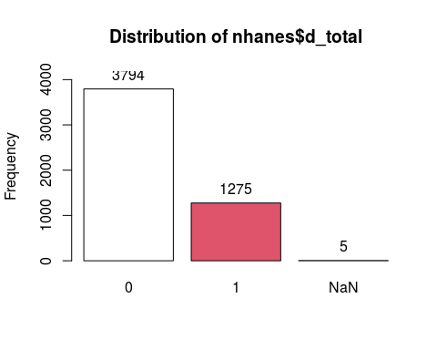

## nhanes$d_total :   
## Frequency %(NA+) %(NA-)  
## 0 3794 74.8 74.8  
## 1 1275 25.1 25.2  
## NaN 5 0.1 0.0  
## Total 5074 100.0 100.0

summ(nhanes$pmon_mec) # Number of months of follow up

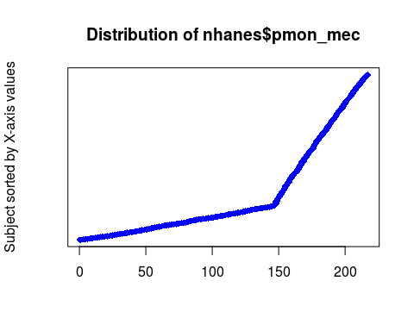

## obs. mean median s.d. min. max.   
## 5069 158.7 170 49.481 0 217

### Define Surv() object to use in later functions  
surv.total <- Surv(nhanes$pmon_mec, nhanes$d_total)  
surv.total[1:10] # Includes information on time of follow up and whether the person died, denoted with a "+"

## [1] 203+ 196+ 215+ 132 184+ 143 202+ 206+ 187+ 115

### K-M Life table and curve  
fit.total <- survfit(Surv(nhanes$pmon_mec, nhanes$d_total) ~ 1) # Model with no predictors, just outcome  
#summary(fit.total)  
summary(nhanes$pmon_mec/12) # How many years of follow up do you have?

## Min. 1st Qu. Median Mean 3rd Qu. Max. NA's   
## 0.00 12.42 14.17 13.22 16.08 18.08 5

fit.total # How many people died over this time period?

## Call: survfit(formula = Surv(nhanes$pmon_mec, nhanes$d_total) ~ 1)  
##   
## 5 observations deleted due to missingness   
## n events median 0.95LCL 0.95UCL   
## 5069 1275 NA NA NA

plot(fit.total)

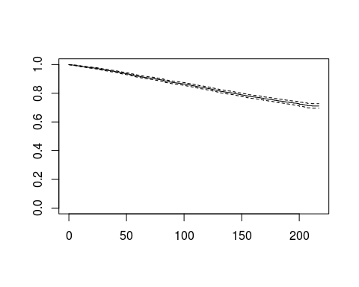

## suppress 95% CI lines and the time marks for censored subjects.  
plot(fit.total, ylim = c(0.7, 1.0), conf.int = F, mark.time = F, ylab="Probability of survival", xlab="Months")

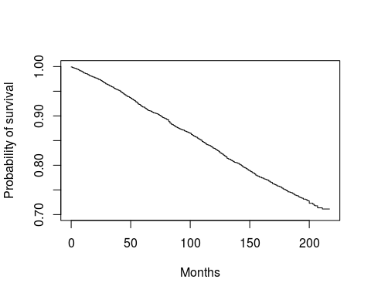

### Survival by different levels of covariates  
fit.total.sex <- survfit(Surv(nhanes$pmon_mec, nhanes$d_total) ~ nhanes$sex)  
fit.total.sex # How many people died in each sex group?

## Call: survfit(formula = Surv(nhanes$pmon_mec, nhanes$d_total) ~ nhanes$sex)  
##   
## 5 observations deleted due to missingness   
## n events median 0.95LCL 0.95UCL  
## nhanes$sex=1 2332 679 NA NA NA  
## nhanes$sex=2 2737 596 NA NA NA

#summary(fit.total.sex)[1:10]  
  
plot(fit.total.sex, ylim = c(0.6, 1.0), col = c("blue", "red"), lty = c(1, 2), mark.time = F, main = "Kaplan-Meier curve", xlab = "Time (months)", ylab = "Survival probability")  
legend("bottomleft", legend = c("Men", "Women"), col = c("blue", "red"), lty = c(1, 2))

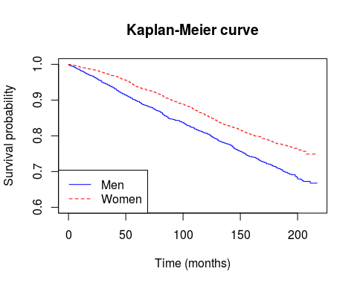

### Test for differences in survival curves  
survdiff(Surv(nhanes$pmon_mec, nhanes$d_total) ~ nhanes$sex) # Is there a difference in survival among males and females?

## Call:  
## survdiff(formula = Surv(nhanes$pmon_mec, nhanes$d_total) ~ nhanes$sex)  
##   
## n=5069, 5 observations deleted due to missingness.  
##   
## N Observed Expected (O-E)^2/E (O-E)^2/V  
## nhanes$sex=1 2332 679 573 19.7 35.8  
## nhanes$sex=2 2737 596 702 16.1 35.8  
##   
## Chisq= 35.8 on 1 degrees of freedom, p= 2e-09

### Cox regression

cox.bpb <- coxph(Surv(nhanes$pmon_mec, nhanes$d_total) ~ nhanes$bpb)  
summary(cox.bpb) # Is blood Pb associated with survival? Easier to visualize in categories of exposure

## Call:  
## coxph(formula = Surv(nhanes$pmon_mec, nhanes$d_total) ~ nhanes$bpb)  
##   
## n= 5069, number of events= 1275   
## (5 observations deleted due to missingness)  
##   
## coef exp(coef) se(coef) z Pr(>|z|)   
## nhanes$bpb 0.070662 1.073219 0.005597 12.63 <2e-16 ***  
## ---  
## Signif. codes: 0 '***' 0.001 '**' 0.01 '*' 0.05 '.' 0.1 ' ' 1  
##   
## exp(coef) exp(-coef) lower .95 upper .95  
## nhanes$bpb 1.073 0.9318 1.062 1.085  
##   
## Concordance= 0.62 (se = 0.008 )  
## Likelihood ratio test= 113.3 on 1 df, p=<2e-16  
## Wald test = 159.4 on 1 df, p=<2e-16  
## Score (logrank) test = 153.9 on 1 df, p=<2e-16

bpb3 <- cut2(nhanes$bpb, g = 3)  
tab1(bpb3) # Tertiles of blood Pb

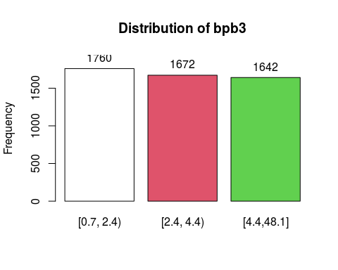

## bpb3 :   
## Frequency Percent Cum. percent  
## [0.7, 2.4) 1760 34.7 34.7  
## [2.4, 4.4) 1672 33.0 67.6  
## [4.4,48.1] 1642 32.4 100.0  
## Total 5074 100.0 100.0

# K-M Life table and curve  
fit.total.bpb3 <- survfit(Surv(nhanes$pmon_mec, nhanes$d_total) ~ bpb3)  
fit.total.bpb3

## Call: survfit(formula = Surv(nhanes$pmon_mec, nhanes$d_total) ~ bpb3)  
##   
## 5 observations deleted due to missingness   
## n events median 0.95LCL 0.95UCL  
## bpb3=[0.7, 2.4) 1758 248 NA NA NA  
## bpb3=[2.4, 4.4) 1670 451 NA NA NA  
## bpb3=[4.4,48.1] 1641 576 NA NA NA

plot(fit.total.bpb3, col = c(1:3), lty = c(1:3), ylim = c(0.6, 1.0), main = "Survival in relation to blood lead levels", xlab = "Time (months)", ylab = "Survival probability")   
legend(30, 0.7, legend = c("Q1", "Q2", "Q3"), lty = c(1:3), col = c(1:3))

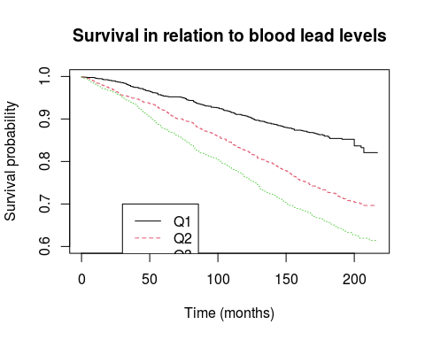

# crude  
cox.bpb3 <- coxph(Surv(nhanes$pmon_mec, nhanes$d_total) ~ bpb3)  
summary(cox.bpb3)

## Call:  
## coxph(formula = Surv(nhanes$pmon_mec, nhanes$d_total) ~ bpb3)  
##   
## n= 5069, number of events= 1275   
## (5 observations deleted due to missingness)  
##   
## coef exp(coef) se(coef) z Pr(>|z|)   
## bpb3[2.4, 4.4) 0.70388 2.02158 0.07906 8.903 <2e-16 ***  
## bpb3[4.4,48.1] 1.00452 2.73061 0.07599 13.219 <2e-16 ***  
## ---  
## Signif. codes: 0 '***' 0.001 '**' 0.01 '*' 0.05 '.' 0.1 ' ' 1  
##   
## exp(coef) exp(-coef) lower .95 upper .95  
## bpb3[2.4, 4.4) 2.022 0.4947 1.731 2.360  
## bpb3[4.4,48.1] 2.731 0.3662 2.353 3.169  
##   
## Concordance= 0.605 (se = 0.007 )  
## Likelihood ratio test= 196.5 on 2 df, p=<2e-16  
## Wald test = 174.7 on 2 df, p=<2e-16  
## Score (logrank) test = 186.5 on 2 df, p=<2e-16

# adjusted  
cox.bpb3.adj <- coxph(Surv(nhanes$pmon_mec, nhanes$d_total) ~ bpb3 + nhanes$age + factor(nhanes$sex) + factor(nhanes$race) + factor(nhanes$educ) + factor(nhanes$smk) + factor(nhanes$alc))  
summary(cox.bpb3.adj)

## Call:  
## coxph(formula = Surv(nhanes$pmon_mec, nhanes$d_total) ~ bpb3 +   
## nhanes$age + factor(nhanes$sex) + factor(nhanes$race) + factor(nhanes$educ) +   
## factor(nhanes$smk) + factor(nhanes$alc))  
##   
## n= 4905, number of events= 1211   
## (169 observations deleted due to missingness)  
##   
## coef exp(coef) se(coef) z Pr(>|z|)   
## bpb3[2.4, 4.4) 0.069004 1.071440 0.081665 0.845 0.39813   
## bpb3[4.4,48.1] 0.084549 1.088226 0.083037 1.018 0.30858   
## nhanes$age 0.088495 1.092529 0.002373 37.287 < 2e-16 ***  
## factor(nhanes$sex)2 -0.294962 0.744560 0.065259 -4.520 6.19e-06 ***  
## factor(nhanes$race)2 0.178596 1.195537 0.070922 2.518 0.01180 *   
## factor(nhanes$educ)2 0.001651 1.001652 0.062588 0.026 0.97895   
## factor(nhanes$educ)3 -0.205472 0.814263 0.102174 -2.011 0.04432 *   
## factor(nhanes$smk)2 0.171628 1.187237 0.070372 2.439 0.01473 *   
## factor(nhanes$smk)3 0.631970 1.881314 0.082193 7.689 1.48e-14 ***  
## factor(nhanes$alc)1 -0.182403 0.833265 0.067767 -2.692 0.00711 **   
## ---  
## Signif. codes: 0 '***' 0.001 '**' 0.01 '*' 0.05 '.' 0.1 ' ' 1  
##   
## exp(coef) exp(-coef) lower .95 upper .95  
## bpb3[2.4, 4.4) 1.0714 0.9333 0.9130 1.2574  
## bpb3[4.4,48.1] 1.0882 0.9189 0.9248 1.2806  
## nhanes$age 1.0925 0.9153 1.0875 1.0976  
## factor(nhanes$sex)2 0.7446 1.3431 0.6552 0.8462  
## factor(nhanes$race)2 1.1955 0.8364 1.0404 1.3738  
## factor(nhanes$educ)2 1.0017 0.9984 0.8860 1.1324  
## factor(nhanes$educ)3 0.8143 1.2281 0.6665 0.9948  
## factor(nhanes$smk)2 1.1872 0.8423 1.0343 1.3628  
## factor(nhanes$smk)3 1.8813 0.5315 1.6014 2.2102  
## factor(nhanes$alc)1 0.8333 1.2001 0.7296 0.9516  
##   
## Concordance= 0.857 (se = 0.005 )  
## Likelihood ratio test= 2351 on 10 df, p=<2e-16  
## Wald test = 1629 on 10 df, p=<2e-16  
## Score (logrank) test = 2328 on 10 df, p=<2e-16

### Test for the proportional hazards assumption  
test.prop <- cox.zph(cox.bpb3.adj) # Do any of the variables violate the proportional hazards assumption? May consider stratifying by sex.  
test.prop

## chisq df p  
## bpb3 0.7663 2 0.682  
## nhanes$age 1.3879 1 0.239  
## factor(nhanes$sex) 4.4387 1 0.035  
## factor(nhanes$race) 0.3733 1 0.541  
## factor(nhanes$educ) 0.1618 2 0.922  
## factor(nhanes$smk) 0.4093 2 0.815  
## factor(nhanes$alc) 0.0235 1 0.878  
## GLOBAL 8.0277 10 0.626

## Display a graph of the scaled Schoenfeld residuals, along with a smooth curve  
plot(test.prop) # for all variables

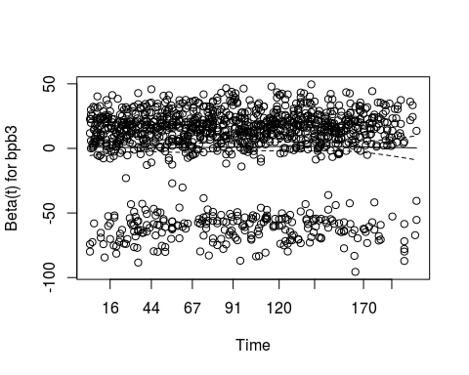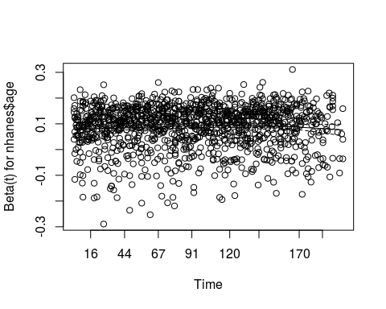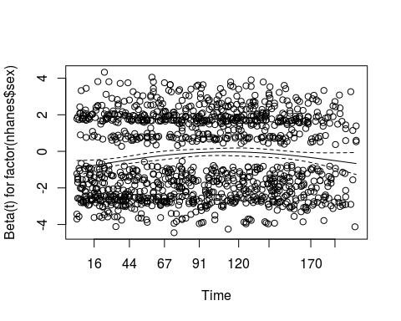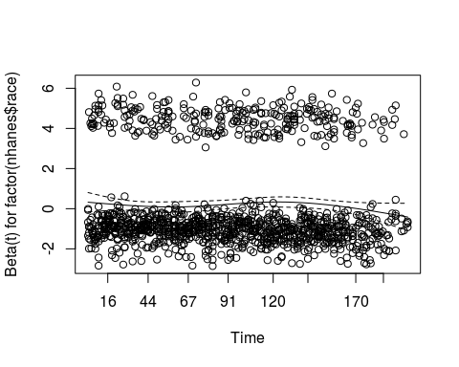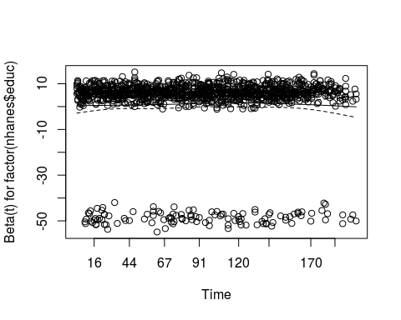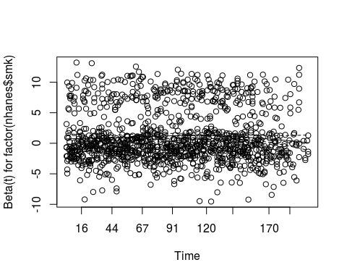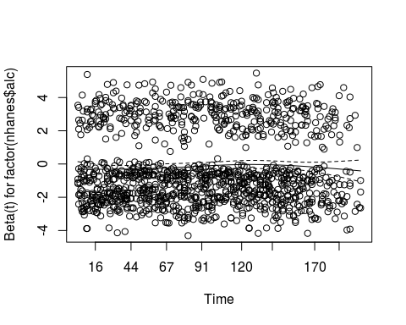

plot(test.prop, var = 4) + # Can call up variables indivdually, here for sex  
abline(h = 0, lty = 3, col = 2)

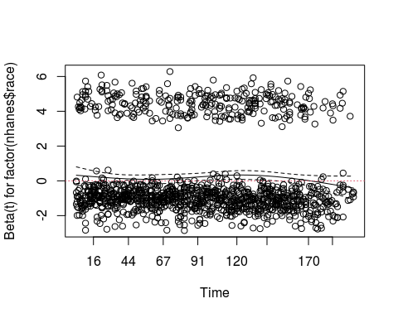

## integer(0)

# Stratify by sex  
cox.bpb3.adj1 <- coxph(Surv(nhanes$pmon_mec, nhanes$d_total) ~ bpb3 + nhanes$age + strata(nhanes$sex) + factor(nhanes$race) + factor(nhanes$educ) + factor(nhanes$smk) + factor(nhanes$alc))  
summary(cox.bpb3.adj1)

## Call:  
## coxph(formula = Surv(nhanes$pmon_mec, nhanes$d_total) ~ bpb3 +   
## nhanes$age + strata(nhanes$sex) + factor(nhanes$race) + factor(nhanes$educ) +   
## factor(nhanes$smk) + factor(nhanes$alc))  
##   
## n= 4905, number of events= 1211   
## (169 observations deleted due to missingness)  
##   
## coef exp(coef) se(coef) z Pr(>|z|)   
## bpb3[2.4, 4.4) 0.069557 1.072033 0.081702 0.851 0.39458   
## bpb3[4.4,48.1] 0.088475 1.092506 0.083082 1.065 0.28692   
## nhanes$age 0.088456 1.092486 0.002374 37.260 < 2e-16 ***  
## factor(nhanes$race)2 0.178662 1.195616 0.070942 2.518 0.01179 *   
## factor(nhanes$educ)2 0.001237 1.001238 0.062599 0.020 0.98424   
## factor(nhanes$educ)3 -0.209755 0.810783 0.102180 -2.053 0.04009 *   
## factor(nhanes$smk)2 0.166505 1.181170 0.070394 2.365 0.01801 *   
## factor(nhanes$smk)3 0.631710 1.880825 0.082187 7.686 1.51e-14 ***  
## factor(nhanes$alc)1 -0.179672 0.835545 0.067736 -2.653 0.00799 **   
## ---  
## Signif. codes: 0 '***' 0.001 '**' 0.01 '*' 0.05 '.' 0.1 ' ' 1  
##   
## exp(coef) exp(-coef) lower .95 upper .95  
## bpb3[2.4, 4.4) 1.0720 0.9328 0.9134 1.2582  
## bpb3[4.4,48.1] 1.0925 0.9153 0.9283 1.2857  
## nhanes$age 1.0925 0.9153 1.0874 1.0976  
## factor(nhanes$race)2 1.1956 0.8364 1.0404 1.3740  
## factor(nhanes$educ)2 1.0012 0.9988 0.8856 1.1319  
## factor(nhanes$educ)3 0.8108 1.2334 0.6636 0.9906  
## factor(nhanes$smk)2 1.1812 0.8466 1.0289 1.3559  
## factor(nhanes$smk)3 1.8808 0.5317 1.6010 2.2096  
## factor(nhanes$alc)1 0.8355 1.1968 0.7317 0.9542  
##   
## Concordance= 0.855 (se = 0.005 )  
## Likelihood ratio test= 2315 on 9 df, p=<2e-16  
## Wald test = 1599 on 9 df, p=<2e-16  
## Score (logrank) test = 2294 on 9 df, p=<2e-16

cox.zph(cox.bpb3.adj1)

## chisq df p  
## bpb3 0.443 2 0.80  
## nhanes$age 1.321 1 0.25  
## factor(nhanes$race) 0.404 1 0.53  
## factor(nhanes$educ) 0.156 2 0.93  
## factor(nhanes$smk) 1.038 2 0.60  
## factor(nhanes$alc) 0.476 1 0.49  
## GLOBAL 3.675 9 0.93

### 6.7. Write your own functions

## Let's make a simple macro that calculates the mean and standard deviation at the same time.  
  
# get the results in vector form  
mystats <- function(x) {  
 mymean <- mean(x, na.rm = T)  
 mysd <- sd(x, na.rm = T)  
 c(mean = mymean, sd = mysd)  
}  
  
mystats(nhanes$age)

## mean sd   
## 48.74359 19.29721

mystats(nhanes$bpb)

## mean sd   
## 3.958041 3.227670

# Regression functions

# Assume that you are examining age-adjusted associations of SBP with from the 13th variables (bmi) to 25th variables (packyrs) (n=13)  
# you want to run 13 linear regression models and save beta's and p-values  
  
summ(nhanes)

##   
## No. of observations = 5074  
##   
## Var. name obs. mean median s.d. min. max.   
## 1 strata 5074 23.26 22 13.49 1 49   
## 2 seqn 5074 27086.17 32365.5 17087.06 3 53594   
## 3 race 5074 1.28 1 0.45 1 2   
## 4 sex 5074 1.54 2 0.5 1 2   
## 5 age 5074 48.74 46 19.3 20 90   
## 6 urban 5074 1.52 2 0.5 1 2   
## 7 region 5074 2.75 3 0.95 1 4   
## 8 pir 4587 2.46 2.01 1.79 0 11.89   
## 9 psu 5074 1.51 2 0.5 1 2   
## 10 wt_mh 5074 10416.3 4495.92 13014 225.93 139744.91  
## 11 sbp 5074 126.26 122 19.96 80 237   
## 12 dbp 5074 74.52 74 10.57 32 134   
## 13 bmi 5064 27.24 26.4 5.82 14.4 68.5   
## 14 hematoc 5013 41.43 41.45 4.17 19.1 57.35   
## 15 bpb 5074 3.96 3.2 3.23 0.7 48.1   
## 16 chol 5016 207.21 204 45.5 83 676   
## 17 trig 5006 147.21 115 122.71 22 3616   
## 18 scalc 4942 9.27 9.3 0.43 7.3 13.9   
## 19 creat 4942 1.09 1 0.4 0.4 13.9   
## 20 calc 5074 50852.16 50049 25961.73 6 90842   
## 21 sodium 5074 8121.3 3155 13206.1 0 99712   
## 22 potass 5074 854.65 0.55 8176.14 0.01 97800   
## 23 educ 5041 1.73 2 0.68 1 3   
## 24 smk 5074 1.75 1 0.83 1 3   
## 25 packyrs 4856 9.58 0 22.02 0 456   
## 26 diag_ca 5074 0.07 0 0.26 0 1   
## 27 diag_dm 5065 0.09 0 0.29 0 1   
## 28 diag_ht 5035 0.28 0 0.45 0 1   
## 29 alc 4942 0.44 0 0.5 0 1   
## 30 phyact 5074 0.77 1 0.42 0 1   
## 31 med_ht 5029 0.17 0 0.37 0 1   
## 32 htn 5074 0.38 0 0.49 0 1   
## 33 d_total 5069 0.25 0 0.43 0 1   
## 34 pmon_int 5069 159.6 171 49.49 1 218   
## 35 pmon_mec 5069 158.7 170 49.48 0 217   
## 36 d_cancer 5069 0.05 0 0.22 0 1   
## 37 d_cvd 5069 0.11 0 0.32 0 1   
## 38 sex1 5074 1.54 2 0.498 1 2   
## 39 AGE5b 5074 2.942 3 1.425 1 5   
## 40 AGE5c 5074 2.516 2 1.55 1 5   
## 41 age5c 5074 2.52 2 1.55 1 5

test.var <- nhanes[, c(13:25)]  
head(test.var)

## bmi hematoc bpb chol trig scalc creat calc sodium potass educ smk  
## 1 25.5 43.80 5.0 268 174 9.5 1.1 70033 460 0.3099999 2 1  
## 2 29.4 46.70 2.0 225 109 9.4 1.2 70385 38591 0.5103998 3 1  
## 3 44.4 49.80 6.0 162 89 9.6 1.2 40040 3050 0.5599999 1 3  
## 4 37.5 47.70 15.5 212 479 10.6 1.0 10003 1321 0.8099999 1 3  
## 5 23.6 40.60 11.3 202 96 9.3 1.0 40021 5295 0.6499996 1 1  
## 6 31.1 37.85 7.2 186 300 8.8 1.3 80005 831 0.7099996 1 3  
## packyrs  
## 1 0.0  
## 2 0.0  
## 3 10.0  
## 4 2.0  
## 5 0.0  
## 6 17.5

# example  
mod <- lm(sbp ~ bmi + age, data = nhanes, na.action = na.omit)  
summary(mod)

##   
## Call:  
## lm(formula = sbp ~ bmi + age, data = nhanes, na.action = na.omit)  
##   
## Residuals:  
## Min 1Q Median 3Q Max   
## -58.828 -10.192 -1.445 8.221 98.816   
##   
## Coefficients:  
## Estimate Std. Error t value Pr(>|t|)   
## (Intercept) 82.71612 1.17680 70.29 <2e-16 ***  
## bmi 0.50219 0.03795 13.23 <2e-16 ***  
## age 0.61277 0.01146 53.47 <2e-16 ***  
## ---  
## Signif. codes: 0 '***' 0.001 '**' 0.01 '*' 0.05 '.' 0.1 ' ' 1  
##   
## Residual standard error: 15.71 on 5061 degrees of freedom  
## (10 observations deleted due to missingness)  
## Multiple R-squared: 0.3793, Adjusted R-squared: 0.3791   
## F-statistic: 1547 on 2 and 5061 DF, p-value: < 2.2e-16

summary(mod)$coef[2, 1] # how to extract beta for bmi

## [1] 0.5021861

summary(mod)$coef[2, 4] # how to extract p-value for bmi

## [1] 2.500308e-39

RegressResults <- function(data, y, cov) {  
 nvar <- ncol(data)  
 newdata <- data.frame(cbind(data, y, cov))  
  
 tmatrix <- data.frame(matrix(NA, 2, nvar)) # 2 rows  
 colnames(tmatrix) <- colnames(data) # create a row for each var  
 rownames(tmatrix) <- c("beta", "p")  
  
 for (i in 1:nvar) {  
 ind <- data[, i]  
 model <- lm(y ~ ind + cov, data = newdata, na.action = na.omit)  
 tmatrix[1, i] <- summary(model)$coef[2, 1]  
 tmatrix[2, i] <- summary(model)$coef[2, 4]  
 }  
 return(tmatrix)  
}  
  
reg_output <- RegressResults(test.var, nhanes$sbp, nhanes$age) # Run the function  
write.csv(reg_output, file = file.path(directory, "sbp.results.csv")) # Look in your output directory for the beta coefficients and p-values for all covariates!

Optional: Exercise 6C