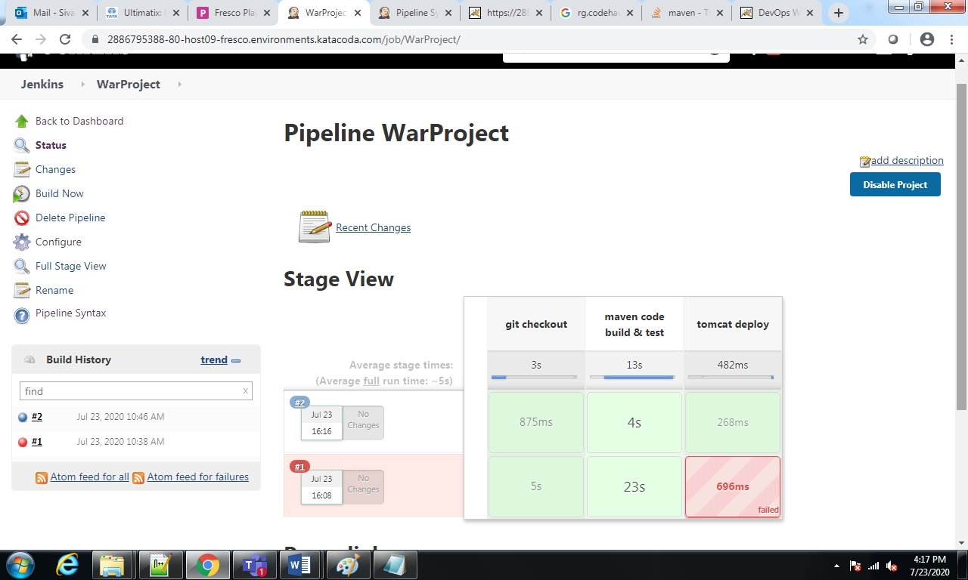

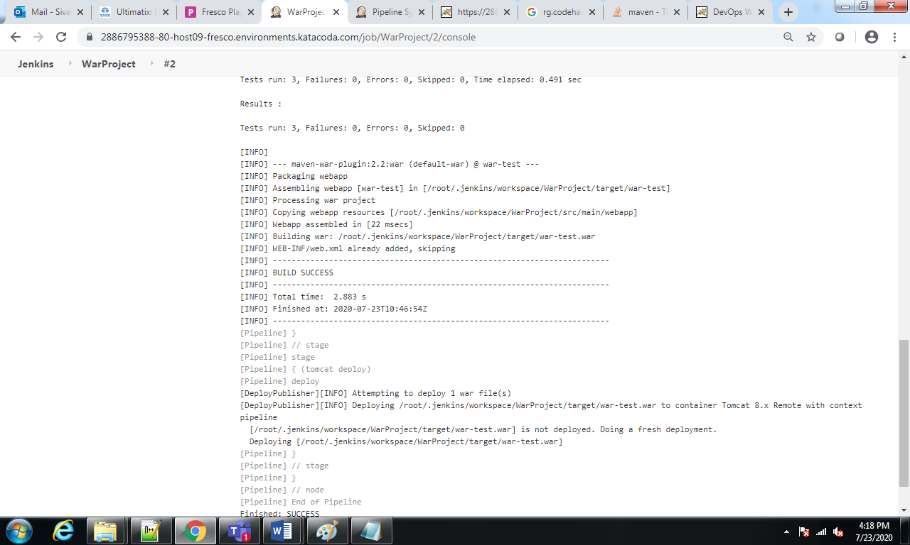

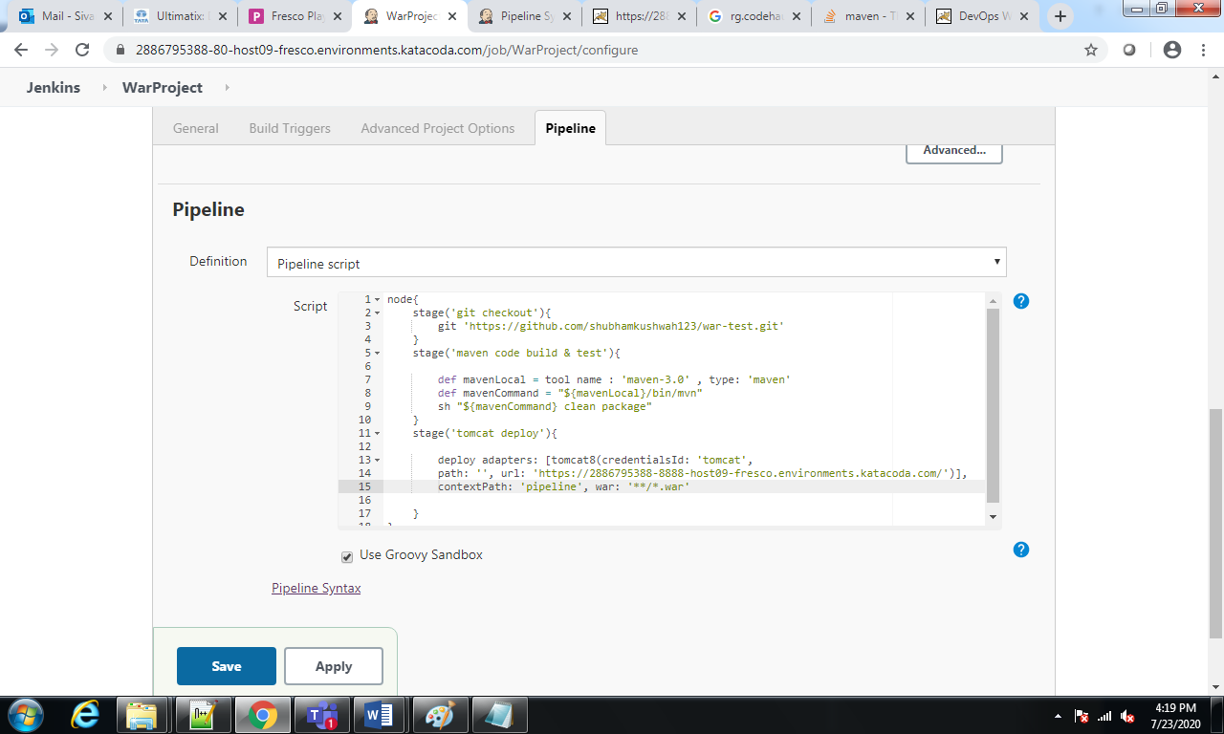

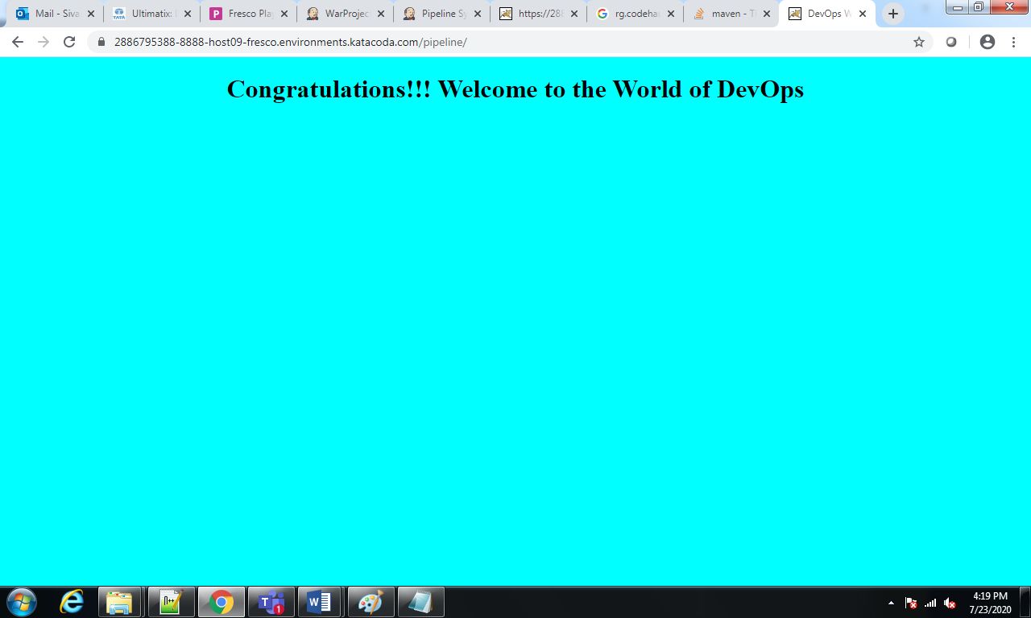

Pipeline-script:

node{

stage('git checkout'){

git 'https://github.com/shubhamkushwah123/war-test.git'

}

stage('maven code build & test'){

def mavenLocal = tool name : 'maven-3.0' , type: 'maven'

def mavenCommand = "${mavenLocal}/bin/mvn"

sh "${mavenCommand} clean package"

}

stage('tomcat deploy'){

deploy adapters: [tomcat8(credentialsId: 'tomcat', path: '', url: 'https://2886795388-8888-host09-fresco.environments.katacoda.com/')], contextPath: 'pipeline', war: '\*\*/\*.war'

}

}