1. Project Overview
SME NEXUS AI
Autonomous Executive Board for Small & Medium Enterprises

SME Nexus AI is an autonomous multi-agent business intelligence platform designed
specifically for Small and Medium Enterprises (SMEs). Rather than offering a simple chatbot or static dashboard, the platform simulates a full Executive Board Meeting where specialized AI executives independently analyze business data, collaborate on strategic decisions, and generate a prioritized action plan for business owners.

The platform transforms raw business data into clear, prioritized, and actionable business decisions — giving SME owners the analytical power of an entire C-suite executive team.

2. Problem Statement

Small businesses consistently face challenges that large enterprises solve with dedicated executive teams. SMEs typically cannot afford specialized directors for each business function, leaving owners to manually analyze spreadsheets rather than focusing on growth.

Key Challenges Faced by SMEs
- Managing inventory efficiently without real-time intelligence
- Tracking sales performance across channels and products
- Monitoring customer sentiment and acting on feedback
- Managing and converting sales leads through the pipeline
- Making strategic, data-driven business decisions without executive support

3. Our Solution

SME Nexus AI creates a Virtual Executive Board powered by multiple specialized AI agents. Each executive focuses on one core business function and independently evaluates business data before contributing to the board discussion.
Instead of a single AI response, every department independently analyzes the business data, then presents recommendations to an AI CEO. The CEO resolves conflicting recommendations and generates a prioritized strategic roadmap tailored to the business.

4. AI Executive Board

The Six Specialized Executive Agents

📈 Sales Director
Analyzes: Revenue Trends • Product Performance • Sales Growth • Order Analytics
Provides: Revenue Opportunities • Sales Insights • Growth Recommendations

📣 Marketing Director
Analyzes: Lead Sources • Marketing Effectiveness • Conversion Opportunities
Provides: Lead Generation Strategy • Marketing Improvements • Campaign Recommendations

⚙ Operations Director
Analyzes: Inventory Levels • Stock Availability • Reorder Levels
Provides: Operational Improvements • Inventory Optimization • Supply Recommendations

💰 Finance Director
Analyzes: Revenue • Business Profitability • Financial Health
Provides: Budget Optimization • Cost Reduction • Financial Planning

❤ Customer Intelligence Director
Analyzes: Customer Reviews • Ratings • Sentiment Analysis
Provides: Customer Satisfaction Insights • Product Feedback • Service Improvements

🛡 Risk Analysis Director
Analyzes: Operational Risks • Low Stock Alerts • Revenue Fluctuations • Customer Complaints
Provides: Risk Alerts • Preventive Recommendations • Business Safeguards

The AI CEO
The CEO receives recommendations from all six executives and serves as the final decision-maker. The AI CEO resolves conflicting opinions from different departments, prioritizes actions by business impact, calculates expected ROI for each recommendation, and generates the final Executive Action Plan presented to the business owner.

5. System Workflow

The platform processes business data through a structured pipeline from raw input to strategic output:

▶ Business Data Upload (Sales CSV, Inventory CSV, Leads CSV, Reviews CSV)
▶ Business Intelligence Engine
▶ Executive Board Meeting (All 6 Directors analyze independently)
▶ CEO Decision Engine (Conflict resolution & prioritization)
▶ Executive Board Voting
▶ Strategic Action Plan Generation
▶ Business Health Dashboard & What-If Simulation
▶ PDF Executive Report Export

6. Key Features

✓ Multi-Agent AI Architecture | ✓ Customer Sentiment Analysis
✓ Executive Board Simulation | ✓ Lead Management Analysis
✓ CEO Decision Intelligence | ✓ Strategic Business Recommendations
✓ Executive Board Voting | ✓ What-If Business Simulator
✓ Business Health Dashboard | ✓ PDF Meeting Minutes Export
✓ Sales Analytics | ✓ Interactive Analytics Dashboard
✓ Inventory Intelligence | ✓ Modern Enterprise User Interface

7. Input Data

The platform accepts four structured business datasets in CSV format:
Dataset |  | Fields Included
Sales Data |  | Orders, Revenue, Products, Sales Channels
Inventory Data |  | Stock Levels, Reorder Thresholds, Product Cost, Inventory Status
Leads Data |  | Pipeline Stage, Lead Source, Conversion Probability, Deal Value
Customer Reviews |  | Ratings, Sentiment, Product Reviews, Customer Feedback

8. Dashboard & Analytics

The interactive dashboard provides real-time business intelligence across all monitored dimensions:

✓ Business Health Score | ✓ Customer Satisfaction Score
✓ Total Revenue Overview | ✓ Sales Trends & Charts
✓ Total Orders Summary | ✓ Revenue Analytics
✓ Inventory Health Index | ✓ Executive KPIs

9. AI Decision Process

Unlike traditional dashboards that simply display data, SME Nexus AI enables every executive agent to independently analyze business information before collaborating in a structured board meeting format.

CEO Output Includes:
- Prioritized action list ranked by business impact
- Expected ROI estimates for each recommended action
- Business impact assessment per recommendation
- Risk evaluation and mitigation strategies
- Comprehensive Executive Summary for the business owner

10. What-If Business Simulator

Business owners can simulate different business scenarios in real time and observe how the Executive Board recalculates its recommendations accordingly. This enables proactive decision-making before committing to operational changes.

Supported Simulation Scenarios
- Revenue decrease scenarios
- Marketing budget increase analysis
- Inventory shortage impact modeling
- Demand spike planning and response

11. Technology Stack

Category | Technologies
Frontend | React, TypeScript, Tailwind CSS
AI Engine | Google Gemini, Google AI Studio,Streamlit
Visualization | Interactive Dashboards, Business Analytics, KPI Widgets
Export | PDF Report Generation

12. Project Structure

The project follows a clean, modular React architecture:

Directory | Purpose
src/components | Reusable UI components
src/pages | Page-level route components
src/services | API and AI service integrations
src/hooks | Custom React hooks
src/utils | Utility functions and helpers
src/assets | Static assets and images
public/ | Public static files

13. Installation & Setup

To run SME Nexus AI locally, follow these steps:

$ git clone https://github.com/bala-coder-dev/SME-Nexus-AI.git
$ cd SME-Nexus-AI
$ npm install
$ npm run dev

14. Real-World Applications

SME Nexus AI is designed to serve a broad range of business types across industries:

✓ Electrical Wholesalers | ✓ Distribution Companies
✓ Retail Businesses | ✓ Trading Businesses
✓ Manufacturing SMEs | ✓ Service Companies

15. Future Roadmap

Planned enhancements to extend the platform capabilities:

- ERP Integration for real-time enterprise data sync
- CRM Integration for seamless lead and customer management
- Email Automation for AI-driven outreach and follow-ups
- WhatsApp Business Integration for mobile executive reports
- Predictive Forecasting with machine learning models
- Cloud Deployment for multi-tenant SaaS delivery
- Multi-language Support for global SME markets
- Voice-Based Executive Meetings using speech AI

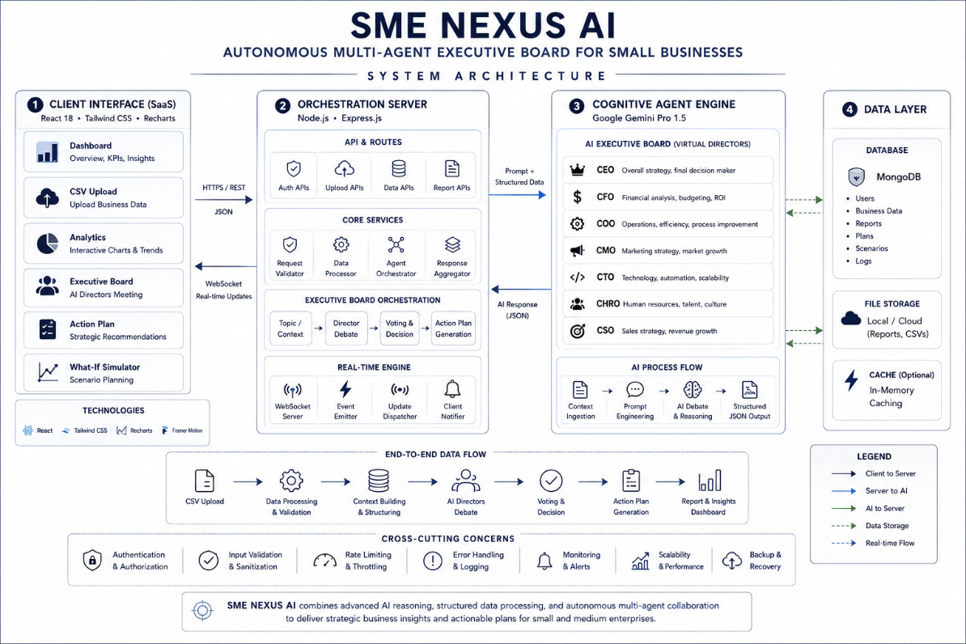

APPLICATION SCREENSHOTS:

1.DASHBOARD PAGE
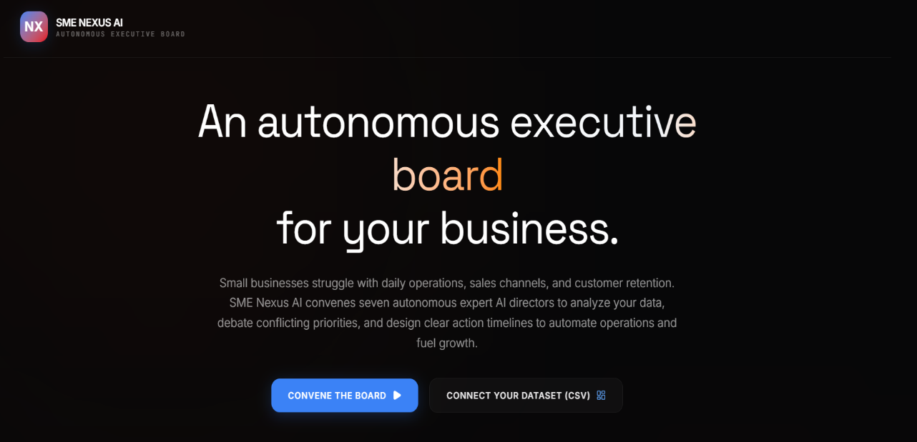

2.UPLOAD DATA PAGE
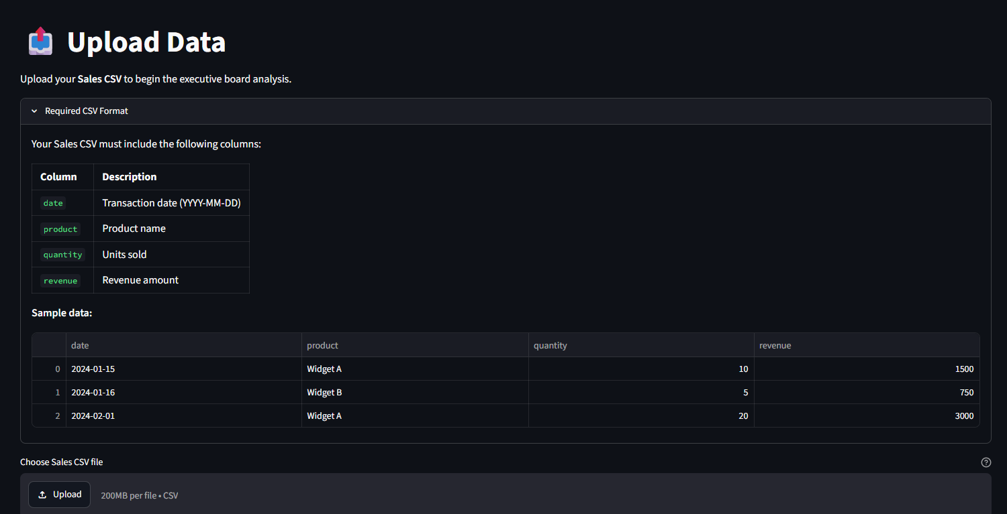

3. ANALYTICS PAGE

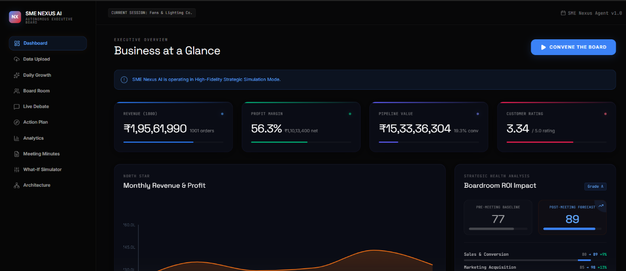

4.BOARD ROOM PAGE

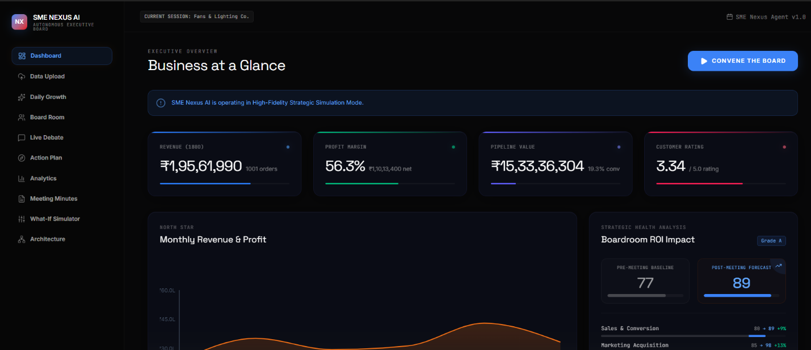

5.DAILY GROWTH PAGE



6.LIVE DEBATE PAGE



7.ACTION PLAN PAGE



8.WHAT IF SIMULATOR

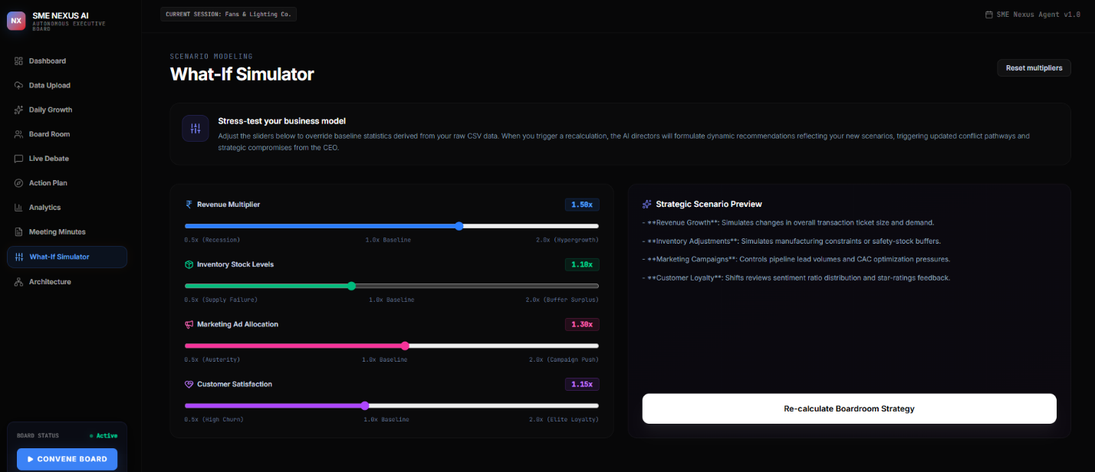

9.MEETING MINUTES PAGE



16. License & Hackathon Submission

License | MIT License — Open Source
Hackathon | Agentic Arena 2026
Theme | Business & Productivity
Case Study | SME Growth Assistant
Repository | github.com/bala-coder-dev/SME-Nexus-AI

Transforming Business Data into Executive Decisions
SME Nexus AI — Agentic Arena 2026

