Apply WLS PSU Patch in Weblogic 12c

Take backup of MW Home

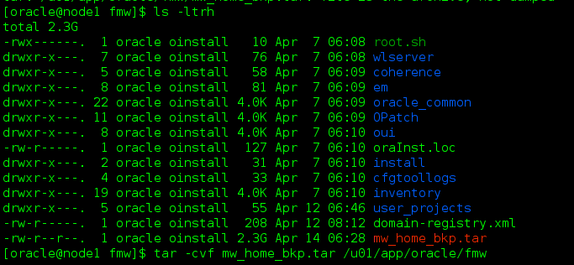

Take Backup of domains

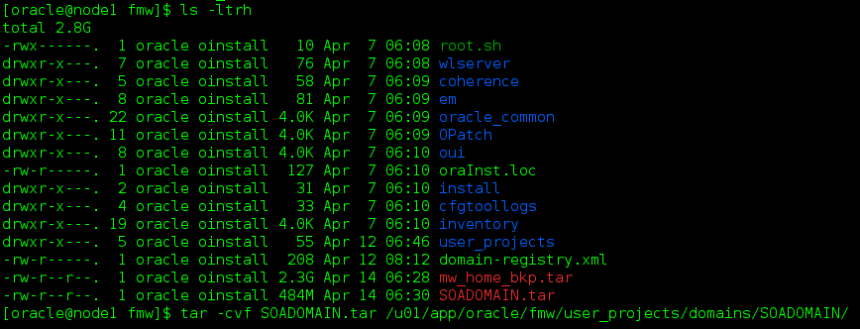

Set the Path and check Opatch Version

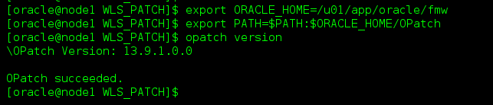

Unzip the patch

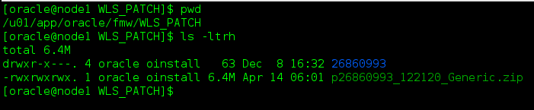

Apply the patch

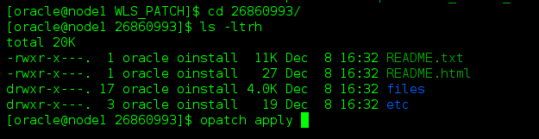

Opatch Logs

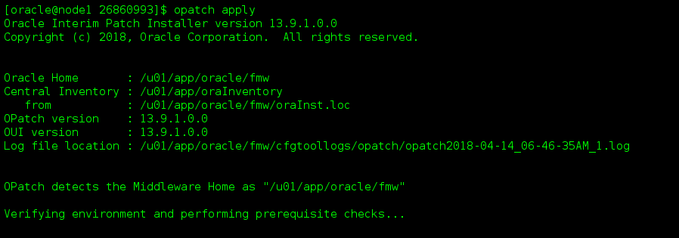

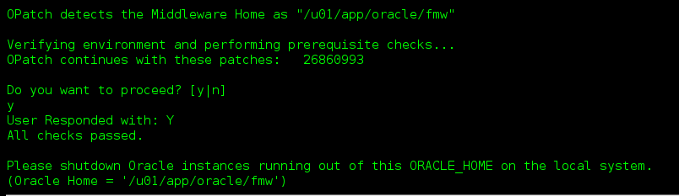

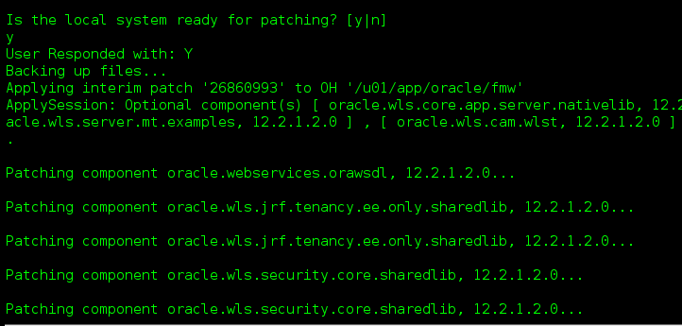

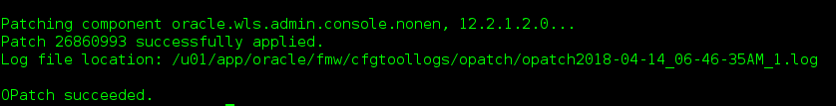

Applied Status

