Remote Diagnostic agent

Run the command

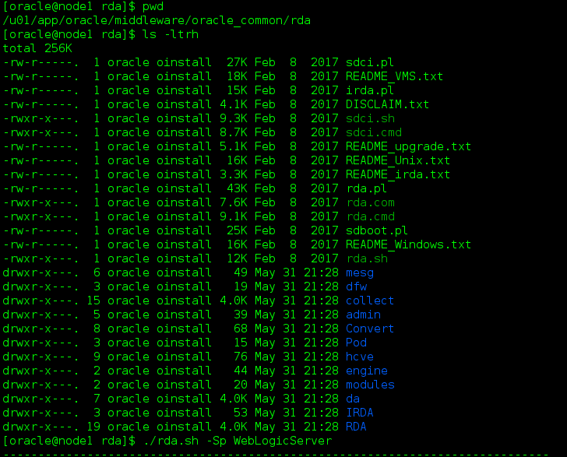

Enter MW home details

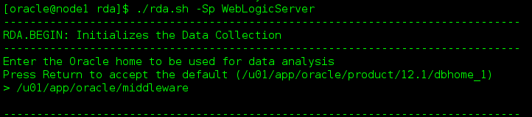

Collect info from Admin and managed servers

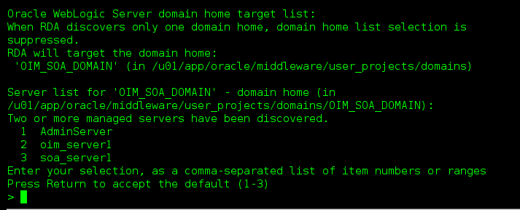

Enter Admin User

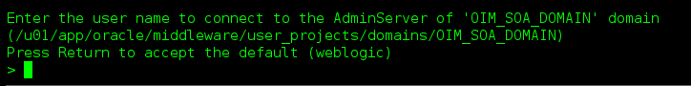

We start Weblogic by standard scripts (startWeblogic.sh)

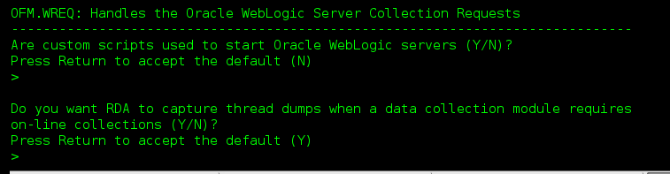

After you finish answering the questions, a profile will be created automatically.

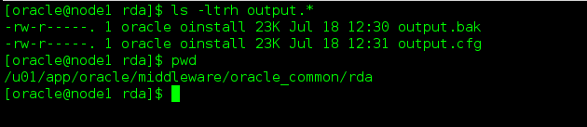

Execute RDA Again

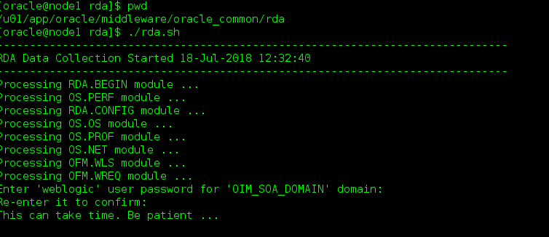

Execution status

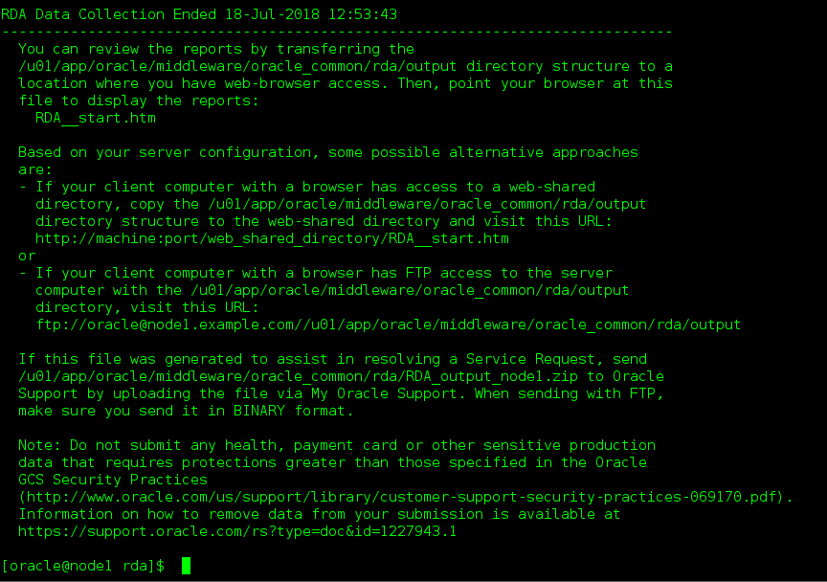

Submit to Oracle Support

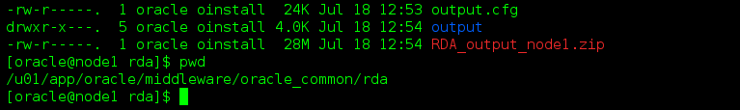

View the output

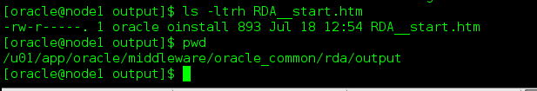

RDA

