Traffic Director

Install Traffic director in a Collocated mode(Managed through Weblogic Domain and installed in Existing FMW home)

Unzip the SW

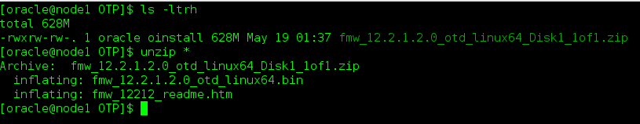

Install OTD

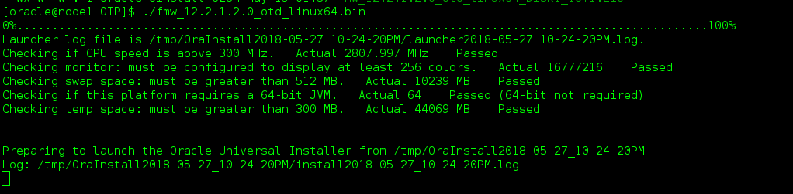

Welcome Screen

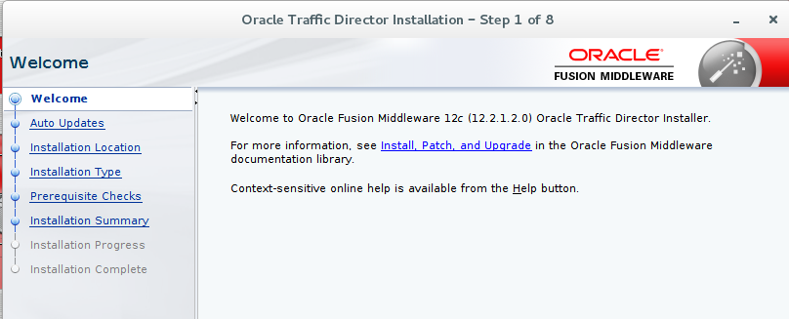

Skip Auto updates

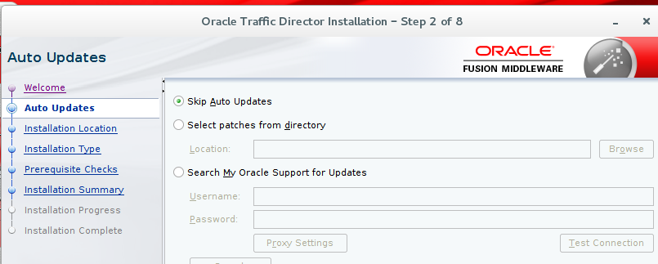

Oracle Home Location

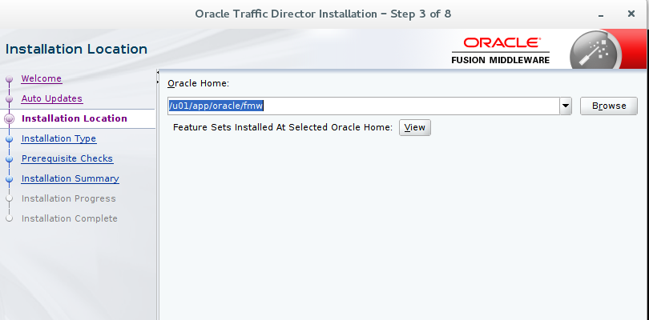

Collocated Mode

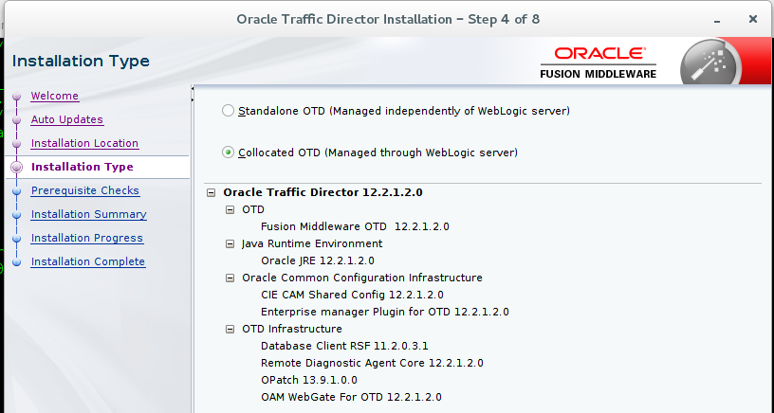

Installation Completed

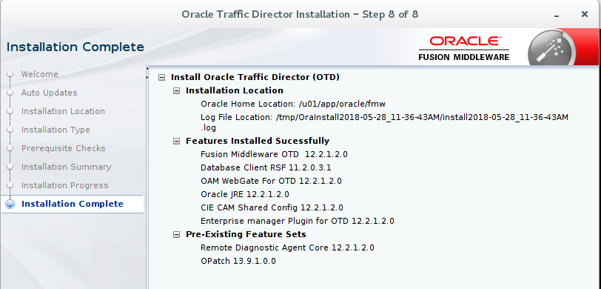

Invoke config.sh to create a domain

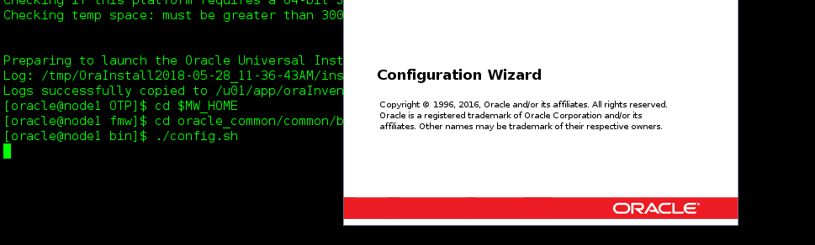

New domain (OTD_DOMAIN)

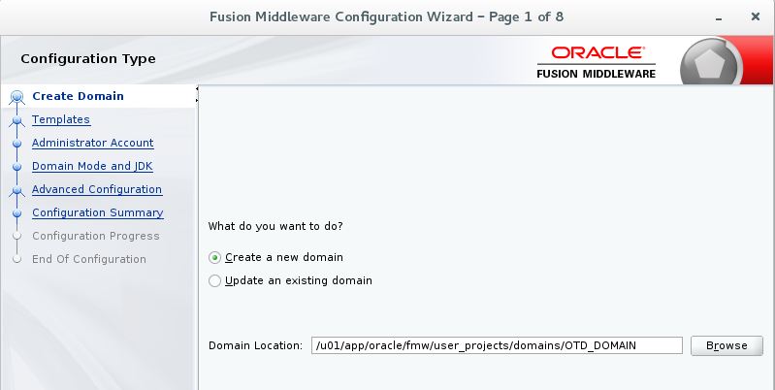

Choose templates

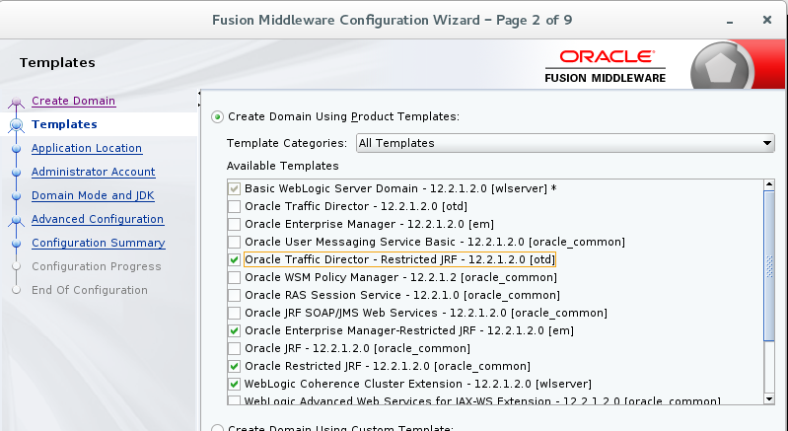

Application Location

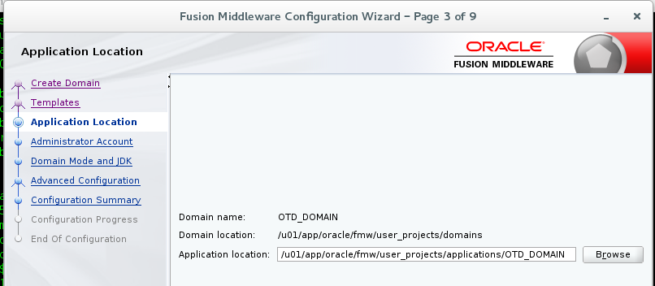

Admin Credentials

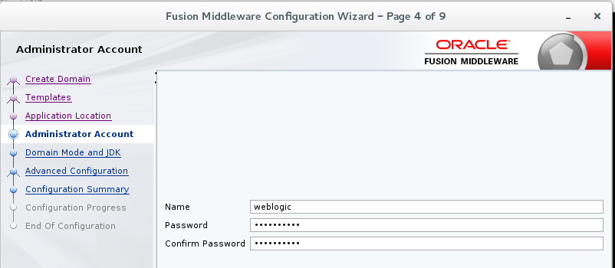

Dev mode

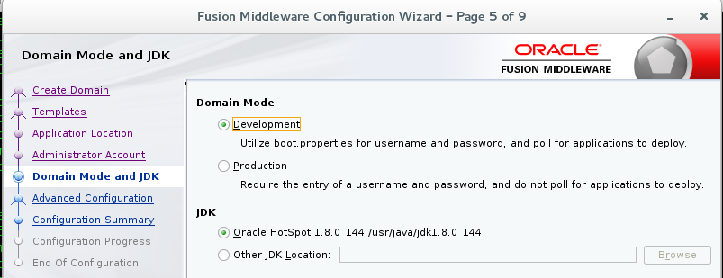

Choose the servers

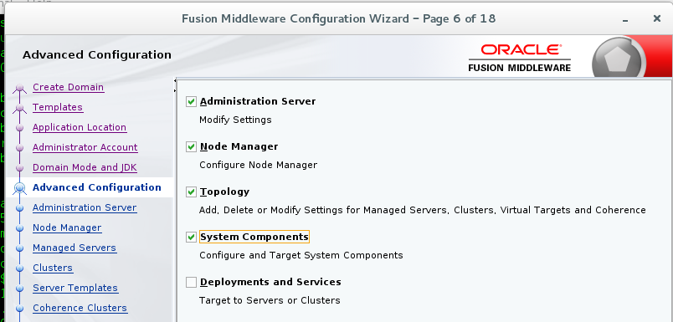

Admin Server Listen Address

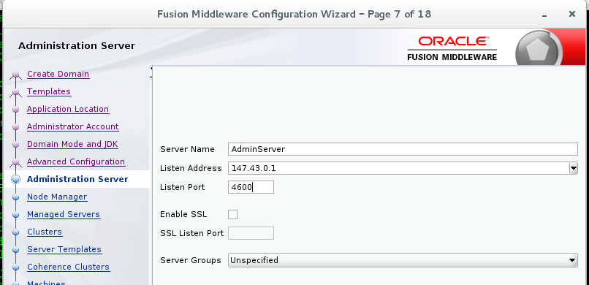

Node manager

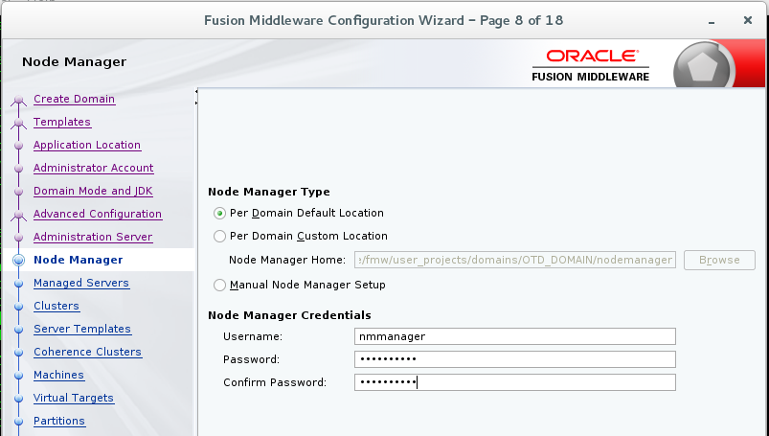

Managed Server details

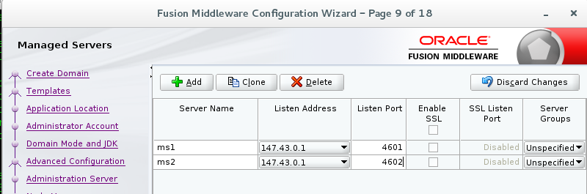

Cluster Name

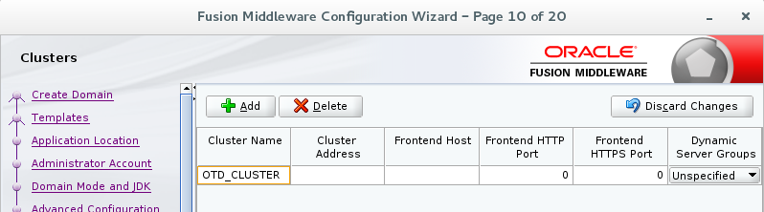

Assign Servers to Clusters

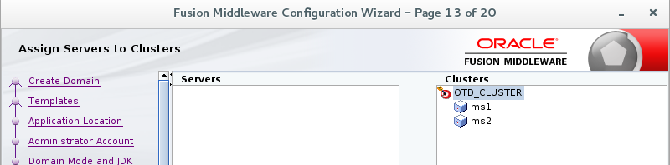

Machine and Node manager Listener address

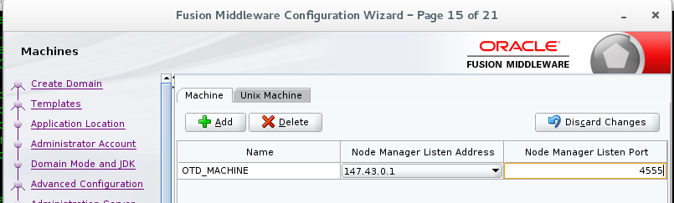

Assign Servers to Machine

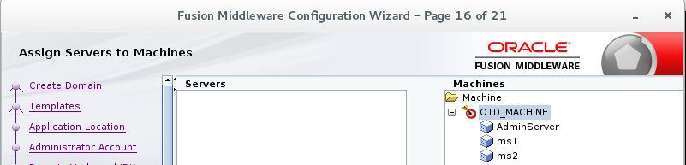

System Component

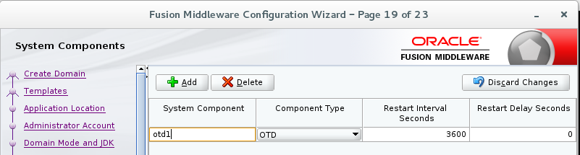

Configuration Process

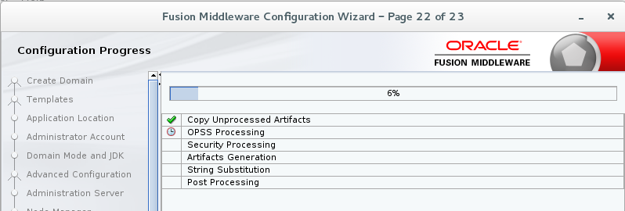

Summary

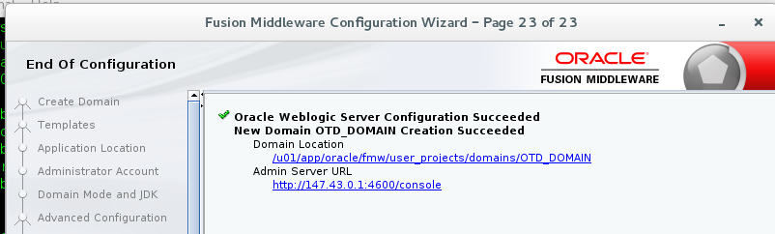

Start Weblogic.sh

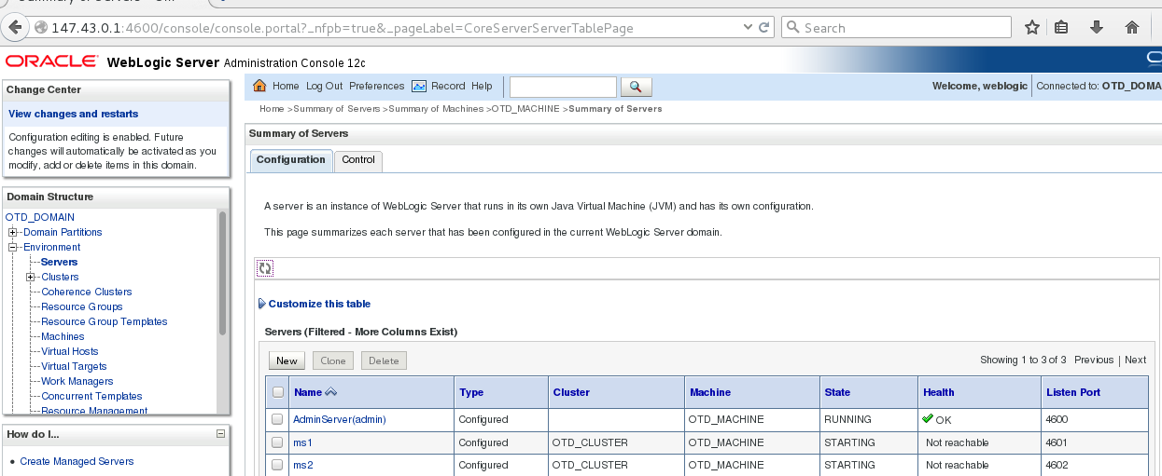

OTD Configuration

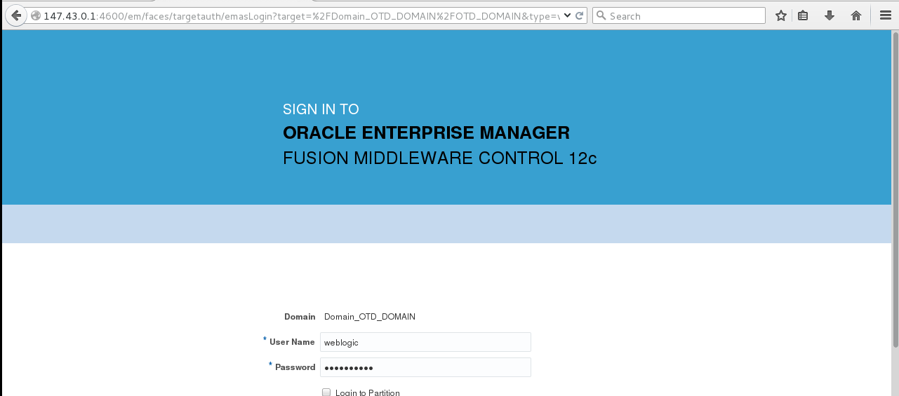

Click Domain->admin->OTD_Configuration

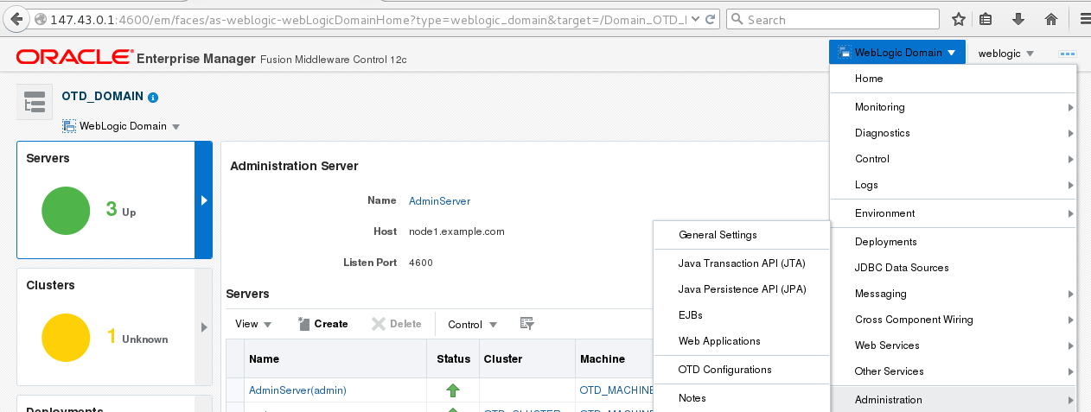

Give unique name

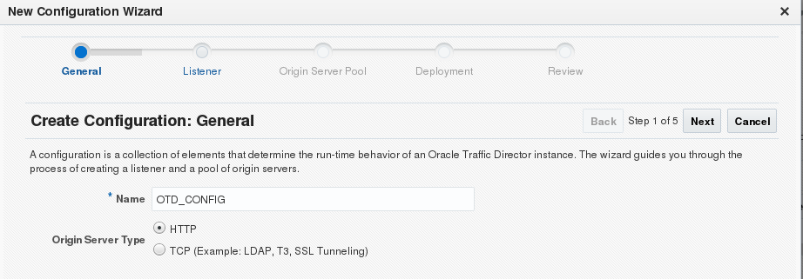

Listen port for OTD

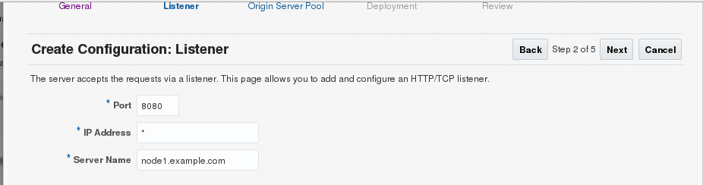

In which machine the OTD is running

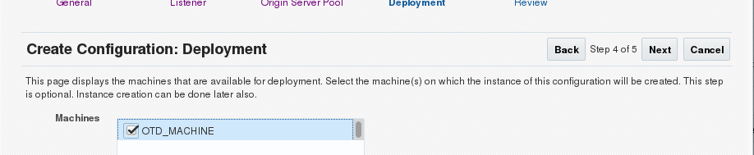

Summary

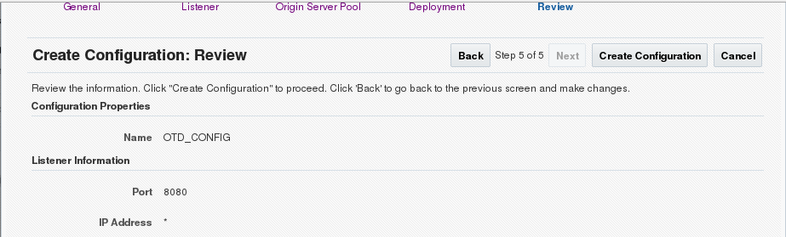

After configuring , start instances

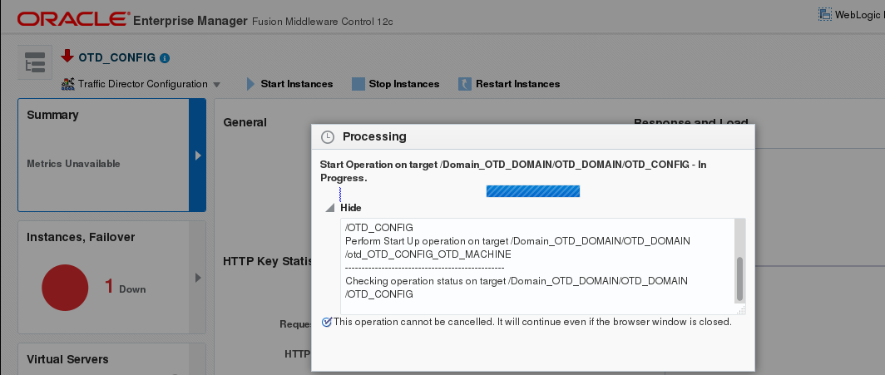

To start Instance in backend

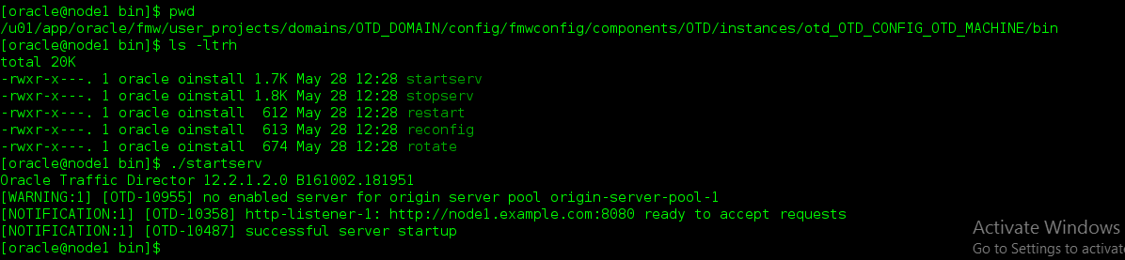

Check the status of OTD_instance

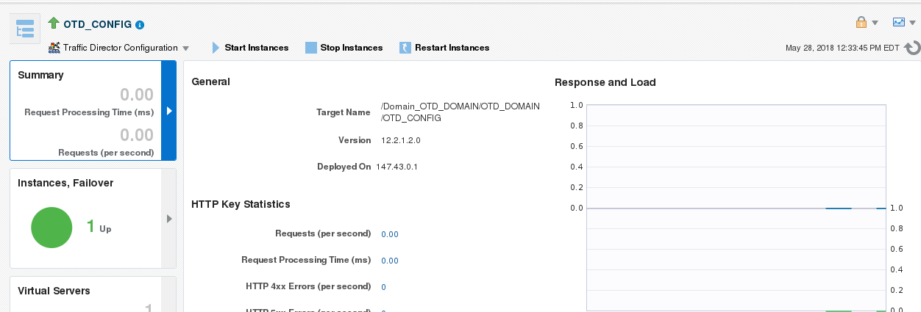

OTD_RUNTIME-Domain->environment->OTD_Runtime

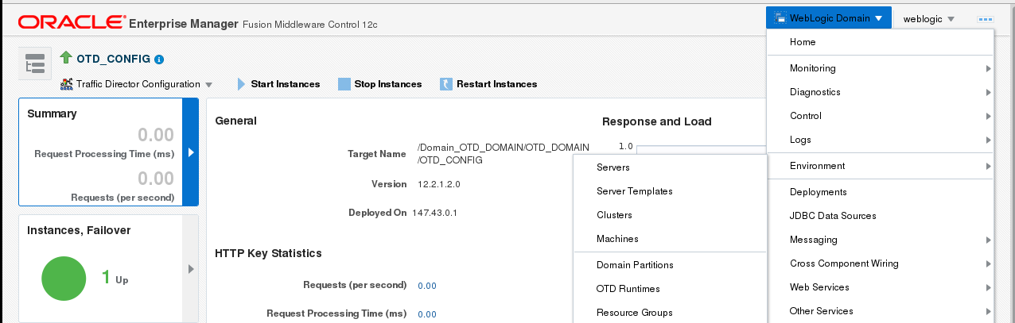

Register Runtime(From which server the request are going to flow)

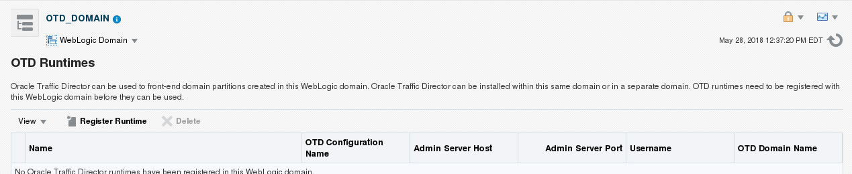

You need to register the servers with OTD

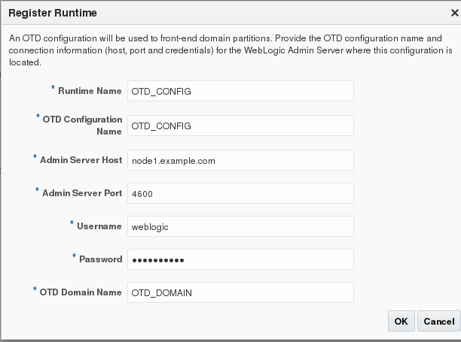

Create Domain Partition

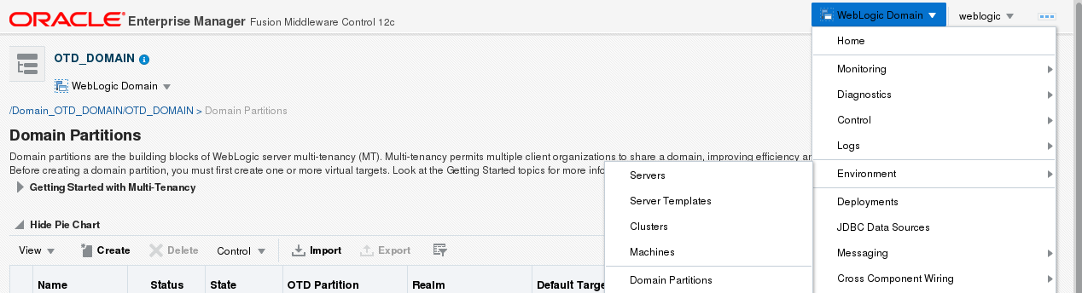

Click Create

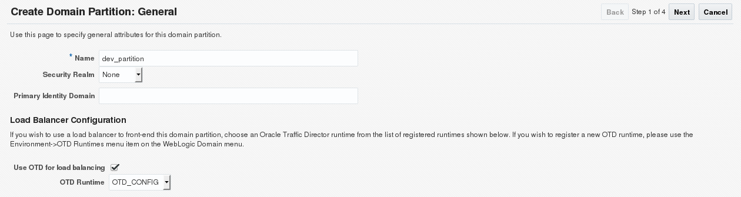

Virtual Target

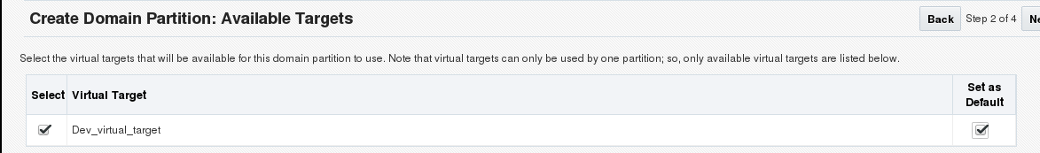

Resource group Name

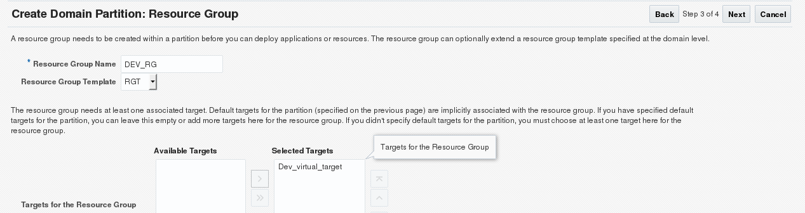

Summary of Partition

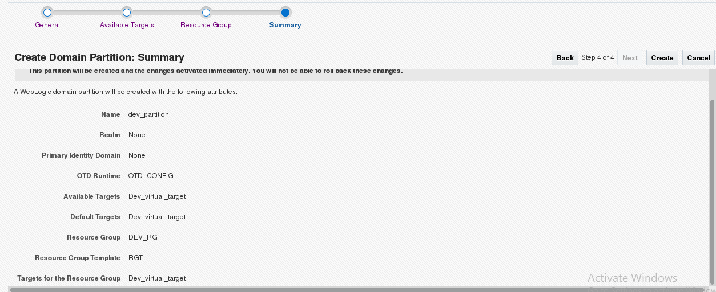

Start the partition

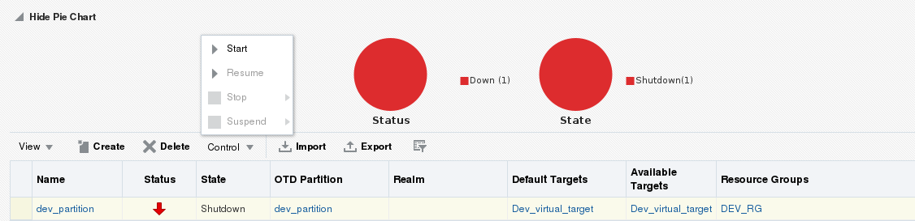

Check whether the app is running on Load balancer port

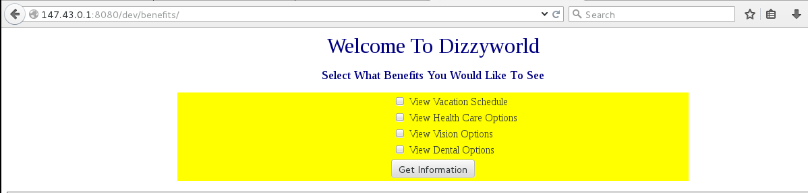

Now shutdown one managed server and crosscheck again

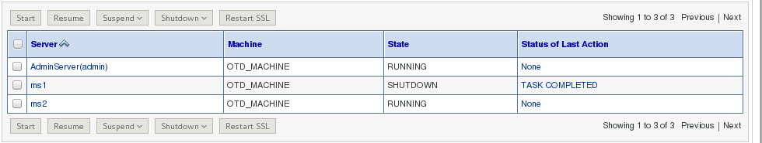

Application is accessible



Now the application is accessible via MS2

