Upgrade Fusion Middleware Infrastructure

Source Middleware Version and Server status

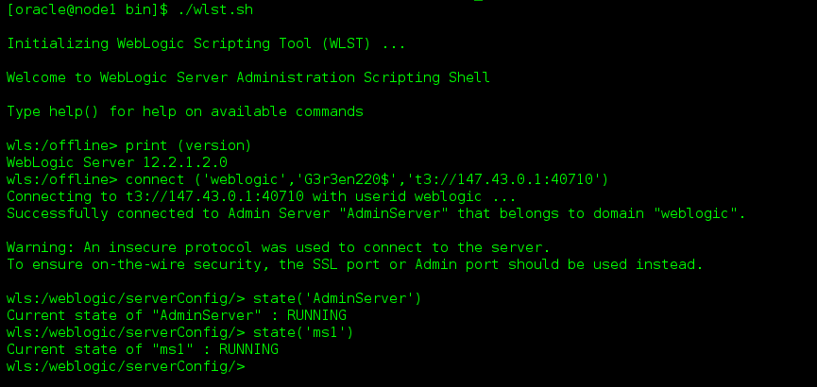

Schema Version Registry Table

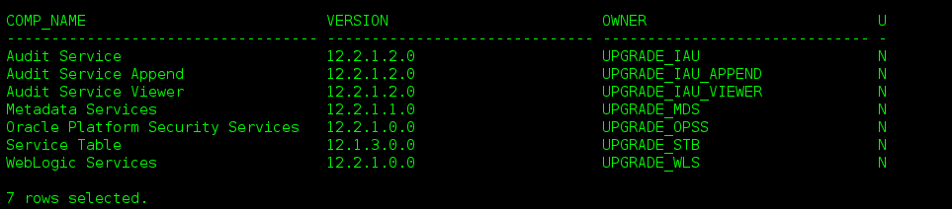

Check the version from console

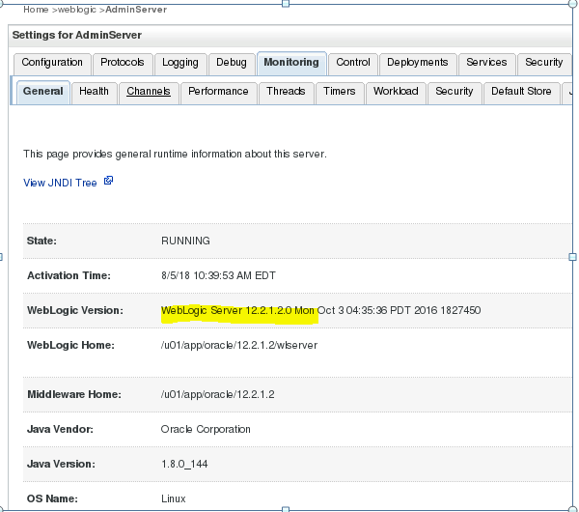

Take a full offline backup of database, domain_home, oracle_home before upgrading

Backup database

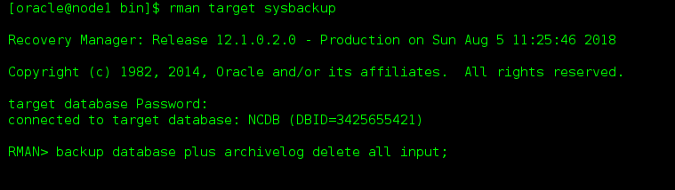

Backup Oracle Home

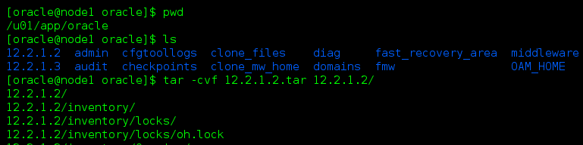

Backup Domain Home

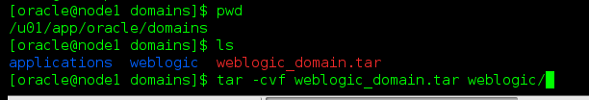

Install FMW 12.2.1.3

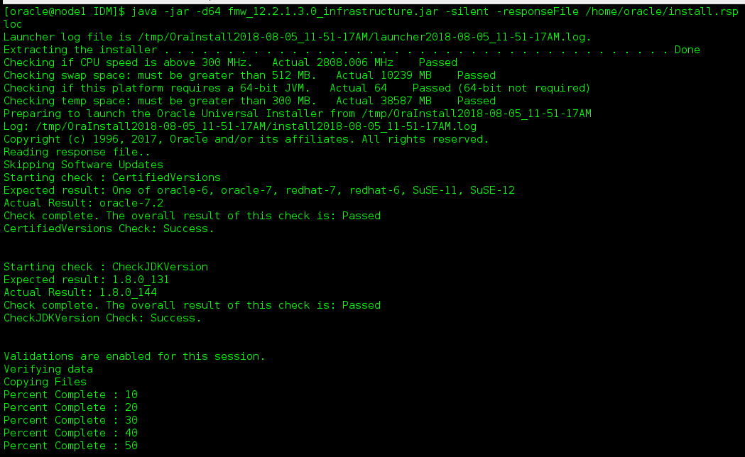

Check the installed version

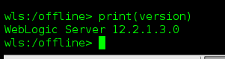

Run Pre-upgrade assistant tool from target (you can run when Servers are online or offline)

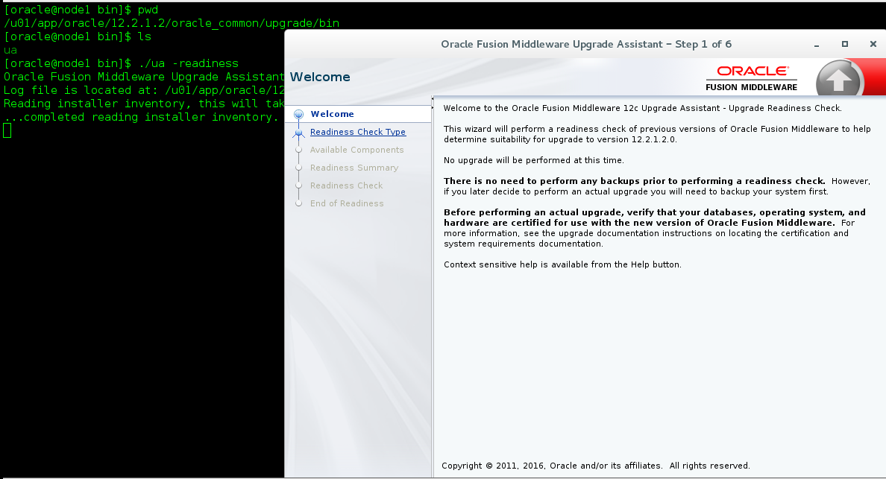

Click Domain Based

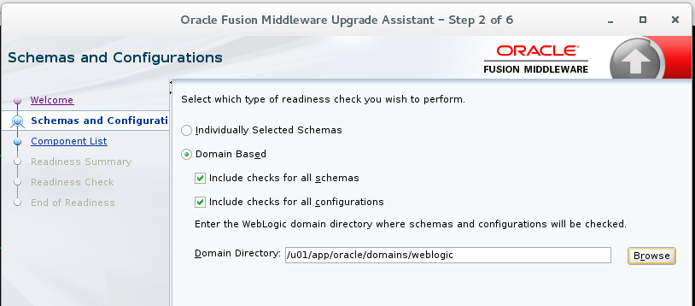

Component list

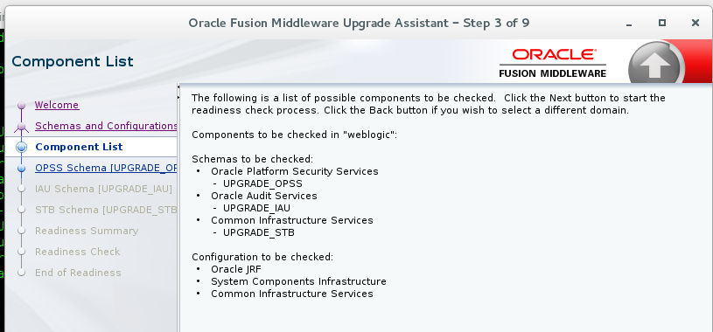

Upgrade Schema

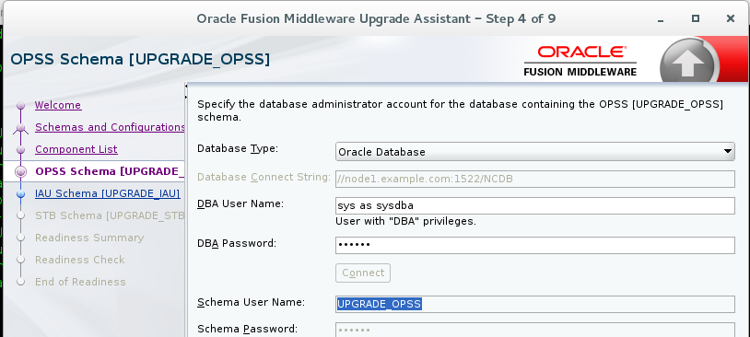

Readiness summary

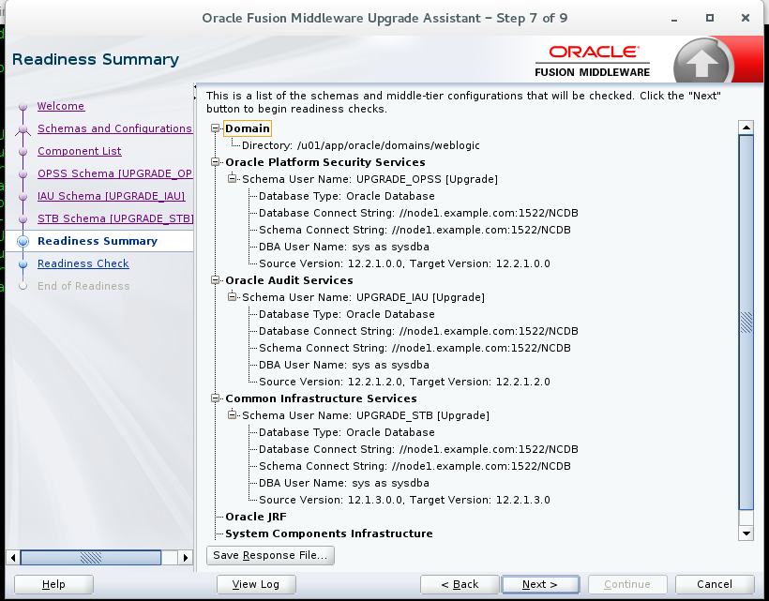

Readiness Check

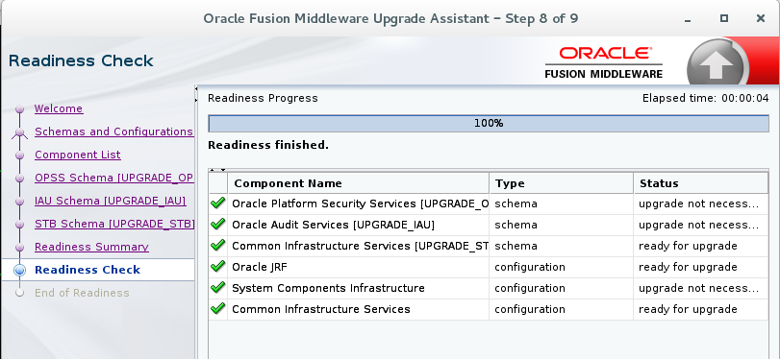

Readiness Success

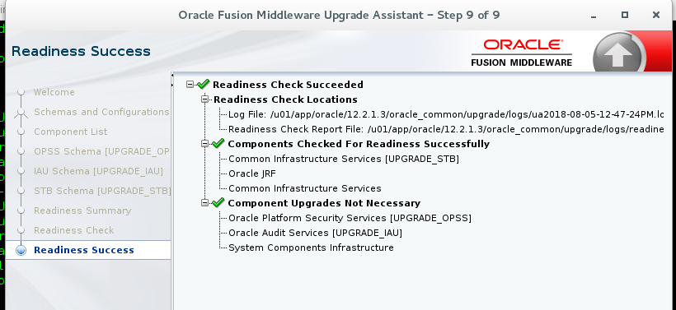

Run the tool UA from target to actually upgrade the schemas and component

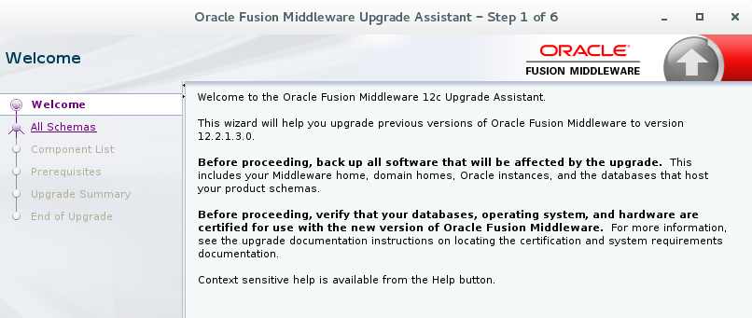

All schemas used by domain

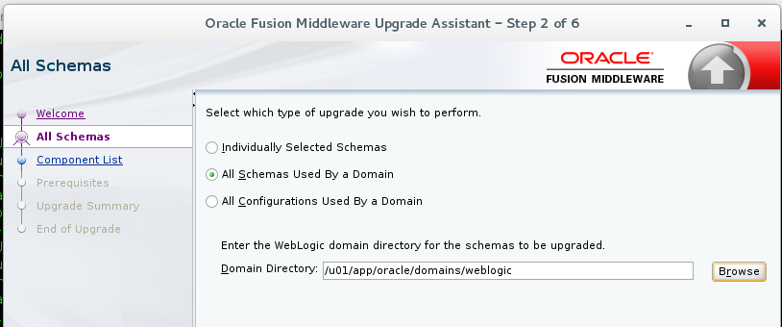

Component List

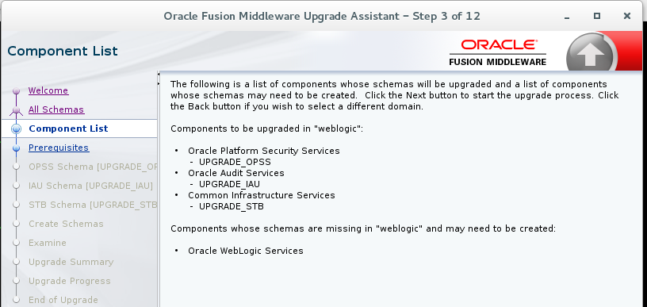

Check the prereq

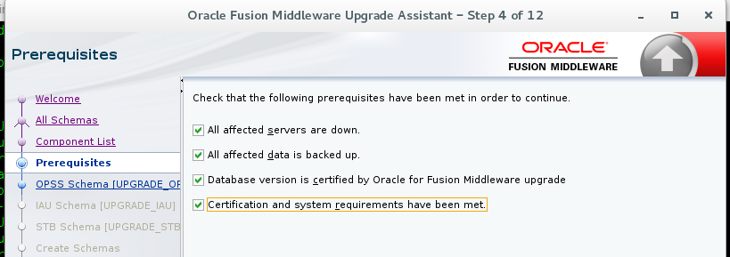

Connect to the schema that needs to be upgraded

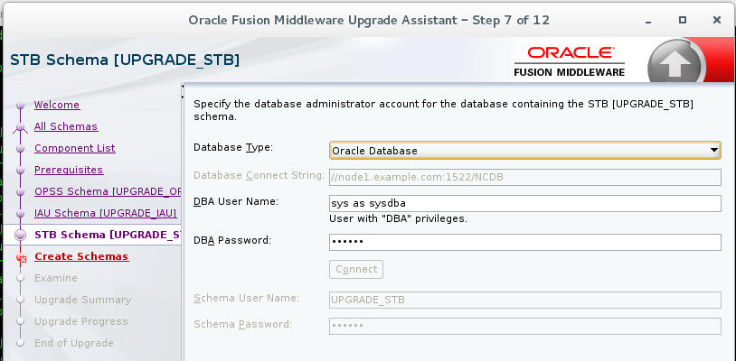

Create Missing Schema

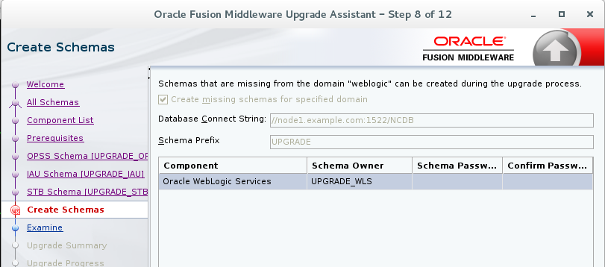

Examine Summary

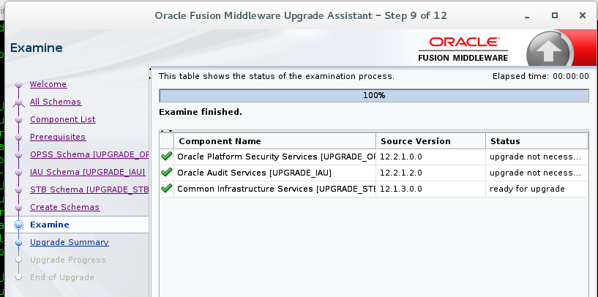

Upgrade Summary

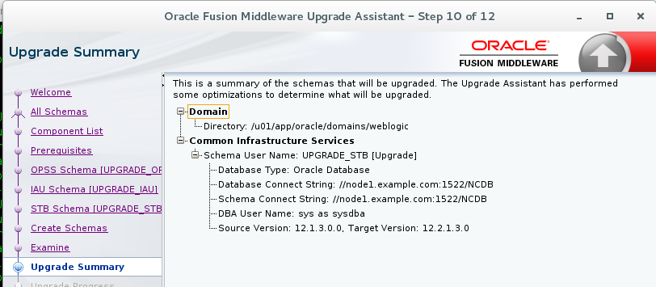

Upgrade Progress

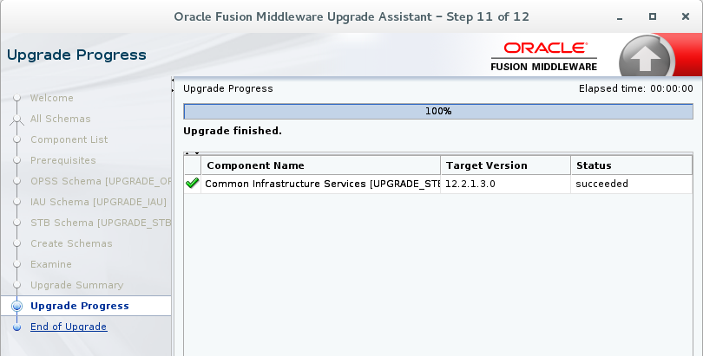

Check the Schema version Post upgrade

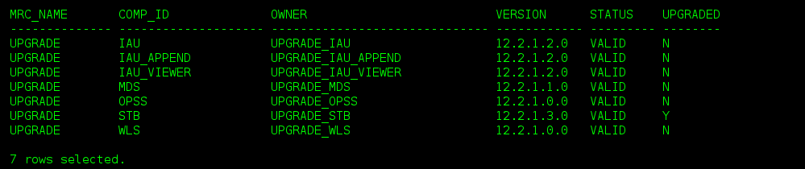

Reconfigure the domain( run from target)

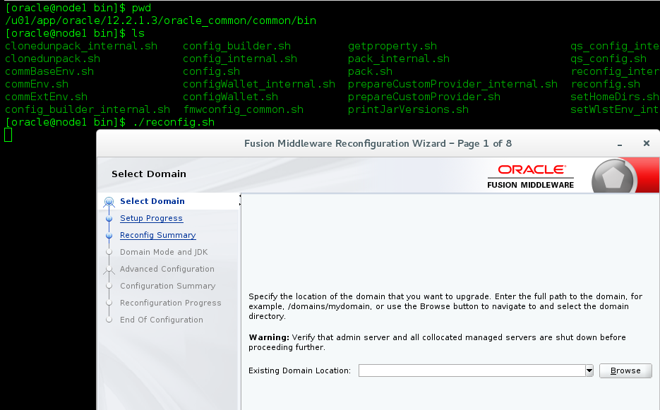

Enter the domain name

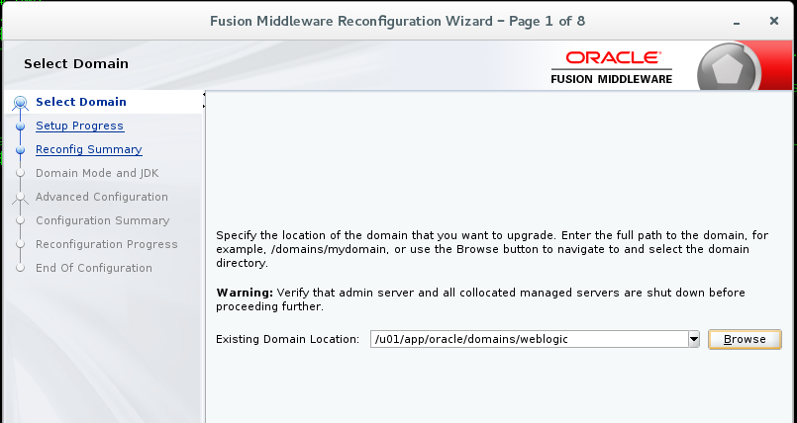

Setup Progress

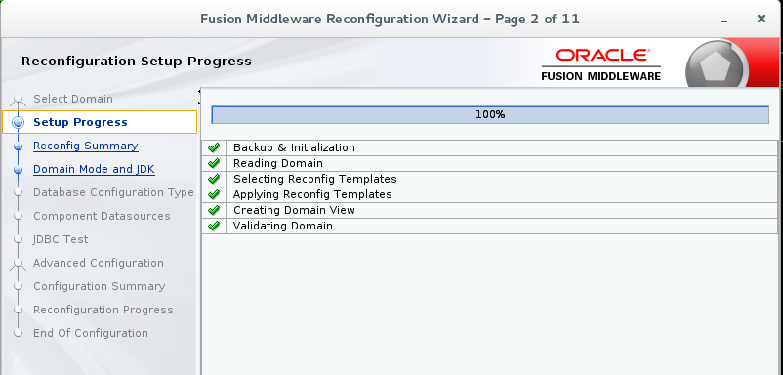

Reconfigure Summary

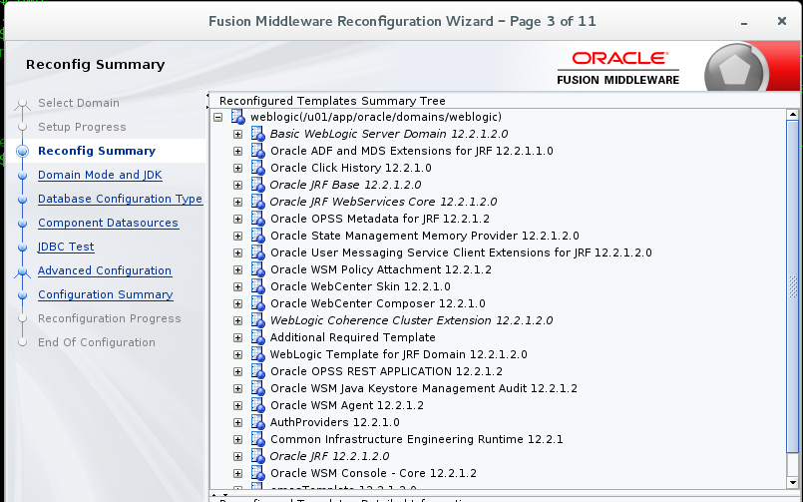

JDK version ( you cannot change the Domain mode)

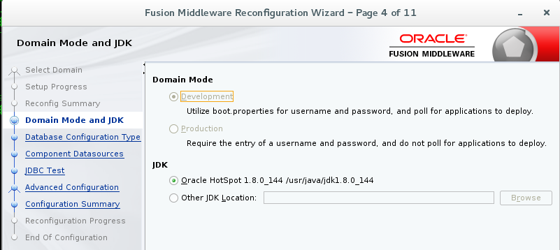

Database configuration

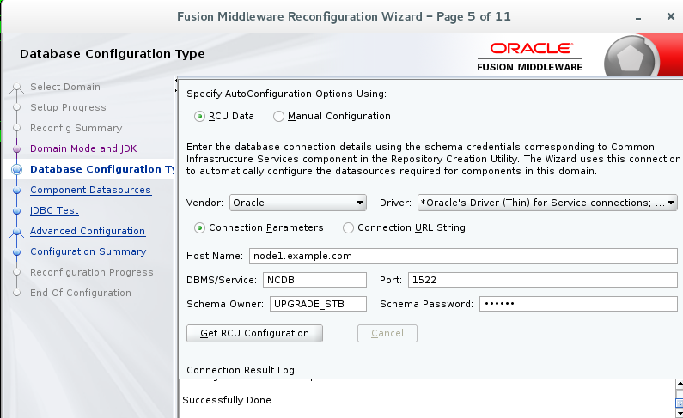

JDBC Test

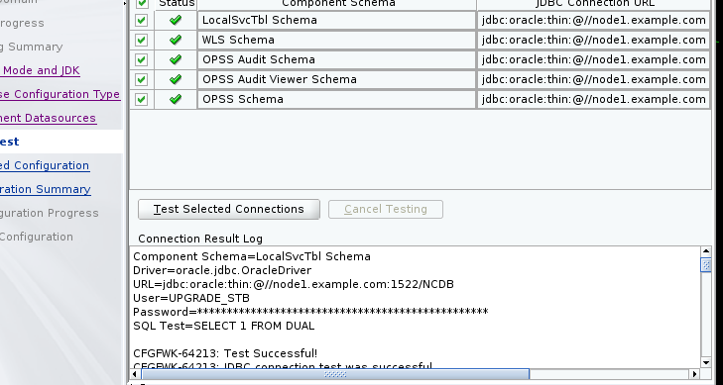

Advanced Configuration

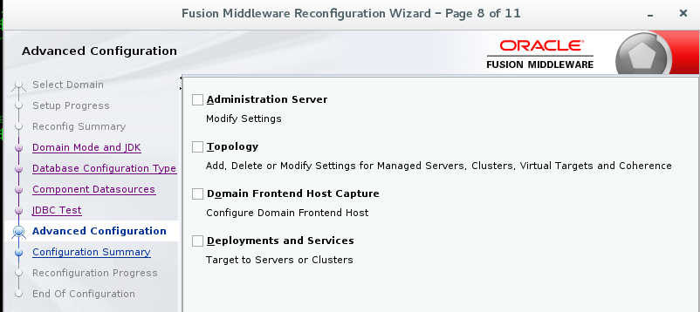

Reconfiguration Summary

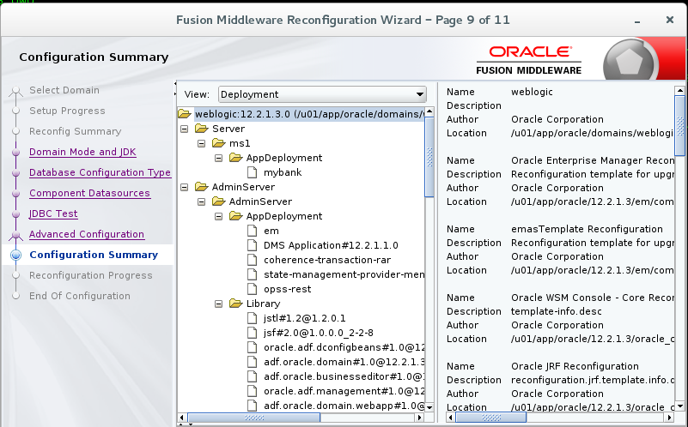

Reconfiguration Success

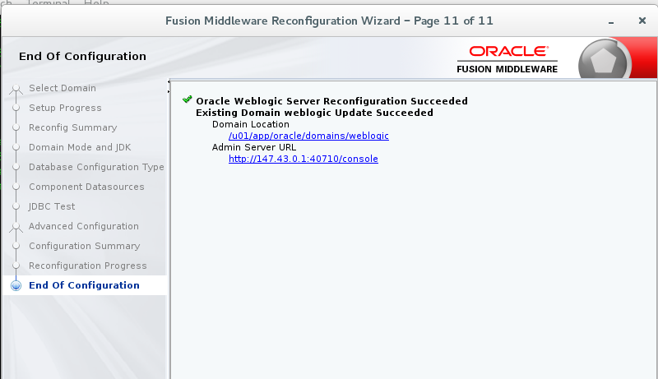

Upgrading Domain Component ( you need to run this after reconfiguring)

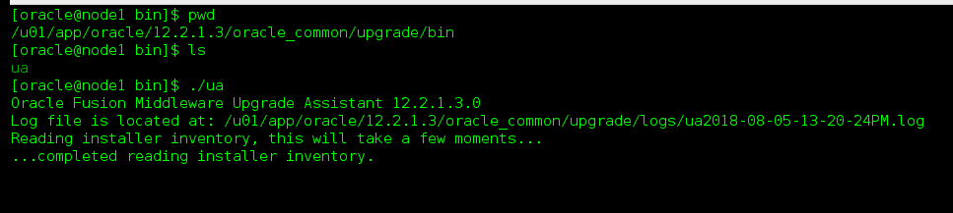

Click Domain Component

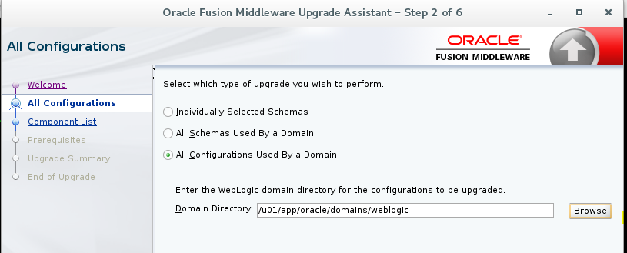

Component list (it will update the domain component configuration)

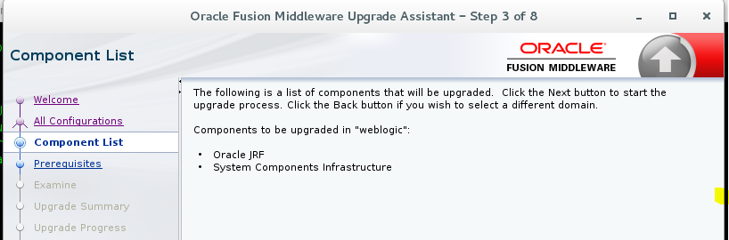

Check the Prerequisites

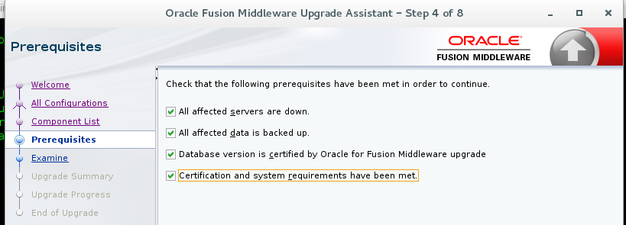

Upgrade Summary

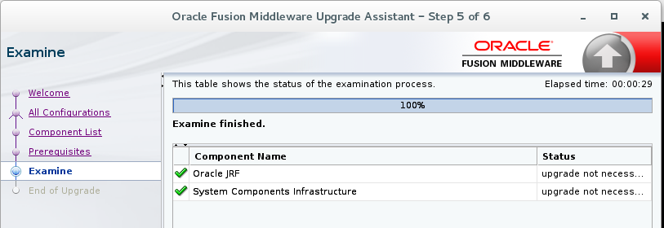

After upgrading, verify the version

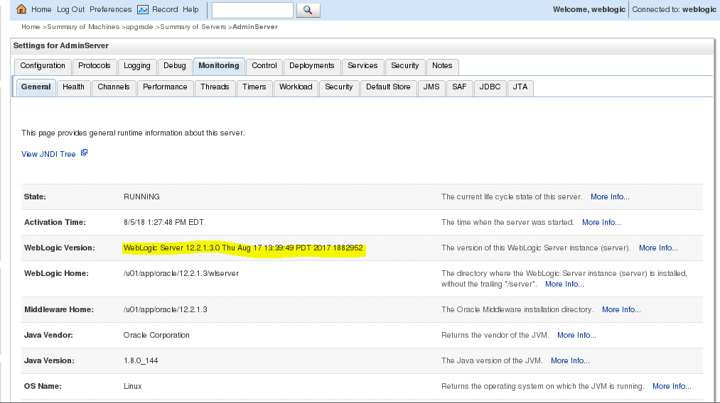

To find JDK location

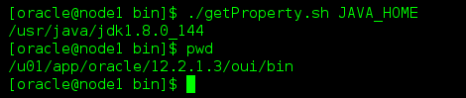

If you change JDK location means , following three files have to be modified

1. (UNIX) *DOMAIN_HOME*/bin/setNMJavaHome.sh
2. (UNIX) *DOMAIN_HOME*/nodemanager/nodemanager.properties
3. (UNIX) *DOMAIN_HOME*/bin/setDomainEnv.sh