Ansible Installation

Install ansible via OS package manager

Install Python3 as a prerequisite

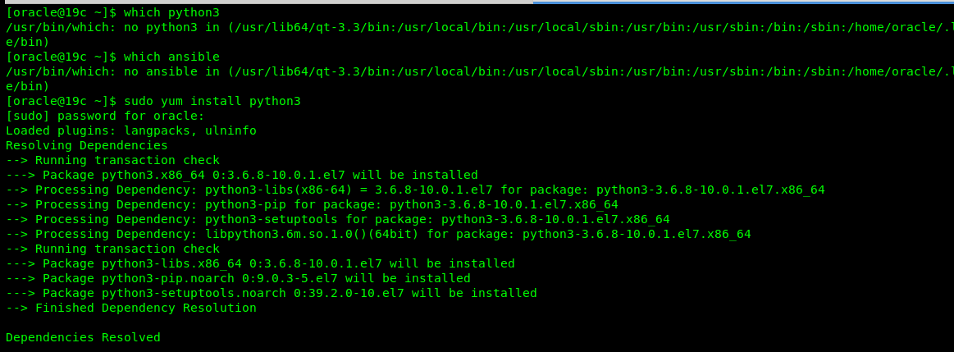

Install Ansible

Enable the repository for installing ansible (applicable only for oracle linux )

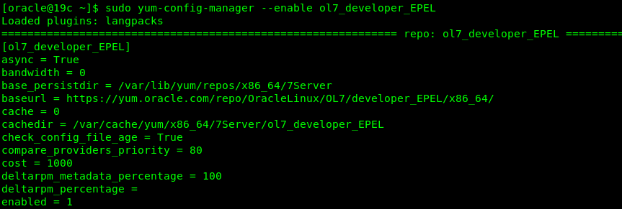

Install ansible via OS package manager

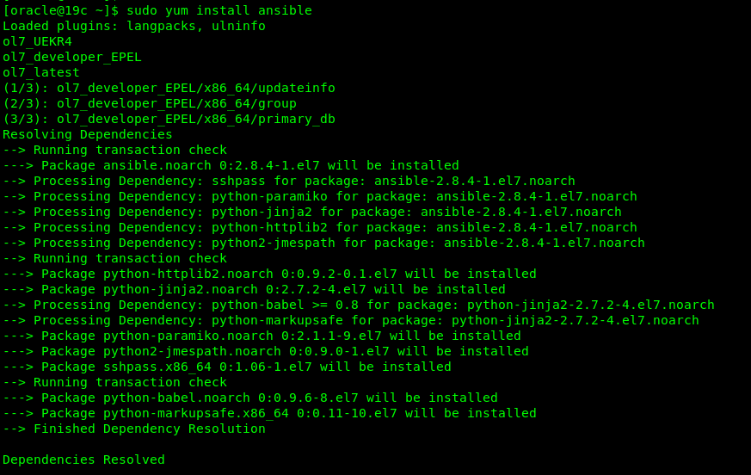

Check Ansible version

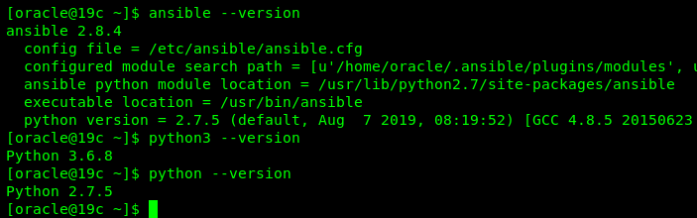

Install Ansible via PIP

Install Ansible via PIP

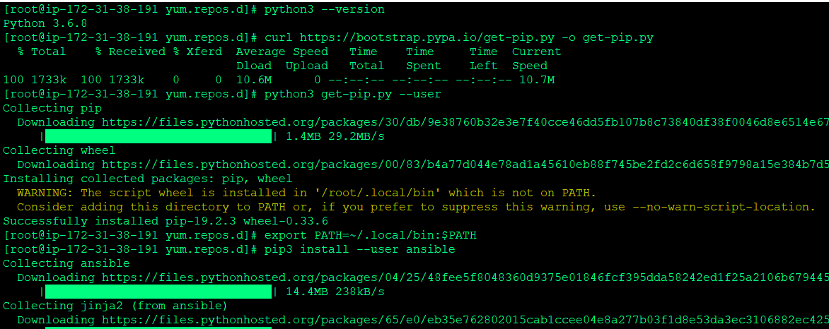

Check the ansible version

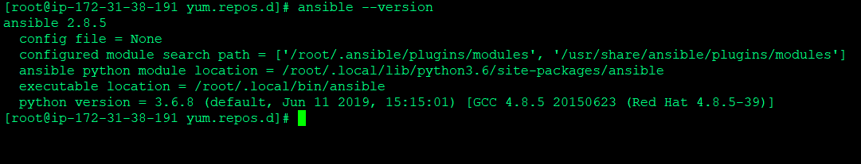

Install ansible from Github

Clone the repository

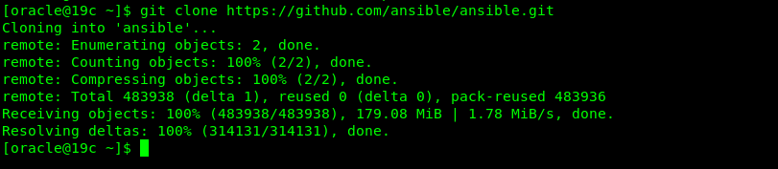

Source the env file (you should always source this)

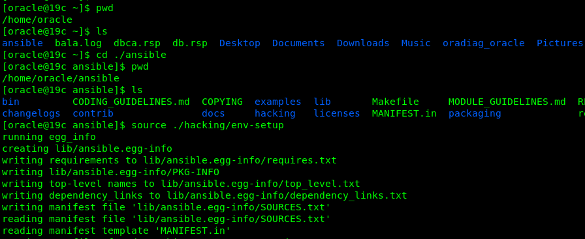

Ansible version

