Installing Ansible

Add a dedicated user for Ansible

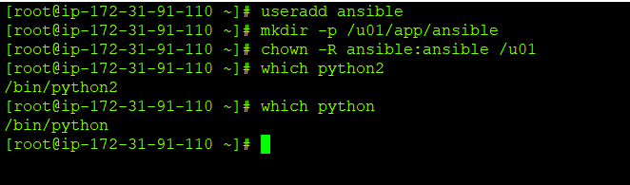

Install the EPEL for RHEL 7

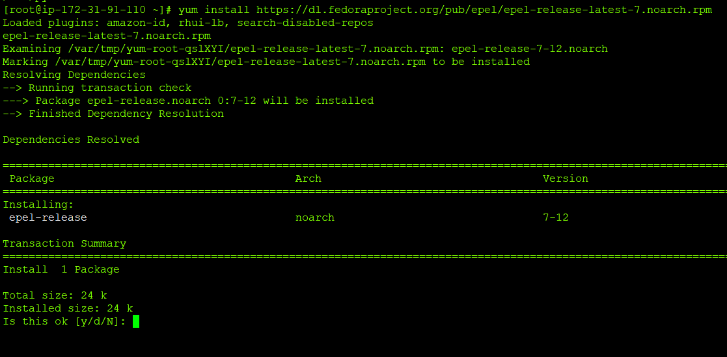

Installing Ansible via Yum

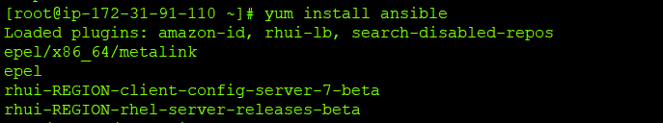

Check Ansible Version

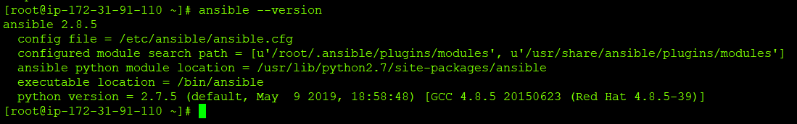

Install Ansible via PIP

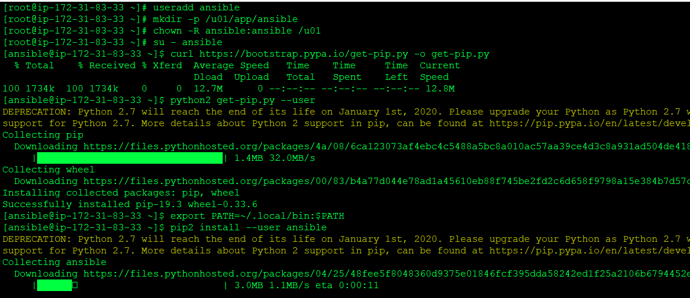

Check Ansible Version

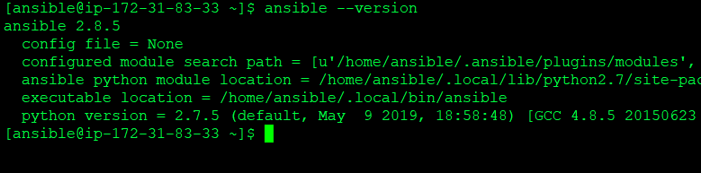

Install Ansible via Git



Clone the git repository

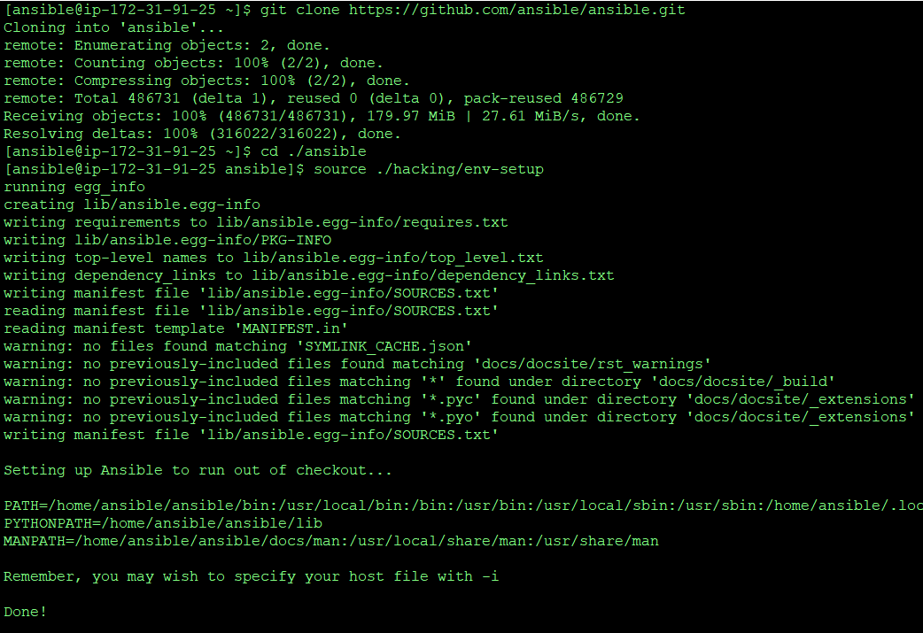

Install additional packages

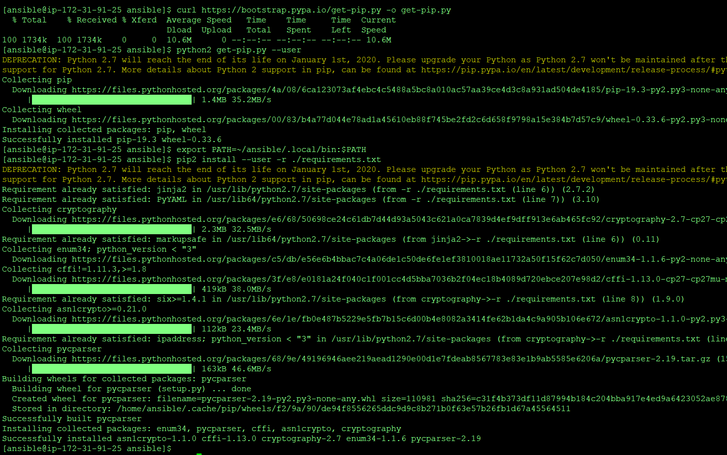

Check Ansible Version

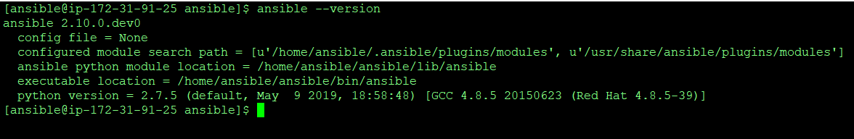

Installing Ansible by subscribing

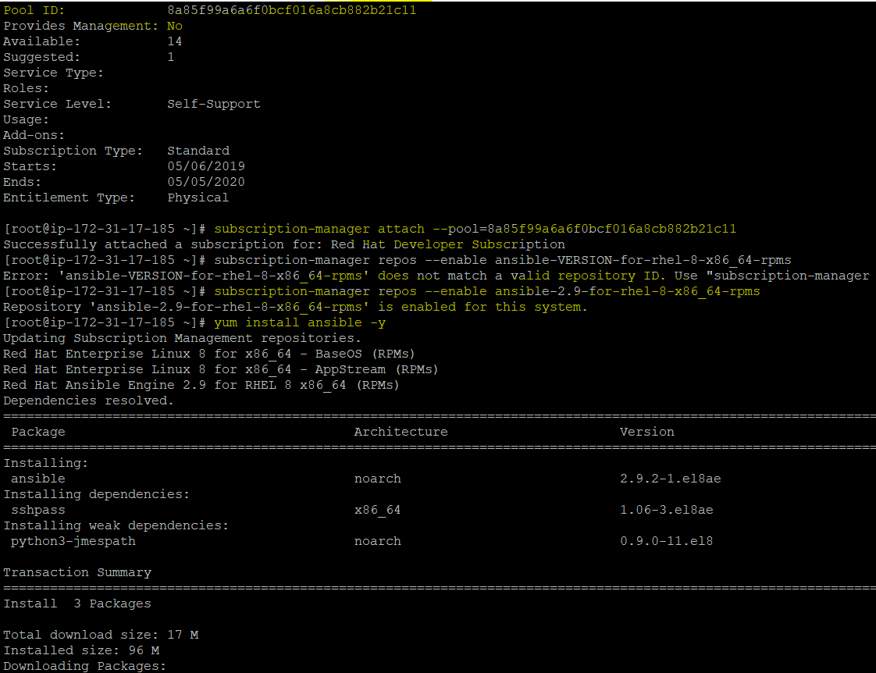

Check Ansible version

