Ansible SSH

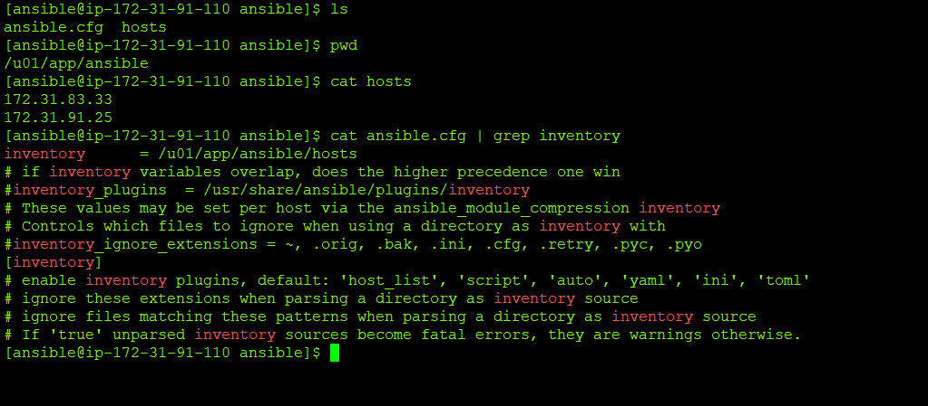

Install SSH key

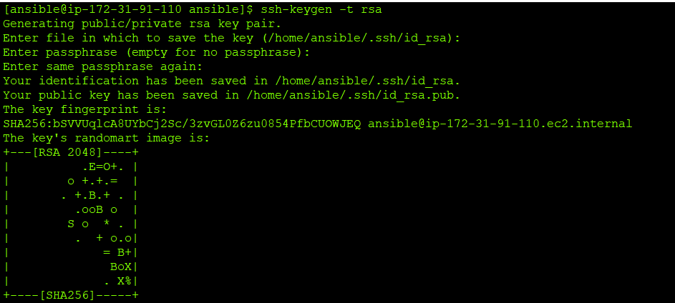

Copy the pub Key to remote machines

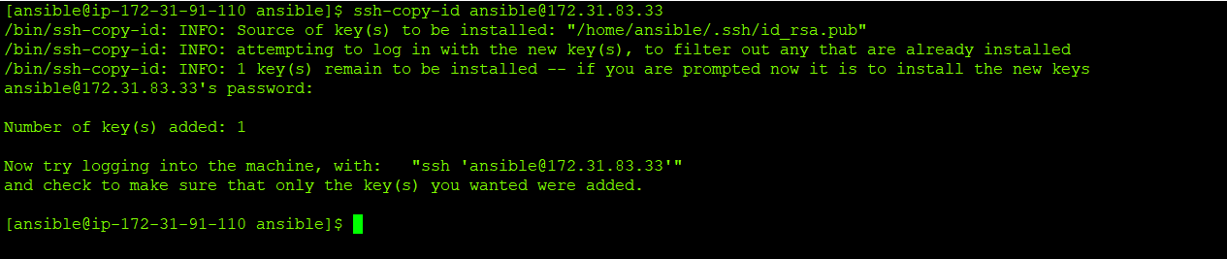

You can verify the authorized key in the remote machine for verification



Now test and see

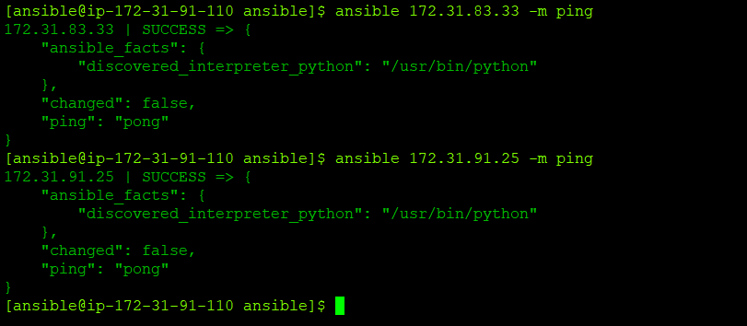

Now try using PEM file.

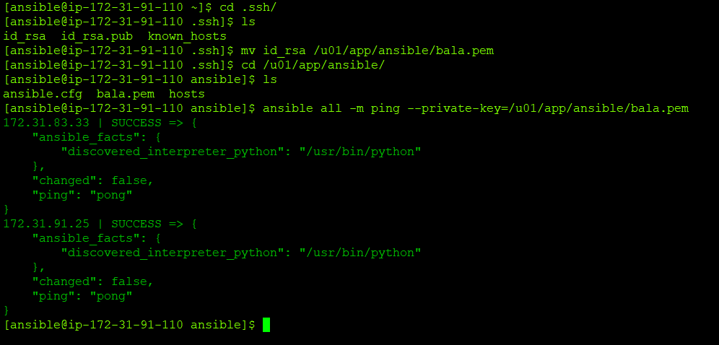

Add passphrase

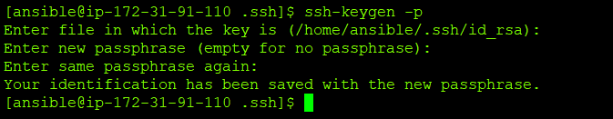

If you don’t want to enter passphrase for each and every time

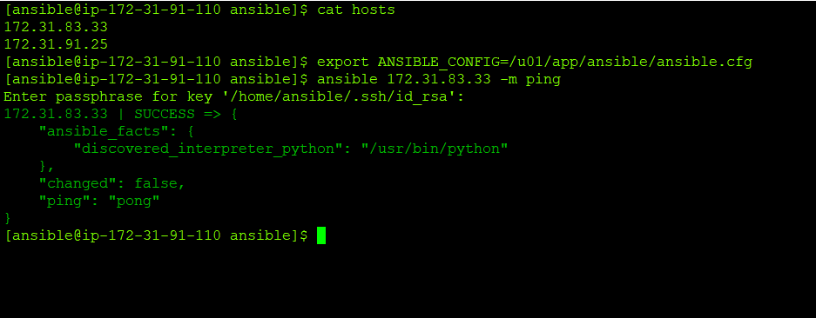

Run SSH agent in the background

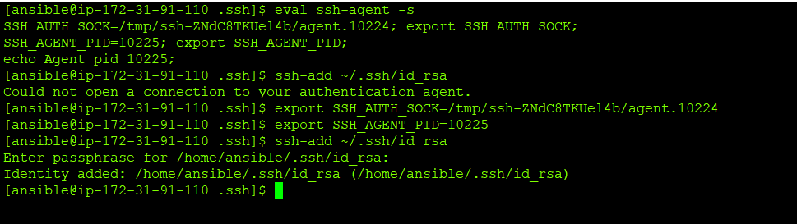

Now connect and See

