Jenkins Installation on War file

Check Java version

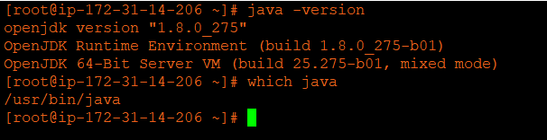

Download Tomcat to host Jenkins war file

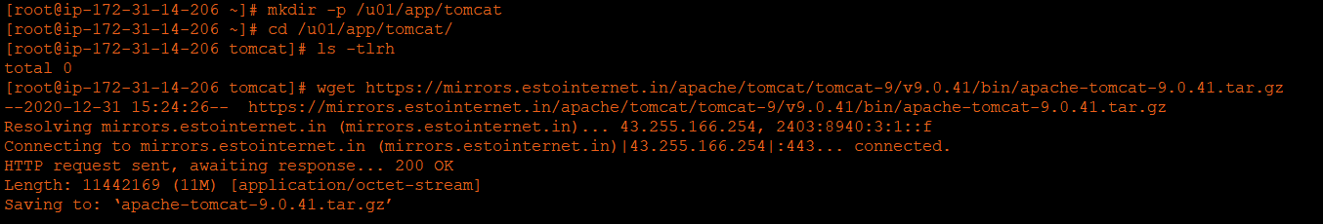

Install tomcat

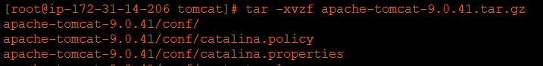

Startup tomcat

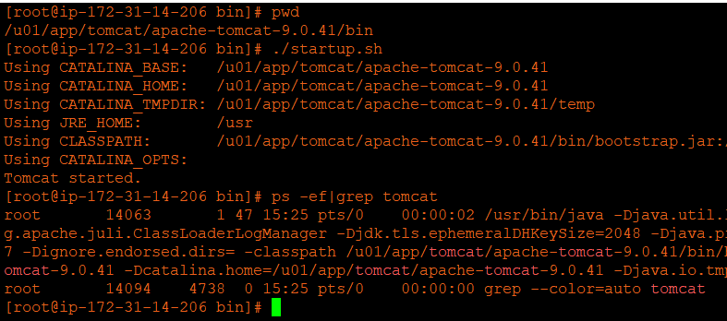

Download Jenkins war file and keep under tomcat webapps directory

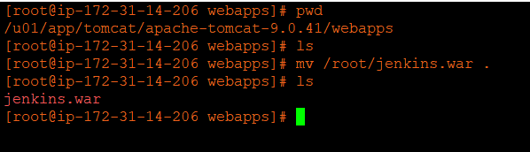

Enter the admin password

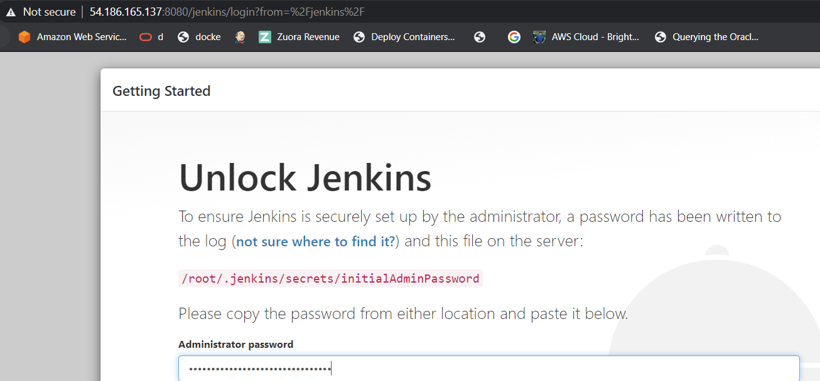

Install plugins

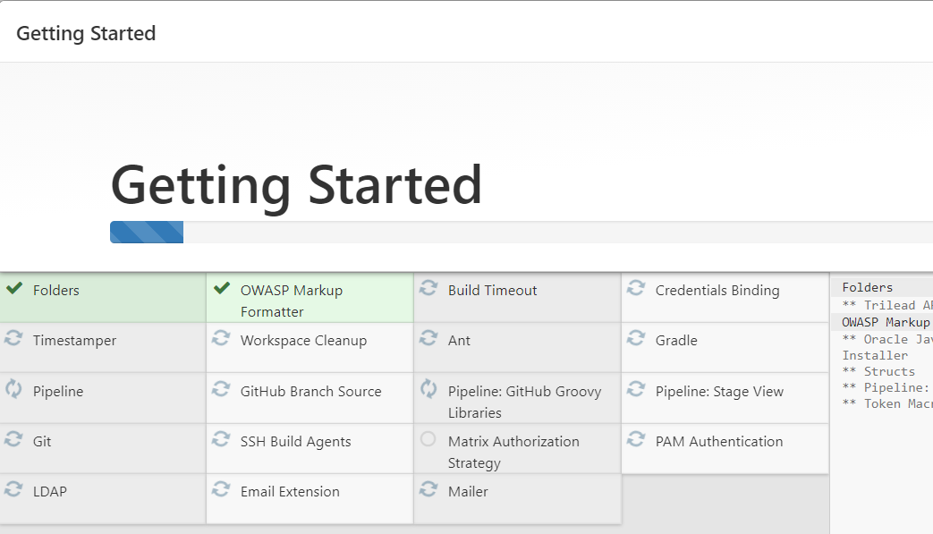

Jenkins Login

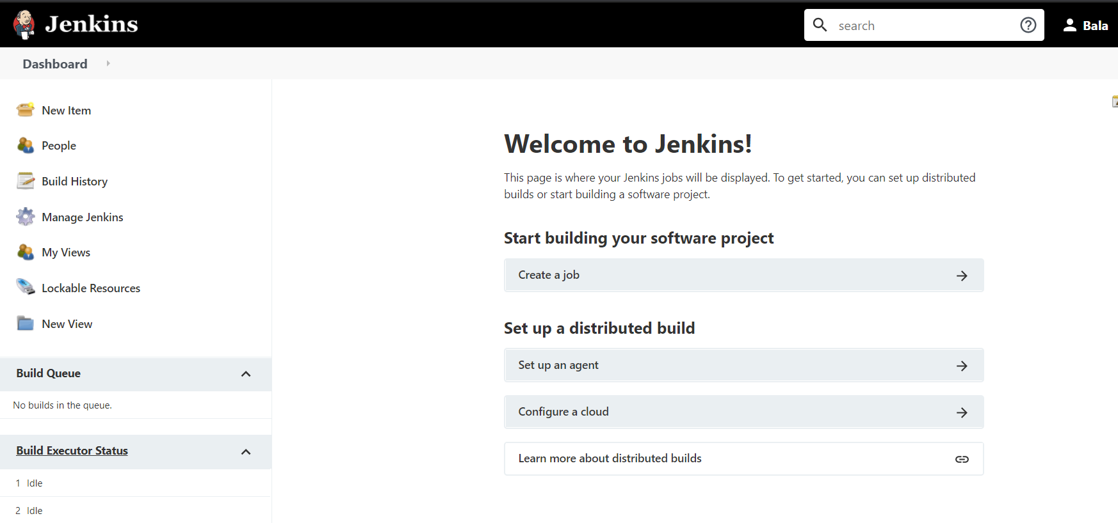

Change the colour of Jenkins UI

Install simple theme plugin

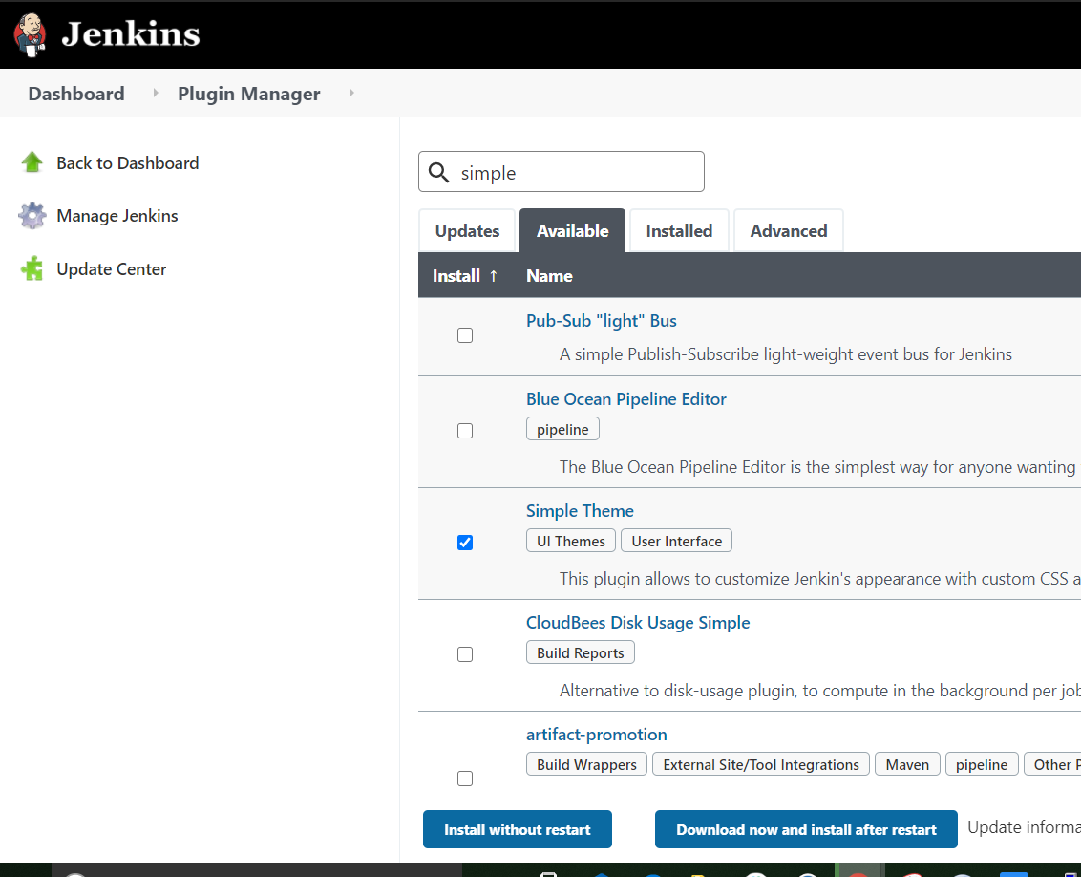

Change the CSS file in themes

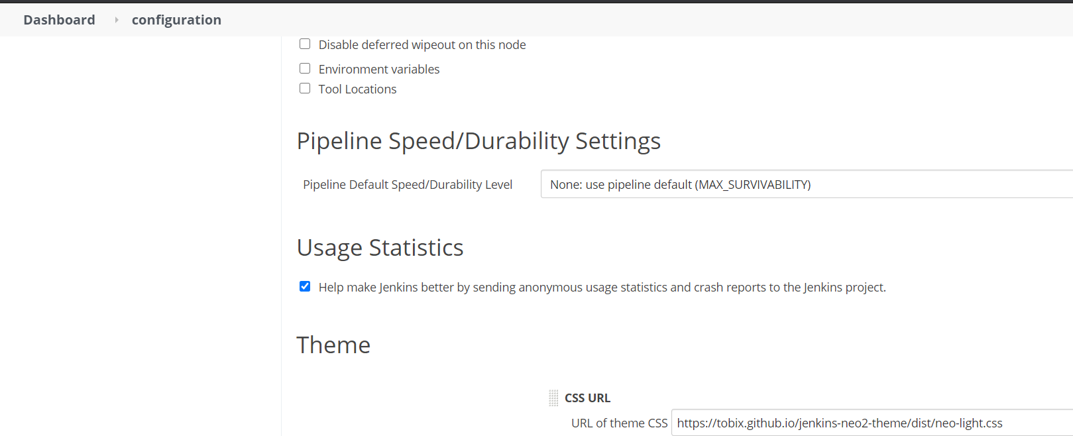

And now login with the new UI

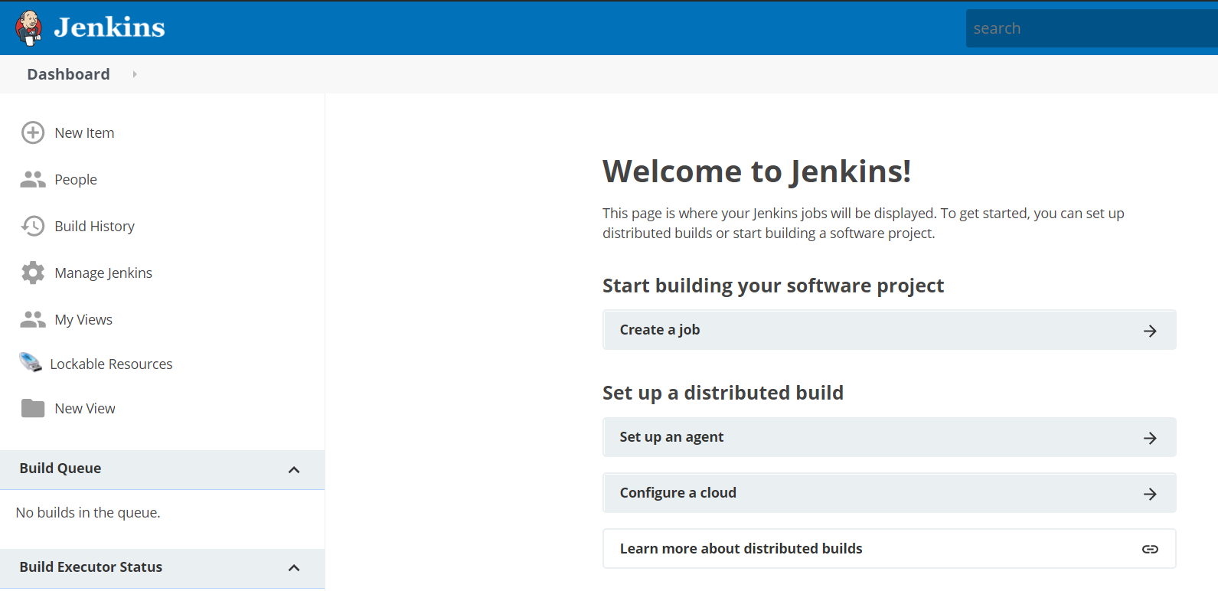

You can also customize using material theme

