Jenkins Master and Slave Setup

Create a separate server with same Java version installed on Master node

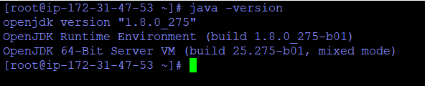

Create a SSH key pair in master node

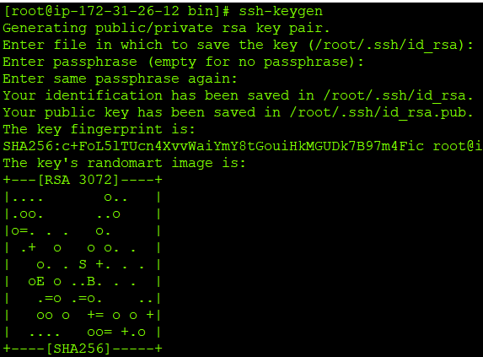

Access from the master to the slave will be via ssh, so we need to ensure that the ssh input from the master to the slave is without a password, i.e. add master ssh-key to allowed slave keys

Create a folder called .ssh in slave node and create a file called authorized file.

Copy the id_rsa.pub key in slave node authorized file.

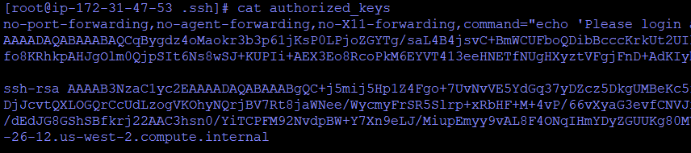

Do an SSH from master to slave and verify connection is successful

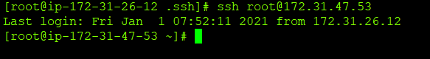

Configure Jenkins master credentials ( you will be adding private key of Jenkins master node)s

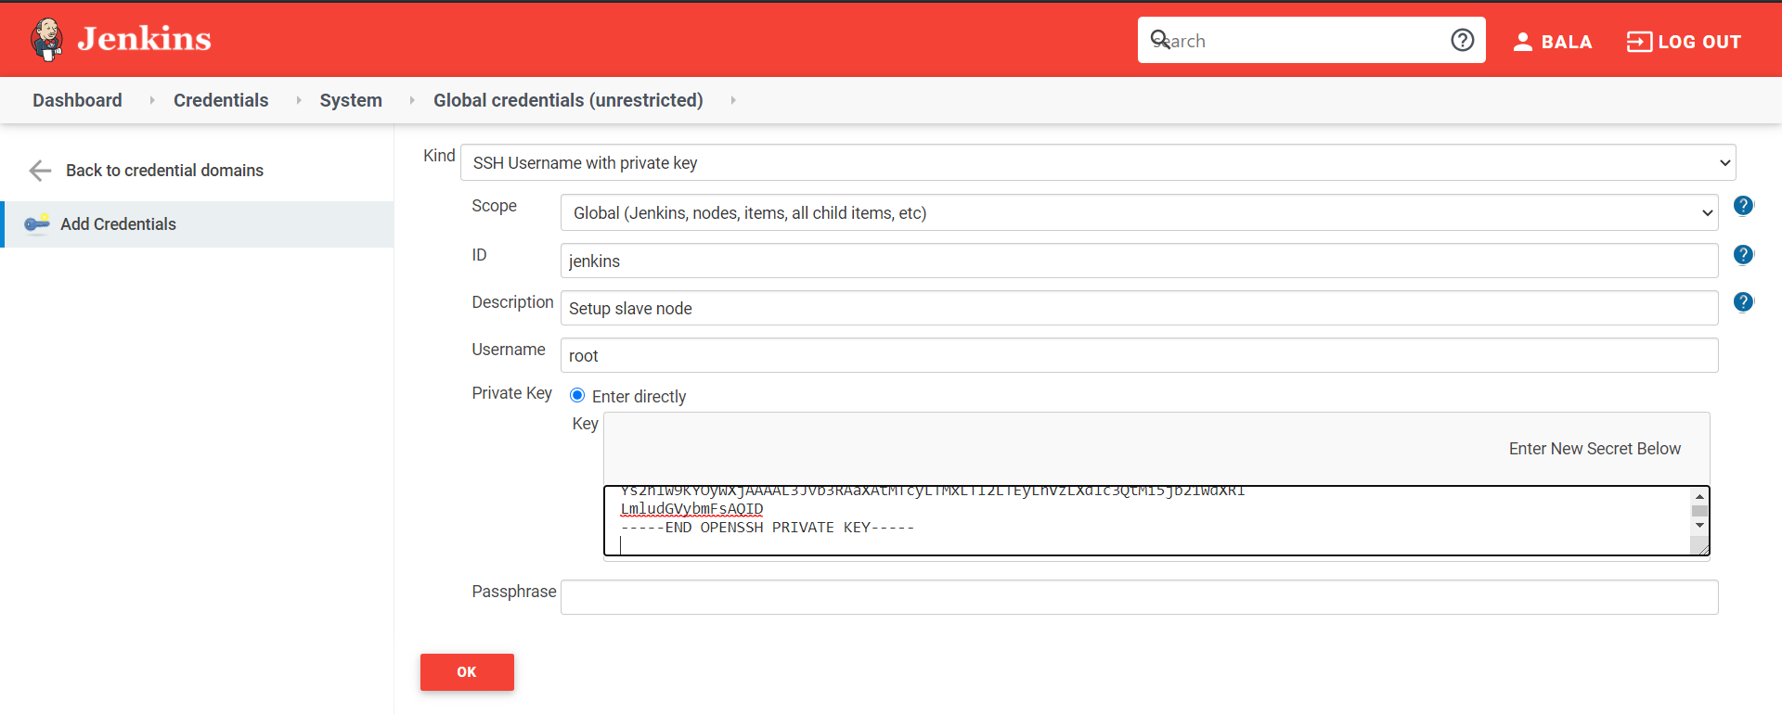

Add slave node

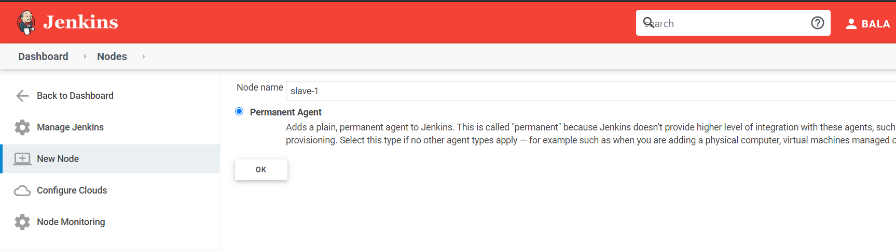

Edit slave node properties

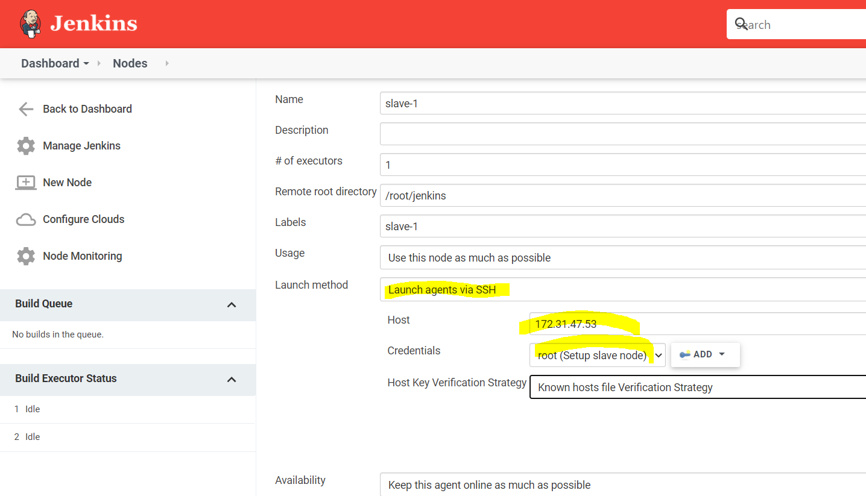

Slave is registered to master but offline

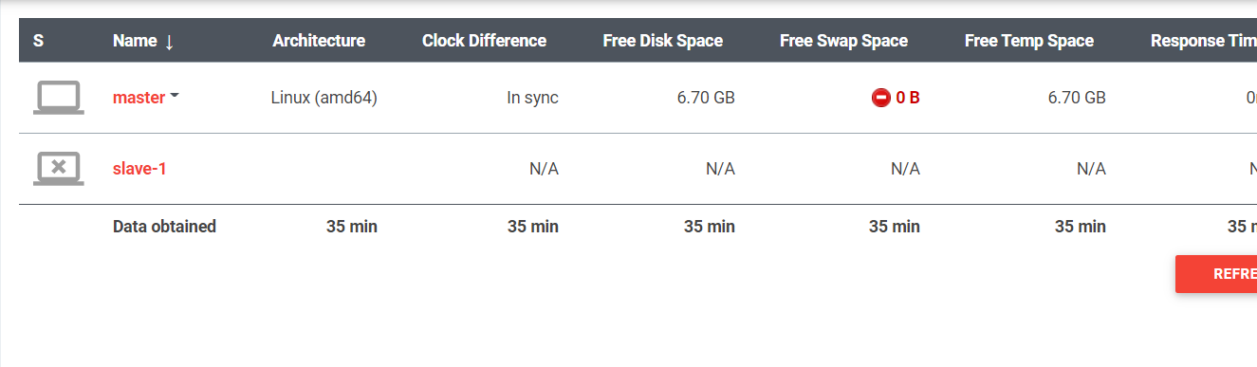

Click the slave-1 and see log

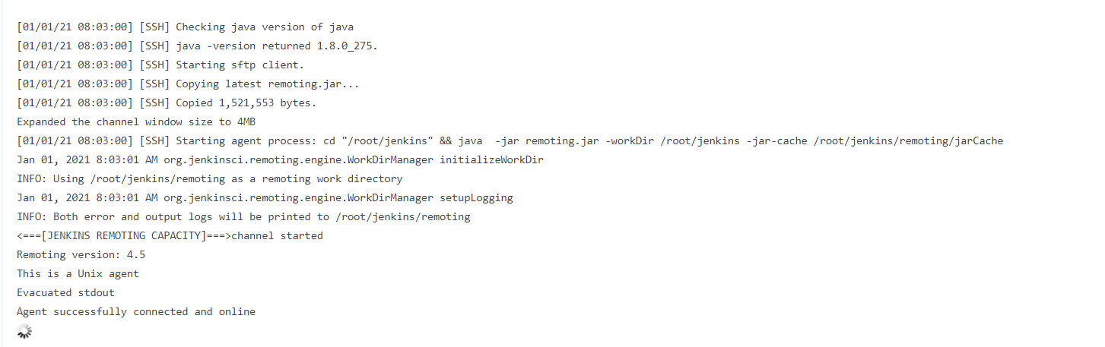

Now restrict the job to Slave node

Create new free style project

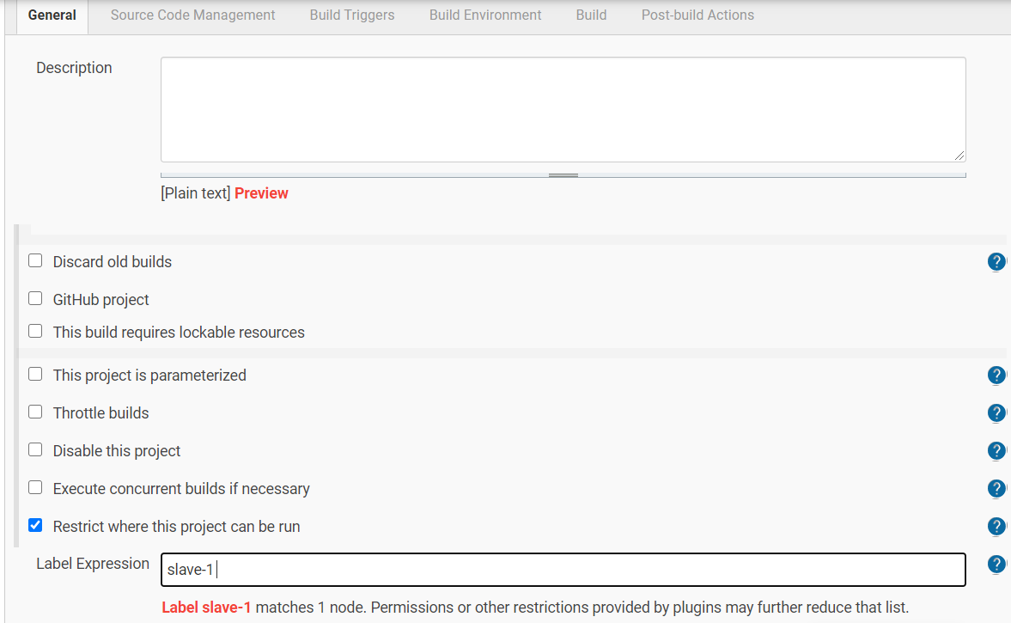

Execute Shell

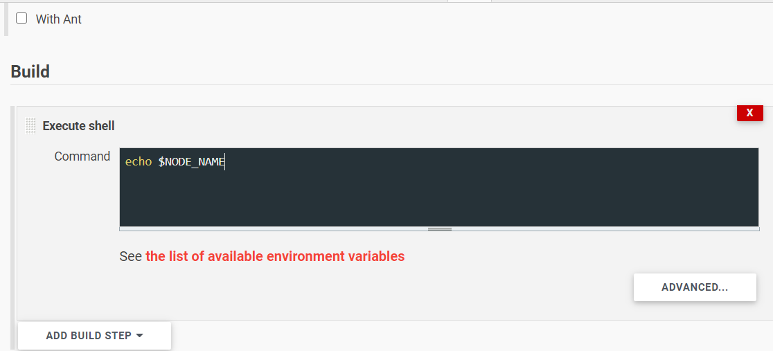

Build now and see the result

