Jenkins on Docker

Add the repository

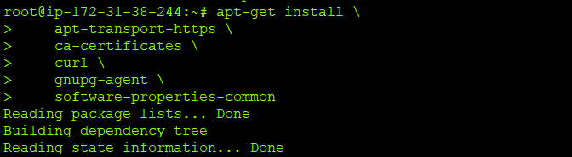

Add GPG keys

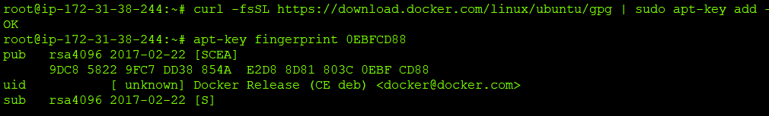

Add repository for installing Docker

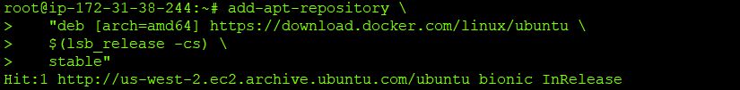  
  
Install Docker on ubuntu

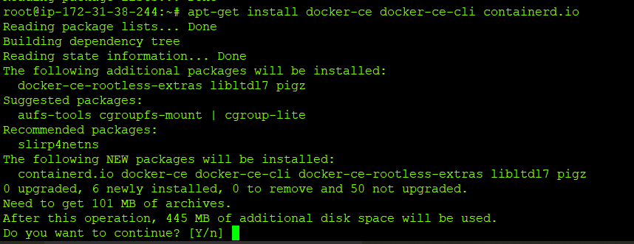

Install OpenJDK

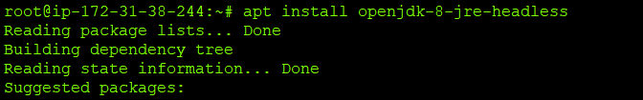

Check Java version

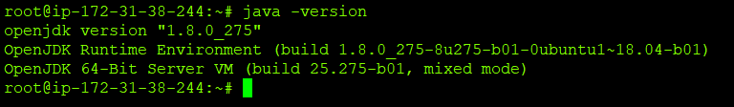  
  
Pull the Jenkins images locally

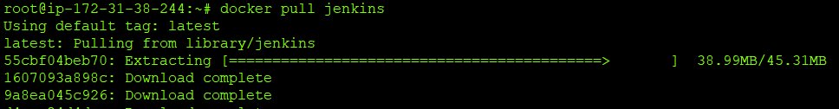  
  
List the images

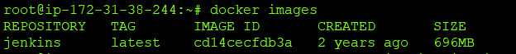  
  
Create a container



Start the container



You can also create container by publishing the host ports w.r.t container ports



Login to Jenkins console

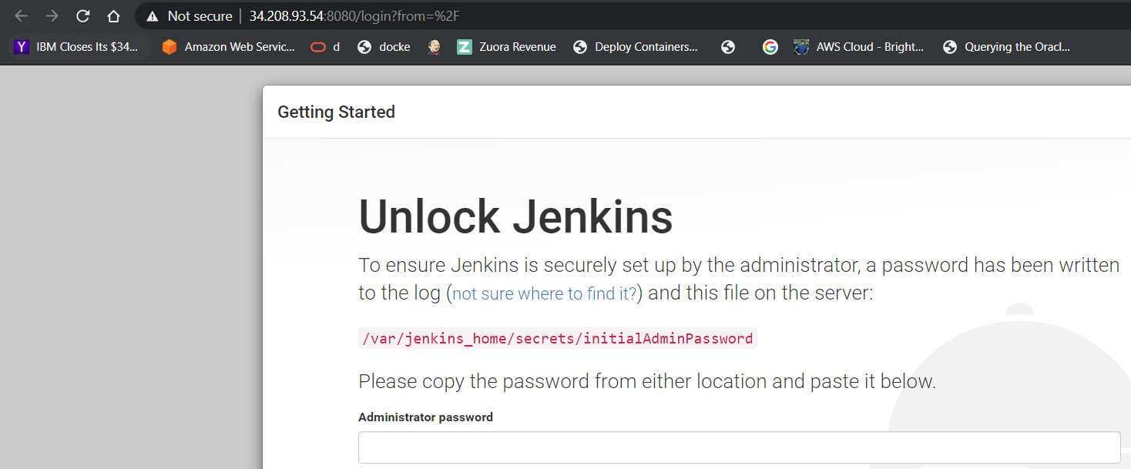

Unlock the admin password by logging to container

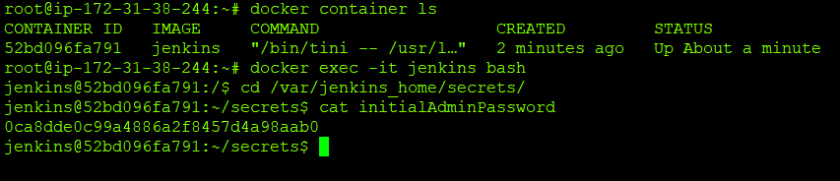

Install the plugins

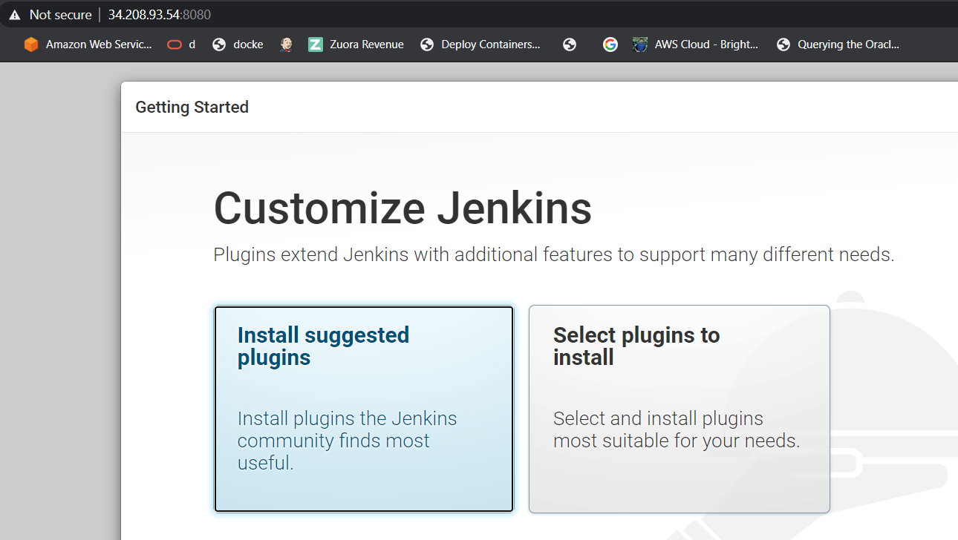

Create first admin user

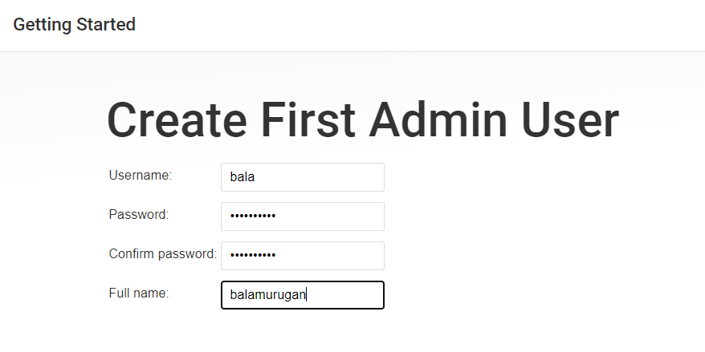

Jenkins Dashboard

