Docker Pull images

To list images that are present locally

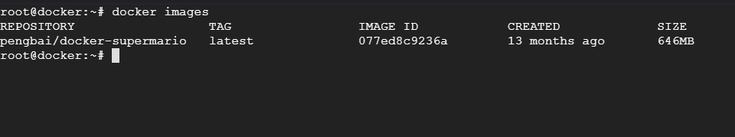

Login to Docker hub and pull docker image

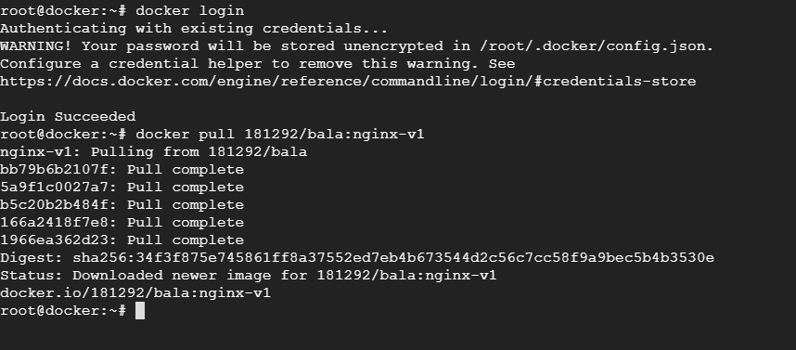

Now list local images



Create container using docker create command  
Docker create will just create the container, does not start it.  
You must start the container manually.

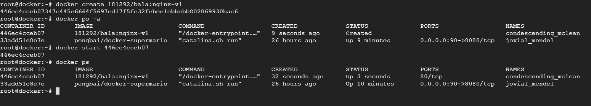

Stop and remove the container

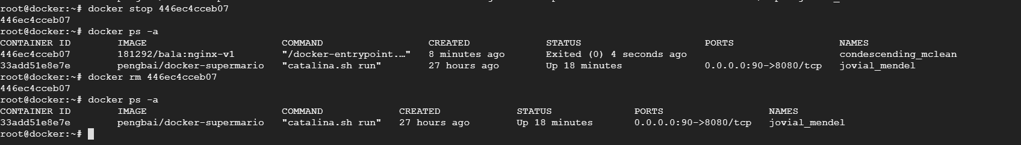

Remove the images

