Docker Search

Search the Jenkins images in Docker hub

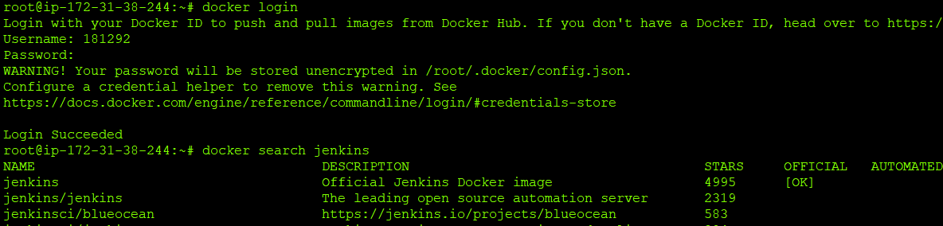

Search by filter

