Docker Container

List / stop / start containers

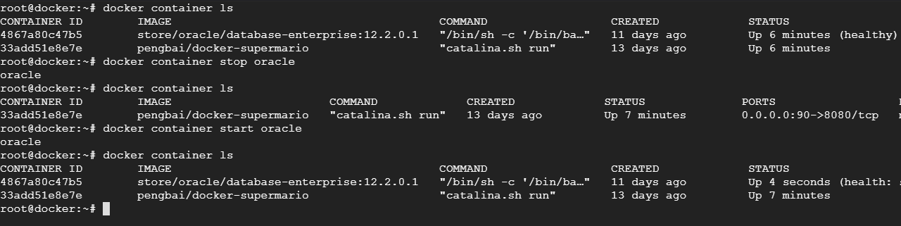

Stats  
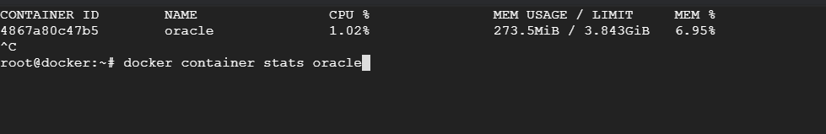

Prune   
  
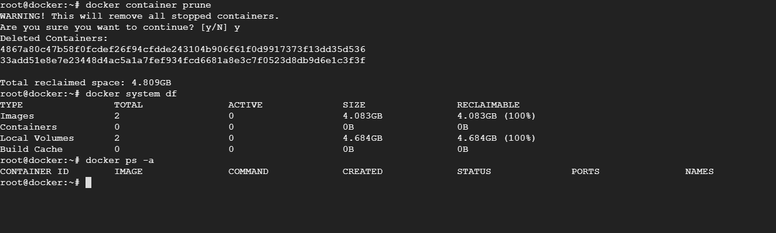

Docker container create

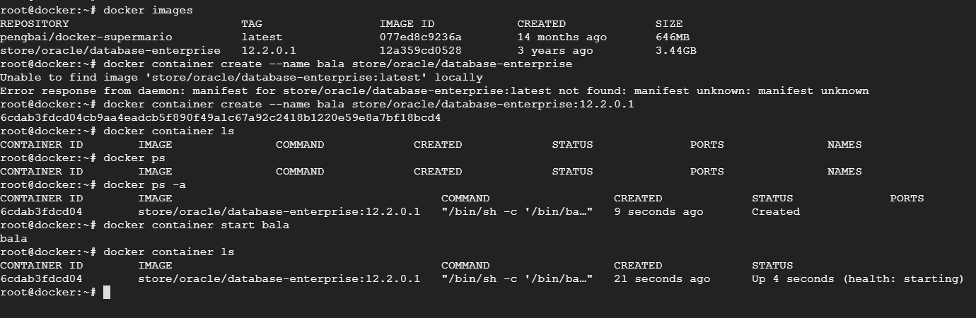

Kill / rm

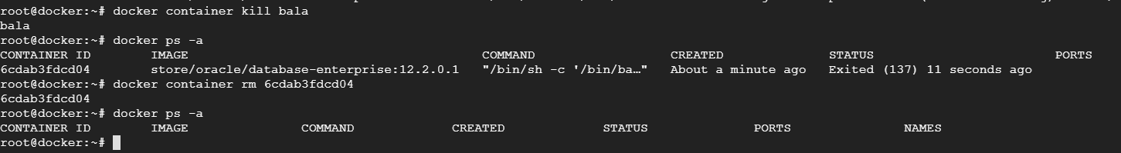  
  
Run

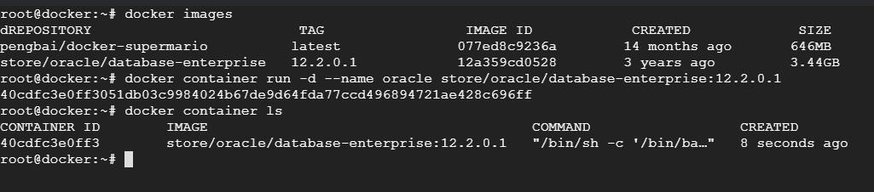

Exec

