Docker export/import and Save

Docker export

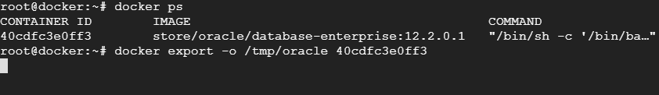  
  
Docker save

