How to tag docker images

List images locally

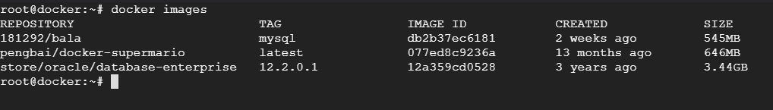

Tag a docker image using image id

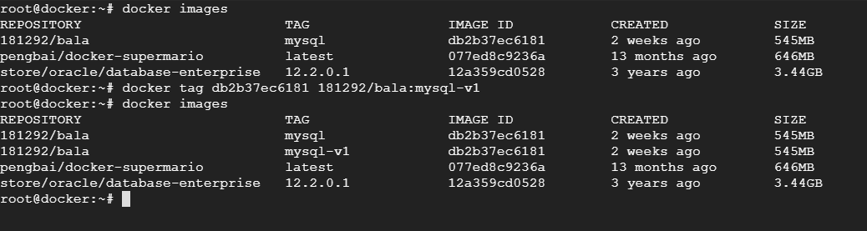

Tag a docker image using image name ( Repository is the image name)

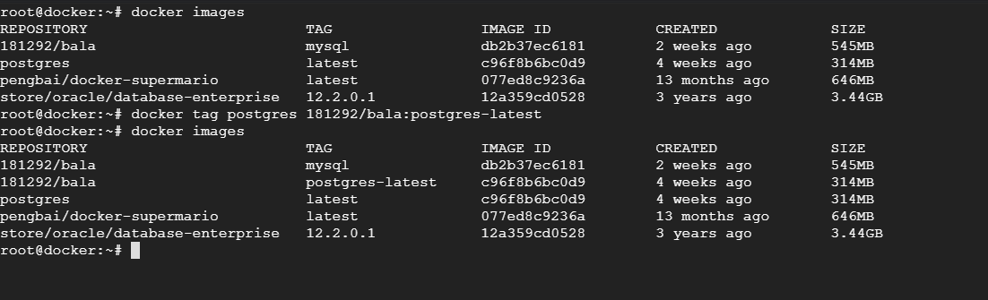  
  
Tag a docker image by name and tag

