ECR

Create an Amazon EC2 instance using Amazon-Linux

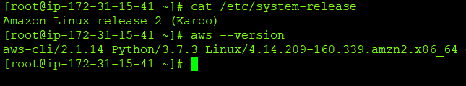

Install Docker

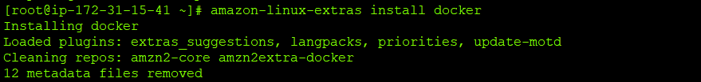

Check Docker status

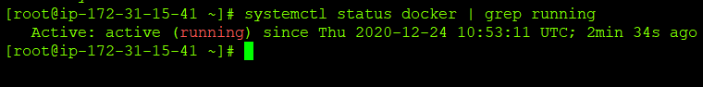

Build docker image

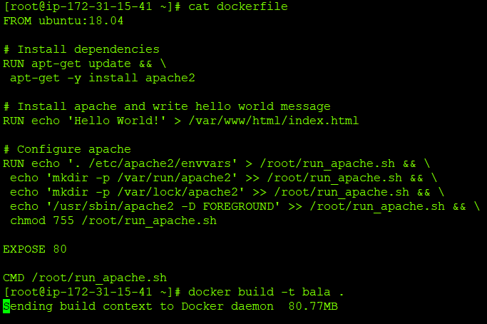

List Docker images

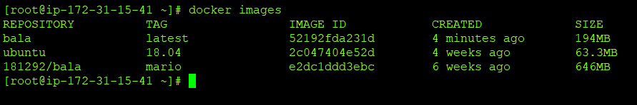

Create a repository in ECR

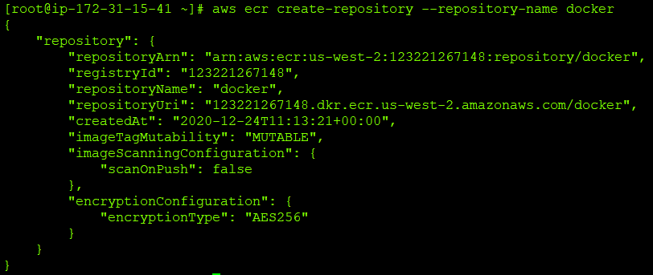

Authenticate to ECR

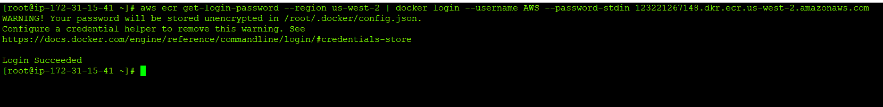

Push the images to ECR

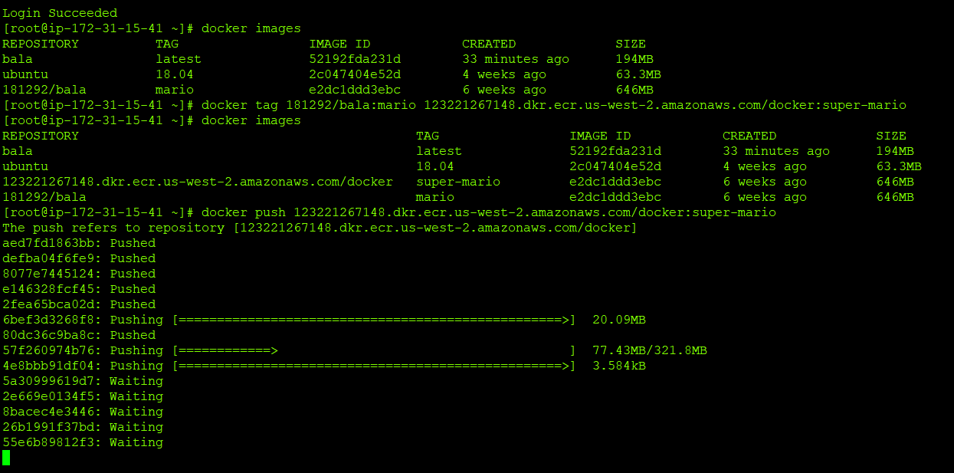

Verify in Console

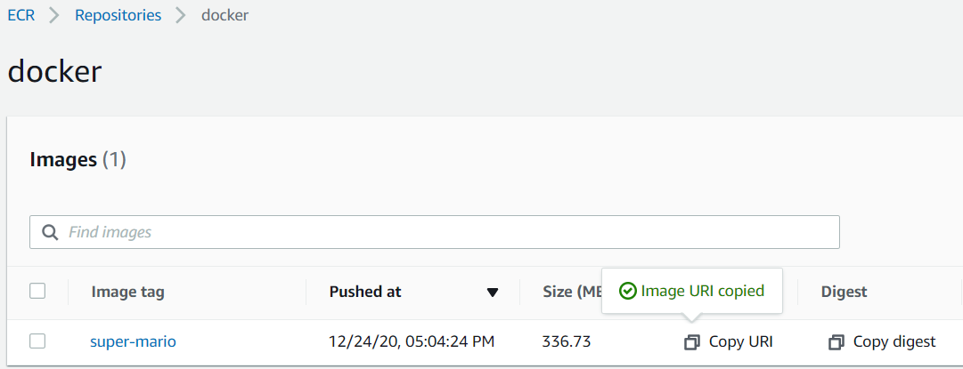

Pull an image from ECR

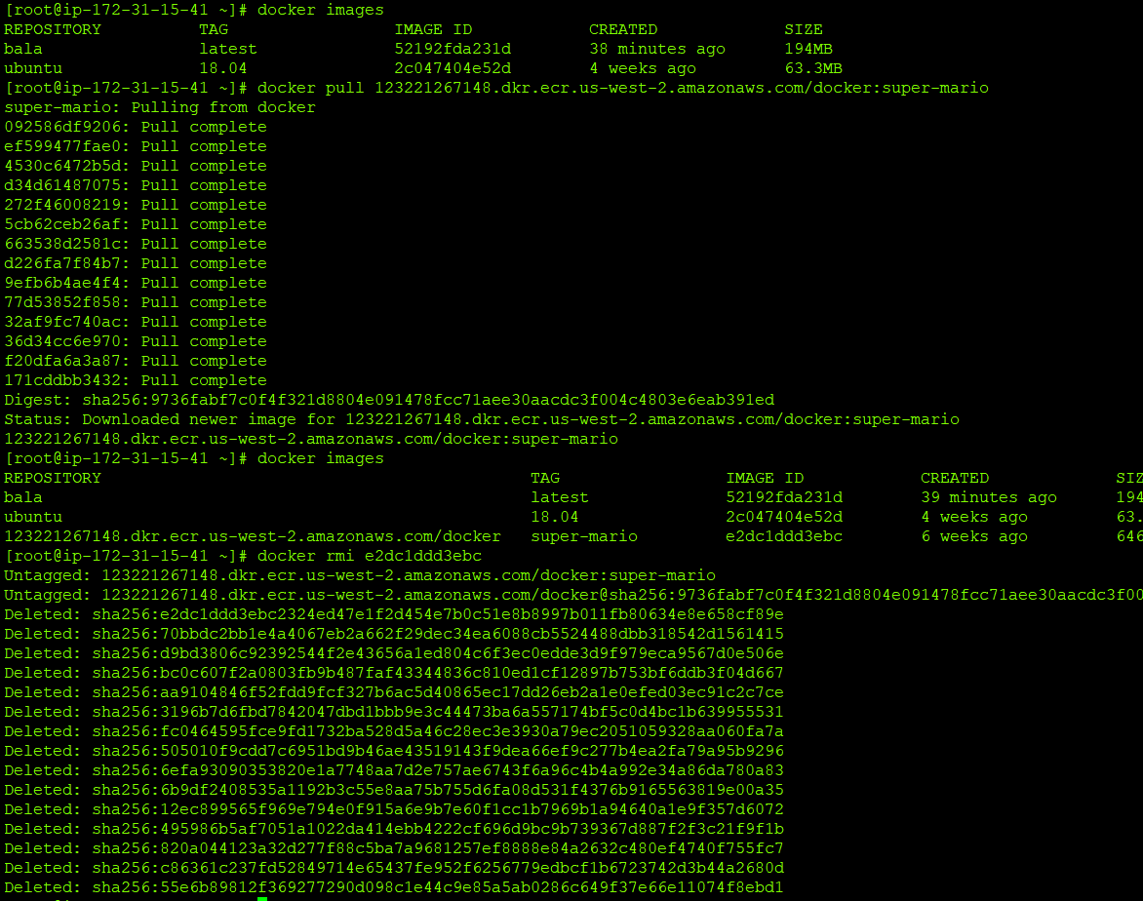

List and Delete the image in ECR

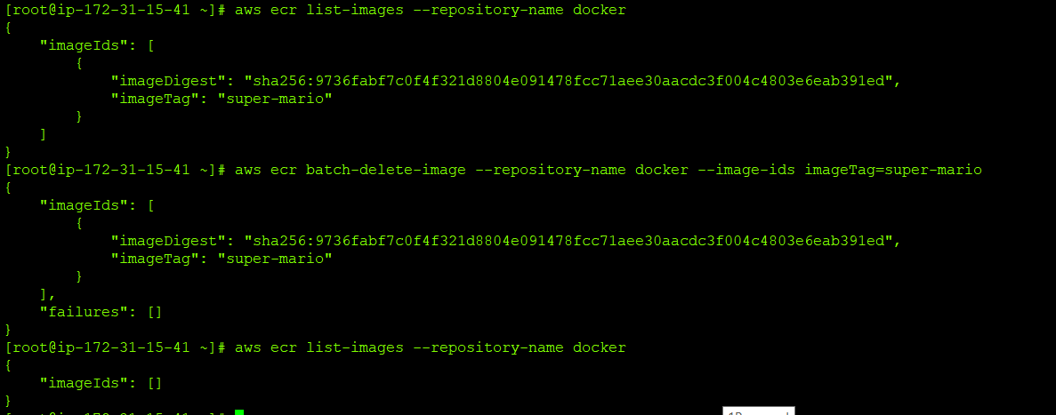

Delete the repository

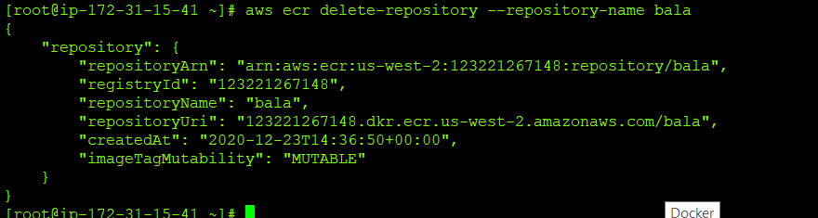

Describe repository and registry

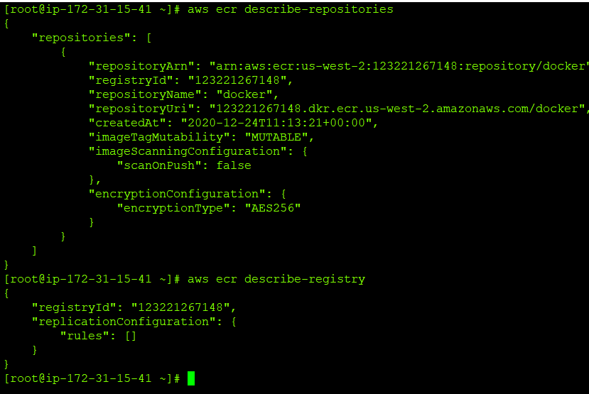

Describe images

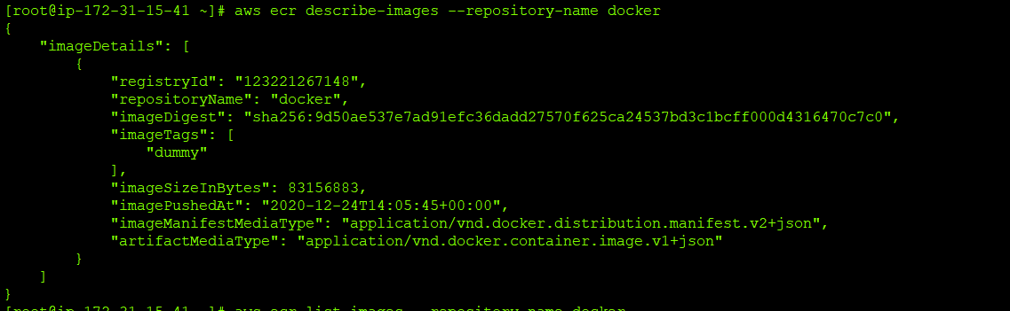

Update Tag Immutability

