ECS-CLI

Download the binary

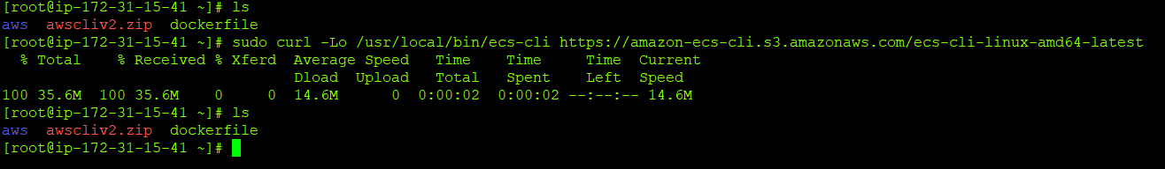

Retrieve Amazon ECS-CLI PBG Key

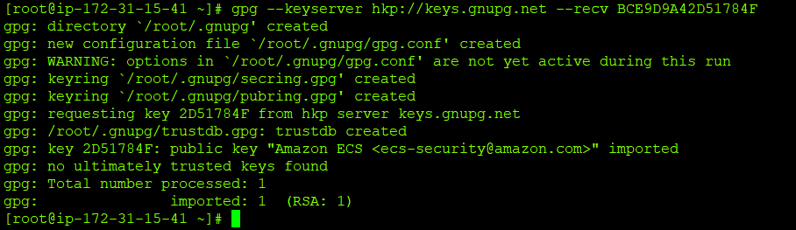

Download the signatures

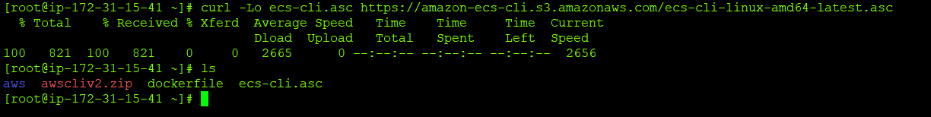

Verify the signature

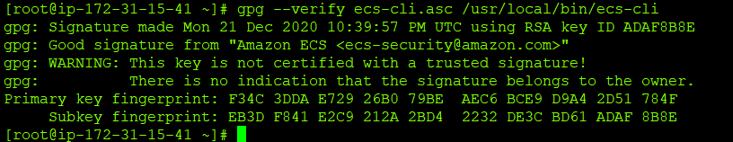

Change permission and verify

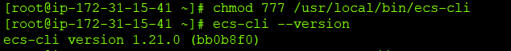

Create ECS-CLI profile



Complete the configuration



View the configuration information

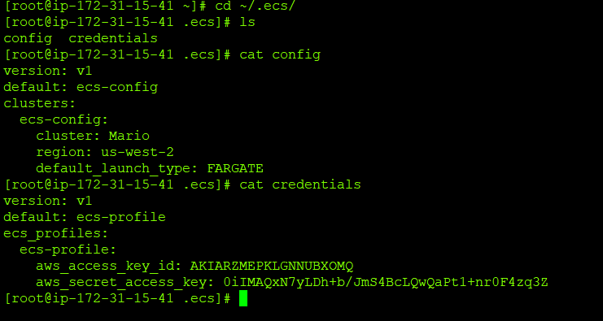

Create an empty cluster using ecs-cli

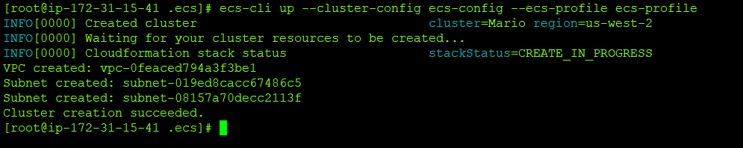List the images in ECR via ecs-cli

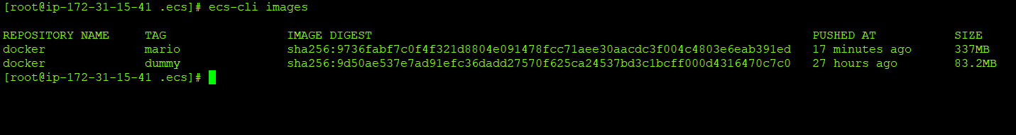

List the container instances using ecs-cli

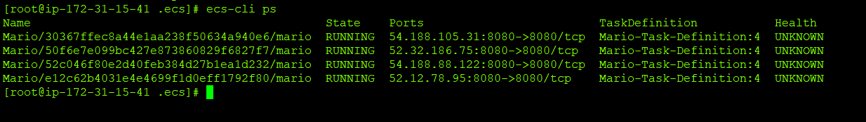

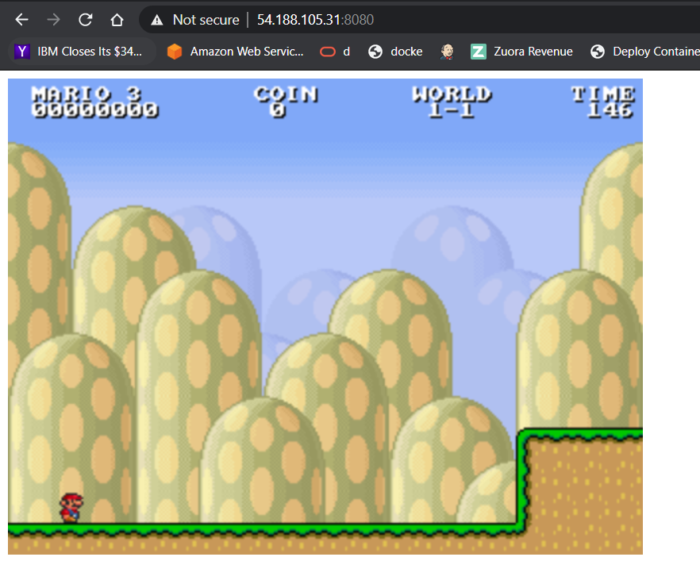

Delete your cluster

