EKS

Pre-requisites

1. Install AWS-cli
2. Install eksctl
3. Install kubectl

Aws-CLI



EKSCTL



Kubectl

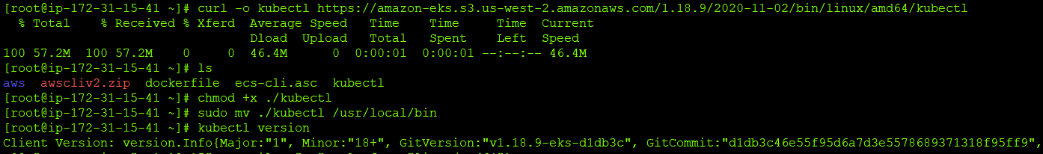

Install eks cluster in fargate using eksctl

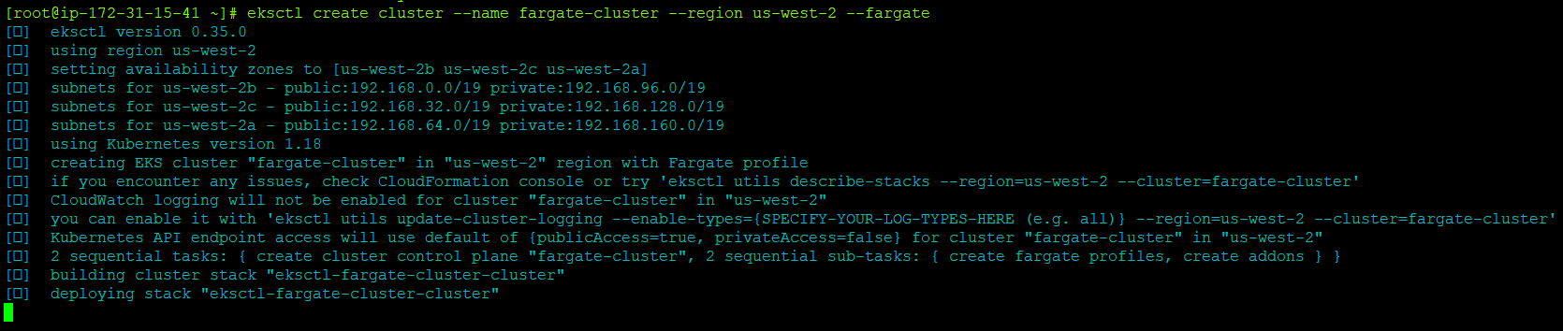  
  
Check the status



Install the managed node cluster in eksctl

