Google Kubernetes Engine

Navigate to k8s engine -> cluster

Enable K8s API

Create Cluster

Choose standard

Cluster basics

Default Node Pool details

Node info

Security

Network

Command line

**Check the status**

From command line

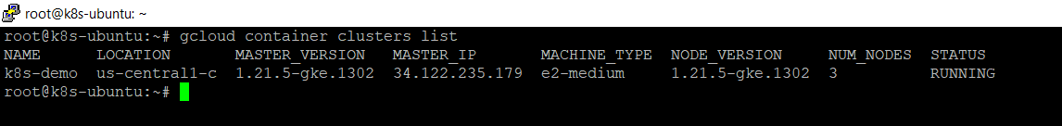

Connect to the cluster

Play with kubectl

Create a naked pod

